UNIVERSIDAD PARA LA COOPERACION INTERNACIONAL
(UCI)

PROJECT MANAGEMENT CONCEPTUAL FRAMEWORK FOR ENHANCING RURAL SAFETY AND SECURITY IN BELIZE

GINEE NICOLE NEAL

FINAL GRADUATION PROJECT SUBMITTED IN PARTIAL FULFILLMENT OF THE REQUIREMENTS FOR THE
MASTER IN PROJECT MANAGEMENT (MPM) DEGREE

BELMOPAN CITY, BELIZE

January 23, 2025

UNIVERSIDAD PARA LA COOPERACION INTERNACIONAL
(UCI)

This Final Graduation Project was approved by the University as
partial fulfillment of the requirements to opt for the
Master in Project Management (MPM) Degree

___________Roger Valverde________
Full name must be written
TUTOR

__________Sophia Crawford__________
Full name must be written
REVIEWER No.1

_________Luis Diego Argüello_________
Full name must be written
REVIEWER No.2

_________Ginee Nicole Neal_________
Student full name
STUDENT

DEDICATION

This project is dedicated to the rural communities who grapple with safety and security concerns. It is for them to know that a comprehensive roll-out plan is on the way, aimed at addressing these challenges and fostering safer and more secure environments.

To my children and family, who have been my unwavering pillars of support throughout this journey, I dedicate this work with heartfelt gratitude. Your moral support, endless patience, and profound understanding during the long hours of studying and researching have been my greatest source of strength and inspiration. This achievement reflects your encouragement, sacrifice, and unwavering belief in my abilities, and for that, I am eternally grateful.

ACKNOWLEDGMENTS

I would like to express my deepest gratitude to all those who have supported and guided me throughout the completion of this project. To my advisors and mentors, your invaluable insights, constructive feedback, and unwavering encouragement have been instrumental in shaping the direction and success of this work.
To my colleagues and peers, thank you for your collaboration, ideas, and shared commitment to addressing safety and security concerns in our communities. Your input has enriched this project and provided perspectives that are critical to its development.
A heartfelt thanks to the Ministry of Home Affairs and New Growth Industries for providing the platform and resources necessary to carry out this project. Your support and dedication to improving safety and security in rural communities have been a driving force behind this initiative.
I must also acknowledge my family for their understanding, cooperation, and unwavering support throughout this journey. Special thanks to the Management and staff of UCI, specifically Ms. Beatriz Davis, my Academic Advisor, whose guidance was invaluable. To my Professor, Roger Valverde, thank you for your unwavering support and mentorship throughout this process. To Dr. Paula Villalta, your insights and encouragement have been truly appreciated.
All honour and praises to the Most High for granting me the strength, wisdom, and perseverance to see this project to completion.

ABSTRACT

The project, titled "Development of a Conceptual Framework for Rural Safety and Security Initiatives in Belize," focuses on addressing the unique challenges faced by rural communities in Belize. These challenges include limited access to resources, fragmented communication networks, and diverse security threats. The framework proposed by this project aims to integrate sustainable and regenerative development principles into safety and security strategies specifically designed for these rural areas.

The project involves a comprehensive diagnosis of the current rural safety and security landscape, using both primary and secondary data sources. This diagnosis is crucial for identifying gaps in project management maturity within relevant ministries, which is essential for implementing adequate security initiatives. Based on these findings, the project proposes a conceptual framework incorporating best practices in project management, sustainability, and community engagement.

Key deliverables include a detailed Project Management Maturity Assessment, a Conceptual Project Management Framework, and a Strategic Methodology Plan. These deliverables provide the foundation for establishing a Project Management Office (PMO) to oversee safety and security projects in rural areas. The necessity and structure of the PMO are justified through an analysis of organizational needs and challenges, ensuring that it is feasible and sustainable. To ensure successful project completion, it is recommended that the relevant leadership teams receive project management training, that the project management plan and Lessons Learned Register be regularly updated, and that future projects align with the overarching organizational strategy of the involved ministries.

The project aligns with regenerative and sustainable development concepts by promoting renewable energy, reducing carbon footprints, and fostering economic and social resilience in rural communities. It emphasizes community involvement, ensuring that the solutions are effective, culturally appropriate, and widely accepted.

The anticipated impact of this project is significant. It aims to create safer and more resilient rural communities in Belize. By integrating sustainability into safety and security initiatives, the project contributes to the long-term well-being of these communities, ensuring that they are better prepared to face future challenges. Success will be measured through indicators such as: improvements in public safety perceptions, reductions in environmental impact, and enhancements in local economic conditions.
INDEX OF CONTENTS
APPROVAL PAGE ……………………………………………………………………...…2
DEDICATION .…………………………………………………………….……………….3
ACKNOWLEDGMENT ……………………………………………………………………4
ABSTRACT ………………………………………………………………………………...5
INDEX OF CONTENTS ……………………………………………………………………6
INDEX OF FIGURES 8
INDEX OF CHARTS 9
ABBREVIATIONS AND ACRONYMS 11
EXECUTIVE SUMMARY 12
1 INTRODUCTION 14
1.1. Background 14
1.2. Statement of the problem 16
1.3. Purpose 18
1.4. General objective 20
1.5. Specific objectives 20
2 THEORETICAL FRAMEWORK 22
2.1 Company/Enterprise framework 22
2.2 Project Management Concepts 31
2.3 Other applicable theory/concepts related to the project topic and context 52
3 METHODOLOGICAL FRAMEWORK 58
3.1 Information sources 58
3.2 Tools 69
3.3 Assumptions and constraints 73
3.4 Deliverables 74
4 RESULTS 76
4.1. Conduct a Comprehensive Diagnosis of the Current Rural Safety and Security Situation in Belize 76
4.2. To diagnose the state of maturity in project management of rural safety and security projects applied to the Ministry of Home Affairs and New Growth Industries, and the Ministry of Rural Transformation and Community Development, in Belize. 85
4.3. To define a conceptual project management framework for the enhancing of rural safety and security projects applied to the Ministry of Home Affairs and New Growth Industries, and the Ministry of Rural Transformation and Community Development in Belize. 91
4.4 To Establish a Project Management Strategic Methodology That Includes Essential Knowledge Areas and Processes Tailored to the Unique Challenges of Rural Safety and Security Initiatives. 168
4.5 To Determine the Necessity and Structure of a Project Management Office (PMO) to Oversee and Support the Execution of Safety and Security Projects, Ensuring Consistency and Quality in Project Management Practices. 201
4.6 To propose an implementation plan to apply the project management framework and methodology as well as the PMO in the Ministry of Home Affairs and New Growth Industries. 210
5 CONCLUSIONS 214
6 RECOMMENDATIONS 218
7 VALIDATION OF THE FGP IN THE FIELD OF REGENERATIVE AND SUSTAINABLE DEVELOPMENT 221
BIBLIOGRAPHY 227
APPENDICES 229
Appendix 1: FGP Charter 230
Appendix 2: FGP WBS 244
Appendix 3: FGP Schedule 245
Appendix 4: Preliminary bibliographical research 246
Appendix 5: Philological Dictum 249

INDEX OF FIGURES
Figure 1 Organizational structure 27
Figure 2 Characteristics of Project Life Cycles 46
Figure 3 Predictive Life Cycle 47
Figure 4 Components of a sample system for delivery 51
Figure 5 Key Safety Concerns Identified by Stakeholders 79
Figure 6 Trust in Law Enforcement Among Residents 79
Figure 7 Residents Perceptions of Safety in Rural Belize 83
Figure 8 Gantt Chart for PMO Implementation Activities 90
Figure 9 Key Measures for Each PMO Assessment Framework Component 91
Figure 10 Organizational Chart for PMO in the Ministry of Home Affairs and New Growth Industries (MHANGI) 100
Figure 11 Methodological Framework: Work Breakdown Structure (WBS) for RSSI Project 180
Figure 12 Methodological Gantt Chart for RSSI Project Implementation 185
Figure 13 P5 Impact Analysis 222

INDEX OF CHARTS
Chart 1 Functions of the Ministry of Home Affairs and New Growth Industries 22
Chart 2. Summary Table of Processes by Knowledge Area and Process Group 43
Chart 3 Information Sources 64
Chart 4 Research methods 68
Chart 5 Tools 72
Chart 6 Assumptions and Constraints 73
Chart 7 Deliverables 74
Chart 8 Community Safety Concerns and Key Themes 78
Chart 9 Key Safety Concerns by Stakeholder Group 80
Chart 10 Community Safety Action Plan 80
Chart 11 Community Safety Analysis and Proposed Measures 83
Chart 12 Key Components, Actions, and Outcomes for PMO Implementation 87
Chart 13 Key Roles and Responsibilities within the PMO 88
Chart 14 Phased Approach to PMO Implementation 89
Chart 15 Key Components and Measures for PMO Effectiveness 89
Chart 16 Accountability and Outcomes in PMO Framework Components 95
Chart 17 Key Deliverables for the Rural Safety and Security Initiatives (RSSI) Project 98
Chart 18 Roles and Responsibilities within the PMO Structure 102
Chart 19 Key Aspects of PMO Decision-Making Framework 105
Chart 20 Phased Implementation Plan for PMO Framework 107
Chart 21 Key Governance Assessment Areas and Questions 108
Chart 22 Quarterly Governance Focus Areas and Expected Outcomes 109
Chart 23 SMART Objective for Reducing Theft Rates 112
Chart 24 Prioritization of Key Initiatives for RSSI Projects 116
Chart 25 Key Actions and Tasks for Enhancing Rural Safety and Security 118
Chart 26 Phased Action Plan for Rural Safety and Security Initiatives 120
Chart 27 Personnel Resource Allocation Plan for RSSI Projects 122
Chart 28 Technology Resource Allocation Plan for RSSI Projects 123
Chart 29 Infrastructure Resource Allocation Plan for RSSI Projects 124
Chart 30 Monitoring and Adjustment Plan for RSSI Projects 125
Chart 31 Alignment of RSSI Project KPIs with National Goals 126
Chart 32 Key Sections of the RSSI Project Report 128
Chart 33 Concern Reporting Template for RSSI Projects 130
Chart 34 RSSI Concern Tracking and Resolution Log 131
Chart 35 Issue Resolution Workflow for RSSI Projects 133
Chart 36 Structured Escalation Process for RSSI Concerns 134
Chart 37 Key Performance Indicators for RSSI Projects 136
Chart 38 KPI Monitoring and Accountability Plan for RSSI Projects 140
Chart 39 Stakeholder Roles and Responsibilities in RSSI Projects 145
Chart 40 Stakeholder Engagement Metrics for RSSI Projects 146
Chart 41 Community Feedback Collection Methods for RSSI Projects 149
Chart 42 Impact of Tools and Technologies in RSSI Projects 154
Chart 43 Phased Implementation of Tools and Technologies for RSSI Projects 154
Chart 44 Risk Management Framework for RSSI Projects 155
Chart 45 Risk Management and Mitigation Status for RSSI Projects 160
Chart 46 Training and Capacity Building Plan for RSSI Projects 164
Chart 47 RSSI Project Review and Assessment Schedule 167
Chart 48 Phased Approach to RSSI Project Implementation 169
Chart 49 Initial Task Framework for RSSI Project Implementation 170
Chart 50 Stakeholder Analysis and Engagement Strategy for RSSI Projects 175
Chart 51 Communication Plan for RSSI Projects 176
Chart 52 Risk Management Methodology for RSSI Projects 177
Chart 53 12-Month Project Schedule Methodology for RSSI Implementation 179
Chart 54 Detailed Gantt Chart Data for RSSI Project Implementation 185
Chart 55 Resource Allocation Details for RSSI Project 187
Chart 56 Procurement Plan for RSSI Project Resources 188
Chart 57 Procurement Timeline for RSSI Project Resources 189
Chart 58 Roles and Responsibilities in the RSSI Procurement Process 189
Chart 59 Procurement Risks and Mitigation Strategies for RSSI Projects 190
Chart 60 Procurement Approval Sign-Off Sheet for RSSI Projects 190
Chart 61 Implementation Tasks and Responsibilities for the RSSI Project 191
Chart 62 Monitoring and Reporting Activities for RSSI Projects 191
Chart 63 Closure Phase Activities for RSSI Projects 191
Chart 64 Phased Timeline and Activities for RSSI Project Lifecycle 194
Chart 65 Key Performance Indicators (KPIs) for RSSI Project Success 195
Chart 66 Risk Register for RSSI Project Management 197
Chart 67 Risk Assessment and Mitigation Plan for RSSI Projects 199
Chart 68 Issue Log for RSSI Project Management 200
Chart 69 Risk Management Metrics for RSSI Projects 201
Chart 70 Phased Implementation Plan for Establishing the PMO in RSSI Projects 213
Chart 71 P5 Analysis 225

ABBREVIATIONS AND ACRONYMS
- FGP - Final Graduation Project
- GIS - Geographic Information System
- MHANGI - Ministry of Home Affairs and New Growth Industries
- MOU - Memorandum of Understanding
- NGI - New Growth Industries
- PMBOK - Project Management Body of Knowledge
- PMI - Project Management Institute
- PMO - Project Management Office
- RSSI - Rural Safety and Security Initiative
- WBS - Work Breakdown Structure

EXECUTIVE SUMMARY
Rural communities in Belize have long struggled with significant challenges related to safety and security. These issues are compounded by the geographical isolation of these areas, limited resources, and a lack of structured project management frameworks designed to address the unique needs of rural populations. Over the years, various safety initiatives have been attempted, but many have failed to deliver sustainable results due to the absence of a cohesive approach to project management. Consequently, problems such as crime, insufficient law enforcement presence, and inadequate infrastructure continue to undermine the safety and security of these communities.
The core problem identified is the lack of a practical project management framework to guide rural safety and security initiatives. This deficiency leads to project delays, budget overruns, and inconsistent outcomes, ultimately preventing meaningful improvements in rural communities' safety and security. Moreover, the absence of a centralized body to oversee and coordinate these projects further complicates efforts to achieve significant progress in this area.
The justification for developing a conceptual project management framework for rural safety and security initiatives in Belize stems from its potential to improve the planning, execution, and sustainability of these projects. By standardizing project management practices, this framework aims to ensure that resources are used efficiently and that projects meet their intended objectives, thereby enhancing Belize's rural populations' overall safety and well-being.
The general objective of this project is to develop a conceptual project management framework to enhance the effectiveness and sustainability of rural safety and security initiatives in Belize. The specific objectives are to conduct a comprehensive diagnosis of the current rural safety and security situation in Belize, diagnose the state of maturity in project management for rural safety and security projects, define a conceptual project management framework for enhancing rural safety and security projects, establish a project management strategic methodology for rural safety and security initiatives, determine the necessity and structure of a Project Management Office (PMO) to oversee safety and security projects, and propose an implementation plan for the project management framework and PMO.
The methodological framework for this project includes a combination of qualitative and quantitative research methods. Surveys, interviews, and geographical information systems (GIS) analysis were conducted to gather data on rural Belize's current safety and security situation. Document analysis, maturity models, and benchmarking tools were used to assess the maturity of existing project management practices. Additionally, workflow management software and collaboration platforms facilitated the development and testing of the proposed framework. This approach ensured that the project was grounded in empirical evidence and aligned to best practices in project management.
The main conclusions drawn from the project are that the current state of rural safety and security in Belize is hampered by inconsistent project management practices, undermining the effectiveness of safety initiatives. The proposed conceptual project management framework has the potential to address these issues by providing a standardized approach that improves project outcomes and ensures sustainability. Establishing a PMO was also critical for coordinating and overseeing these initiatives, to ensure that they align with national safety and security goals.
The key recommendations derived from the project include implementing the proposed project management framework to standardize and improve the management of rural safety and security initiatives, establishing a PMO to oversee these projects, and providing ongoing project management training for stakeholders involved in these initiatives. Additionally, it is recommended that the framework be regularly reviewed and updated to reflect changes in Belize's safety and security landscape, to secure its continued relevance and effectiveness.

INTRODUCTION

Background
The Ministry of Home Affairs and New Growth Industries in Belize ensures public safety, fosters economic growth and manages emerging industries. Despite the critical role that rural areas play in Belize’s economy and cultural heritage; these regions have historically been neglected regarding safety and security initiatives. Rural Belize faces significant challenges, including geographic isolation, limited law enforcement presence, and inadequate infrastructure, contributing to an elevated crime risk and social unrest. The disparity between urban and rural safety measures has become increasingly apparent, necessitating a more focused and comprehensive approach to addressing these issues.
Rural communities in Belize are often more vulnerable to crime due to their isolation and lack of resources. These areas are important for the country's agricultural output and cultural identity but lack effective safety measures. Traditional crime prevention strategies, primarily designed for urban areas, are often unsuitable for rural contexts, leaving these communities at risk (Abraham & Ceccato, 2022). Additionally, the limited presence of the Belize Police Department and the challenging geography of rural regions make it difficult to implement the same security strategies used in urban areas. This gap highlights the need for a tailored approach that considers the unique conditions of rural Belize.
In response to these challenges of the Ministry of Home Affairs and New Growth Industries, the "Development of a Conceptual Framework for Rural Safety and Security Initiatives" has been initiated. This project aims to create a strategic framework specifically designed to meet the needs of rural communities. The proposed framework will incorporate a blend of analytical, inductive, and case study methods to establish a comprehensive, data-driven approach adaptable to the diverse needs of these areas. Therefore, by focusing on the specific characteristics of rural Belize, the framework will aim to improve safety outcomes and reduce crime in these vulnerable communities.
The proposed framework also includes establishing a Project Management Office (PMO) to oversee and coordinate safety and security projects within the rural context. This initiative aligns with global project management trends, emphasizing the importance of structured methodologies and stakeholder engagement in achieving successful project outcomes (Peake, 2019). By integrating these principles with a deep understanding of local conditions, the framework aims to create a sustainable and practical approach to rural safety and security in Belize.
Previous research has shown that when adequately supported by governmental frameworks, community-based safety initiatives can significantly enhance security in rural areas (Government of Ireland, 2022). The framework being developed will draw on these insights, thereby ensuring that community engagement is a central component of the strategy. This approach addresses immediate safety concerns and empowers communities to actively maintain their security.
The "Development of a Conceptual Framework for Rural Safety and Security Initiatives" represents a critical advancement in addressing the safety challenges faced by rural Belize. Through leveraging robust project management methodologies and incorporating insights from global best practices, this initiative aims to create a more secure environment for all Belizeans, particularly those in the most isolated and vulnerable rural areas.

Statement of the problem
Rural areas in Belize are currently facing urgent safety and security challenges, largely due to the absence of a structured and comprehensive project management framework within the Ministry of Home Affairs and New Growth Industries. The situation is critical, as various safety initiatives, though launched over the years, have often suffered delays, budget overruns, and failure to meet their intended objectives, leaving rural communities vulnerable to crime and insecurity.
One of the primary issues that needs urgent attention is the lack of project management expertise within the Ministry. While efforts have been made to address rural safety, not every designated team or individual has the requisite skills and knowledge to plan, execute, and monitor these projects effectively. This has resulted in inefficiencies, including significant delays in project timelines, substandard deliverables, and misalignment with the needs of rural communities (Peake, 2019).
Efforts to implement community policing programs have been sporadic and inconsistent, with no standardized approach to ensuring success across different regions. This has resulted in varying levels of effectiveness and continued insecurity in some areas (Sharpe, 2022). Moreover, the Ministry's inability to establish a Project Management Office (PMO) or to implement a standardized project management methodology has exacerbated these challenges. Without a PMO, there is no central oversight or coordination of safety initiatives, leading to fragmented efforts and a lack of accountability (Koeppel, 2023). The absence of a structured approach means that each project is managed in isolation, with little consideration for best practices or lessons learned from previous initiatives. This not only hampers the effectiveness of current projects but also hinders the Ministry's ability to plan and implement future safety measures (Chen, et al., 2021).
The lack of a comprehensive conceptual framework for managing rural safety and security initiatives has resulted in a reactive approach to safety, where measures are implemented without a clear strategy or long-term vision. This has left rural communities in Belize vulnerable to crime and insecurity, with little progress in addressing their safety concerns. As the Ministry seeks to improve rural safety and security, it is clear that a new approach is needed, one grounded in sound project management principles and tailored to the unique challenges of rural areas (Abraham & Ceccato, 2022).
Developing a conceptual project management framework for rural safety and security initiatives is therefore crucial. This framework will address the current gaps in project management maturity and provide a strategic approach to overcoming the logistical and infrastructural challenges unique to rural Belize. By establishing a dedicated PMO and adopting a structured, comprehensive approach to rural safety, the Ministry can significantly enhance the effectiveness of its initiatives, leading to safer and more resilient communities across the country.

Purpose
This study aims to develop a conceptual project management framework specifically designed for rural safety and security initiatives in Belize. This framework addresses the unique challenges in rural areas, such as geographical isolation, limited resources, and varying infrastructure levels. The study seeks to create a structured process for planning, executing, and monitoring safety and security projects within the Ministry of Home Affairs and New Growth Industries by investigating the key elements necessary for an effective and sustainable project management approach. The goal is to enhance the overall effectiveness of these initiatives, particularly in rural communities.
This project seeks to bridge the gaps in current project management practices within the Ministry, which have historically led to inefficiencies, delays, and suboptimal outcomes in safety and security projects. By establishing a comprehensive framework, the Ministry can improve the management and execution of future initiatives, resulting in better safety outcomes for rural areas. The proposed framework will integrate the Project Management Institute (PMI) best practices, encompassing scope, schedule, cost, quality, resources, communications, risk, procurement, and stakeholder engagement.
The research hypothesis suggests that developing and applying a tailored project management framework will significantly enhance the success rate of rural safety and security projects. This enhancement is expected to manifest in more timely and cost-effective solutions that better align with the needs of Belize’s rural communities. The hypothesis will be tested through an in-depth analysis of current project management practices and the practical implementation of the proposed framework in ongoing and future projects.
The anticipated benefits of this project include increased efficiency and effectiveness in managing rural safety and security projects, leading to reductions in delays and cost overruns. Furthermore, the framework is expected to improve the alignment of project outcomes with specific needs and expectations of rural communities, ensuring that initiatives are more responsive to their unique circumstances. Additionally, establishing a structured project management approach within the Ministry will enhance coordination and consistency across all safety and security projects, thereby strengthening the Ministry's capacity to manage complex initiatives. Ultimately, the successful implementation of this framework is expected to contribute to a safer and more secure rural environment in Belize, providing long-term benefits to these communities.
Through this study, the Ministry of Home Affairs and New Growth Industries can significantly improve its project management capabilities, leading to more effective and sustainable safety and security initiatives in rural areas. The framework developed will address current challenges and lay the groundwork for the successful execution of future projects, ensuring that Belize's rural populations' safety and security needs are met comprehensively.

General objective
To develop a conceptual project management framework for rural safety and security initiatives in Belize, addressing unique challenges and ensuring sustainable outcomes to improve the effectiveness and efficiency of these projects.

Specific objectives
- To conduct a comprehensive diagnosis of the current rural safety and security situation in Belize to identify key challenges, needs, and opportunities for improvement.
- To assess the maturity of project management practices in rural safety and security initiatives within the Ministry of Home Affairs and New Growth Industries and the Ministry of Rural Transformation and Community Development to identify gaps and areas for enhancement.
- To define a conceptual project management framework tailored for rural safety and security projects, incorporating best practices and methodologies suited to the unique context of Belize.
- To establish a strategic project management methodology that integrates essential knowledge areas and processes, ensuring effective planning, execution, and monitoring of rural safety and security initiatives.
- To determine the necessity and structure of a Project Management Office (PMO) to oversee rural safety and security projects, ensuring consistency, quality, and continuous improvement in project management practices.
- To propose an implementation plan for the conceptual framework and PMO that outlines the steps, resources, and timelines required for successful adoption within the relevant ministries.

THEORETICAL FRAMEWORK

Company/Enterprise framework

Company/Enterprise background
The primary organization involved in this research is the Ministry of Home Affairs and New Growth Industries in Belize. Established as a critical governmental body, the Ministry is dedicated to ensuring public safety and security while fostering economic development and innovation across the country.
The Ministry includes several critical departments:
- Belize Police Department
- National Forensic Science Service
- Belize Prison
- Belize Crime Observatory
- Leadership Intervention Unit
- New Growth Industries
These units collaborate to enhance national security and support the Ministry's broader goals of sustainable growth and innovation in new industries.

Chart 1 Functions of the Ministry of Home Affairs and New Growth Industries

(Source: MHANGI, n.d. a)
Department | Function
Belize Police Department | Law enforcement and public safety
National Forensic Science Service | Scientific analysis and evidence processing
Belize Prison | Correctional services
Belize Crime Observatory | Data collection and analysis for crime prevention
Leadership Intervention Unit | Community engagement and violence prevention
New Growth Industries | Promoting the development and growth of new and emerging industries, ensuring sustainable economic growth and resilience to provide sustainable growth and employment opportunities for Belizeans.
Note: Ministry of Home Affairs and New Growth Industries, n.d. The functions listed are based on internal reports and official documentation from the Ministry of Home Affairs and New Growth Industries, emphasizing the Ministry’s integrated approach to public safety, crime prevention, and economic development in Belize.

The Ministry has initiated several local and international partnerships to enhance its capabilities and reach. These include collaborations with regional security bodies, international law enforcement agencies, and local community organizations to drive a holistic approach to national security and community development.
In recent years, the Ministry has emphasized the importance of data-driven decision-making and innovative solutions to address complex public safety and economic growth challenges. This approach includes integrating advanced technologies and methodologies into everyday operations and strategic planning.

Mission and vision statements
Mission:
As the official Ministry website articulated, the mission statement of the Ministry of Home Affairs and New Growth Industries is: "To ensure safety and security, promote innovation, and prosperity through collaboration with the public and private sectors, civil society, and all communities. Utilize advanced systems, maintain law and order, ensure citizen security, champion emerging industries and the government’s demand for sustainable growth for Belize."
This mission statement encapsulates the Ministry's dedication to fostering a secure environment while simultaneously driving economic innovation and growth. It emphasizes the integration of advanced systems and collaborative approaches across sectors to achieve comprehensive national development.
Vision:
In alignment with recent strategic planning, the Ministry of Home Affairs and New Growth Industries has outlined a vision statement that reflects its commitment to future goals: "A safe, secure, and prosperous nation fostered through collaboration, innovation, and data-driven processes to ensure social justice, sustainable growth, and economic sovereignty."
The priorities of this vision include:
- Strengthening Community Engagement – Strengthening community engagement will enhance the involvement of communities in safety and security initiatives to foster a cooperative approach to law enforcement.
- Driving Technological Advancement - Incorporate innovative technologies to improve public safety measures and data collection, such as digitizing and digitalizing the ministry’s systems
- Promoting Economic Development – The ministry supports and assists with developing emerging industries that contribute to national prosperity.
- Enhancing Interdepartmental Collaboration – Including these collaborations, improve coordination between different government agencies to ensure a unified approach to public safety and economic issues.
- Expanding International Partnerships – This vision is important because it assists in engaging more actively with international partners/stakeholders to exchange knowledge and resources, enhancing global presence and capabilities.
The relation between these visions and the Final Graduation Project (FGP) is to:
Develop a conceptual project management framework for enhancing rural safety and security initiatives in Belize, which are intrinsically linked to the Ministry’s mission and vision. The FGP addresses explicitly:
- Strategic Vision Community Engagement—The framework aims to foster a more engaged and cooperative community atmosphere in rural areas of Belize by improving the management of safety projects.
- Strategic Vision Economic Development - The framework supports the economic aspect of the vision by ensuring that safety initiatives also consider and incorporate opportunities for economic development in rural areas.
- Strategic Vision Interdepartmental Collaboration - The project will facilitate better coordination and collaboration between the Ministry’s departments, ensuring a cohesive approach to rural safety.
- Strategic Vision International Partnerships—These best practices and innovative solutions from global partners enhance the project's goal of strengthening the Ministry’s capacity to implement effective safety and security measures.
Establishing a robust project management framework will allow the Ministry of Home Affairs and New Growth Industries to effectively communicate its mission, optimize resources, and implement initiatives that align with the mission and strategic vision priorities. This cohesion will ultimately contribute to building a safer, more secure, and prosperous Belize, reflecting the Ministry's core commitments and strategic objectives.

Organizational structure
The Ministry of Home Affairs and New Growth Industries' organizational structure efficiently manages and integrates the functions and roles necessary to maintain public safety and foster new growth industries within the Government of Belize. This setup facilitates effective administration, oversight, and inter-departmental collaboration, which are essential for the Ministry’s objectives.
Overview of the Organizational Structure
Minister: At the top of the hierarchy, the Minister is responsible for setting strategic policies and overseeing the Ministry.
Chief Executive Officer (CEO): The CEO assists the Minister in overseeing the ministry's daily operations and ensuring that policy directives are implemented across all departments.
Departments and Key Positions
- Belize Police Department Commissioner of Police: This person heads the department and is responsible for all policing and law enforcement activities.
- National Forensic Science Services Director: This director manages forensic operations and provides critical scientific support for criminal investigations.
- Belize Crime Observatory Coordinator: Oversees crime data collection, analysis, and dissemination to support policing strategies and public safety policies.
- Belize Central Prison, Prison Controller: This person manages all operations of the Belize Central Prison, ensuring security and rehabilitation services.
- New Growth Industries Director: This director focuses on promoting and developing new sectors within the economy to foster economic growth and diversification.
- Leadership Intervention Unit Director: Implements programs aimed at community leadership and preventive interventions to reduce crime and enhance community engagement.
Support Functions
Administrative Staff: Provides essential administrative support across all departments, ensuring smooth operations and efficient service delivery.
Accounts Section: This section manages financial matters, budgeting, and accounting for the Ministry, supporting all departments in financial planning and expenditure tracking.
Figure 1 Organizational structure
(Source: MHANGI ORGANOGRAM 2023)
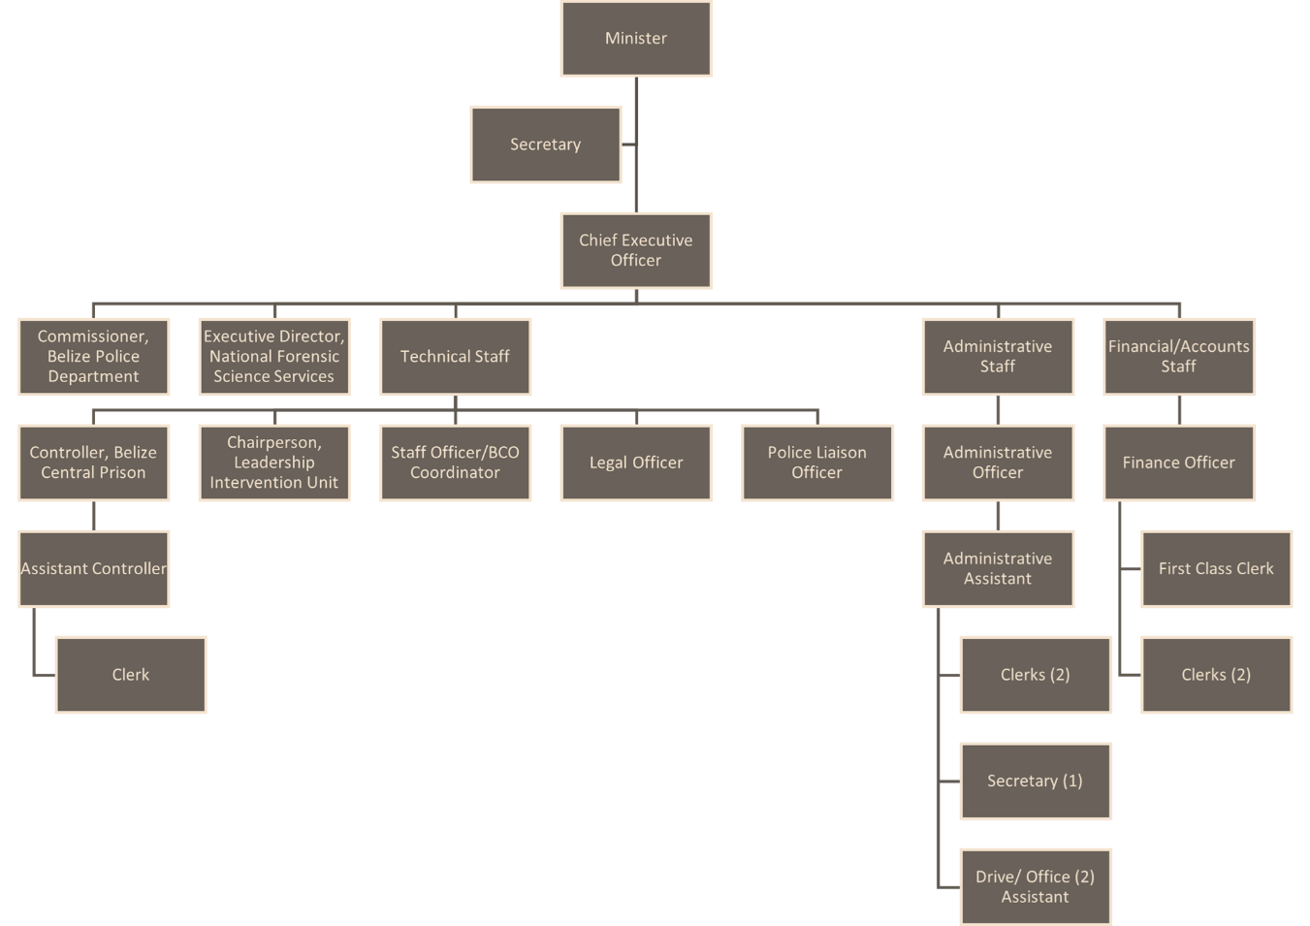
Understanding this organizational structure is essential for successfully implementing the Final Graduation Project (FGP), which aims to develop a conceptual framework for rural safety and security initiatives in Belize. The structure facilitates collaboration among various departments, which is essential for the integrated approach required in the FGP. For instance, initiatives developed under the FGP can be supported by data from the Belize Crime Observatory and expertise from the National Forensic Science Services. Insight into the structure helps identify where resources can be allocated most effectively to support the FGP’s objectives. Identifying key stakeholders within each department enables tailored engagement strategies, ensuring that all relevant parties are involved in the framework development and implementation.
Aligning the FGP with this organizational structure will allow the project to leverage existing capabilities and to ensure that its initiatives are effectively implemented, contributing to the Ministry’s goals of enhancing public safety and promoting new industries in Belize.

Products Offered
The Ministry of Home Affairs and New Growth Industries is instrumental in providing various critical services and initiatives that can be regarded as 'products' in their contribution to public safety and economic development. Here, 'products' refer to the significant services, initiatives, and regulatory frameworks developed to meet the needs of the Belizean people and to ensure the nation’s security and prosperity. Each product plays an important role in the broader context of the Final Graduation Project (FGP) objectives. The products are outlined below.
Belize Police Department - Public Safety and Law Enforcement Services
Public safety and law enforcement services include routine policing, emergency response, crime investigation, and public order maintenance conducted primarily through the Belize Police Department. The FGP’s focus on developing a conceptual framework for rural safety and security initiatives in Belize directly supports and leverages these services, aiming to improve the effectiveness and efficiency of law enforcement in the rural areas through better project management practices, thereby making this product relevant.
Forensic and Scientific Services
Forensic and scientific services offered by the National Forensic Science Service include crime scene investigation, forensic analysis, and the provision of scientific evidence for criminal cases. This is relevant to the FGP, given that the project management framework developed by the FGP will ensure that these services are efficiently integrated into rural safety operations, enhancing the scientific backing for investigations in rural settings.
Prison and Correctional Services
Belize Central Prison, under the Ministry, manages prison and correctional services that focus on the incarceration, rehabilitation, and reintegration of offenders. The FGP will explore ways to integrate a solid project management framework into enhancing these services, particularly rehabilitation programs that can be managed to reduce recidivism among rural communities.
Belize Crime Observatory
The Belize Crime Observatory collects, analyzes, and dissemination of crime data to inform policy and operational decisions. Regarding the FGP, it will be effective project management practices to include the development of a conceptual framework for the rural safety and security initiative to help in better data management, leading to more informed decision-making processes that enhance safety and security strategies.
Leadership Intervention Unit - Community Engagement Initiatives
Community engagement initiatives are various programs managed by the Leadership Intervention Unit that aim to strengthen community relations and enhance public participation in safety measures. The FGP will utilize project management frameworks to optimize the planning, execution, and monitoring of community engagement safety initiatives, ensuring that they are more effective and aligned with community needs.
New Growth Industries Unit - Economic Development Projects
This product includes initiatives to promote and develop emerging industries, supported by the Ministry’s efforts to foster economic growth and sustainability. The conceptual project management framework aims to bolster these initiatives by introducing efficient management practices that ensure that projects are completed on time, within budget, and with the desired impact on economic development, which reflects the safety and security measures to be established.
Regulatory Frameworks and Policies
This product involves developing and enforcing laws and regulations that govern public safety, economic activities, and overall community well-being. The FGP will support the development and implementation of these regulatory frameworks by ensuring that law reform and policy development projects are effectively managed and executed.
Each product is crucial for the Ministry's functioning and directly influences Belize's safety, security, and economic stability. The FGP is designed to enhance the delivery and effectiveness of these products through improved project management practices, ensuring that they not only meet their intended objectives but also contribute to the long-term vision of a safe and prosperous Belize.

Project Management Concepts
This section outlines the fundamental project management concepts based on the Project Management Institute's standards (PMI, 2021). It discusses their application within the context of the Ministry of Home Affairs and New Growth Industries, particularly concerning the Final Graduation Project (FGP). The FGP involves developing a conceptual framework for rural safety and security initiatives in Belize, a unique outcome tailored to the specific needs. The FGP also applies project management methodologies to ensure that those initiatives are effectively planned, executed, and reviewed. This process involves aligning project outcomes with strategic objectives set by the Ministry of Home Affairs and New Growth Industries.

Project management principles
Under the Project Management Institute's (PMI) "A Guide to the Project Management Body of Knowledge (PMBOK Guide)" Seventh Edition, 2021, the principles of project management are fundamental guidelines that shape the approach to managing projects effectively. These principles are operationalized in the Final Graduation Project (FGP), which is focused on enhancing rural safety and security initiatives within the Ministry of Home Affairs and New Growth Industries.
The principle of stewardship will help a diligent, respectful, and caring steward. In the FGP, this principle ensures responsible management of resources, including adherence to legal and ethical standards and respectful engagement with community stakeholders and partners.
The principle of teamwork builds a culture of accountability and respect. The FGP promotes a collaborative environment where team members are accountable for their contributions, and mutual respect is foundational. This includes regular team meetings, transparent communication, and clear role definitions.
Stakeholder engagement is a critical principle that helps to understand stakeholders' interests and needs. The FGP involves continuous stakeholder engagement through surveys, community meetings, and feedback sessions to ensure that the project meets rural communities' needs and expectations and aligns with ministry goals.
The value principle focuses on value, which includes every aspect of the FGP and is evaluated based on its ability to deliver value in enhanced safety and security for rural areas. This ensures that project outcomes directly contribute to community well-being.
The holistic approach and principle recognize and respond to systems' interactions. The FGP considers the broader impact of safety and security initiatives on economic development, social justice, and community resilience, integrating cross-functional insights to create a comprehensive approach.
Leadership principles motivate, influence, coach, and learn. Project leaders in the FGP demonstrate proactive leadership by motivating team members, fostering a learning environment, and adapting project strategies based on ongoing learnings and stakeholder feedback.
The tailoring principle tailors the delivery approach based on context. The project management approach in the FGP is customized to fit rural Belize's specific challenges and opportunities, incorporating local customs, governance structures, and available technologies.
The principle of quality is to build quality into processes and results. Quality assurance processes are integrated throughout the FGP, from initial planning through implementation, ensuring that all deliverables meet high standards of excellence and efficacy.
The complexity principle addresses complexity using knowledge, experience, and learning. The FGP tackles the complexities of rural safety by leveraging expert knowledge, historical data, and continuous learning cycles to refine and improve project outcomes.
The opportunities and threats principle optimizes risk responses. The project includes a thorough risk management plan that identifies potential threats and opportunities, with strategies tailored to mitigate risks while maximizing the benefits of potential opportunities.
The adaptability and resilience principle requires adaptability and resilience. The FGP is designed to be flexible, allowing adjustments in response to new information or changing conditions in rural areas, thereby ensuring the project's resilience and continued relevance.
Change management principle enables change to achieve the envisioned future state. Change management strategies are central to the FGP, ensuring that all changes are carefully managed and communicated to facilitate smooth transitions and acceptance among stakeholders.

Project management domains
Several performance domains are essential to effective project management. These domains are broad performance areas that collectively enable project delivery. The domains listed below will be directly related to the specific needs and objectives of the Final Graduation Project (FGP), which focuses on developing a conceptual framework for rural safety and security initiatives in Belize.
The stakeholder performance domain emphasizes the importance of actively engaging stakeholders throughout the project life cycle to understand their needs, expectations, interests, and impact on project success. For the FGP, engaging stakeholders such as rural community leaders, the Belize Police Department, other government officials, and non-governmental organizations is critical. Their input will help tailor the safety and security framework to address specific local challenges and ensure community buy-in and support.
The team performance domain fosters team behaviours and dynamics, supports leadership, and promotes an environment conducive to successful project outcomes. The FGP will include safety, security, rural development, and project management experts. Developing a cohesive team dynamic is essential for effectively integrating diverse perspectives and expertise to craft a comprehensive and actionable framework.
The development approach and life cycle performance domain involve selecting and tailoring the project management approach and life cycle to the unique aspects of the project context. The FGP will require a flexible and adaptive project management approach, potentially blending traditional and agile methodologies to accommodate the evolving nature of safety and security needs in rural areas.
The planning performance domain encompasses all aspects of project planning, including scope, schedule, cost, resource, quality, and procurement management plans. Effective planning is crucial for the FGP, ensuring that all safety and security framework elements are well-defined, feasible, and aligned with the strategic objectives of enhancing rural safety.
Project Work Performance Domain deals with fulfilling project requirements by producing project deliverables. This involves drafting, developing, and testing the safety and security framework, ensuring that deliverables meet the specified requirements and are ready for implementation.
- Delivery Performance Domain - concerns the delivery of project outputs and the transition of these outputs to the next stages, including operations or maintenance. Ensuring that the developed framework is effectively handed over to local authorities and community leaders, including training and support for implementation, is vital to the FGP’s success.
- Measurement Performance Domain - focuses on assessing project performance and monitoring progress toward objectives throughout the project life cycle. It implements performance metrics and evaluation techniques to measure the effectiveness of the safety and security framework and its impact on reducing rural crime rates.
- Uncertainty Performance Domain - involves identifying and managing risks and other sources of uncertainty throughout the project. This process will be critical in addressing potential risks and challenges specific to rural Belize, such as logistical issues, cultural barriers, and resistance to new security measures.

Predictive, adaptative, and hybrid projects
Project management methodologies can generally be categorized into predictive, adaptive, and hybrid. Each type has distinct characteristics and is suited to different project demands and environments. Here is an overview of each and how they relate to the Final Graduation Project (FGP), which is focused on developing a conceptual framework for rural safety and security initiatives in Belize.
Predictive projects, often called "waterfall" projects, are highly structured and follow a linear sequence of phases. Each phase generally needs to be completed before the next one begins. The scope, timeline, and costs are defined early in the project, and changes are managed through a formal process. This approach works well with projects that have precise, well-understood requirements. Due to the rigid structure, there is limited flexibility to adapt to changes or new information once the project has commenced.
Adaptive Projects - Change-Friendly, also known as agile projects, these are designed to accommodate and respond to changes rapidly. They are ideal for projects where requirements and scopes are likely to evolve. For this, it is iterative and incremental. Work is completed in short cycles or sprints, allowing for regular reassessment and adjustments based on stakeholder feedback and project team insights. High stakeholder engagement requires constant collaboration with stakeholders, making it highly responsive to user needs and preferences.
Hybrid methodologies integrate elements of both predictive and adaptive approaches. It allows for a flexible yet structured approach, suitable for projects where certain parts of the work are well-defined while others are more dynamic. With balanced control and agility, this approach provides the ability to plan and execute well-understood project components predictively while adapting the management of less certain aspects iteratively. Customizable hybrid models are tailored to the project's specific needs, and elements from both predictive and adaptive frameworks are chosen to best meet project demands.
The FGP for developing a conceptual framework for rural safety and security in Belize could benefit from a hybrid project management approach. Combining the structure of predictive methodologies with the flexibility of adaptive methodologies, this approach appears most suitable for the FGP. This balanced approach would allow the project to effectively manage the development of a comprehensive and adaptable safety and security framework, catering to the rigid requirements of government policies and the dynamic needs of rural community safety initiatives.
The FGP likely involves components with well-defined objectives and deliverables, such as regulatory requirements and established safety protocols, alongside areas requiring innovation and community-specific tailoring (e.g., community engagement strategies and implementation of new technology). A hybrid approach allows for the structured management of predictable tasks while retaining the flexibility to innovate and adapt in areas with less certainty.
Stakeholder Involvement: The FGP's success depends on continuous input and collaboration with various stakeholders, including government bodies, local communities, and possibly international partners. The hybrid model supports high engagement levels, similar to adaptive projects, ensuring that the framework remains relevant and effectively addresses the unique needs of rural communities.
Given the governmental context and the need for compliance with existing policies and standards, some level of predictability and formal planning is essential. However, the changing dynamics of rural security issues also demand a degree of adaptability not typically afforded by purely predictive methodologies.

Project management
Project management is a critical discipline used in various industries to ensure that projects are completed within scope, time, and budget constraints while achieving their objectives. It involves applying processes, methods, skills, knowledge, and experience to achieve specific project goals. Here, we will explore definitions from three authoritative sources in project management, synthesizing their perspectives to offer a comprehensive understanding.
Harold Kerzner (2013) - "Project Management: A Systems Approach to Planning, Scheduling, and Controlling" - Perspective: Kerzner views project management as ensuring that project objectives are met through a systematic process, which includes planning, organizing, and controlling allocated resources. According to Kerzner, effective project management should adapt to the needs of the business environment and focus heavily on achieving project deliverables that directly contribute to the company's strategic goals.
        - Analysis: Kerzner emphasizes the need for a holistic approach in project management, integrating it into the larger business strategy. This perspective is crucial for projects that are not just about completion but are also about alignment with broader business outcomes.
PMI - Project Management Institute (2021) - "A Guide to the Project Management Body of Knowledge (PMBOK® Guide)" - Perspective: PMI defines project management as the application of knowledge, skills, tools, and techniques to project activities to meet project requirements. PMI outlines a framework comprising five process groups: initiating, planning, executing, monitoring and controlling, and closing.
        - Analysis: PMI’s definition underscores the structured aspect of project management, focusing on standardization and repeatability. This framework provides a consistent methodology across various projects, enhancing efficiency and predictability in project outcomes.
Rita Mulcahy (2020) - "PMP Exam Prep" - Perspective: Mulcahy approaches project management as a dynamic and flexible practice that requires a balance between the science of managing numbers and the art of managing people. She highlights the importance of leadership skills, stakeholder management, and the ability to negotiate and resolve conflicts.
        - Analysis: This perspective brings a human-centric approach to project management, stressing the importance of soft skills as critical components of successful project management. This approach is particularly relevant in projects that require high levels of cross-functional collaboration and stakeholder engagement.
Synthesis and Application to the FGP
Combining these perspectives provides a robust framework for understanding project management. Strategic Alignment (Kerzner) ensures that the FGP's objectives are aligned with the strategic goals of the Ministry of Home Affairs and New Growth Industries, enhancing rural safety and security. Structured Methodology (PMI) applies a systematic approach to managing the FGP, ensuring that all stages of the project lifecycle are addressed methodically to meet the defined objectives. Stakeholder and Team Management (Mulcahy) emphasizes engaging with stakeholders and managing the project team effectively. This is crucial for the FGP, given its impact on diverse community groups and its dependence on various governmental and non-governmental bodies. With these aspects integrated, project management for the FGP can be coordinated to respond to the project's challenges. These challenges aim to develop a conceptual framework for rural safety and security that will cater to the target communities' safety in a way consistent with the same communities' broad objectives of safety and development.

Project management knowledge areas and processes
Project management is structured around several key knowledge areas and processes that guide project managers in systematically executing and managing projects. The Project Management Institute (PMI) defines these knowledge areas and associated processes in the PMBOK Guide, which helps to standardize practices across various industries. Here is an overview of each knowledge area and its methods, accompanied by a summary table categorizing the processes by knowledge area and process group.
Project Management Knowledge Areas include integration management, scope management, schedule management, cost management, quality management, resource management, communication management, risk management, procurement management, and stakeholder management.
Integration management involves the processes and activities needed to identify, define, combine, unify, and coordinate the various methods and project management activities within the Project Management Process Groups. The integration management processes are to develop a project charter and a Project Management Plan, Direct and Manage Project Work, Manage Project Knowledge, Monitor, and Control Project Work, Perform Integrated Change Control and Close the Project or Phase.
The scope management ensures that the project includes all the work required, and only the work required, to complete the project successfully. The scope management processes are planning Scope Management, Collect Requirements, Define Scope, Creating WBS, Validate Scope, and Control Scope.
Schedule management involves ensuring the timely completion of the project. The processes are planning Schedule Management, Defining Activities, Sequencing Activities, Estimating Activity duration, Developing Schedules, and Controlling Schedules.
Cost management involves planning, estimating, budgeting, financing, funding, managing, and controlling costs to complete the project within the approved budget. The processes include planning Cost Management, estimating costs, determining the Budget, and controlling costs.
Quality management involves incorporating the organization’s quality policies into the project's planning and execution to meet stakeholders’ objectives. The processes are plan Quality Management, Manage Quality, and Control Quality.
Resource management involves planning, estimating, and acquiring resources to ensure that human and non-human resources are available when needed for the project. The processes are plan Resource Management, Estimate Activity Resources, Acquire Resources, Develop Team, Manage Team, and Control Resources.
Communication management ensures timely and appropriate planning, collection, creation, distribution, storage, retrieval, management, control, monitoring, and the ultimate disposition of project information. The processes include planning Communications Management, managing communications, and monitoring communications.
Risk management involves conducting risk management planning, identification, analysis, response planning, response implementation, and monitoring risk on a project. The processes are Plan Risk Management, Identify Risks, Perform Qualitative Risk Analysis, Perform Quantitative Risk Analysis, Plan Risk Responses, Implement Risk Responses, and Monitor Risks.
Procurement management involves conducting the procurement processes from purchasing or acquiring products, services, or results needed from outside the project team to contract closure. The processes include Planning Procurement Management, Conducting Procurements, and Controlling Procurements.
Stakeholder management involves engaging stakeholders at appropriate project stages to obtain and confirm their continued commitment and involvement in the successful completion of the project. The processes include identifying stakeholders, planning stakeholder engagement, managing stakeholder engagement, and monitoring stakeholder engagement.

Chart 2. Summary Table of Processes by Knowledge Area and Process Group

Knowledge Area | Initiating | Planning | Executing | Monitoring & Controlling | Closing
Integration Management | Develop Project Charter | Develop Project Management Plan | Direct and Manage Project Work | Monitor and Control Project Work, Perform Integrated Change Control | Close Project or Phase
Scope Management | - | Plan Scope Management, Collect Requirements, Define Scope, Create WBS | - | Validate Scope, Control Scope | -
Schedule Management | - | Plan Schedule Management, Define Activities, Sequence Activities, Estimate Activity Duration, Develop Schedule | - | Control Schedule | -
Cost Management | - | Plan Cost Management, Estimate Costs, Determine Budget | - | Control Costs | --
Quality Management | - | Plan Quality Management | Manage Quality | Control Quality | -
Resource Management | - | Plan Resource Management, Estimate Activity Resources | Acquire Resources, Develop Team, Manage Team | Control Resources | -
Communications Management | - | Plan Communica-tions Management | Manage Communi-cations | Monitor Communi-cations | -
Risk Management | - | Plan Risk Management, Identify Risks, Perform Qualitative Risk Analysis, Perform Quantitative Risk Analysis, Plan Risk Responses | Implement Risk Responses | Monitor Risks | -
Procurement Management | - | Plan Procurement Management | Conduct Procure-ments | Control Procure-ments | -
Stakeholder Management | Identify Stakeholders | Plan Stakeholder Engagement | Manage Stakeholder Engage-ment | Monitor Stakeholder Engagement | -
Note: This table summarizes the processes by knowledge area and process group as outlined in the PMBOK Guide, showing how each process is applied across the different phases of project management, from initiation to closing.

Project life cycle
The project life cycle delineates the phases a project traverses from its inception to its conclusion. This cyclical understanding is crucial for managing the progression of a project effectively and ensuring that its objectives are met successfully. Here are definitions of the project life cycle by three esteemed authors in project management are presented, alongside an analysis of how this cycle is applied explicitly within the context of the Ministry of Home Affairs and New Growth Industries for the Final Graduation Project (FGP) focused on Developing a Conceptual Framework for Rural Safety and Security Initiatives in Belize.
Harold Kerzner (2013), in "Project Management: A Systems Approach to Planning, Scheduling, and Controlling," describes the project life cycle as a series of sequential phases essential for the systematic execution of a project. These phases typically include initiation, planning, execution, and closure, each tailored to accommodate the project's unique demands and complexity.
Rita Mulcahy (2020). - "PMP Exam Prep" - Mulcahy emphasizes that the project life cycle provides a high-level overview of the project phases, each designed to handle specific tasks and to deliver distinct outcomes. Understanding these phases helps predict resource needs and timing, which are critical for project success.
Figure 2 Characteristics of Project Life Cycles
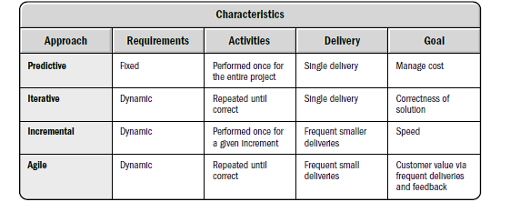
Note: This figure illustrates the typical characteristics of project life cycles, highlighting the progression through various phases outlined by the Project Management Institute (2021).

PMI - Project Management Institute (2021) - "A Guide to the Project Management Body of Knowledge (PMBOK Guide)" outlines the project life cycle as a succession of phases necessary for project governance, spanning from the project's outset to its termination. The phases are grouped into initiation, planning, execution, monitoring and controlling, and closing. This structured approach is fundamental in effectively managing the project's scope, cost, and timeline.
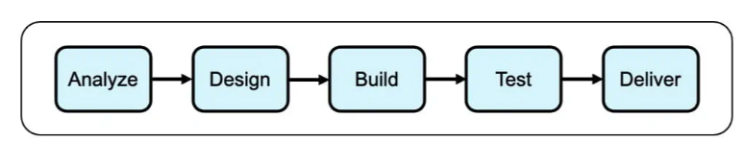
Figure 3 Predictive Life Cycle
Note: This figure depicts the stages and characteristics of a Predictive Life Cycle, as described by the Project Management Institute (2021).
The PMI outlines the project life cycle in a manner that can be universally applied to any project, regardless of its specific domain. The life cycle, according to PMI, typically involves the following phases:
- The project is formally started, defined, and authorized in the initiation phase. In this phase, a project charter is created, which outlines the project's purpose, objectives, and scope. It also involves identifying the main stakeholders. For the FGP, define its scope and objectives, identifying key stakeholders from the Ministry of Home Affairs and New Growth Industries, local communities, and possibly international safety consultants.
- The critical planning phase involves detailed path mapping to achieve the project objectives successfully. This includes developing a project management plan that covers scope, budget, timeline, resources, quality, and communications. Risk management plans are also developed to identify potential issues that could impact the project; for the FGP, develop a detailed plan that includes stakeholder engagement, data collection, and framework development methodologies.
- The project management plan is implemented in the execution phase. This is where deliverables are developed and completed. It often requires resource allocation, coordination, and management of various project teams. The FGP will implement the plan by conducting workshops, surveys, and consultations to gather input for the framework.
- The monitoring and controlling phases run concurrently with the execution phase. They measure project progression and performance to ensure that everything aligns with the project management plan. This phase is vital for managing changes and ensuring that the project remain on track. For the FGP, continuous monitoring of progress and adjustment as necessary to handle new challenges and information is necessary.
- In the closing phase, the project is formally closed and completed. It involves releasing resources, completing tasks, and formally accepting the stakeholders' deliverables. A final project report is generated, and a review is conducted to capture lessons learned. For the FGP, Finalize the framework, document the outcomes, and obtain formal approval from the Ministry. Conduct a project review to evaluate successes and lessons learned.

Company strategy, portfolios, programs, and projects
Understanding how company strategy, portfolios, programs, and projects interact is crucial for aligning individual project outcomes with an organization's broader goals. This is a breakdown of the concepts using insights from renowned authors and a discussion on their relevance to the Ministry of Home Affairs and New Growth Industries in the context of the Final Graduation Project (FGP) focused on developing a conceptual framework for rural safety and security in Belize.
The company strategy is an organization's game plan to achieve its long-term goals. It involves making thoughtful choices about where to compete and how to win. This strategy helps an organization focus its efforts and resources on the most promising opportunities, which can lead to sustained growth and competitive advantage. Michael E. Porter suggests that the strategy is about choosing a unique position and doing things differently from competitors in a way that delivers exceptional value (Porter, 1996). Henry Mintzberg describes strategy as a pattern in decisions that help an organization deal with its competitive environment (Mintzberg, 1987).
The portfolio is a collection of projects and programs grouped to streamline management and achieve strategic objectives. Managing projects and programs as a portfolio ensures that an organization can oversee and coordinate initiatives across the board, making strategic adjustments as necessary to maximize returns or impact. According to strategy experts, a well-managed portfolio directly supports the strategic direction of an organization by ensuring that all efforts are aligned and contribute effectively to the overall goals.
A program is a coordinated group of related projects managed together to gain benefits that would not be possible if they were managed separately. Programs allow for optimized resource sharing and enhanced project outcomes through coordinated effort, especially when projects are interdependent or share a common strategic goal. As Mintzberg might suggest, programs represent how strategy comes to life in an organization through coordinated, cohesive project efforts that reflect planned strategic actions.
A project is a temporary endeavour with a start and an end to create a unique product, service, or result. Projects are how strategies are executed; they turn ideas and plans into reality and are the building blocks for achieving strategic objectives. Porter might argue that each project should be designed to strengthen the organization’s strategic position by aligning closely with chosen strategic activities.
The Ministry of Home Affairs and New Growth Industries' company strategy, portfolios, programs, and projects related to the FGP aim to enhance public safety and security across Belize, focusing significantly on under-served rural areas. The FGP supports this strategy by aiming to develop a practical, effective framework that addresses unique rural safety challenges. The FGP is part of a more extensive portfolio that might include various initiatives to improve national security, economic development, and community welfare. This portfolio approach helps the ministry manage its projects so that they collectively support overarching strategic goals. The FGP could be nested within a broader program focusing on national safety improvements. While it is a stand-alone project, its success contributes to the program’s goals of enhancing public safety and security protocols nationwide.
The FGP itself is a project that focuses on creating a structured framework to improve rural safety and security systematically. It is a concrete effort with specific outcomes that, once completed, will provide tools and strategies to improve life in rural communities. Aligning the FGP with the ministry's strategic framework ensures that this project tackles immediate issues and contributes to broader, long-term objectives. It helps to justify allocating resources and supports the achievement of substantial, meaningful outcomes that resonate with the needs and aspirations of Belize's rural communities.
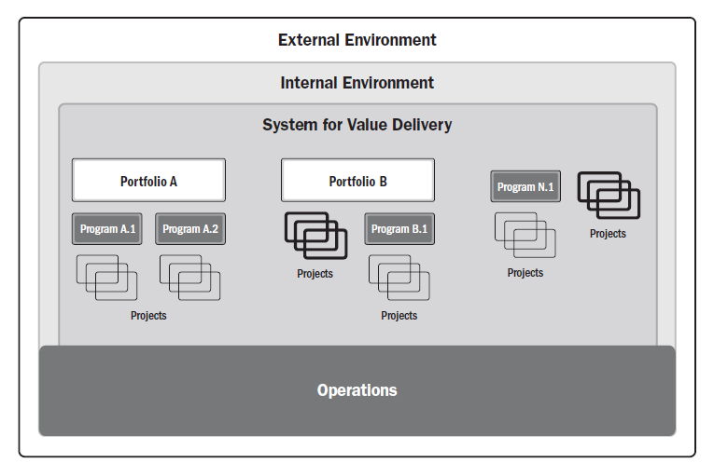
Figure 4 Components of a sample system for delivery
Note: This figure illustrates the key components of a sample delivery system, as outlined by the Project Management Institute (2021).

Other applicable theory/concepts related to the project topic and context
This section explores relevant theories and concepts crucial for understanding and enhancing rural safety and security initiatives, particularly within the Final Graduation Project (FGP), which aims to develop a conceptual framework. The discussion is grounded in references provided in the initial bibliographical list.
- Rural crime prevention theory of rural crime prevention focuses on strategies specifically tailored to address the unique challenges faced in rural settings, where geographic isolation and limited police resources can complicate traditional urban crime prevention methods. According to Abraham and Ceccato (2022), effective rural crime prevention must consider factors like community engagement and the adaptation of strategies to local contexts. This strategy involves situational crime prevention tailored to the rural environment (Abraham, et al., V. (2022).
- Community policing theory in rural areas involves forming partnerships between law enforcement agencies and rural communities to identify and solve safety issues collaboratively. The effectiveness of community policing in rural settings can enhance trust and cooperation between residents and law enforcement, which is essential for the sustainable development of safety initiatives (The National Rural Safety Strategy. (n.d.).
- The environmental design theory of Crime Prevention Through Environmental Design (CPTED) suggests that proper design and effective use of the built environment can reduce the fear and incidence of crime and improve the quality of life. Strategic environmental modifications in rural settings can deter criminal activities by increasing the perceived risk of apprehension for would-be offenders (Community Safety Framework | Department of Justice. (2020).
- Integrated safety strategy theory combines various aspects of crime prevention, community engagement, and environmental design to create a comprehensive approach to rural safety. The Government of Ireland (2022) emphasizes the need for a holistic approach, integrating community resources, law enforcement, and local government initiatives to address safety concerns effectively (Government of Ireland. 2022).
These theories and concepts provide a solid theoretical foundation for the FG. By integrating these established strategies, the project can address the immediate safety concerns and the broader goal of sustainable community development.

Current situation of the problem or opportunity in study
The rural areas of Belize face unique safety and security challenges that stem from various socio-economic and geographical factors. These areas are often isolated, with limited access to the immediate response services that urban settings might offer. While beneficial for a tranquil lifestyle, the sparse population density also presents significant hurdles in crime prevention and law enforcement coverage. Issues such as petty theft, agricultural crime, and more serious offenses like drug trafficking and violent crime are not uncommon. Historically, Belize's approach to rural safety has primarily been reactive rather than proactive. Law enforcement efforts have often been stretched thin, trying to cover large areas with insufficient resources. Community policing efforts, while present, have not been consistently implemented across all rural areas, leading to varying degrees of effectiveness.
Recent initiatives have focused on improving the situation through increased funding for rural police stations, better training for rural police officers, and the introduction of community watch programs. Additionally, there has been an emphasis on integrating technology, such as surveillance cameras and mobile reporting apps, to enhance crime reporting and response time. Several studies have evaluated the effectiveness of different rural safety initiatives. The importance of adapting crime prevention strategies to rural communities' specific context suggests that a one-size-fits-all approach does not work effectively in these diverse settings. Further research has indicated that better lighting, improved road infrastructure, and increased community engagement activities could enhance safety. Programs that focus on environmental design have been proposed to reduce crime by changing the physical environment that deters criminal activities.

Previous research done for the topic in study
Abraham and Ceccato (2022) systematically reviewed the literature on crime and safety in rural areas from 1980 to 2020. Their findings emphasize the diversity of rural crime issues and the need for context-specific crime prevention strategies. The study suggests that generic urban strategies often fail when directly applied to rural settings due to differences in social structure, crime types, and law enforcement capacity. This research is crucial for the FGP as it underscores the necessity of developing bespoke strategies that account for the unique characteristics of rural Belize.
The National Rural Safety Strategy outlines a comprehensive approach to addressing safety in rural communities, focusing on collaboration between law enforcement and community members. The strategy highlights the importance of community engagement and the integration of local knowledge into safety planning. The strategy provides a framework that can be adapted for the FGP, particularly in promoting community involvement in safety initiatives.
The government of Ireland (2022) published the Rural Safety Plan, which discusses integrated approaches to enhancing safety in rural communities. The plan advocates for a multi-dimensional approach that combines physical security measures with social and community-based strategies. This plan supports the FGP's goal of integrating diverse safety measures, suggesting that combining technology, community policing, and infrastructure improvements can effectively reduce rural crime.
The reviewed studies provide a solid foundation for the FGP, validating chosen approaches and insights into potential new strategies. Specifically emphasized across studies, the engagement of local communities in safety efforts is pivotal and will be a core component of the FGP's framework. Learning from Abraham and Ceccato's systematic review, the FGP will focus on tailoring strategies to fit rural Belize's specific environmental, cultural, and social contexts. Inspired by Ireland's Rural Safety Plan, the FGP will explore integrating various dimensions of safety, from physical security enhancements to social initiatives that address underlying causes of insecurity.
2.3.3 Other theories related to the topic in study
Exploring the relationship between the resilience theory and the Final Graduation Project (FGP) theme focuses on developing a conceptual framework for rural safety and security initiatives in Belize. The resilience theory provides a robust framework for understanding how communities withstand and respond to challenges such as crime and natural disasters, particularly relevant to rural communities that often face unique safety and security challenges.
Resilience theory, often explored in psychology and ecology, examines the capacity of systems, individuals, communities, or ecosystems to tolerate disturbance without collapsing into a qualitatively different state. In the context of community safety, this theory translates into the ability of rural communities to adapt and recover from safety threats.
Applying resilience theory to the FGP involves assessing and enhancing the adaptive capabilities of rural communities in Belize to respond to and recover from crime-related incidents and emergencies. This includes creating strategies based on local strengths and resources to improve community safety and cohesion.
Community engagement is a critical aspect of building resilience. This involves developing partnerships between law enforcement and community members to enhance trust and cooperative relationships, which are crucial for effective crime prevention and response.
The FGP aims to incorporate community engagement as a core component of the safety framework. The project empowers residents by involving community members in the planning and implementation stages of safety initiatives. It ensures that the solutions are culturally appropriate and contextually relevant, enhancing their effectiveness and sustainability.
Resilience theory also emphasizes the importance of sustainable practices that ensure long-term safety and security. This involves integrating environmental, economic, and social considerations into planning and response strategies, ensuring that safety solutions do not compromise the community's future well-being.
For the FGP, applying resilience theory means developing sustainable safety solutions that do not rely excessively on external resources, which might be scarce. This could include training residents to handle certain types of emergencies, implementing crime prevention through environmental design (CPTED) principles to reduce crime opportunities naturally, and using technology that supports self-sufficiency.
Resilience theory is not just a theoretical concept in the FGP, but a guiding principle that shapes the project's approach. It frames the project as more than just a response to immediate safety concerns, but as a comprehensive strategy to build a robust, self-reliant community. This approach, deeply rooted in enhancing the adaptive capacities of rural communities in Belize, ensures that they are prepared to face current and future challenges.

METHODOLOGICAL FRAMEWORK
The methodological framework chapter provides a detailed research plan for developing a conceptual framework for the rural safety and security initiative in Belize. It meticulously outlines the types of information sources, including primary data from field interviews, surveys, and semi-structured interviews with community stakeholders, and secondary data from academic literature and government reports. This comprehensive approach governs the rigor and validity of the proposed study.
The research methods section clarifies using qualitative approaches such as thematic analysis and quantitative techniques, including statistical analysis, to ensure a balanced examination of the collected data. Essential tools such as SurveyMonkey for surveys and NVivo for qualitative data analysis are specified to support these methods. Assumptions about stakeholder participation and data accessibility are acknowledged, alongside potential constraints related to resources and time that might impact the research's scope and depth.
The chapter outlines expected deliverables, which include a comprehensive report detailing the research findings, a strategic conceptual framework for future initiatives, and a presentation of the outcomes to key stakeholders. This methodological foundation is crucial for guiding the systematic investigation of the project’s theme, ensuring that the research is rigorous and aligned with the practical needs of enhancing safety and security in rural communities of Belize.

Information sources
Information sources are vital components in research that provide data and insights for understanding, analysing, and discussing a topic. They are classified based on their origin and the nature of their creation into primary, secondary, and tertiary sources. Each type plays a crucial role in the breadth and depth of research findings and helps construct a well-rounded argument or analysis.
Primary sources are original materials not filtered through interpretation or evaluation, making them critical for new research discoveries. Secondary sources are one step removed from primary sources and include interpretations or evaluations of primary data. Tertiary sources compile and summarize primary and secondary sources, providing an overview and general information about a topic.
For the project "Developing a Conceptual Framework for Enhancing Rural Safety and Security in Belize," a combination of these sources ensures comprehensive coverage of the topic. Primary sources such as interviews with law enforcement officials and community surveys provide insight into rural communities' current safety challenges in Belize. Secondary sources, including scholarly articles and policy reviews, offer context and depth, analysing and discussing broader trends and the efficacy of past interventions. Tertiary sources like textbooks and encyclopedias are used to obtain foundational knowledge about key concepts and existing frameworks relevant to rural safety and security.

Primary sources
In the project 'Developing a Conceptual Framework for Rural Safety and Security Initiative in Belize,' primary sources are indispensable for gaining direct, unfiltered insights into rural communities' unique safety and security challenges. These primary sources, including field interviews, surveys, and observational data, which are pivotal in understanding the issues comprehensively.
Field interviews with stakeholders such as the Belize Police Department, community leaders, and residents are invaluable in capturing qualitative insights. These insights, essential for understanding the personal experiences, perceptions, and expectations of rural safety and security, help capture nuanced perspectives that might not be evident through quantitative data alone. Deployed across various rural communities, surveys collect quantitative data regarding the prevalence of crime, residents' perceptions of safety, and the perceived effectiveness of existing security measures. This data helps to quantify the issues and to assess the impact of current safety strategies, facilitating a data-driven approach to understanding the scope and scale of safety concerns.
Observational data collected during visits to rural areas include notes on environmental conditions, infrastructure, and community dynamics that might influence safety and security. Observing physical settings directly allows for a better assessment of environmental factors such as lighting, road conditions, and the general upkeep of public spaces, which can significantly impact the effectiveness of safety measures. The project combines interviews, surveys, and observations to create a solid basis for the proposed conceptual framework. This approach ensures that the framework is firmly rooted in the real experiences and specific requirements of rural populations in Belize.
This methodological approach enhances the reliability of the research findings and ensures that the proposed safety enhancements are both practical and feasible. The project aligns closely with the target communities' experiences and real-world conditions by tailoring solutions to the challenges identified through first-hand data. Engaging with stakeholders to gather requirements and expectations will help to define a practical and effective management framework tailored to the specific needs of Belize’s rural areas. Gathering detailed insights from project managers and staff to identify methodology needs and challenges will inform the development of a strategic approach that is both feasible and effective. Collecting data from potential PMO staff and stakeholders to understand organizational needs and structure requirements aids in designing a PMO that fits the project's scope and goals.
Feedback from these sessions will refine the implementation plan, ensuring that it addresses real challenges and leverages opportunities identified through direct community and stakeholder engagement.
Integrating these primary sources provides a solid foundation for the project, ensuring that the resulting conceptual framework is grounded in the conditions and needs of Belize’s rural populations. This approach enhances the reliability and relevance of the research findings. It ensures that the proposed safety enhancements are practical and feasible, tailored to address the specific challenges identified through first-hand data.
This careful and detailed gathering of primary data underscores the project's commitment to developing a sustainable and effective safety and security framework that is deeply informed by the target communities' lived experiences and real-world conditions. Such a framework aims to address the current issues and equip the communities with the tools and strategies needed to manage and mitigate future safety challenges.

Secondary sources
Secondary information sources analyse, interpret, critique, or summarize data from primary sources. These sources are crucial in research as they provide context, depth, and a broader understanding of the topic under study. Secondary sources often include journal articles, books, systematic reviews, and meta-analyses that discuss previously published data and trends. They are integral in forming the theoretical basis of research, offering insights that guide the interpretation of new data.
For "Developing a Conceptual Framework for Rural Safety and Security Initiative in Belize," secondary sources include academic journal articles that discuss rural crime prevention strategies, government reports on crime statistics, and publications on community policing and public safety initiatives. These sources provide a comprehensive overview of existing knowledge and practices for building a practical conceptual framework.
Secondary sources support the project by providing evidence of what strategies have or have not worked in similar contexts, offering a comparative perspective that enriches the project's approach. They also highlight gaps in current knowledge and practices, guiding the research focus toward areas where it can make the most significant impact.
Secondary sources for Developing a Conceptual Framework for Rural Safety and Security Initiatives in Belize include the following sources:
Abraham, J., & Ceccato, V. (2022) provides a systematic review of rural crime trends. This source is essential for the first objective, offering a broad understanding of rural crime dynamics and effective prevention strategies that can inform the diagnostic phase of the project.
The Government of Ireland's (2022) Rural Safety Plan offers insights into structured approaches and frameworks for enhancing rural safety relevant to defining the project management framework and PMO structure (Objectives 3 and 5). It provides examples of governmental strategies that can be adapted to the Belizean context.
Chen, G., Yang, Q., Chen, X., and Huang, K. (2021) discuss urban safety and security assessment methodologies, which can be adapted to rural settings for Objective 4. This source offers a risk management perspective that can enhance the strategic methodologies for managing rural safety and security projects.
Peake, Tony (2019) offers perspectives on achieving safety and security in contexts of disruption and distrust, applicable to Objective 2 for diagnosing project management maturity in handling safety and security projects. This resource provides practical insights into enhancing trust and security through effective project management.
Sharpe, B. (2022) discusses rural vs. urban security needs and strategies, which can inform the proposed strategies and implementation plan for the project management framework (Objective 6). This source provides a comparative analysis essential for understanding different security requirements and adapting strategies accordingly.
Koeppel, Claire (2023) focuses on home security challenges unique to rural areas, relevant to both the diagnosis and implementation phases (Objectives 1 and 6). This article provides practical guidelines and recommendations for enhancing security measures in rural settings.
These secondary sources collectively support the project by providing rich data and insights from academic and practical viewpoints. They guide the project's strategy and framework development across all objectives. They ensure a thorough understanding of the challenges and potential solutions for enhancing rural safety and security in Belize, making the framework robust and contextually relevant.
Chart 3 Information Sources
Information sources (Source: The Author)
Objectives | Information sources
Objectives | Primary Sources | Secondary Sources
1. Conduct a comprehensive diagnosis of rural safety and security | Interviews with community leaders, residents, and law enforcement; Surveys assessing perceptions of safety. | Abraham, J., & Ceccato, V. (2022). Crime and safety in rural areas: A systematic review of the English-language literature 1980–2020. Journal of Rural Studies, 94, 250–273. https://doi.org/10.1016/j.jrurstud.2022.05.010  Academic articles on rural crime trends, Government safety reports, and crime statistics.
2. Diagnose the state of project management maturity | Observational studies within the ministries; Structured interviews with project management personnel. | Government of Ireland (2022). Rural Safety Plan. https://assets.gov.ie/235118/e99aebbb-cf7d-4509-a177-7c9212eb0bee.pdf. Studies on effective rural safety programs; Reviews of community policing effectiveness. Studies from academic journals on rural safety programs; Research papers on project management maturity models, Industry standards, and benchmarks.
3. Define a conceptual project management framework | Workshops with stakeholders to gather requirements and expectations; Direct feedback from project teams. | Peake, Tony. (2019). Achieving safety and security in an age of disruption and distrust. https://www.pwc.com/gx/en/government-public-sector-research/pdf/pwc-achieving-safety-security.pdf  Case studies of successful project management frameworks; Best practices literature in public sector project management.
4. Establish a project management strategic methodology | Focus groups with project managers and staff to identify methodology needs and direct observations of project execution. | Chen, G., Yang, Q., Chen, X., Huang, K. (2021). Methodology of Urban Safety and Security Assessment Based on the Overall Risk Management Perspective. Sustainability, 13(12), 6560. https://doi.org/10.3390/su13126560 Scholarly articles on strategic methodologies in safety and security; Methodology guidelines from professional bodies.
5. Determine the necessity and structure of a Project Management Office (PMO) to oversee safety and security projects | Interviews with potential PMO staff and stakeholders; Questionnaires on organizational needs and challenges. | Sharpe, B. (2022). Rural vs Town & City Security: A Guide. Safe Security Solutions. https://safesecuritysolutions.co.uk/rural-vs-town-city-security-guide/  Case studies on PMO structures in similar organizational settings; Standards and guidelines from PMI or similar entities.
6. Propose an implementation plan for the framework and PMO | Stakeholder meetings to discuss implementation challenges and requirements; Feedback sessions post-trial implementations. | Koeppel, Claire. (2023). Home Security for Rural Areas: Addressing Unique Challenges. StaySafe.org. https://staysafe.org/home-safety/home-security-for-rural-areas/  Articles on best practices for implementing project management frameworks and PMOs; Government guidelines on project management practices.
Note: This table outlines the primary and secondary sources used in the "Developing a Conceptual Framework for Rural Safety and Security Initiatives in Belize" project.

Research methods
Research methods are systematic strategies used to conduct scientific inquiries. These methods encompass researchers' procedures, techniques, tools, and strategies for collecting and analysing information about a particular topic. According to Pfeiffer Library (n.d.), research methods are fundamentally "ways in which you will collect the data for your research project." Choosing the correct research methods is crucial and should align with the project's specific needs, the nature of the data, the people involved, and the way data are collected.
For the project "Developing a Conceptual Framework for Rural Safety and Security Initiatives in Belize," three main research methods will be utilized: the analytical, inductive, and case study. These methods were selected based on their suitability for addressing the complex and dynamic nature of safety and security in rural settings.

Analytical Method
The analytical method involves using critical thinking skills to evaluate facts and data relevant to the research. This method is often used to formulate and test hypotheses, making it invaluable for examining the underlying causes and potential solutions for rural safety and security issues. Staff Writer (2020) defines the analytical method as collecting relevant data or facts pertinent to the research topic, evaluating these data, and drawing conclusions based on the analysis.
In "Developing a Conceptual Framework for Rural Safety and Security Initiatives in Belize," the analytical method will be employed during the initial planning phase. This phase will develop hypotheses about factors contributing to safety and security challenges. These hypotheses will guide the data collection, including crime statistics, survey results, and structured interviews. The findings from this data will help support or refute the initial hypotheses and inform the development of targeted interventions.

Inductive Method
The inductive research method, or inductive reasoning, is a "bottom-up" approach where researchers start with specific observations and gradually move toward broader generalizations and theories. This method does not begin with a hypothesis; instead, it involves collecting data first, identifying patterns, and then formulating tentative hypotheses that can be explored further. Trochim (n.d.) emphasizes that the inductive method is beneficial for discovering patterns and regularities that inform the development of general conclusions or theories.
The inductive method will be crucial for understanding the specific contexts and nuances of rural safety and security in Belize. This method, which involves collecting data, identifying patterns, and then formulating tentative hypotheses, will allow researchers to gather detailed information on the current safety measures, community response mechanisms, and the socio-cultural dynamics influencing these processes. By conducting field observations and unstructured interviews with residents and local officials, the insights gained will help shape more contextually appropriate safety strategies and interventions, instilling confidence in the depth of our research.

Case Study Method
The case study method is a valuable tool in research. It involves an in-depth, detailed examination of a particular case within a real-world context. According to Yin (2018), this method is particularly useful when understanding complex social phenomena is needed. The real-world context provided by case studies can bring theoretical issues to life and help test theoretical models or generate new theories, enlightening our understanding of the research subject.
In "Developing a Conceptual Framework for Rural Safety and Security Initiatives in Belize," the case study method will be employed to investigate specific instances of successful community-led safety initiatives or to study instances of crime spikes or unique security challenges within certain rural areas. This method will allow for a concentrated study of the circumstances, stakeholder responses, and outcomes of such initiatives or challenges, providing valuable insights that can be generalized to broader strategies within the conceptual framework.
Chart 4 Research methods

(Source: The Author)
Objectives | Research methods
Objectives | Analytical Method |  | Case Study Method
  Inductive Method
Conduct a comprehensive diagnosis of rural safety and security | Analyze existing crime data and safety reports to identify patterns and underlying factors of rural safety issues. | Conduct surveys and interviews to gather firsthand accounts of safety concerns and community needs. | Explore specific incidents of security breaches or successful interventions as detailed case studies.
Diagnose the state of project management maturity | Use maturity models to evaluate current project management practices within relevant ministries. | Conduct observational studies and interviews with project staff to understand daily practices and challenges. | Examine case studies of past projects to assess the effectiveness and areas for improvement in project management.
Define a conceptual project management framework | Develop a framework based on the synthesis of analyzed data from project management practices and needs identified. | Use field studies and stakeholder discussion findings to tailor the framework to local conditions. | Investigate specific successful frameworks applied in similar contexts elsewhere as case studies.
Establish a project management strategic methodology | Evaluate the alignment of potential methodologies with strategic goals through analytical comparisons. | Gather feedback from project managers and stakeholders to adapt methodologies to local needs. | The study detailed implementations of project management methodologies in similar projects.
Determine the structure of a PMO | Analyze organizational needs and project outcomes to define a PMO's necessary structure and functions. | Interviews and workshops with potential PMO staff and other stakeholders to identify operational requirements. | Examine case studies of effective PMOs in similar governmental settings.
Propose an implementation plan for the framework and PMO | Develop a detailed plan based on analyses of organizational readiness and resource availability. | Engage with all levels of staff to ensure the plan meets practical, on-the-ground needs and capabilities. | Review comprehensive case studies where similar frameworks and PMOs have been successfully implemented.
Note: This table outlines the research methods employed to achieve each objective in the "Developing a Conceptual Framework for Rural Safety and Security Initiatives in Belize" project, integrating analytical, inductive, and case study methods to ensure a comprehensive approach.

Tools
Identifying and utilizing appropriate tools is crucial to effectively managing and implementing the project "Developing a Conceptual Framework for Enhancing Rural Safety and Security Initiatives in Belize." Project management tools are specific software, techniques, and methodologies used to facilitate the planning, execution, and monitoring of project tasks.
In project management, tools refer to the instruments or software used to aid project managers and teams accomplish project objectives. These tools can range from software for scheduling and resource allocation to techniques for risk analysis and stakeholder management. The Project Management Institute (PMI) provides guidelines in the PMBOK Guide, which detail various tools essential for effective project management across different knowledge areas and process groups.
The tools selected for this project are aligned with the PMBOK Guide’s recommendations, chosen based on their relevance to the specific objectives of enhancing rural safety and security in Belize.
Geographic Information Systems (GIS) - GIS will be employed to visualize and analyze spatial data related to crime, demographics, and environmental factors across rural areas. This tool aids in identifying patterns, trends, and specific locations that require targeted interventions. Surveys and Questionnaires - These collect quantitative and qualitative data from residents and stakeholders in rural communities. These tools help gather insights into current safety and security concerns, perceptions of existing measures, and improvement areas.
Interviews and Focus Groups - These methods will gather in-depth qualitative data from key stakeholders, such as law enforcement officials, community leaders, and rural residents. The information obtained will provide nuanced insights into the specific safety challenges faced by these communities.
Document Analysis - Review existing reports, policies, and crime statistics to understand the historical context and current policies affecting rural safety. This analysis helps validate and triangulate findings from primary data sources.
Maturity Models - Maturity models will be used to assess the current project management practices within the relevant ministries. This assessment will help identify gaps and areas needing improvement, guiding the development of the project management framework.
Benchmarking Tools - Benchmarking tools will compare current project management practices against best practices and industry standards. This comparison will highlight areas for improvement and inform the refinement of management strategies for rural safety and security initiatives.
Workflow Management Software will design, monitor, and optimize the processes within the conceptual project management framework. It ensures that workflows are efficient, streamlined, and aligned with project objectives.
Collaboration Platforms will facilitate communication, document sharing, and stakeholder coordination. These tools ensure alignment, transparency, and real-time updates throughout the project lifecycle.
Risk Management Software will identify, assess, and manage potential risks associated with rural safety and security projects. It will help develop robust strategies adaptable to rural environments' dynamic challenges.
Decision Support Systems (DSS) will support decision-making by analysing large datasets and providing actionable insights. This tool will be handy for strategic planning and making informed decisions regarding safety interventions.
Organizational Project Management Software (OPMS) - OPMS will assist in structuring and managing the Project Management Office (PMO). This software integrates various aspects of project management, ensuring consistency and efficiency in overseeing safety and security projects.
Project Scheduling Tools - Tools like Microsoft Project will be used to create and manage project schedules. These tools ensure that project activities are appropriately planned, tracked, and executed on time, contributing to the successful completion of the project.
Resource Allocation Tools - Resource allocation tools will manage and optimize resource use throughout the project. Efficient resource management is essential for ensuring the project’s objectives are met within time and budget constraints.
Chart 5 Tools
(Source: The Author)
Objectives | Tools
1. Conduct a comprehensive diagnosis of the current rural safety and security situation in Belize | Surveys and Geographic Information Systems (GIS)
2. Diagnose the state of maturity in project management for rural safety and security projects | Maturity Models and Benchmarking Tools
3. Define a conceptual project management framework for rural safety and security projects. | Workflow Management Software and Collaboration Platforms
4. Establish a project management strategic methodology for rural safety and security initiatives | Risk Management Software and Decision Support Systems (DSS)
5. Determine the necessity and structure of a PMO to oversee safety and security projects | Organizational Project Management Software (OPMS)
6. Propose an implementation plan for the project management framework and PMO | Project Scheduling and Resource Allocation Tools
Note: This table lists the tools utilized for each objective in the "Developing a Conceptual Framework for Rural Safety and Security Initiatives in Belize" project, ensuring targeted and effective project outcomes.

Assumptions and constraints
In project management, assumptions refer to factors considered true, accurate, or specific for planning and project execution. These assumptions are made because certain aspects of the project are uncertain or unknown, yet decisions and plans must be made to move forward. According to the Project Management Institute (PMI), assumptions are elements that, while uncertain, are accepted as accurate without proof at the planning stage (Project Management Institute, 2021).
On the other hand, constraints are limiting factors that restrict the project's options and must be managed to ensure project success. Constraints can relate to scope, time, cost, quality, resources, or risk, and they are critical in defining the boundaries within which the project must be executed (Project Management Institute, 2021).
Chart 6 Assumptions and Constraints

(Source: The Author)
Objectives | Assumptions | Constraints
1. Conduct a comprehensive diagnosis of the current rural safety and security situation in Belize | Stakeholder engagement, Data availability | Time frame, Geographical challenges
2. Diagnose the state of maturity in project management for the rural safety and security project's second specific objective. | Access to relevant project management data | Budget, Stakeholder availability
3. Define a conceptual project management framework for enhancing rural safety and security projects | Technology access, Expert availability | Timeframe, Budget
4. Establish a project management strategic methodology for rural safety and security initiatives | Access to historical data, Stakeholder engagement | Geographical challenges, Stakeholder availability
5. Determine the necessity and structure of a PMO to oversee safety and security projects | Funding for PMO establishment, Access to organizational data | Budget, Timeframe
6. Propose an implementation plan for the project management framework and PMO | Availability of necessary technology and resources | Budget, Timeframe
Note: This table highlights the key assumptions and constraints for each objective in the "Developing a Conceptual Framework for Rural Safety and Security Initiatives in Belize" project, highlighting factors that may impact project execution and outcomes.

Deliverables
Deliverables are tangible or intangible outputs produced because of project activities. According to the Project Management Institute (2021), deliverables are “any unique and verifiable product, result, or capability to perform a service that is required to be produced to complete a process, phase, or project” (p. 720). Deliverables are essential in project management as they represent the outcomes that fulfil the project’s objectives and stakeholder expectations.
Chart 7 Deliverables
(Source: The Author)
Objectives | Deliverables
1. Conduct a comprehensive diagnosis of the current rural safety and security situation in Belize | Diagnostic Report on Rural Safety and Security  This report will summarize the findings from surveys, GIS analysis, interviews, and stakeholder focus groups. It will also analyse the current challenges, risks, and opportunities related to safety and security in Belize's rural areas.
2. Diagnose the state of maturity in project management for rural safety and security projects | Project Management Maturity Assessment Report  This document will evaluate the current state of project management practices within relevant ministries. It will identify strengths, weaknesses, and areas for improvement in managing rural safety and security projects.
3. Define a conceptual project management framework for enhancing rural safety and security projects | Conceptual Project Management Framework Document  This framework will outline the proposed project management processes, methodologies, and best practices tailored to the unique challenges of rural safety and security initiatives in Belize.
4. Establish a project management strategic methodology for rural safety and security initiatives | Strategic Methodology Plan  A detailed plan outlines the strategic approach for managing rural safety and security projects, including risk management, stakeholder engagement, and resource allocation strategies.
5. Determine the necessity and structure of a Project Management Office (PMO) to oversee safety and security projects | PMO Necessity and Structure Report  This report will justify the need for a PMO and propose its structure, including roles, responsibilities, and governance models to ensure consistent and effective management of safety and security projects.
6. Propose an implementation plan for the project management framework and PMO | Implementation Plan for Project Management Framework and PMO  A comprehensive plan detailing the steps required to implement the project management framework and establish the PMO, including timelines, resource requirements, and key milestones.
Note: This table details the deliverables for each objective in the "Developing a Conceptual Framework for Rural Safety and Security Initiatives in Belize" project.

RESULTS

4.1. Conduct a Comprehensive Diagnosis of the Current Rural Safety and Security Situation in Belize
The first specific objective of the Rural Safety and Security Initiative (RSSI) was to conduct a comprehensive diagnosis of the current safety and security situation in rural Belize. This diagnosis aimed to identify existing challenges, community perceptions, and specific needs related to safety. The activities performed as part of this diagnosis involved multiple data collection methods, including interviews, surveys, and literature reviews. Below is a detailed description of the activities, findings, and methodologies used to achieve this objective.
Activities Conducted
Interviews
Interviews were conducted with Local Leaders, Residents, and Law Enforcement. These structured approaches of interviews were carried out to collect qualitative data on safety perceptions, crime trends, and experiences. Key participants included village council members, rural residents, police officers, and community organizers. The interviews focused on identifying major safety concerns, perceived threats, and gaps in existing safety measures. The analysis of interview transcripts helped categorize issues like domestic violence, drug trafficking, theft, and land disputes as significant concerns in rural areas.
The range of recurring safety concerns in rural communities, including domestic violence, drug trafficking, theft, and land dispute issues, often have unique dynamics in rural settings due to geographical isolation, limited infrastructure, and resource constraints. For instance, domestic violence emerged as one of the most prevalent issues, with community leaders identifying cultural stigmas and inadequate legal recourse as barriers to addressing the problem. Women and children were particularly vulnerable, with many cases going unreported due to fear of retaliation and limited access to support services.
Drug trafficking, on the other hand, has led police officers to report that rural areas were increasingly being used as transit routes for drug trafficking. This not only heightened the risk of gang-related violence but also exposed younger populations to recruitment and exploitation by criminal organizations.
Moreover, most, if not all, stakeholders identified theft as the most common crime in their communities. This illicit activity was attributed to economic hardships, weak law enforcement presence, and insufficient deterrents such as lighting or surveillance systems.
In some communities, land ownership conflicts are frequently cited, with some disputes escalating into violent confrontations. A lack of formal conflict resolution mechanisms exacerbates these tensions, often leaving disputes unresolved for years.
Across all interviews, a recurring theme was law enforcement's limited visibility and perceived ineffectiveness. Residents expressed frustration with the lack of police presence in rural areas, which contributed to feelings of insecurity and underreporting of crimes. Police officers acknowledged that infrequent patrols resulted from insufficient personnel and logistical challenges. Many rural communities reported seeing police patrols only during emergencies or scheduled community events. Residents revealed that many crimes, particularly domestic violence and theft, went unreported due to mistrust in law enforcement and fear of stigma or retaliation. This under-reporting created gaps in crime data, making it harder for policymakers to allocate resources effectively.
Poor road conditions and a lack of street lighting are common in most communities, and these were frequently mentioned as contributing factors to rural insecurity. These issues not only hindered police access to remote areas but also made residents more vulnerable to crime, especially at night.
Gaps in Existing Safety Measures
The interviews indicated consequential shortcomings in the current safety and security project. These gaps spanned community engagement, resource allocation, and technology integration. Community organizers noted that safety meetings and initiatives often lacked participation from residents. Many felt their concerns were not valued or acted upon, leading to disengagement. Police officers highlighted outdated equipment and insufficient training as major barriers to effective policing. For instance, officers reported relying on personal cell phones for communication during emergencies. The lack of surveillance systems and digital communication tools hindered the prevention and reporting of crimes. Village council members suggested that even essential technologies like WhatsApp groups could enhance coordination and safety.
Chart 8 Community Safety Concerns and Key Themes

(Source: The Author)
Theme | Frequency of Mention | Illustrative Quotes
Domestic Violence | High | "We hear stories, but most victims don't come forward because they fear retaliation or stigma." – Resident
Drug Trafficking | Moderate | "Rural roads are increasingly being used for trafficking, and we're concerned about the younger generation being lured in." – Police
Theft and Burglary | Very High | "It happens so often that people no longer report it to the police because nothing changes." – Business Owner
Police Visibility | High | "We only see patrols during big events or after something serious happens." – Resident
Infrastructure Gaps | High | "Without proper lighting, especially in the markets, it becomes a prime spot for crime at night." – Village Council Member
Note: This table highlights the key community safety concerns, their frequency of mention, and illustrative quotes, providing insights into priority areas for intervention.

Figure 5 Key Safety Concerns Identified by Stakeholders

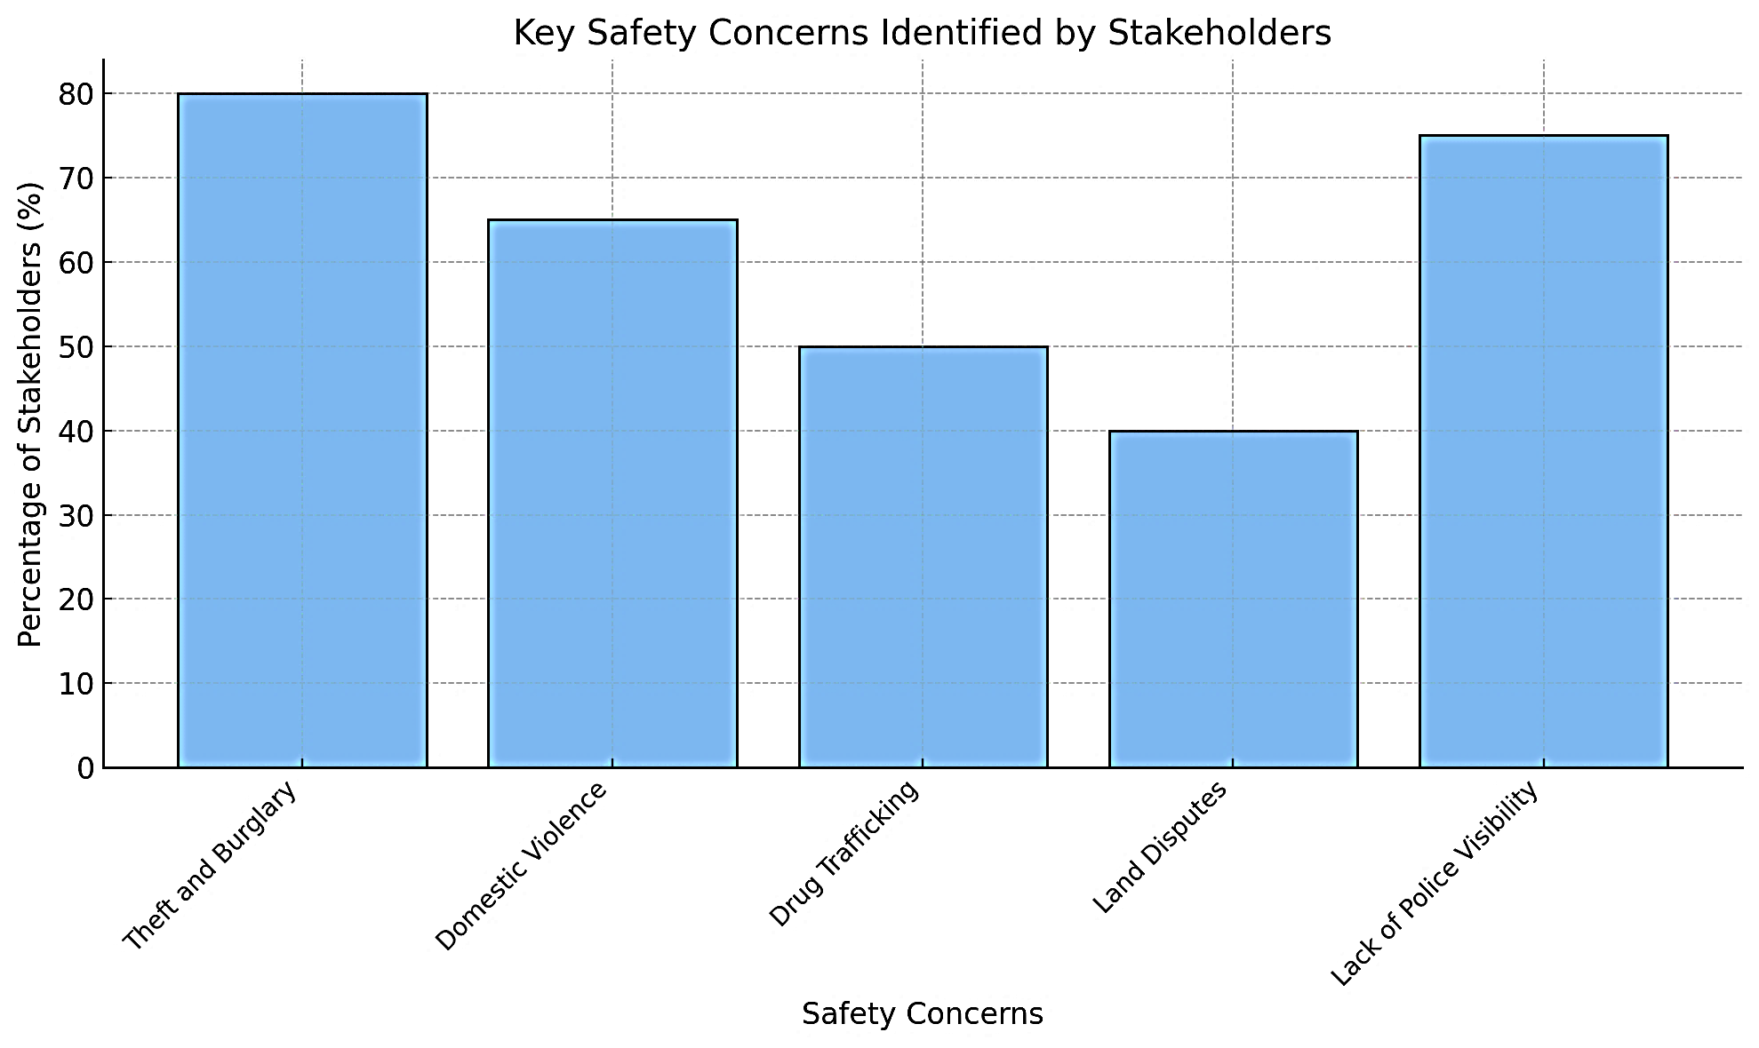
(Source: The Author)
Note: This figure illustrates the percentage of stakeholders highlighting various safety concerns, offering a visual representation of priority areas for intervention in rural safety and security initiatives.

Figure 6 Trust in Law Enforcement Among Residents

(Source: The Author)
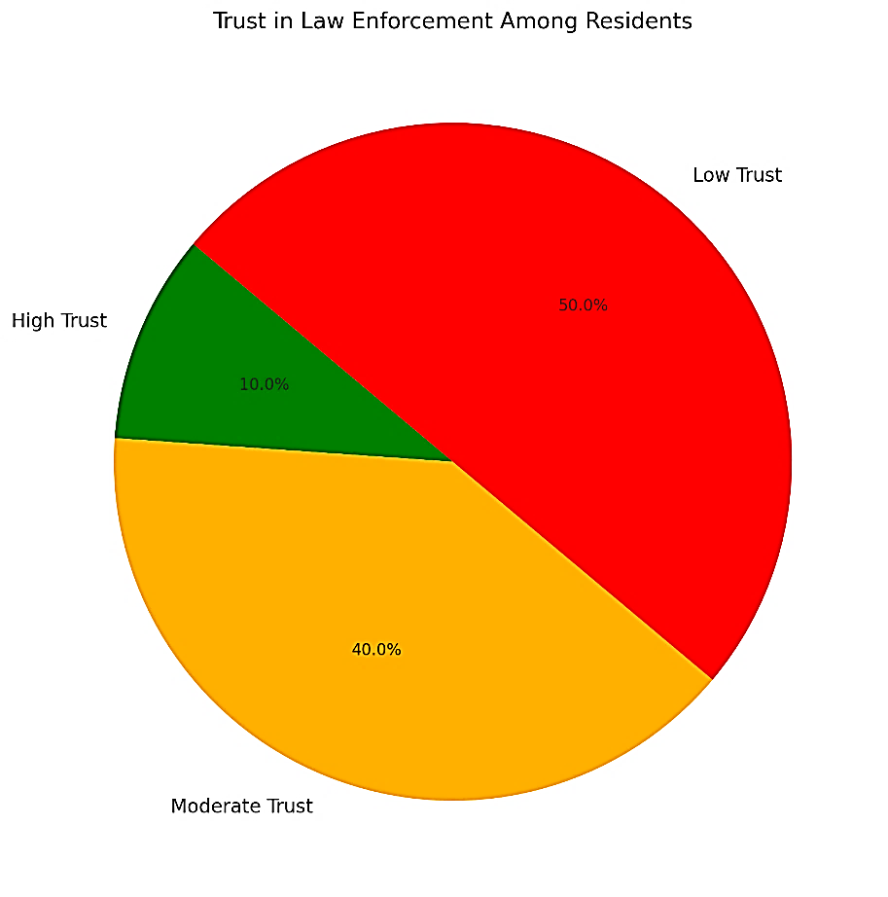
Note: This figure displays the distribution of trust levels among residents in law enforcement, highlighting the proportion of low, moderate, and high trust, which provides insights into public perception and areas for improvement in community policing strategies.

Chart 9 Key Safety Concerns by Stakeholder Group

(Source: The Author)
Stakeholder Group | Top Safety Concern | Secondary Concern
Village Council | Theft/Burglary | Land Disputes
Rural Residents | Domestic Violence | Inadequate Lighting
Police Officers | Drug Trafficking | Lack of Resources
Community Organizers | Low Police Visibility | Limited Community Engagement
Note: This chart summarizes the key safety concerns identified by various stakeholder groups, highlighting their primary and secondary priorities.
Chart 10 Community Safety Action Plan

(Source: The Author)
Action Item | Responsible Party | Timeline | Expected Outcome
Increase patrol frequency | Police Department | 3 months | Enhanced visibility and deterrence
Conduct community workshops | Local Leaders | 6 months | Improved awareness and reporting
Install public lighting | Village Council | 4 months | Safer public spaces
Develop safe reporting mechanisms | Police Department | 2 months | Increased crime reporting
Note: This chart outlines the Community Safety Action Plan, detailing specific action items, responsible parties, timelines, and expected outcomes.
Surveys
Surveys on the perception of safety were designed and distributed among residents and community leaders to quantitatively assess what they believe is safety. The surveys focused on collecting data on recent criminal incidents and types of crimes experienced by residents, their sense of security in public spaces and at home, and community trust in law enforcement and other security measures.
The survey sample included households from key rural areas identified using population density and crime history. The tools used for survey administration were online and paper-based forms, followed by analysis using statistical tools to derive insights.
The results from the surveys were analysed using statistical software to identify trends and patterns, revealing that 65% of respondents felt “unsafe” or “very unsafe” in their communities at night. Only 35% felt “safe” or “very safe” during the day, demonstrating that safety perceptions improve with daylight but remain far from ideal. The findings indicate a pressing need to address safety concerns during night-time through increased patrolling, better lighting, and community watch initiatives.
The frequency and types of crimes include theft and burglary, the most frequently reported crimes, with 45% of respondents experiencing such incidents in the past year.
The results indicated that assaults are at 20% and drug-related crimes 15% followed, suggesting that criminal activities are varied but heavily concentrated around property and physical harm., However, interestingly, 30% of respondents reported no incidents, suggesting that safety levels vary significantly between different communities.
Safety in specific locations such as public spaces (e.g. parks and markets) were rated as the least safe, with 60% feeling unsafe or very unsafe. Roads and pathways followed closely, with 55% expressing concerns about safety when moving between locations. Homes were relatively safer, with 40% feeling unsafe at home, suggesting that improving security in public spaces and transit areas should be prioritized.
Trust in law enforcement is critically low; 50% of respondents expressed “little” or “no trust” in police effectiveness. 75% reported rarely or never seeing police patrols in their communities. Only 30% of those who reported crimes felt their concerns were satisfactorily addressed, indicating a need for significant improvements in police responsiveness and presence.
When it comes to community engagement, 40% of respondents reported regular participation in community safety meetings, while 60% were less engaged, citing lack of interest or value. Only 20% felt that their concerns were always heard, signalling a need for better inclusivity and communication in safety initiatives.
Chart 11 Community Safety Analysis and Proposed Measures

(Source: (The Author)
Category | Key Insights | Proposed Measures
Safety Perception | 65% feel unsafe at night; 35% feel safe during the day. | Increase street lighting, enhance night-time patrolling.
Frequency and Types of Crimes | Theft/burglary is most common; assault and drug crimes follow. | Introduce neighbourhood watch programs, address theft hotspots.
Safety in Specific Locations | Public spaces and roads are perceived as least safe. | Secure public spaces with fencing, install CCTV cameras.
Trust in Law Enforcement | 50% have little/no trust in police; 75% rarely see patrols. | Increase police patrols, implement community policing.
Community Engagement | 40% actively participate in safety meetings; 20% feel heard. | Conduct workshops, enhance inclusivity in safety discussions.
Note: This chart provides an overview of key safety insights from community feedback and proposes targeted measures to address these concerns.

Figure 7 Residents Perceptions of Safety in Rural Belize

(Source: The Author)
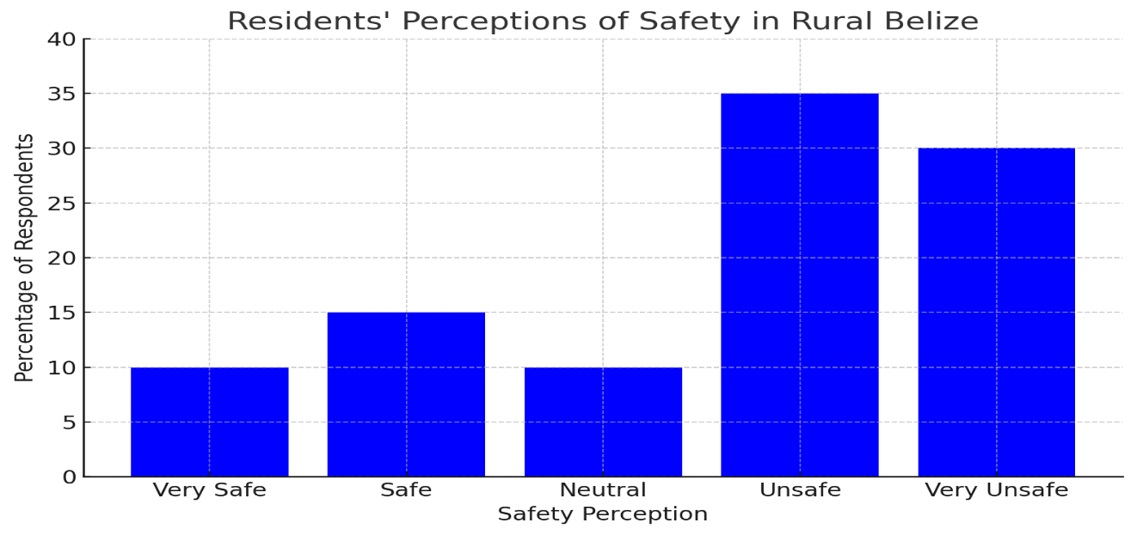
Note: This chart illustrates the distribution of safety perceptions among rural residents in Belize, highlighting a significant proportion who feel unsafe or very unsafe.

Literature Review
An extensive review of relevant literature was conducted to understand global trends and strategies in addressing rural safety, drawing comparisons to Belize and offering critical insights into patterns of rural crime, challenges in law enforcement, and effective community safety strategies. A key source included, Abraham, J., & Ceccato, V. (2022), which provided insights into crime patterns and safety measures in rural areas, offering comparative analysis for Belize’s rural communities. The review also looked at government reports and academic papers on crime trends and safety initiatives in Belize. The literature review provided a foundational understanding of successful safety initiatives that could be adapted for the Belizean context.
Globally, theft remains the predominant crime in rural settings, often driven by poverty, limited employment opportunities, and minimal deterrence due to low law enforcement presence. Similarly, rural Belize faces heightened risks due to unmonitored borders and the economic disparities between urban and rural areas. Rural areas often become corridors for drug trafficking due to their remote locations and weak law enforcement. This situation aligns with findings from Belize, where rural communities close to Guatemala face infiltration by traffickers.
The review highlighted domestic violence as a pervasive but under-reported issue in rural communities worldwide. Factors include limited access to support services and stigma surrounding reporting, both of which are significant in rural Belize. Also, in Belize, land ownership and usage disputes often lead to violence, reflecting a broader pattern of conflict in rural areas dependent on land as a primary resource.
Rural policing faces structural and logistical challenges. Rural police departments often lack personnel, vehicles, and funding, creating significant response delays and gaps in patrol coverage. Inadequate police presence leads to low trust in law enforcement, discouraging crime reporting and cooperation. In Belize, 50% of survey respondents reported “little” or “no trust” in law enforcement, reflecting this global trend.
The literature review followed a structured approach to gather comprehensive and relevant insights. Peer-reviewed journals, such as the Journal of Rural Studies, provided academic rigor. Government publications offered data specific to Belize, including crime statistics and safety policy frameworks. International examples of rural safety programs were compared with Belizean challenges to identify adaptable strategies. Factors like population density, socioeconomic conditions, and geographic isolation were considered to contextualize the findings. The findings were organized into thematic categories such as crime patterns, law enforcement challenges, and community engagement.

4.2. To diagnose the state of maturity in project management of rural safety and security projects applied to the Ministry of Home Affairs and New Growth Industries, and the Ministry of Rural Transformation and Community Development, in Belize.
Establishing a Project Management Office (PMO) directly benefits the goal of diagnosing the state of maturity in project management for rural safety and security initiatives within the Ministry of Home Affairs and New Growth Industries, and the Ministry of Rural Transformation and Community Development in several significant ways. Diagnosing the Project Management Maturity (PMM) of an organization involves a comprehensive evaluation of several aspects beyond the core criteria (processes, resources, governance, and outcomes). These additional factors help provide a holistic view of the organization's capabilities and readiness to operate at higher maturity levels.
Assessment Framework Development
The assessment framework evaluates the readiness and capacity of the Ministry of Home Affairs and New Growth Industries to establish and operate a Project Management Office (PMO) effectively. It aligns with global best practices for project management and ensures that the PMO will address current gaps in rural safety and security project implementation.
The key components of the framework will include governance and structure to assess the Ministry’s ability to define roles, responsibilities, and reporting structures. This assessment will determine the alignment of the PMO with the Ministry’s strategic objectives. Processes and methodologies will also form a part of the key components to evaluate existing project management practices. This evaluation will aid in Identifying gaps in planning, execution, monitoring, and closing processes.
Technology and tools are another key component and will assess the availability and use of project management software and tools, as well as review current data collection and reporting systems. Human resources, another key component, will evaluate the project management expertise of existing staff and identify training needs and capacity-building opportunities. The stakeholder component will analyse current community engagement and collaboration practices. This component will also determine the role of external partners, such as NGOs and local councils. The performance measure component will develop key performance indicators (KPIs) for the PMO’s effectiveness. This will align with the Ministry’s rural safety and security goals.
Chart 12 Key Components, Actions, and Outcomes for PMO Implementation

(Source: The Author)
Component | Actions | Outcomes
Governance | - Develop organizational charts  - Create reporting templates  - Draft governance policies | - Centralized PMO with clear roles and structures
Processes | - Standardized templates  - Conduct audits  - Provide training | - Repeatable and efficient project management practices
Technology | - Procure software  - Train staff  - Monitor and upgrade tools | - Integrated tools that enhance decision-making
Human Resources | - Conduct skills assessments  - Offer certifications  - Establish mentorships | - Skilled staff with continuous learning opportunities
Stakeholder Engagement | - Develop engagement plans  - Use feedback mechanisms  - Track metrics | - Active involvement of all stakeholders
Performance Measurement | - Define KPIs  - Create dashboards  - Analyse performance data | - Effective tracking and reporting of project success
Note: This chart outlines the essential components, corresponding actions, and expected outcomes for implementing a PMO.

By implementing these actions, the Ministry can systematically evolve from a fragmented operational approach to a highly mature and optimized project management environment. This strategy directly impacts the success and sustainability of rural safety and security initiatives, ensuring better outcomes for all stakeholders. These actions and their corresponding outcomes will advance through the key stages and directly contribute to the Project Management Maturity (PMM) of the Ministry of Home Affairs and New Growth Industries.
Organizational charts to define roles and responsibilities clearly will be implemented. This standardization will ensure uniformity in how projects are managed and communicated across the organization, establishing a foundation for consistent practices. To measure this impact, assigning accountability will make it easier to track the efficiency of individual contributions and team performance. Clear reporting lines enhance oversight, ensuring that issues are evaluated appropriately and managed effectively. Feedback from staff and stakeholders can be used to refine role definitions and optimize the structure further.
Effective governance ensures strategic alignment, amplifies decision efficiency, and reduces project risks, helping the Ministry transition to higher maturity levels by strengthening leadership and accountability. Therefore, effective governance policies will be drafted to outline decision-making processes. Governance policies formalize decision-making processes, reducing variability and aligning actions with organizational goals. Policies provide a framework for evaluating the timeliness and effectiveness of decisions, ensuring alignment with strategic objectives. Escalation protocols and defined oversight mechanisms ensure that challenges are addressed systematically and efficiently. Periodic reviews of governance policies based on outcomes and stakeholder feedback ensure ongoing refinement.
Chart 13 Key Roles and Responsibilities within the PMO

(Source: The Author)
Role | Responsibilities
Director of the PMO | Oversees the PMO's operations, ensures alignment with strategic goals, and reports to senior officials.
Project Managers | Lead individual rural safety and security projects, manage timelines, and coordinate with stakeholders.
Risk Analyst | Monitors risks, develops mitigation plans, and ensures projects align with compliance standards.
Data Analyst | Collects, analyses, and reports project data, including KPIs and safety performance metrics.
Community Liaison | Engages with rural communities, gathers feedback, and ensures alignment with local needs.
Training Coordinator | Develops and delivers training programs to enhance project management skills among staff.
Note: This chart details the primary roles within the PMO and their corresponding responsibilities, ensuring a structured approach to managing rural safety and security initiatives.

Chart 14 Phased Approach to PMO Implementation

(Source: The Author)
Phase | Activities | Duration | Dependencies
Assessment | Evaluate Governance, Processes, Tools, etc. | 4 weeks | None
Framework Development | Define templates, processes, and reporting tools | 6 weeks | Dependent on assessment
Implementation | Roll out training programs, stakeholder mechanisms | 8 weeks | Framework development
Monitoring | Track progress using KPIs | Ongoing | Implementation completion
Note: This chart outlines the phased approach to implementing a PMO, detailing activities, durations, and dependencies for each phase.

Chart 15 Key Components and Measures for PMO Effectiveness

(Source: The Author)
Component | Key Measures
Governance and Structure | Roles defined, Alignment with strategy, Reporting structures
Processes and Methodologies | Gap analysis, Planning processes, Execution methods
Technology and Tools | Project management tools, Data reporting systems, Usage rates
Human Resources | Training needs, Capacity building, Expertise assessment
Stakeholder Engagement | Community involvement, Collaboration practices, External partnerships
Performance Measurement | KPIs development, Alignment with goals, Effectiveness metrics
Note: This chart highlights the critical components of PMO implementation and their corresponding key measures.

Figure 8 Gantt Chart for PMO Implementation Activities

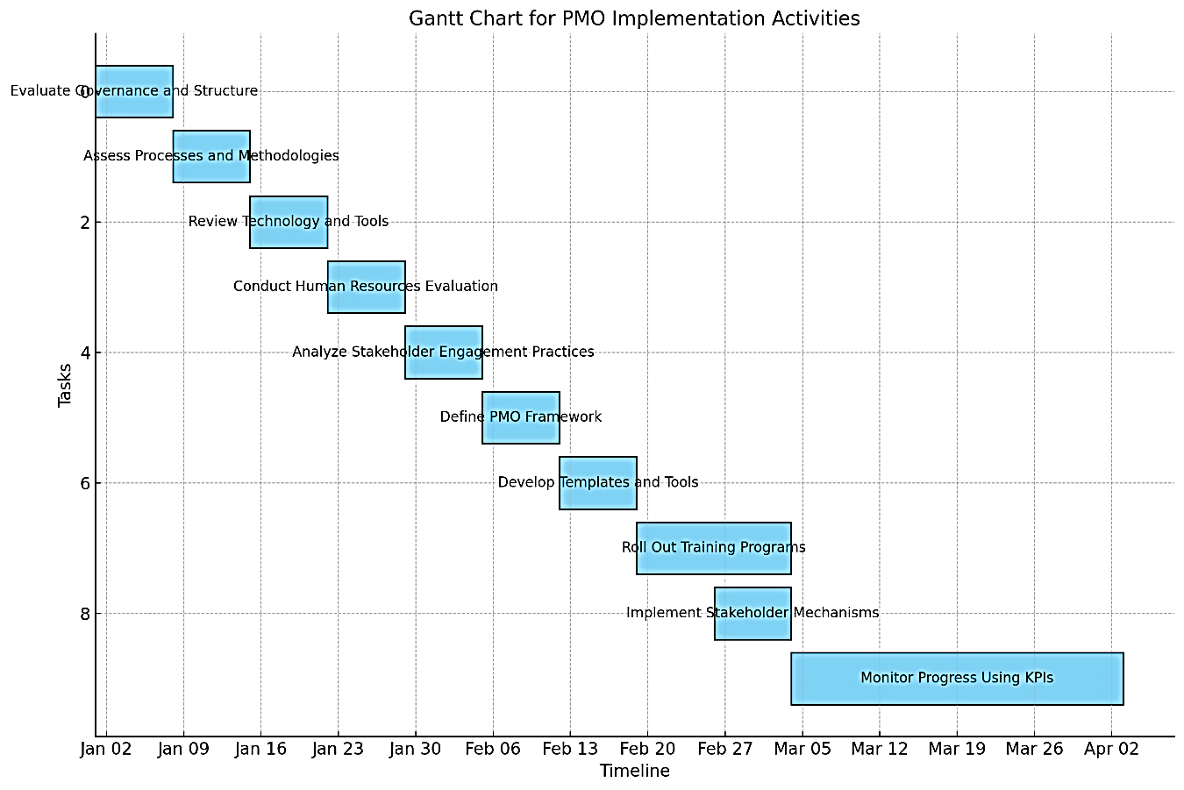
(Source: The Author)

Note: This Gantt chart provides a visual timeline of key activities involved in implementing the PMO, from initial evaluations to ongoing monitoring.

Figure 9 Key Measures for Each PMO Assessment Framework Component

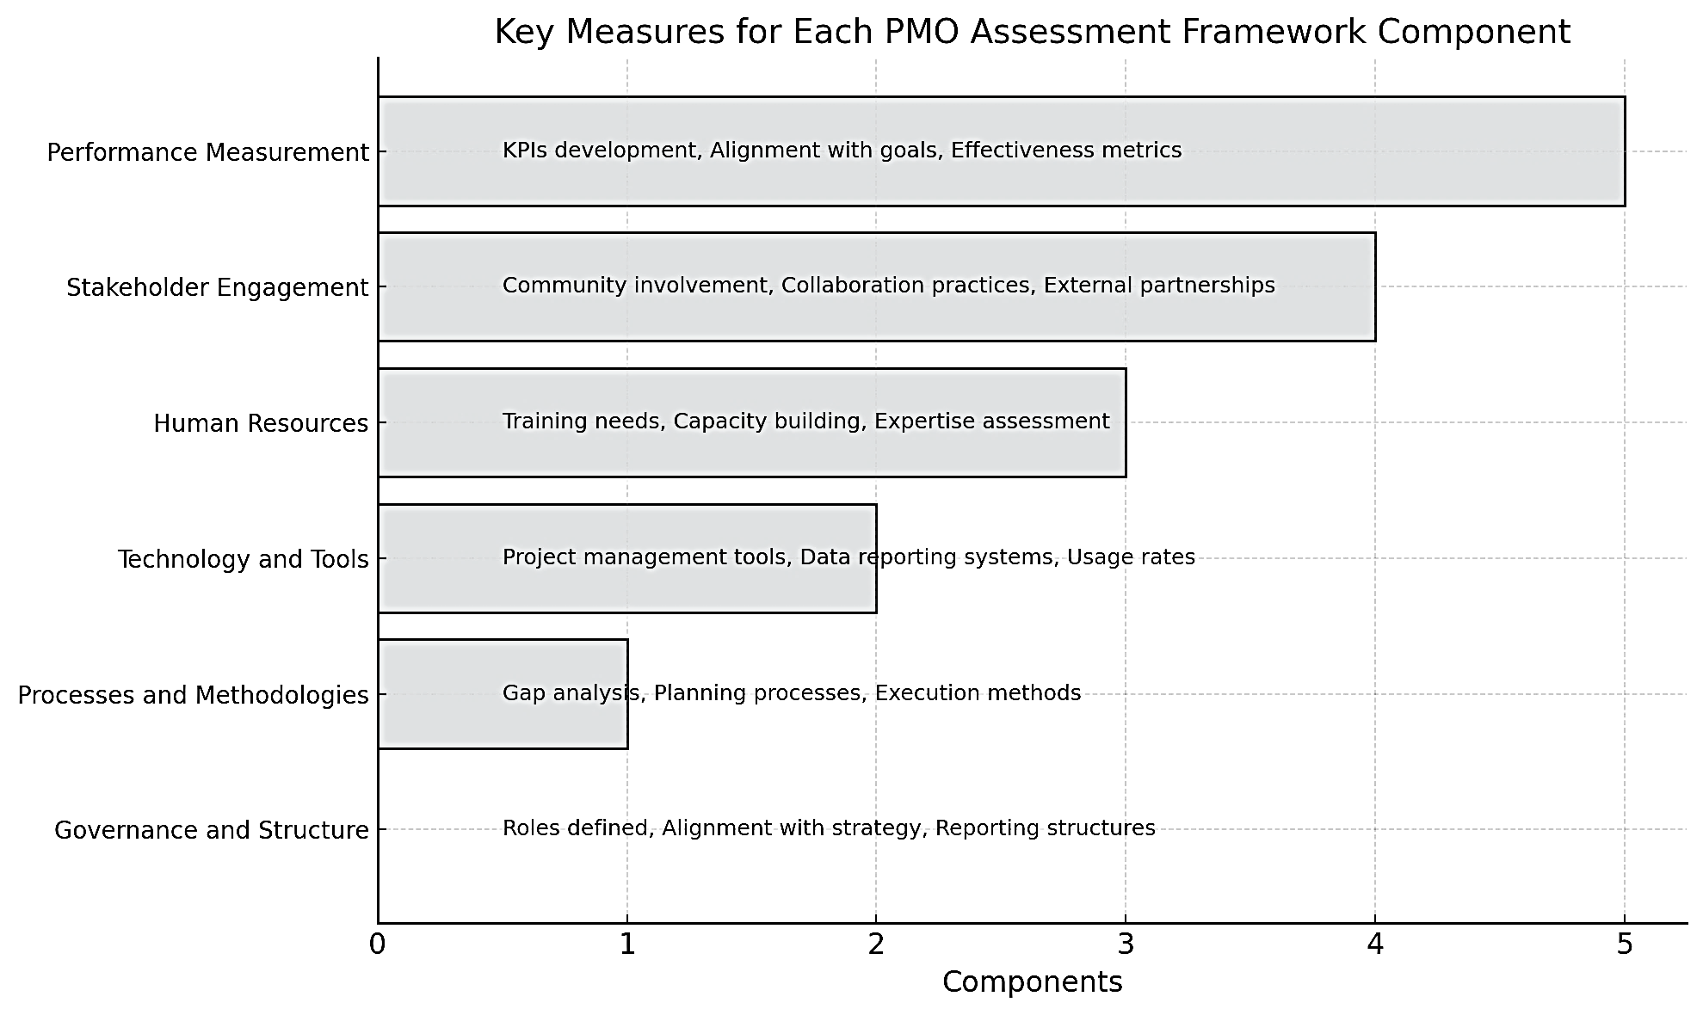
(Source: The Author)
Note: This chart highlights the critical components of the PMO assessment framework and their associated key measures.

4.3. To define a conceptual project management framework for the enhancing of rural safety and security projects applied to the Ministry of Home Affairs and New Growth Industries, and the Ministry of Rural Transformation and Community Development in Belize.
The Conceptual Project Management Framework for Enhancing Rural Safety and Security Projects represents a strategic blueprint to address identified gaps and elevate the project management maturity within the Ministry of Home Affairs and New Growth Industries and the Ministry of Rural Transformation and Community Development. This framework integrates best practices, aligns with strategic goals, and ensures sustainable, data-driven outcomes that directly benefit rural communities across Belize.
The framework is grounded in six key objectives, governance and structure, processes and methodologies, human resource, technology and tools, stakeholder collaboration and performance measurement, each designed to address identified gaps and align project outcomes with strategic goals. The primary objective of the framework is to standardize project management practices across all rural safety initiatives. By introducing consistent, repeatable processes, the framework ensures that projects are executed with
efficiency and predictability, reducing delays and minimizing resource wastage. Standardized templates, workflows, and methodologies form the backbone of this objective, fostering a uniform approach to planning, execution, monitoring, and closure.
A second vital goal is to strengthen governance structures by establishing a centralized Project Management Office (PMO). This office will oversee the alignment of projects with broader strategic objectives, ensuring accountability through clearly defined roles, responsibilities, and reporting hierarchies. Governance policies, escalation protocols, and structured decision-making processes will provide a solid foundation for managing the complexities of rural safety projects.
The framework also seeks to build the capacity of human resources by equipping project teams with the necessary skills, tools, and resources. Comprehensive training programs, professional certifications, and mentorship opportunities will enable staff to manage projects effectively and adapt to evolving challenges. These objectives address existing capacity constraints while fostering a culture of continuous learning and improvement.
The framework prioritizes the integration of technology and tools to support data-driven decision-making. Advanced project management software, GIS for crime mapping, and real-time dashboards will enable accurate monitoring and analysis, enhancing project oversight and resource allocation. These technological solutions ensure that projects are informed by reliable data and aligned with measurable outcomes.
Another critical objective is to foster stakeholder collaboration by establishing structured engagement plans. Meaningful partnerships with rural communities, NGOs, and local councils are essential for the success of safety initiatives. The framework emphasizes the importance of regular consultations, feedback mechanisms, and transparent communication to build trust and ensure that projects address the unique needs of stakeholders.
The framework is designed to drive continuous improvement by implementing robust performance measurement systems. Key performance indicators (KPIs) will be defined to track project success, while lessons learned reviews will inform ongoing refinements. The framework ensures that each initiative contributes to developing more effective and sustainable practices by embedding feedback loops into the project lifecycle.
Through these objectives, the conceptual framework is a transformative tool for elevating the project management maturity of rural safety and security initiatives in Belize. It aligns resources, processes, and outcomes with strategic goals, ensuring that projects deliver tangible, lasting benefits to rural communities.
The conceptual framework is designed to standardize practices by establishing consistent, repeatable processes that ensure project efficiency and effectiveness. The framework will also strengthen governance and define clear roles, responsibilities, and reporting structures to enhance accountability and decision-making. It will equip staff with the skills, tools, and resources necessary to manage complex projects through building capacity. It will also foster stakeholder collaboration by creating mechanisms for meaningful engagement with communities and partners. Robust performance measurement systems will be implemented to ensure alignment with strategic objectives.
The successful implementation of the Conceptual Project Management Framework for enhancing rural safety and security projects begins with a critical first step: Foundation Building. Phase 1 establishes the organizational structures, governance mechanisms, and standardized processes necessary to create a robust and scalable framework that addresses current gaps in project management maturity.
This phase is designed to lay the groundwork for a centralized and efficient Project Management Office (PMO) to ensure that all subsequent phases are built on a firm, well-structured foundation. Phase 1 aims to align resources, roles, and objectives with the ministries' strategic goals by focusing on governance, processes, and performance metrics. It also seeks to foster a culture of accountability and collaboration, which is critical for achieving measurable and sustainable outcomes in rural safety and security initiatives.
The centralized Project Management Office (PMO) will act as the nucleus for planning, implementing, monitoring, and evaluating rural safety and security projects under the Ministry of Home Affairs and New Growth Industries. It ensures alignment with the ministry’s strategic goals, fosters accountability, and standardizes project management practices across initiatives. The mission is to provide governance, oversight, and support for rural safety and security projects while ensuring consistency, efficiency, and alignment with national safety objectives. The scope is that the PMO will manage all aspects of rural safety and security initiatives, including project initiation, risk assessment, resource allocation, stakeholder engagement, and performance measurement. The PMO will consist of a structured team, each with clearly defined roles and responsibilities.
Chart 16 Accountability and Outcomes in PMO Framework Components

(Source: The Author)
Framework Component | Accountability Incorporated | Outcome
Governance and Structure | Defines roles responsible for resource allocation and issue resolution. | Clear accountability and streamlined decision-making.
Processes and Methodologies | Embeds resource planning and escalation protocols into project workflows. | Efficient resource management and issue resolution.
Technology and Tools | Uses dashboards and tracking systems to monitor resources and escalations. | Real-time visibility into resource gaps and unresolved issues.
Stakeholder Engagement | Engages external partners in resolving escalated issues. | Collaborative problem-solving and improved stakeholder trust.
Performance Measurement | Tracks KPIs related to resource utilization and issue resolution timelines. | Data-driven improvements to resource allocation and governance.
Note: This chart outlines how accountability is incorporated into each PMO framework component and the resulting outcomes.

Project Planning and Scope
This section outlines the foundational components and scope of the Rural Safety and Security Initiatives (RSSI) project. Providing a clear framework for objectives, deliverables, roles, and timelines ensures alignment among stakeholders and a structured approach to project execution. The following subsections detail the critical elements of the RSSI project plan, including its objectives, scope, deliverables, and governance framework. This structured documentation forms the basis for effective decision-making, resource allocation, and performance monitoring, ensuring the successful implementation of safety and security measures tailored to rural areas.
Chart Key Sections of the RSSI Project Plan

(Source: The Author)
Section | Description
Project Objectives | Define the goals and purpose of the RSSI project.
Scope and Deliverables | Specify what the project will accomplish and deliver.
Roles and Responsibilities | Identify team members and their specific roles.
Timeline | Provide a high-level schedule for key milestones.
Approval Signatures | Include signatures of approving authorities.
Note: This table outlines the essential sections of the RSSI Project Plan, ensuring that objectives, scope, roles, timeline, and approvals are clearly defined and documented.

Project Charter Template
The Project Charter Template and outlined scope serve as the foundational framework for the Rural Safety and Security Initiatives (RSSI) project. This section provides a structured approach to defining and achieving the project's objectives by detailing key focus areas, deliverables, and governance elements.
The Project Charter Template formalizes the RSSI project by documenting its objectives, scope, and expected outcomes. It ensures alignment among all stakeholders and provides a blueprint for effective project execution. The focus is on addressing the unique safety and security challenges faced by rural communities through comprehensive planning and collaboration.
Project Charter Template
Purpose: To document the foundational details of the project.
Scope
Scope and Deliverables for RSSI Projects outlines targeted interventions across five critical areas, ensuring a holistic approach to enhancing rural safety and security.
Scope: The Rural Safety and Security Initiatives aim to enhance safety and security in rural areas by focusing on the following key areas:
- Law Enforcement Enhancements:
  - Deploy additional officers to under-served rural areas.
  - Establish or refurbish police outposts to improve accessibility.
- Community Engagement:
  - Implement community-oriented policing strategies.
  - Conduct safety workshops to raise awareness and foster trust between law enforcement and residents.
- Infrastructure Improvements:
  - Upgrade rural roads to facilitate efficient law enforcement response times.
  - Develop centralized emergency response hubs.
- Technology Integration:
  - Install surveillance systems in high-crime areas to deter criminal activities and enhance evidence collection.
  - Utilize GIS for crime mapping and resource allocation.
- Governance and Processes:
  - Standardize project management practices with templates, workflows, and monitoring tools.
  - Develop and implement governance policies for decision-making and accountability.
Deliverables
The outlined deliverables serve as the measurable outputs that guide and validate the success of the Rural Safety and Security Initiatives (RSSI) project. These deliverables ensure that each key area of the project achieves tangible results, aligning actions with the overarching goals of enhancing safety and security in rural areas.
Chart 17 Key Deliverables for the Rural Safety and Security Initiatives (RSSI) Project

(Source: The Author)
Category | Deliverable
Law Enforcement | - Deployment of 50 additional officers to rural areas.  - Establishment of 15 operational police outposts.
Community Engagement | - Quarterly safety workshops in key rural districts.  - Comprehensive community policing program.
Infrastructure | - Upgraded roads in high-priority rural regions.  - Construction of 3 centralized emergency response hubs.
Technology | - Operational surveillance systems in 20 high-crime hotspots.  - Fully functional GIS platform for monitoring.
Governance | - Approved governance policies and decision-making frameworks.  - Templates for project charters, risk assessments, and progress reports.
Monitoring and Reporting | - Real-time KPI dashboards.  - Quarterly and annual project performance reports.
Note: This table outlines the critical deliverables for the RSSI project across key categories, including law enforcement, community engagement, infrastructure, technology, governance, and monitoring.

Success Criteria
- Crime Reduction: Achieve a 20% reduction in crime rates in rural areas within three years.
- Community Satisfaction: Improve stakeholder satisfaction with safety measures, as measured by post-workshop surveys.
- Infrastructure Usability: Reduce law enforcement response time by 30% in upgraded regions.
Project Efficiency: Complete all deliverables within the specified timelines using the standardized governance framework.
Governance and Structure
Developing robust governance policies and organizational structures is critical to fostering transparency, accountability, and efficiency in managing rural safety and security projects. Governance provides the framework for decision-making, establishes clear roles and responsibilities, and ensures that all stakeholders operate within a unified structure aligned with strategic objectives.
Organizational structures complement governance policies by defining reporting relationships and clarifying accountability at every Project Management Office (PMO) level. These elements create an environment where projects are managed consistently, issues are escalated effectively, and resources are allocated equitably. The Governance and Structure component of the Rural Safety and Security Initiatives (RSSI) framework defines the roles and responsibilities for resource allocation and issue resolution. This structure ensures that accountability, streamlined decision-making, and effective project execution are aligned with strategic objectives.
Key Objectives
- Establish clear roles and reporting lines to manage resources efficiently.
- Develop a structured decision-making process to address project challenges promptly.
- Promote accountability and transparency in governance practices.
The Ministry of Home Affairs and New Growth Industries (MHANGI) will establish a strong foundation for achieving project management maturity by instituting governance policies and organizational structures. These initiatives ensure that all projects align with the ministry’s strategic goals, meet stakeholder expectations, and deliver measurable outcomes that enhance rural safety and security.
Figure 10 Organizational Chart for PMO in the Ministry of Home Affairs and New Growth Industries (MHANGI)

(Source: The Author)
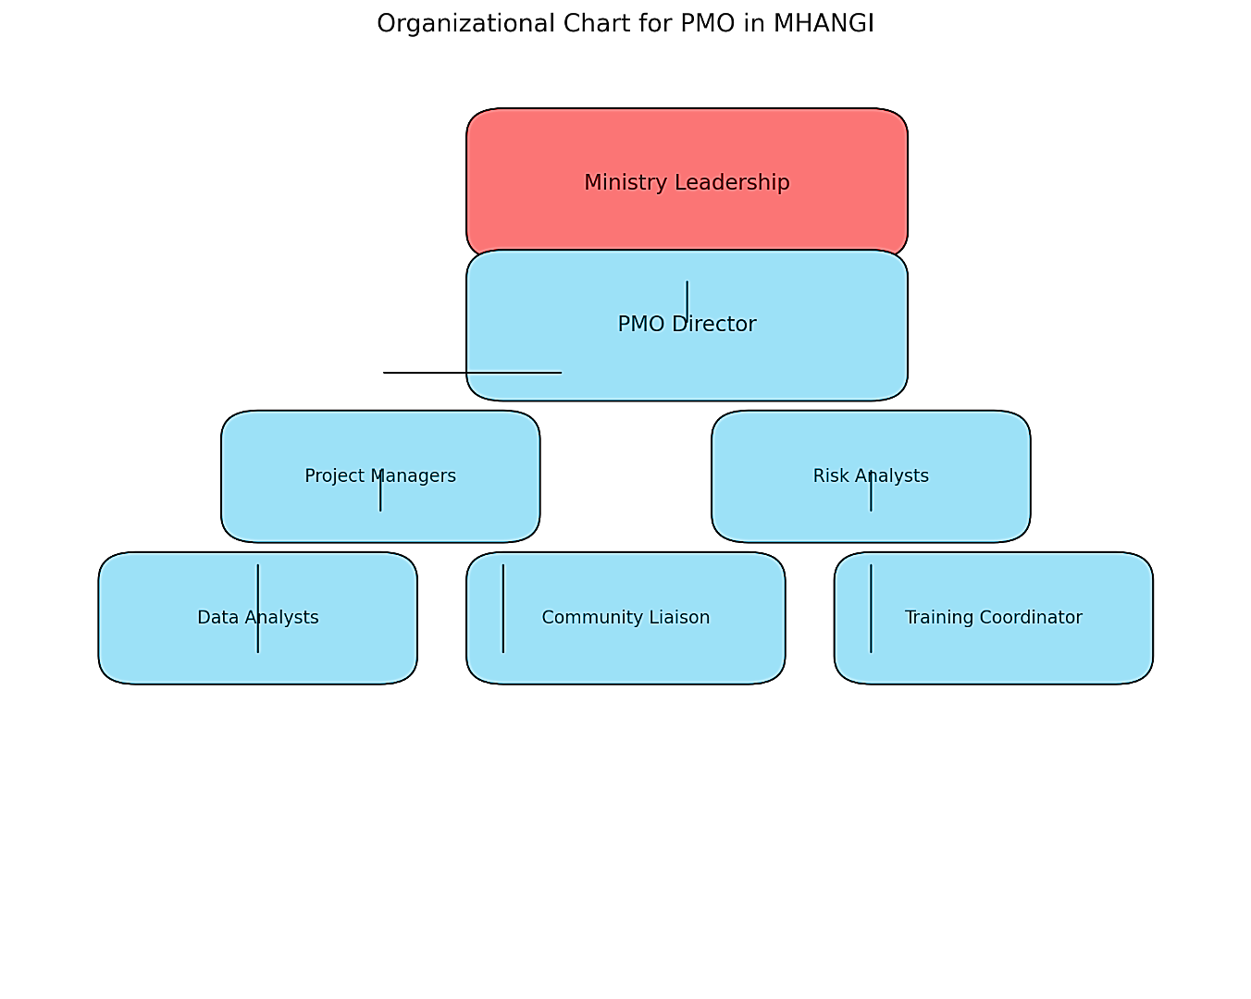
Note: This figure illustrates the hierarchical structure of the PMO within MHANGI, highlighting the key roles and their relationships.

The above visual (Figure 10) represents the Organizational Chart for the Project Management Office (PMO) within the Ministry of Home Affairs and New Growth Industries (MHANGI). It outlines the hierarchy and reporting lines to ensure clarity and accountability. The hierarchy and reporting relationship between the Ministry leadership and the PMO Director will provide the PMO with strategic direction, oversight, and regular updates.
Governance policies are the foundation for effective project management to ensure that all stakeholders operate within a structured and transparent framework. These policies define how decisions will be made, how responsibilities will be allocated, and how issues will be resolved, promoting accountability and alignment with strategic objectives.
Well-defined governance policies are essential for the MHANGI to manage the complexities of rural safety and security projects. They enable the PMO to maintain consistency, to address challenges efficiently, and to ensure that projects are timely and aligned with organizational goals. The objective is to establish clear guidelines for decision-making and issue resolution within the PMO, providing timely and effective management of project challenges.
Chart 18 Roles and Responsibilities within the PMO Structure

(Source: The Author)
Role | Responsibilities
PMO Director | - Oversee all PMO operations  - Ensure alignment with strategic goals  - Report to ministry leadership
Project Managers | - Manage individual projects  - Coordinate timelines, budgets, and resources  - Engage with stakeholders
Risk Analyst | - Identify and assess project risks  - Develop mitigation strategies  - Monitor compliance with safety standards
Data Analyst | - Collect, analyse, and report project performance data  - Track KPIs and trends
Community Liaison | - Engage with rural communities  - Gather feedback and ensure alignment with local needs
Training Coordinator | - Develop and deliver training programs  - Identify capacity-building opportunities
Administrative Support | - Maintain documentation, schedules, and communication records for the PMO
Note: This table outlines the key roles within the PMO and their specific responsibilities.
Decision-making
Decision-making protocols outline the steps and authority levels required to make project-related decisions, ensuring consistency and reducing delays. A detailed template for documenting all decisions made within the PMO of the Ministry of Home Affairs and New Growth Industries. This ensures consistency, transparency, and accountability in decision-making.
To ensure transparency, accountability, and efficiency in decision-making, the MHANGI PMO will establish a Decision-Review Process. This process provides a structured approach to regularly assessing significant decisions and addressing critical issues promptly. The review process will align with governance policies and include mechanisms for escalation, documentation, and monitoring.
Decision Documentation Template
1. Decision ID:
[Unique identifier for tracking, e.g., DEC-2024-001]
2. Date of Decision:
[Date when the decision was finalized]
3. Decision Title:
[Concise description of the decision, e.g., "Approval of Additional Resources for Project A"]
4. Decision Description:
[Provide a detailed explanation of the decision, including what is being approved, changed, or rejected.]
Example:
"The PMO has approved an additional $50,000 budget allocation for Project A to address unforeseen logistical challenges and ensure timely project delivery."
5. Rationale for Decision:
[Explain why the decision was made, providing the context, analysis, or justification.]
Example:
"Delays caused by inclement weather have increased transportation costs, necessitating additional funding to maintain the project timeline. Failure to allocate these funds could jeopardize the completion of key milestones."
6. Approval Signatures:
[Include spaces for signatures of all relevant approvers.]
Name | Role | Signature | Date
PMO Director | Overall Approval
Project Manager | Operational Approval
Finance Officer | Budgetary Approval
7. Expected Outcomes:
[List the anticipated results or impacts of the decision.]
Example:
- Mitigate risks associated with project delays.
- Maintain alignment with the original project timeline.
- Ensure stakeholder satisfaction by meeting deliverable deadlines.
8. Implementation Plan:
[Provide a brief summary of how the decision will be executed.]
Example:
"The additional funds will be allocated from the contingency budget. The finance team will process the allocation within three business days, and the logistics team will be notified to resume transportation activities."
9. Notes/Additional Information:
[Include any relevant supporting information or attachments.]
Example:
- Budget impact analysis attached.
- Updated risk assessment report included.
PMO Decision-making Framework
Creating the PMO Decision-Making Framework involves establishing clear processes and standards to ensure efficient and transparent decision-making within the organization. This process includes scheduling regular and ad hoc meetings for reviews, designing flowcharts to outline authority levels and escalation points, and providing targeted training to equip staff with the necessary skills for using these tools effectively. Standardized templates are developed to document all decisions consistently, leading to outcomes such as improved accountability, streamlined processes, and alignment with strategic goals. This structured approach ensures that decisions are both informed and actionable, enhancing the PMO's overall effectiveness.
Chart 19 Key Aspects of PMO Decision-Making Framework

(Source: The Author)
Aspect | Details
Meeting Schedule | Quarterly reviews; ad hoc meetings as needed
Flowchart Focus | Authority levels (operational, strategic, critical) and escalation points
Training Goals | Equip staff with skills to use the flowchart and document decisions.
Documentation Standards | Use standardized templates for all decisions.
Expected Outcomes | Transparent, accountable, and efficient decision-making
Note: This table highlights critical aspects of the PMO’s decision-making framework, including meeting schedules, flowchart focus, training goals, documentation standards, and expected outcomes.

This review aims to assess overall project progress, review significant decisions, and address ongoing challenges. Members who should be in attendance are the PMO Director, Project Managers, Risk Analysts, Data Analysts, and representatives from Ministry Leadership. The outcomes of these meetings ensure that decisions are evaluated for their alignment with strategic goals, actions are documented, accountability is assigned to specific roles, and escalated issues are resolved promptly, minimizing project delays or risks. Create quarterly reports through monitoring and reporting to summarize all decisions reviewed, including outcomes and escalations. Highlight recurring issues or trends requiring process refinement.
Phased approach to rolling out the framework
This phased implementation plan is designed to guide the establishment and operationalization of the Project Management Office within an organization, such as the Ministry of Home Affairs and New Growth Industries (MHANGI). It provides a roadmap for systematically rolling out the PMO framework, ensuring that governance structures, tools, and workflows are implemented effectively and sustainably.
- Phase 1: Focuses on creating foundational elements such as governance structures and templates, which are critical for consistent project management practices.
- Phase 2: Involves equipping staff with the necessary skills and deploying technological tools to enhance operational efficiency.
- Phase 3: Concentrates on executing workflows and monitoring project performance to ensure that objectives are being met.
- Phase 4: Emphasizes reviewing and refining the framework to address gaps, integrate lessons learned, and ensure long-term adaptability.
This plan ensures that the PMO operates efficiently, supports organizational objectives, and continuously evolves to meet future challenges. It serves as a structured approach to transitioning from planning to sustainable implementation.
Chart 20 Phased Implementation Plan for PMO Framework

(Source: The Author)
Phase | Activity | Timeline | Deliverables
Phase 1 | Develop governance structures and project templates | Months 0–3 | Organizational chart, templates
Phase 2 | Train staff and deploy technology tools | Months 3–6 | Trained personnel, operational systems
Phase 3 | Execute workflows and monitor performance | Months 6–12 | Progress reports, dashboards
Phase 4 | Review and refine the framework | Month 12+ | Updated policies and workflows
Note: This table outlines the phased approach to implementing the PMO framework, detailing activities, timelines, and deliverables for each phase.

Quarterly Governance Review Plan
The Rural Safety and Security Initiatives framework incorporates structured quarterly governance reviews to ensure compliance with roles, policies, and decision-making protocols. These reviews provide an opportunity to assess the effectiveness of governance structures and refine processes based on observed outcomes and feedback.
Objectives of Quarterly Governance Reviews
- Ensure adherence to established roles, responsibilities, and policies.
- Detect any deficiencies or inefficiencies in governance and decision-making processes.
- Use findings to update and improve governance frameworks and escalation protocols.
- Maintain open communication with stakeholders by sharing review outcomes.
Governance Review Checklist
The Governance Review Checklist is a comprehensive tool used to assess the effectiveness and alignment of governance practices within the PMO. It focuses on key areas such as policy compliance, clarity of roles and responsibilities, efficiency of decision-making protocols, effectiveness of issue escalation and resolution, and stakeholder satisfaction. The checklist ensures transparency, accountability, and alignment with organizational objectives by systematically addressing these areas through targeted questions. This structured review process helps identify gaps, implement improvements, and maintain robust governance standards over time.
Chart 21 Key Governance Assessment Areas and Questions

(Source: The Author)
Area | Key Questions
Policy Compliance | Are all policies being followed as written? Have there been any deviations?
Role Clarity | Are team members clear on their roles and responsibilities?
Decision-Making Protocols | Were decisions made efficiently and effectively? Were escalation protocols followed?
Escalation Handling | How many issues were escalated, and were they resolved promptly?
Stakeholder Satisfaction | Have stakeholders expressed concerns about governance or decision-making?
Note: This table outlines critical areas and key questions for assessing governance within the PMO.

Governance Review Schedule
The Governance Review Schedule outlines a structured timeline for evaluating the effectiveness of governance practices within the PMO. It breaks governance assessments into quarterly focus areas, such as policy adherence, decision-making protocols, stakeholder feedback, and a comprehensive annual review. This schedule ensures continuous improvement by systematically identifying gaps, implementing corrective actions, and updating governance policies. It fosters accountability, transparency, and alignment with organizational objectives, ensuring the PMO operates efficiently and effectively throughout the year.
Chart 22 Quarterly Governance Focus Areas and Expected Outcomes

(Source: The Author)
Quarter | Key Focus Areas | Expected Outcome
Q1 | Policy adherence and role clarification | Identify initial gaps in compliance and assign corrective actions.
Q2 | Decision-making and escalation protocols | Refine escalation processes based on performance data.
Q3 | Stakeholder feedback integration | Implement feedback-driven improvements to governance structures.
Q4 | Comprehensive governance assessment | Summarize annual findings and update governance policies.
Note: This table outlines the key focus areas for governance each quarter and their expected outcomes.

Strategic Direction
Providing a strategic direction and oversight ensures that Rural Safety and Security Initiatives are aligned with the Ministry of Home Affairs and New Growth Industries broader goals, are executed effectively, and deliver measurable benefits to rural communities. Strategic direction focuses on defining the vision, goals, and priorities for RSSI projects, while oversight ensures these projects are implemented as planned, within budget, and achieve their intended outcomes.
Vision & Goals
The strategic directions include defining a clear vision for RSSI projects, such as “enhancing rural safety and security through proactive community engagement and modernized infrastructure.” The vision must also align with national priorities and the Sustainable Development Goals. This also includes setting goal developments for the RSSI, such as:
- reducing rural crime rates by 20% within three years
- Increase community engagement in safety programs by 50% by the end of year two. These goals will impact trust and improve cooperation and communication between police and communities, leading to faster issue resolution.
- Another goal is to launch a rural safety awareness campaign that will reach 80% of rural households within 18 months. This will increase community knowledge about crime prevention strategies.
- The goal is to establish ten youth safety clubs in rural areas by the end of year three. These clubs will reduce youth involvement in criminal activities through education and mentorship programs.
- Another goal is to construct or refurbish 15 rural police outposts within three years. This goal will enhance response times and the visible law enforcement presence in under-served areas.
- The goal of installing surveillance cameras in 50 high-crime rural areas within two years. This will increase the deterrence of criminal activities and improve evidence collection.
- Training and building capacity are an important goal. Within two years, 200 rural police officers will be trained in community policing strategies. This will result in more effective and community-friendly policing practices.
- A crime response team will train crisis response teams in all rural districts by the end of year three. This will aid in improved handling of emergencies such as natural disasters or public disturbances.
- The crime reduction goal is essential as it will decrease theft rates in rural areas by 25% within three years through targeted interventions and community engagement. This intervention will create greater safety among rural residents and reduce economic losses.
- Combatting domestic violence will reduce reported cases of domestic violence in rural areas by 15% within two years through awareness and support programs. This program will improve the well-being and security of vulnerable populations.
- Leveraging technology goal: Partner with technology providers to deploy mobile safety apps for rural residents within two years. This will enhance real-time reporting and communication between communities and law enforcement.
- Develop performance dashboards as a goal to launch a real-time project performance dashboard for all RSSI initiatives within one year. This will improve tracking of project progress and data-driven decision-making.
- Conducting annual safety audits as a goal and priority to perform comprehensive safety audits in 80% of rural communities annually. This audit will assist in identifying gaps and targeted improvements in safety measures.
These goals will allow for a 25% reduction in the theft safety rate within the next three years. Developing SMART goals for RSSI projects ensures clarity, accountability, and alignment with strategic objectives. Each goal is designed to address a specific need, whether it's infrastructure, community engagement, or crime reduction, ensuring that rural safety and security initiatives deliver meaningful and measurable outcomes.
Chart 23 SMART Objective for Reducing Theft Rates

(Source: The Author)
SMART Element | Explanation
Specific | Focuses on reducing theft rates.
Measurable | Target a 25% reduction.
Achievable | Aligns with available resources, such as increased patrols and community awareness.
Relevant | Addresses a key issue affecting rural safety.
Time-Bound | Achieve within three years.
Note: This table demonstrates the application of the SMART framework to establish a clear and actionable objective for reducing theft rates in rural areas.

Standardization
For Rural Safety and Security Initiatives (RSSI), the standardization and consistency approach are crucial in overcoming the unique challenges posed by rural environments, such as geographic dispersion, limited resources, and varied socio-cultural contexts. This approach will allow for the reduction of insufficiencies. The standardized templates, workflows, and procedures minimize redundancy and confusion, ensuring that the project team will spend less time reinventing processes and more time on execution. This process will also create uniformity and enhance the understanding among diverse stakeholders, including government bodies, rural communities, and external partners, reducing the risk of miscommunication. With clear standards in place, new team members can quickly adapt to their roles, maintaining momentum in the RSSI project.
This process is also equitable and allows for resource allocation. Standardized resource planning ensures that allocation decisions are transparent and based on predefined criteria, such as crime rates, population density, or geographic vulnerability. Consistency in processes ensures that rural areas are prioritized based on needs rather than subjective decision-making.
This component also includes addressing rural-specific risks. Standardized risk assessment tools and contingency plans ensure teams are prepared to handle issues like poor road conditions, long travel times, and limited communication networks. The standardized frameworks will incorporate rural-specific elements (e.g., community engagement protocols or cultural considerations) to ensure relevance. This framework will also include uniform procedures for identifying and mitigating risks to ensure that no critical area is overlooked, reducing the likelihood of project failure.
Human Resource Development
The success of the Rural Safety and Security Initiatives framework relies heavily on the capabilities and expertise of the individuals responsible for its implementation. Building a skilled and knowledgeable workforce is critical to achieving project objectives, fostering community trust, and addressing safety concerns effectively.
The Human Resource Development component of the RSSI framework is designed to identify training needs, close skills gaps, and provide ongoing capacity-building opportunities for ministry staff, law enforcement personnel, and stakeholders. By offering targeted workshops and continuous learning initiatives, this component ensures that all team members are equipped with the tools and knowledge to execute their roles efficiently.
Through structured training programs in project management, technology utilization, community engagement, and risk management, the RSSI framework aims to enhance operational efficiency, promote stakeholder collaboration, and support long-term sustainability. This section outlines a comprehensive plan for assessing training needs, developing capacity-building workshops, and monitoring their effectiveness to build a workforce capable of driving meaningful change in rural safety and security.
Identifying Training Needs
Capacity-Building Workshops – Training Focus Areas
- Project Management Fundamentals:
  - Training Topics: Planning, execution, monitoring, and closure phases of projects.
  - Personnel: Ministry staff, law enforcement, and stakeholders.
  - Duration: 3-day intensive workshop.
- Technology Utilization:
  - Training Topics: Using GIS for crime mapping, dashboards for KPI tracking, and mobile reporting platforms.
  - Personnel: Data analysts, risk analysts, and project managers.
  - Duration: 2-week training program with practical exercises.
- Community Engagement Best Practices:
  - Training Topics: Building trust, effective communication, and collecting feedback from stakeholders.
  - Personnel: Community liaisons, local councils, and NGOs.
  - Duration: 2-day interactive workshop.
- Risk Management and Mitigation Strategies:
  - Training Topics: Identifying, prioritizing, and addressing project risks effectively.
  - Personnel: Risk analysts, PMO staff, and senior leadership.
  - Duration: 1-day workshop with case studies and simulations.
Resource & Allocation
As part of the Rural Safety and Security Initiatives (RSSI) framework under the Ministry of Home Affairs and New Growth Industries (MHANGI), identifying and prioritizing key focus areas ensures that resources are allocated efficiently and that efforts yield the greatest impact. Enhancing law enforcement capabilities in rural areas is to strengthen law enforcement’s capacity to address crime and maintain safety in remote regions. Building trust between law enforcement and rural communities through proactive engagement and collaboration and addressing the infrastructure challenges that hinder the effectiveness of safety and security measures in rural areas are three important priority areas that ensure that the RSSI projects address immediate challenges while building sustainable safety and security systems in rural areas. This prioritization framework balances urgency, impact, and feasibility, aligning efforts with the strategic goals of MHANGI.
This prioritization framework plays a crucial role in resource allocation by identifying which initiatives require immediate attention and the highest investment of time, effort, and resources. By evaluating each initiative based on urgency, impact, and feasibility, the framework ensures that critical efforts, such as enhancing law enforcement and community policing, are prioritized. This structured approach enables efficient allocation of limited resources, focusing on initiatives that yield the most significant and immediate benefits for rural safety and security.
Chart 24 Prioritization of Key Initiatives for RSSI Projects

(Source: The Author)
Priority | Urgency | Impact | Feasibility | Overall Priority
Enhancing Law Enforcement | High | High | Medium | Top Priority
Community-Oriented Policing | Medium | High | High | High Priority
Rural Infrastructure | Medium | High | Medium | Medium Priority
Note: This table categorizes key initiatives for the Rural Safety and Security Initiatives based on their priority, urgency, impact, and feasibility.
Needs Assessment for Resource Allocation
Conducting a needs assessment is essential to identify the resource requirements for the successful execution of RSSI under the Ministry of Home Affairs and New Growth Industries. This assessment evaluates the personnel, technology, and infrastructure needed to support project objectives effectively.
Needs Assessment Steps
Establish alignment of resources with the goals of the RSSI projects.
- Key Objectives for RSSI Projects:
  - Enhance rural law enforcement capabilities.
  - Promote community-oriented policing.
  - Improve rural infrastructure to support safety and security.
Resource Categories:
- Personnel:
  - Law enforcement officers
  - Community liaisons
  - Data analysts
  - Training coordinators
- Technology:
  - Surveillance equipment (cameras, lighting systems)
  - Project management tools
  - GIS systems for crime mapping
- Infrastructure:
  - Rural police outposts
  - Roads and transportation access
  - Emergency response hubs
- Stakeholder Input:
  - Conduct surveys and interviews with rural community leaders, law enforcement personnel, and local councils to identify specific needs.
- Existing Resource Inventory:
  - Review current ministry resources available for RSSI projects.
  - Identify gaps based on project goals and stakeholder feedback.
- Environmental Scanning:
  - Assess external factors that influence resource needs, such as crime trends, population distribution, and geographic challenges.
The key actions and expected outcomes of these priority areas are listed below:
Chart 25 Key Actions and Tasks for Enhancing Rural Safety and Security

(Source: The Author)
Key actions | Tasks | Expected Outcomes
Establish Community Policing Units | Assign officers specifically trained in community-oriented policing to rural areas. | Increased cooperation between communities and law enforcement.
Conduct Community Safety Workshops | Organize monthly workshops focusing on crime prevention, conflict resolution, and public safety awareness. | Reduction in underreported crimes due to improved trust and communication.
Build Community Safety Partnerships | Collaborate with local councils, NGOs, and community leaders to co-develop safety initiatives. | Empowered communities actively participate in their own safety and security.
Upgrade Transportation Networks | Improve rural road infrastructure to ensure timely law enforcement and emergency response access. | Improved accessibility for law enforcement and emergency services.
Install Surveillance Systems | Deploy surveillance cameras and lighting in high-crime rural areas to deter criminal activities. | Reduced criminal activities due to increased surveillance and visibility.
Develop Emergency Response Facilities | Establish centralized hubs in rural districts to serve as bases for crisis response teams. | Enhanced capacity to respond to crises, including natural disasters and public health emergencies.
Note: This table outlines critical actions, associated tasks, and expected outcomes for improving rural safety and security.

Phased Action Plan
The phased action plan plays a critical role in ensuring the structured implementation of the Rural Safety and Security Initiatives (RSSI). Breaking down the initiative into focused phases, the plan allows for:
- Prioritized Resource Allocation: Resources such as personnel, funding, and equipment are allocated effectively based on the specific goals and actions of each phase.
- Clear Progression: The phased structure ensures that foundational activities (e.g., recruiting officers and establishing outposts) are completed before moving to more advanced actions (e.g. infrastructure improvements and surveillance installation).
- Sustained Focus: Each phase concentrates on a specific aspect of safety and security, ensuring that attention is not diluted across competing priorities.
- Incremental Improvements: The phased approach allows for gradual enhancements, enabling the identification of lessons learned and making necessary adjustments before advancing to the next phase.
- Stakeholder Engagement and Buy-In: The clear timeline and focus areas of the plan foster collaboration and trust among stakeholders, who can see tangible progress and align their efforts accordingly.
This structured approach ensures that the RSSI objectives are achieved efficiently and sustainably, addressing critical safety needs in rural communities.
Chart 26 Phased Action Plan for Rural Safety and Security Initiatives

(Source: The Author)
Phase | Focus Area | Key Actions
Phase 1 (0–12 Months) | Enhancing Law Enforcement Capabilities | Recruit officers, identify locations for new outposts, begin officer training, and deploy modern equipment.
Phase 2 (12–24 Months) | Promoting Community-Oriented Policing | Launch community workshops, establish safety partnerships, and train and assign officers to community policing roles.
Phase 3 (24–36 Months) | Improving Rural Infrastructure | Begin road upgrades, install surveillance systems, and establish emergency response hubs.
Note: This table presents a phased approach to implementing the Rural Safety and Security Initiatives, focusing on enhancing law enforcement, promoting community-oriented policing, and improving rural infrastructure.

Resource Allocation Framework for Rural Safety and Security Initiatives (RSSI)
For the Project Management Office (PMO) under the Ministry of Home Affairs and New Growth Industries (MHANGI), the process of approving high-level decisions ensures alignment with strategic priorities, efficient resource allocation, and timely resolution of critical escalations. This framework provides a structured approach to evaluate and approve decisions. Since the Rural Safety and Security Initiatives (RSSI) projects will not utilize a direct budget, high-level decision-making will focus on strategic priorities, resource allocation, and escalations, ensuring alignment with ministry objectives and efficient utilization of non-monetary resources.
Accountabilities such as ensuring resource allocation and resolving escalated issues are integral to the Rural Safety and Security Initiatives (RSSI) conceptual framework. These responsibilities are embedded within the framework's governance structure, resource management processes, and decision-making protocols.
Adequate resource allocation will include governance and structure. Resource allocation is a key function of the Project Management Office (PMO) and Ministry Leadership. The governance policies outline clear responsibilities for identifying resource needs, prioritizing allocations, and ensuring equitable distribution based on strategic priorities. As part of the process and methodologies, the framework includes resource planning as a core step during project initiation. This involves assessing personnel, technology, and infrastructure requirements and aligning these with RSSI's strategic objectives. Dashboards and tracking tools monitor resource utilization and ensure optimal deployment across projects. This will also guide the implementation mechanisms. Quarterly planning sessions involve the PMO Director, project managers, and ministry leadership to review resource needs and ensure alignment with project goals. Specific KPIs, such as “percentage of resource gaps resolved” or “deployment efficiency,” are tracked to evaluate resource allocation effectiveness. By embedding resource allocation into the governance structure, the framework ensures that RSSI initiatives have the necessary personnel, tools, and infrastructure to succeed.
The following Resource Allocation Plan outlines the steps and timelines for deploying personnel, technology, and infrastructure resources to support RSSI under the MHANGI.
Personnel Resource Allocation Plan
Goals:
- Strengthen rural law enforcement presence.
- Improve community engagement and trust.
Chart 27 Personnel Resource Allocation Plan for RSSI Projects

(Source: The Author)
Action | Responsible Party | Timeline | Deliverables
Recruit additional law enforcement officers | Ministry Leadership & PMO Director | Within 6 months | 50 newly recruited officers deployed to rural districts.
Train officers in rural-specific challenges (e.g., community policing) | Training Coordinator | Within 6 months | Training completion certificates for all new officers.
Assign community liaisons to rural regions | PMO Director & Community Liaison | Within 3 months | Community liaisons actively engaged in high-priority areas.
Note: This table outlines key actions, responsible parties, timelines, and deliverables for deploying personnel resources under the Rural Safety and Security Initiatives.

Technology Allocation
Technology Allocation is a vital component of the Resource Allocation Framework for the RSSI. It focuses on procuring and deploying advanced tools like surveillance systems and GIS platforms to enhance crime monitoring and evidence-based decision-making. Training project teams on these technologies ensures effective utilization, supporting the initiative's goal of improving safety and security in rural areas.
Goals:
- Enhance crime monitoring and reporting.
- Leverage data for evidence-based decision-making.
Chart 28 Technology Resource Allocation Plan for RSSI Projects

(Source: The Author)
Action | Responsible Party | Timeline | Deliverables
Procure surveillance equipment for high-crime hotspots | PMO Director & Procurement Team | Within 9 months | Surveillance systems are operational in 20 high-priority areas.
Implement GIS systems for crime mapping and analysis | Data Analysts & Technology Team | Within 9 months | Fully integrated GIS platform with trained users.
Train project teams on using surveillance and GIS tools | Training Coordinator | Within 12 months | Training modules and user competency tests completed.
Note: This table outlines the key actions, responsible parties, timelines, and deliverables for allocating technological resources under the Rural Safety and Security Initiatives.

Infrastructure Allocation
Infrastructure Allocation focuses on enhancing facilities and accessibility to support rural safety and security initiatives. Key actions include constructing or refurbishing police outposts, upgrading road infrastructure, and establishing centralized emergency response hubs. These efforts aim to improve law enforcement presence, to facilitate timely responses, and to promote safer rural communities.
Goals:
- Improve law enforcement facilities and accessibility.
- Establish emergency response capabilities.
Chart 29 Infrastructure Resource Allocation Plan for RSSI Projects

(Source: The Author)
Action | Responsible Party | Timeline | Deliverables
Construct or refurbish rural police outposts | PMO Director & Infrastructure Team | Within 12 months | 15 operational rural police outposts.
Upgrade road infrastructure in high-traffic areas | Ministry Leadership & Local Councils | Within 12 months | Enhanced accessibility to remote regions.
Establish centralized emergency response hubs in rural districts | PMO Director & Risk Analysts | Within 12 months | 3 fully equipped emergency response hubs are operational.
Note: This table details key actions, responsible parties, timelines, and deliverables for allocating infrastructure resources under the Rural Safety and Security Initiatives.

Monitoring and Adjustments
Monitoring and Adjustments ensure the effective implementation and continuous improvement of the RSSI project. Regular tracking activities, such as monitoring recruitment progress, technology installations, and infrastructure development, are carried out by designated teams. These efforts provide real-time insights into project milestones, identify gaps, and facilitate timely adjustments to ensure alignment with project objectives and desired outcomes.
Chart 30 Monitoring and Adjustment Plan for RSSI Projects

(Source: The Author)
Monitoring Activity | Responsible Party | Frequency | Outcome
Track recruitment and training progress | PMO Director & Training Coordinator | Monthly | Status reports on personnel deployment.
Monitor installation of technology systems | Data Analysts & PMO Director | Bi-Monthly | Updated dashboards showing system readiness.
Review progress on infrastructure development | PMO Director & Infrastructure Team | Quarterly | Reports on milestones achieved.
Note: This table outlines key monitoring activities, responsible parties, frequencies, and expected outcomes for the RSSI project.

Expected Outcomes
- Enhanced law enforcement presence and community engagement in rural areas.
- Improved ability to monitor and respond to crime through advanced technology.
- Safer and more accessible rural regions with upgraded infrastructure.
Monitoring and Evaluation
Monitoring the alignment of Rural Safety and Security Initiatives (RSSI) with national safety goals ensures that project activities contribute to the broader objectives of the Ministry of Home Affairs and New Growth Industries (MHANGI). This process involves assessing project performance, identifying gaps, and making necessary adjustments to maintain strategic coherence, which is also part of the framework.
Before monitoring can begin, the ministry must clearly articulate its national safety goals, which include:
- Reduce Crime Rates: Achieve a 20% reduction in rural crime rates within three years.
- Enhance Community Trust: Increase community participation in safety initiatives by 50%.
- Improve Response Times: Reduce law enforcement response times in rural areas by 30%.
Key Performance Indicators Monitoring
The framework also requires developing and establishing measurable KPIs for each RSSI project to assess alignment with the national safety goals.
Chart 31 Alignment of RSSI Project KPIs with National Goals

(Source: The Author)
National Goal | Project KPI | Monitoring Frequency
Reduce Crime Rates | Percentage reduction in crime rates in rural districts | Monthly
Enhance Community Trust | Number of community workshops held | Quarterly
Improve Response Times | Average time for law enforcement to respond to incidents | Monthly
Note: This table highlights how the Rural Safety and Security Initiatives align with national goals by defining specific Key Performance Indicators and their monitoring frequency.

This structured monitoring process provides the framework for ensuring that RSSI projects remain focused and impactful, ultimately contributing to safer and more resilient rural communities. Utilize tools and processes to track project activities and their outcomes, including:
- Data Collection for using crime statistics, survey results, and law enforcement reports to gather data.
- Project Dashboards to develop a real-time dashboard to visualize KPIs and monitor progress.
- Regular Progress Reviews will be conducted monthly or quarterly to assess project performance against national goals.
Stakeholder Monitoring
Conducting stakeholder engagement forms a part of the framework’s monitoring process. This is to engage key stakeholders to ensure alignment and gather qualitative insights. This will include community feedback and inter-agency collaboration. From all the data gathered, data collection, data analysis, dashboard updates, progress review meetings, and realignment decisions will be a part of the monitoring workflow. This process will allow for gathering of monthly crime data from law enforcement databases, collecting feedback from community workshops, comparing crime reduction statistics with project targets, assessing community participation rates in workshops, updating KPI dashboards to reflect current progress, discussing findings with PMO staff and relevant stakeholders, and if crime rates have not decreased as planned, consider deploying additional law enforcement resources or revising intervention strategies.
Review and Reviews
Regular review of reports from the PMO Director ensures that the Ministry of Home Affairs and New Growth Industries (MHANGI) leadership maintains oversight of the Rural Safety and Security Initiatives (RSSI) and their alignment with national safety goals. These reviews provide a structured opportunity to assess progress, address challenges, and make informed decisions to guide future efforts of the framework.
The report aims to assess progress; therefore, it will evaluate whether RSSI projects meet their established milestones and key performance indicators (KPIs) and identify successes and areas requiring attention.
This report review will maintain alignment by ensuring that RSSI projects align with the ministry's strategic objectives and national safety priorities. Accountability will be enhanced by holding the PMO accountable for delivering results and adhering to governance policies. Supporting the decision-making process is key to revising the reports so that insights can be used to make informed decisions on resource allocation, policy adjustments, or project realignment.
Chart 32 Key Sections of the RSSI Project Report

(Source: The Author)
Report Section | What to Review
Executive Summary | Overview of major achievements, challenges, and key decisions.
KPI Performance | Progress against key indicators, e.g., crime reduction rates and community engagement metrics.
Project Updates | Status of ongoing RSSI projects, including milestones achieved and upcoming activities.
Risk Management | Summary of risks identified, mitigation actions taken, and unresolved risks requiring attention.
Stakeholder Engagement | Insights on community and partner feedback, collaboration outcomes, and engagement challenges.
Resource Utilization | Summary of how non-monetary resources (e.g., personnel, equipment) have been deployed.
Lessons Learned | Insights from completed or ongoing projects to improve future initiatives.
Recommendations | Suggested actions or decisions requiring leadership approval.
Note: This table outlines the critical sections to be included in the RSSI project report, detailing what aspects to review in each section.
Reviewing the reports will be conducted through pre-reviewing preparations, receiving the reports, and requiring the PMO Director to submit quarterly reports within two weeks of the quarter’s end and annual reports at the year’s conclusion. Reviewers will be assigned through designated ministry leadership members or relevant department heads to review specific sections of the report. To conduct the review, key questions that will be asked are as follows:
  - Are the projects progressing as planned and meeting KPIs?
  - Are there significant risks or challenges requiring ministry intervention?
  - Are resources being utilized efficiently to achieve project goals?
  - What lessons or insights can guide future strategies?
This structured approach ensures that quarterly and annual report reviews are routine processes and integral tools for strategic oversight and continuous improvement of RSSI projects.
Escalation Matrix
The implementation mechanisms will include the escalation matrix. These issues are categorized by severity and mapped to the appropriate decision-making tier, ensuring prompt attention at the right level. The PMO Director resolves some operational issues, such as delays in training sessions, while strategic disputes, such as community resistance to new law enforcement facilities, are escalated to Ministry Leadership. The framework outcome is a structured resolution process that minimizes delays, maintains project momentum, and ensures alignment with national safety goals. Escalated issues are agenda items in governance meetings, providing visibility and timely resolution.
Step-by-Step Breakdown of Escalation
Community Identifies Issue
A safety concern is identified by community members, village councils, and law enforcement officers. This includes increased crime in a specific area, lack of police presence, or malfunctioning surveillance equipment.
- Action Items:
  - Report the issue via established channels:
    - Mobile reporting app.
    - Suggestion boxes in community centers.
    - Verbal reports during community meetings.
  - Use the Community Safety Concern Report Form to document key details such as location, description, and immediate risks.
Community Safety Concern Report Form
Chart 33 Concern Reporting Template for RSSI Projects

(Source: The Author)
Section | Details
Report ID | [Assigned ID]
Date of Report | [Date the concern is reported, e.g., DD/MM/YYYY]
Reporter Details | - Name: [Full name of the reporting party]
 | - Contact Information: [Phone number, email address, or other means of contact]
Concern Description | [Provide a detailed description of the issue, including what happened, who is involved, and another relevant context.]
Location of Concern | - Address: [Specific address or general location]
 | - Landmarks: [Nearby landmarks or identifying markers to help locate the area]
Immediate Risks | [Describe any urgent risks or potential threats related to the issue, such as harm to people or property.]
Initial Actions Taken | [List any actions that have already been taken to address the concern, such as contacting local authorities or taking precautionary measures.]
Additional Notes | [Include any other relevant details or observations that may assist in resolving the concern.]
Attachments | [List and attach supporting documents or evidence, such as photos, videos, or written statements.]
Note: This template outlines the essential sections for reporting concerns within the Rural Safety and Security Initiatives (RSSI).

Local Review (Community Liaison)
The Community Liaison or local council representative reviews the reported concern to assess whether it can be resolved locally.
- Action Items:
  - Verify the issue by gathering additional information from relevant stakeholders (e.g. local law enforcement).
  - Attempt immediate resolution using available resources, such as temporary patrols or community safety workshops.
  - Document actions taken in the Community Safety Concern Log.
Community Safety Concern Log
Chart 34 RSSI Concern Tracking and Resolution Log
(Source: The Author)

Report ID | Date Reported | Reporter Name | Concern Description | Location | Status | Assigned To | Actions Taken | Resolution Date | Remarks
2024-CSCR-001 | 11/12/2024 | John Doe | Loitering and vandalism at community park | Community Park, Village A | In Progress | Community Liaison | Initial patrols by neighbourhood watch | Pending | Escalated to PMO for further review
2024-CSCR-002 | 10/12/2024 | Jane Smith | Lack of police presence in high-crime areas | Main Street, Village B | Resolved | Risk Analyst | Additional patrols deployed | 12/12/2024 | Community satisfied with actions
2024-CSCR-003 | 09/12/2024 | Mark Johnson | Malfunctioning streetlights near school | School Lane, Village C | Open | Infrastructure Team | Inspection scheduled | Pending | Awaiting technical team’s response
2024-CSCR-004 | 08/12/2024 | Anna Williams | Illegal dumping causing health hazards | North End, Village D | Resolved | Local Council | Cleanup crew deployed | 10/12/2024 | Regular monitoring initiated
Note: This table tracks reported concerns under the Rural Safety and Security Initiatives (RSSI), detailing key information such as the issue description, location, status, assigned personnel, actions taken, and resolution details.

Key Principles of the Escalation Process
- Clear roles and responsibilities at each level ensure accountability and efficiency.
- Defined timelines for each step to ensure issues are resolved promptly.
- Continuous communication with stakeholders builds trust and supports collaboration.
- Comprehensive records provide a basis for tracking progress and refining processes.
Timeline for Escalation Process
The Timeline for Escalation Process provides a structured approach to addressing issues raised within the RSSI framework. It outlines clear timeframes for each step, from community identification of the issue (Day 0) to final resolution and closure (Day 15). By defining responsibilities and deadlines, this timeline ensures timely and efficient handling of escalations, promoting accountability and swift action to resolve community concerns.
Chart 35 Issue Resolution Workflow for RSSI Projects

(Source: The Author)
Step | Responsible Party | Timeframe
Community Identifies Issue | Community Members | Day 0
Local Review | Community Liaison | Within 48 hours
Escalation to PMO | Community Liaison | Day 3
Resolution Plan Development | Risk Analyst, Project Manager | Days 4–7
Implementation of Resolution | Assigned Team | Days 8–14
Final Review and Closure | PMO Director | Day 15
Note: This table outlines the step-by-step process for addressing community-raised concerns within the Rural Safety and Security Initiatives (RSSI).

Escalation Process in the RSSI framework
The RSSI Framework's escalation process ensures that community-raised concerns are addressed systematically and efficiently. It begins with issue identification by community members, followed by a local review, and escalates to the PMO if further intervention is required. The process involves developing a resolution plan, implementing corrective actions, and conducting a final review to ensure successful closure. This structured approach fosters accountability, timely resolution, and alignment with RSSI objectives.
Chart 36 Structured Escalation Process for RSSI Concerns

(Source: The Author)
Step | Description | Responsible Party | Timeframe
Community Identifies Issue | Community members, local councils, or law enforcement report a safety concern using designated channels. | Community Members | Day 0
Local Review | Community Liaison reviews the issue, gathers additional details, and attempts resolution at the local level. | Community Liaison | Within 48 hours
Escalation to PMO | If unresolved, the concern is formally escalated to the PMO Risk Analyst with an escalation report. | Community Liaison | Day 3
Resolution Plan Development | The PMO Risk Analyst collaborates with the Project Manager to create a detailed resolution plan. | Risk Analyst, Project Manager | Days 4–7
Implementation of Resolution | The assigned team implements the resolution plan while progress is monitored, and updates are provided. | Assigned Team | Days 8–14
Final Review and Closure | The PMO Director reviews the resolution, provides feedback to stakeholders, and closes the case. | PMO Director | Day 15
Note: This table details the step-by-step escalation process for addressing safety concerns within the RSSI framework.

Performance Measures
The success of the Rural Safety and Security Initiatives (RSSI) depends on the ability to evaluate progress, identify challenges, and ensure alignment with strategic objectives. Establishing clear and measurable Key Performance Indicators (KPIs) is essential for assessing the effectiveness of the framework and its implementation. These metrics provide a structured approach to tracking outcomes, ensuring transparency, and promoting accountability among stakeholders.
This section introduces the key metrics that will be used to measure the success of RSSI projects, focusing on areas such as crime reduction, community engagement, law enforcement efficiency, infrastructure development, and stakeholder satisfaction. Aligning these KPIs with project goals, the RSSI framework ensures that initiatives deliver tangible benefits to rural communities and contribute to national safety objectives.
The metrics outlined in this section are designed to:
- Provide quantifiable measures of success for each project component.
- Enable real-time monitoring and data-driven decision-making.
- Foster continuous improvement through periodic reviews and stakeholder feedback.
This structured approach to performance measurement allows the Ministry of Home Affairs and New Growth Industries to ensure that RSSI projects achieve their intended outcomes and contribute to a safer, more secure Belize. These KPIs align with project outcomes and provide quantifiable metrics to evaluate progress and effectiveness.
Chart 37 Key Performance Indicators for RSSI Projects

(Source: The Author)
Category | KPI | Measurement Method | Target Outcome
Crime Reduction | Percentage reduction in rural crime rates | Compare pre- and post-implementation crime statistics | Achieve a 20% reduction in rural crime rates within three years.
Community Engagement | Number of community members participating in safety programs | Attendance records from workshops and initiatives | Increase participation by 50% within two years.
Law Enforcement Efficiency | Average law enforcement response time in rural areas | Measure time from incident report to officer arrival | Reduce response times by 30% within two years.
Technology Utilization | Percentage of high-crime areas covered by surveillance systems | System deployment and operational records | Cover 90% of high-crime hotspots within one year.
Infrastructure Impact | Number of operational police outposts | Site inspections and project completion reports | Construct or refurbish 15 police outposts within one year.
Project Governance | Percentage adherence to standardized workflows | Audit reports on project process compliance | Achieve 95% adherence to workflows across all projects.
Stakeholder Satisfaction | Stakeholder satisfaction score | Survey results from community members and stakeholders | Achieve an average satisfaction score of 80% or higher.
Note: This table outlines critical KPIs for the Rural Safety and Security Initiatives (RSSI) and their respective measurement methods and target outcomes.

These KPIs provide measurable benchmarks for evaluating progress and determining the effectiveness of project activities. Focusing on critical areas such as crime reduction, community engagement, infrastructure development, and governance, the framework ensures that all initiatives contribute to strategic goals and deliver tangible benefits.
Crime Reduction Metrics
Assess the impact of RSSI on reducing rural crime.
Data Collection:
  - Gather monthly crime statistics from local law enforcement agencies.
  - Analyse trends over time to identify patterns of improvement.
Target: Reduce crime rates by 20% within three years.
Monitoring Tools: Real-time dashboards, crime heatmaps.
Community Engagement Metrics
Measure the effectiveness of engagement programs.
Data Collection:
  - Track attendance at community workshops.
  - Collect feedback through post-workshop surveys.
Target: Increase participation by 50% within two years.
Monitoring Tools: Participation records, survey analytics.
Law Enforcement Efficiency Metrics
Improve response time for rural law enforcement.

Data Collection:
  - Use incident reports to record response times.
  - Compare averages before and after infrastructure upgrades.
Target: Reduce response time by 30% within two years.
Monitoring Tools: Incident tracking software.
Technology Utilization Metrics
Assess the deployment and effectiveness of surveillance systems.
Data Collection:
  - Maintain deployment logs for all surveillance systems.
  - Track usage and functionality of systems in high-crime areas.
Target: Cover 90% of high-crime hotspots within one year.
Monitoring Tools: System performance dashboards.
Infrastructure Impact Metrics
Evaluate the completion and operational status of infrastructure projects.
Data Collection:
  - Conduct site inspections for police outposts and emergency hubs.
  - Document progress in construction
Target: Complete 15 police outposts within one year.
Monitoring Tools: Project management software.
Governance and Process Adherence Metrics
Ensure compliance with standardized workflows and processes.
Data Collection:
  - Conduct quarterly audits of project workflows.
  - Review audit results to identify non-compliance issues.
Target: Achieve 95% adherence to workflows across all projects.
Monitoring Tools: Audit reports, compliance checklists.
Stakeholder Satisfaction Metrics
Measure the satisfaction of stakeholders, including community members and partners.
Data Collection:
  - Administer surveys after community workshops and meetings.
  - Collect feedback through stakeholder interviews.
Target: Achieve an average satisfaction score of 80% or higher.
Monitoring Tools: Survey results, qualitative feedback summaries.
Metrics Table
The Metrics Table serves as a comprehensive guide for tracking and evaluating the performance of the Rural Safety and Security Initiatives. It outlines specific metrics such as crime reduction rates, community engagement levels, law enforcement efficiency, and infrastructure development. Each metric is paired with clear targets, monitoring frequencies, responsible parties, and tools to ensure systematic and accountable progress tracking. This table supports data-driven decision-making and ensures alignment with the initiative's strategic goals.
Chart 38 KPI Monitoring and Accountability Plan for RSSI Projects

(Source: The Author)
KPI | Target | Monitoring Frequency | Responsible Party | Monitoring Tool
Percentage reduction in rural crime rates | 20% reduction in 3 years | Quarterly | Data Analysts | Crime heatmaps, dashboards
Number of community members engaged | 50% increase in 2 years | Quarterly | Community Liaisons | Workshop attendance records
Average law enforcement response time | 30% reduction in 2 years | Monthly | Project Managers | Incident tracking reports
Coverage of high-crime areas with surveillance systems | 90% coverage in 1 year | Quarterly | PMO Director | Deployment logs, system analysts
Number of operational police outposts | 15 outposts in 1 year | Quarterly | Infrastructure Team | Site inspections
Workflow adherence | 95% adherence across projects | Quarterly | Risk Analysts | Audit reports
Stakeholder satisfaction score | 80% or higher | Annually | Community Engagement Team | Survey results, feedback forms
Note: This table outlines the key performance indicators for the Rural Safety and Security Initiatives, including target outcomes, monitoring frequency, responsible parties, and tools used.

Monitoring and Reporting
- Real-Time Dashboards:
  - Visualize KPIs, milestones, and performance trends.
- Quarterly Progress Reports:
  - Summarize data and provide updates on success metrics.
- Annual Review Meetings:
  - Evaluate outcomes and adjust strategies based on insights.
This comprehensive metrics system ensures that RSSI projects are measured effectively, promoting transparency, accountability, and continuous improvement.
Stakeholder Integration
Effective stakeholder integration is essential for the successful implementation of the RSSI. By actively involving local councils, NGOs, rural residents, and other key stakeholders, the framework ensures that project activities are aligned with the needs and priorities of the communities they are designed to serve.
Stakeholder integration fosters collaboration, builds trust, and enhances the sustainability of project outcomes. It creates opportunities for meaningful engagement at every phase of the project lifecycle—planning, execution, monitoring, and closure—allowing stakeholders to contribute their unique perspectives, resources, and expertise.
The RSSI framework leverages stakeholder input to:
- Identify and prioritize community-specific challenges and resource needs.
- Promote transparency and accountability through regular updates and feedback mechanisms.
- Ensure that project outcomes are sustainable and widely supported.
This section outlines detailed strategies for stakeholder integration, highlighting their roles, responsibilities, and expected contributions to the RSSI projects. By embedding these strategies into the framework, the RSSI initiatives aim to create a participatory and inclusive approach to enhancing rural safety and security in Belize.
Stakeholder Integration Strategies
Planning Phase
Gather input to ensure the framework addresses the unique needs and priorities of rural communities.
Strategies:
  - Conduct meetings and workshops with local councils, NGOs, and community representatives to identify challenges and resource gaps for stakeholders’ consultation.
  - Involve stakeholders in surveys and interviews to define project objectives and resource requirements for needs assessment.
  - Work with stakeholders to co-develop project charters and risk assessments for collaborative planning
Key Actions:
  - Develop a consultation schedule for community workshops.
  - Document stakeholder feedback and integrate it into project plans.
  - Assign a Community Liaison to maintain open communication with stakeholders.
Execution Phase
Ensure that stakeholders actively participate in project activities and monitor progress.
Strategies:
  - Involve rural residents in implementing safety measures, such as neighbourhood watch programs and local policing efforts for community- led initiatives.
  - Leverage NGO expertise in areas like public safety training and resource mobilization for partnering with NGOs.
  - Provide regular updates through town hall meetings, newsletters, and digital platforms for ongoing communication
Key Actions:
  - Form community safety committees with representation from local councils and residents.
  - Partner with NGOs to deliver workshops on conflict resolution and crime prevention.
  - Use local media to keep stakeholders informed of project progress.
Monitoring Phase
Gather feedback and track the effectiveness of stakeholder engagement in achieving project goals.
Strategies:
  - Use surveys, suggestion boxes, and feedback sessions to collect stakeholder input on project performance for feedback mechanisms
  - Share project performance data with stakeholders to maintain transparency f performance reporting.
  - Organize quarterly meetings to review progress and refine strategies for stakeholder review meetings.
Key Actions:
  - Administer community surveys to measure satisfaction with project outcomes.
  - Share progress reports highlighting milestones and challenges.
  - Use stakeholder feedback to adjust project activities and priorities.
Closure Phase
Evaluate project outcomes and document lessons learned with stakeholder input.
Strategies:
  - Conduct joint evaluations with stakeholders to assess project impact and sustainability for post project evaluation.
  - Recognize stakeholder efforts through certificates, awards, or public acknowledgment for acknowledgement and contribution.
  - Collaborate with stakeholders to document best practices and lessons learned for documentation and knowledge sharing.
Key Actions:
  - Host final review meetings with all stakeholders to evaluate project success.
  - Publish a project completion report highlighting stakeholder contributions.
  - Create a repository of knowledge for future projects.
Stakeholder Roles and Responsibilities
The Stakeholder Roles and Responsibilities outline the specific contributions and duties of individuals and groups involved in the RSSI project. This framework ensures clear accountability and collaboration among stakeholders such as community members, law enforcement, local councils, and PMO teams. Defining roles like decision-making, resource allocation, and community engagement, it fosters effective communication, streamlined workflows, and alignment with the project's safety and security objectives.
Chart 39 Stakeholder Roles and Responsibilities in RSSI Projects

(Source: The Author)
Stakeholder Group | Role | Responsibilities
Local Councils | Community representatives and decision-making partners | Provide local insights, approve initiatives, and assist with resource mobilization.
NGOs | Technical experts and implementation partners | Offer expertise in training, resource mobilization, and monitoring project impact.
Rural Residents | Beneficiaries and active participants in project activities | Participate in workshops, provide feedback, and contribute to safety measures.
Ministry of Home Affairs | Strategic oversight and funding | Ensure alignment with national safety goals, allocate resources, and monitor progress.
Note: This table outlines the roles and responsibilities of key stakeholder groups involved in the Rural Safety and Security Initiatives.

Expected Outcomes of Stakeholder Integration
- Stakeholders feel valued and actively contribute to the project’s success, which will enhance trust.
- Initiatives are better aligned with the unique needs of rural communities.
- Engaged stakeholders are more likely to support and sustain project outcomes.
- Regular updates and feedback mechanisms foster a sense of ownership and accountability.
Monitoring Stakeholder Integration
Monitoring Stakeholder Integration ensures that all stakeholder groups actively participate and align with the goals of the Rural Safety and Security Initiatives (RSSI). This involves tracking their engagement, collaboration, and contributions to decision-making, resource mobilization, and project activities. Regular monitoring helps identify gaps in participation, foster stronger partnerships, and ensure that stakeholder efforts collectively advance the initiative’s objectives for rural safety and security.
Chart 40 Stakeholder Engagement Metrics for RSSI Projects

(Source: The Author)
Metric | Measurement Method | Target Outcome
Number of stakeholders engaged | Attendance records from meetings and workshops | Engage at least 90% of identified stakeholders.
Stakeholder satisfaction score | Surveys and feedback forms | Achieve a satisfaction score of 80% or higher.
Frequency of communication | Log of meetings, newsletters, and updates | Maintain bi-monthly updates to stakeholders.
Feedback incorporation rate | Review of feedback and its integration into project plans | Incorporate at least 75% of actionable stakeholder feedback.
Note: This table outlines key metrics for monitoring stakeholder engagement in the Rural Safety and Security Initiatives.

Community Feedback
Community feedback is a vital component of the RSSI framework, serving as a bridge between project planners and the communities they serve. Creating channels for meaningful dialogue, the initiatives can adapt to changing needs, build trust, and achieve lasting impacts in rural areas. Integrating community perspectives ensures that RSSI projects remain relevant, effective, and sustainable.
Aligning Project with Community Needs
Feedback from community members helps identify safety and security concerns that may not be evident to external stakeholders. It ensures that projects focus on addressing the most pressing issues faced by rural communities.
- Residents may highlight specific high-crime areas that require immediate attention or recommend locations for new police outposts.
Enhancing Stakeholder Trust
Soliciting and acting on feedback fosters trust and goodwill between the community and project implementers. When residents see their voices reflected in project decisions, they are more likely to support and participate in the initiatives.
- Including community suggestions in workshop topics or outreach programs demonstrates a commitment to collaboration.
Improving Project Design and Implementation
Community feedback provides real-time insights into what is working and what needs adjustment, allowing for adaptive project management. This iterative process leads to more effective interventions.
- If a workshop format is not engaging or accessible to residents, feedback can guide changes to improve participation and outcomes.
Promoting Transparency and Accountability
Regularly engaging with the community through feedback mechanisms demonstrates a commitment to transparency. It ensures that the project remains accountable to those it aims to serve.
- Sharing updates on how feedback has influenced project activities helps build confidence in the RSSI framework.
Ensuring Sustainability
Incorporating community insights into project planning and execution ensures that initiatives are relevant and have long-term community support. Residents are more likely to maintain and sustain outcomes if they feel ownership over the process.
- Community members may propose sustainable practices, such as forming neighbourhood watch groups, to extend the impact of the initiatives.
Feedback Collection Methods
Feedback Collection Methods outline the approaches used to gather input from stakeholders and community members involved in the RSSI projects. These methods include surveys, focus groups, town hall meetings, and feedback forms, each designed to capture diverse perspectives and concerns. By employing a variety of techniques, the process ensures comprehensive and inclusive feedback, which is essential for aligning project strategies with community needs and improving engagement and outcomes.
Chart 41 Community Feedback Collection Methods for RSSI Projects

(Source: The Author)
Method | Purpose | Advantages
Surveys | Gather quantitative and qualitative data | Easy to distribute and analyse; captures broad input
Focus Groups | Facilitate in-depth discussions with residents | Provides detailed insights and fosters dialogue
Community Meetings | Share updates and collect feedback in real-time | Encourages participation and builds trust
Suggestion Boxes | Allow anonymous feedback on project activities | Removes barriers to candid input
Note: This table outlines various methods used to collect feedback from community members in the Rural Safety and Security Initiatives.

Feedback in Action
- Infrastructure Decisions:
  - Community feedback on the location of police outposts ensures facilities are accessible to those most in need.
- Workshop Topics:
  - Residents may suggest workshop topics like conflict resolution or personal safety tips, increasing relevance and attendance.
- Performance Reviews:
  - Input on law enforcement response times or the effectiveness of surveillance systems helps refine operational strategies.
In the modern era, technology plays a critical role in the successful implementation and management of projects. For the RSSI, integrating advanced tools and technologies is essential to enhance monitoring, evaluation, and reporting capabilities. This integration ensures that data-driven decisions guide project activities, resources are allocated efficiently, and stakeholders remain informed and engaged.
The RSSI framework incorporates key technologies such as interactive dashboards, Geographic Information Systems (GIS), mobile reporting platforms, and project management software. These tools enable real-time tracking of project progress, provide spatial insights for targeted interventions, and facilitate seamless communication among stakeholders.
This section outlines the tools and technologies integrated into the RSSI framework, their implementation strategies, and the transformative impact they will have on achieving project goals.
Key Tools and Technologies
Dashboards
The dashboards will provide a real-time overview of project performance metrics and progress. It will display key performance indicators (KPIs) such as crime rate reduction, officer response times, and community participation. Milestone progress will be visualizing timelines, highlighting completed, ongoing, and upcoming activities. Track deployment of personnel, technology, and infrastructure resources through resource utilization.
Implementation:
  - Use software like Google or Data Studio to design interactive dashboards.
  - Integrate data sources such as law enforcement reports, attendance records, and project management tools.
  - Train stakeholders on how to interpret and utilize dashboard insights.
  - The benefits will be to enables real-time monitoring and quick adjustments.
  - Enhances communication between the PMO and stakeholders by providing transparent data.
Geographic Information Systems (GIS)
The geographic information system will map spatial data to identify crime hotspots, monitor resource allocation, and plan interventions. Its crime mapping will identify high-crime areas using spatial data to prioritize resource allocation. Infrastructure planning will help visualize locations of police outposts, emergency response hubs, and surveillance systems. Trend analysis will be used for historical data to analyse crime trends and predict future patterns.
Implementation:
  - Use GIS platforms like ArcGIS, QGIS, or Google Earth Pro.
  - Collect and input geotagged data from law enforcement, community reports, and existing infrastructure maps.
  - Overlay additional data layers, such as population density and transportation networks.
  - The benefits will provide a visual representation of data for better decision-making and will optimize resource deployment and infrastructure planning.
Mobile Reporting Platforms
The mobile report platform will enable field personnel and community members to report incidents and provide real-time updates. It will allow officers and residents to report crimes or safety issues directly from their mobile devices. Information gathering on response time, crime details, and community feedback will be a part of the data collection. Automated reply will help to notify law enforcement and project teams of high-priority incidents.
Implementation:
  - Develop or deploy existing mobile apps like iAuditor or custom solutions tailored to RSSI needs.
  - Integrate mobile platforms with centralized databases and dashboards for seamless data transfer.
  - Train field officers and community members on app usage and reporting protocols.
  - The benefits will be to improves responsiveness and communication between stakeholders.
  - Facilitates real-time data collection for accurate monitoring.
Project Management Software
The project management software will streamline planning, tracking, and execution of RSSI activities. Assign and track tasks for team members will formulate task tracking. Centralize project-related documents and templates will aid in document sharing. Timeline variations will use Gantt charts to track milestones.
Implementation:
  - Use tools like Microsoft Project, Smartsheet, or Asana.
  - Customize project workflows and templates for RSSI-specific needs.
  - Provide access to all stakeholders involved in the project
  - This will benefit by enhancing collaboration and accountability.
  - Provide a single platform for managing all project activities.
Integrated Workflow
- Data Collection:
  - Field officers and community members use mobile reporting platforms to submit incident data.
  - GIS systems map and analyse spatial data for crime trends and infrastructure needs.
- Data Analysis:
  - Dashboards aggregate data from multiple sources for real-time visualization.
  - Project management software tracks task completion and resource deployment.
- Reporting:
  - Generate periodic performance reports using dashboards and GIS insights.
  - Share updates with stakeholders through visual presentations and mobile notifications.
Impact of Tools and Technology
The Impact of Tools and Technologies in RSSI Projects emphasizes how leveraging advanced tools such as dashboards, GIS, mobile reporting platforms, and project management software enhances the effectiveness of the initiatives. These technologies improve real-time decision-making, optimize resource allocation, streamline workflows, and boost accountability, ensuring that the RSSI achieves its strategic objectives efficiently and transparently.
Chart 42 Impact of Tools and Technologies in RSSI Projects

(Source: The Author)
Tool/Technology | Impact
Dashboards | Improved real-time decision-making and transparency.
GIS | Optimized resource allocation and targeted interventions.
Mobile Reporting Platforms | Enhanced responsiveness and real-time data collection.
Project Management Software | Streamlined workflows and improved accountability.
Note: This table highlights the tools and technologies utilized in the Rural Safety and Security Initiatives and their respective impacts.

Implementation Plan
Chart 43 Phased Implementation of Tools and Technologies for RSSI Projects

(Source: The Author)
Phase | Activity | Responsible Party | Timeline
Phase 1: Planning | Select and procure tools, train stakeholders | PMO Director & IT Team | Months 0\u20133
Phase 2: Execution | Deploy tools and integrate data sources | IT Team & Data Analysts | Months 3\u20136
Phase 3: Monitoring | Use tools for tracking and reporting | Data Analysts & Project Managers | Months 6\u201312
Note: This table outlines the phased approach to implementing tools and technologies in the Rural Safety and Security Initiatives

Risk and Mitigation
Managing risks is an essential component of the Rural Safety and Security Initiatives framework. Identifying potential barriers and implementing mitigation strategies ensures that projects remain on track and achieve their objectives, even in the face of challenges. Below is a detailed risk management plan for the RSSI framework.
Key Risks and Mitigation Strategies
The Key Risks and Mitigation Strategies outline potential challenges faced in the RSSI projects across governance, data management, community engagement, infrastructure development, and technology. It assesses the impact and likelihood of risks, such as resistance to new governance structures, data gaps, and delays in infrastructure or technology deployment. Corresponding mitigation strategies, including stakeholder consultations, training programs, and phased approaches, ensure proactive management of risks to minimize disruptions and enhance project outcomes. This framework supports resilient and effective project execution.
Chart 44 Risk Management Framework for RSSI Projects

(Source: The Author)

Risk Category | Potential Risk | Impact | Likelihood | Mitigation Strategy
Governance | Resistance to new governance structures | Delayed implementation | High | Conduct stakeholder consultations to explain governance benefits.  - Provide training for smoother adoption.
 | Lack of clarity in roles and responsibilities | Confusion and inefficiencies | Medium | Develop detailed role descriptions and an organizational chart.  - Regularly review governance practices.
Data Management | Data gaps or inconsistencies | Poor decision-making | High | Implement centralized data collection and validation processes.  - Train staff in data management best practices.
 | Cybersecurity threats to sensitive project data | Data breaches and loss of trust | Medium | Use secure data storage solutions and implement robust cybersecurity protocols.  - Conduct regular security audits.
Community Engagement | Resistance from rural communities to new safety measures | Lack of participation and support | Medium | Engage community leaders in project planning.  - Conduct awareness campaigns to explain project benefits.
 | Mistrust between law enforcement and communities | Weak collaboration | High | Promote community policing initiatives.  - Organize trust-building workshops and events.
Infrastructure Development | Delays in construction of police outposts or emergency hubs | Project timeline extensions | Medium | Use phased construction approaches to ensure progress.  - Maintain contingency resources for unexpected delays.
 | Inadequate road infrastructure affecting law enforcement mobility | Limited project effectiveness | High | Prioritize road upgrades in high-impact areas.  - Partner with local councils for faster implementation.
Technology | Delays in deploying surveillance systems or GIS tools | Reduced effectiveness of interventions | Medium | Procure technology early in the project.  - Establish multiple vendor agreements to avoid procurement delays.
 | Lack of technical expertise to use new tools | Underutilization of technology | High | Provide comprehensive training programs for project teams.  - Offer continuous technical support.
Note: This table identifies potential risks across governance, data management, community engagement, infrastructure development, and technology within the Rural Safety and Security Initiatives

Risk Management Framework
Risk Identification
Risk Identification within the Risk Management Framework involves systematically recognizing potential challenges that could impact the success of RSSI projects. This process categorizes risks into governance, data management, community engagement, infrastructure, and technology, assessing their likelihood and impact. Early identification enables the development of targeted mitigation strategies and ensures accountability by assigning risk ownership. By proactively addressing risks, the framework supports smoother project execution and enhances resilience against disruptions. Using workshops, brainstorming sessions, and stakeholder consultations to identify risks at every project phase. Document risks in a risk register with details on their likelihood, impact, and potential mitigation strategies.
Risk Assessment
Risk Assessment within the Risk Management Framework evaluates the likelihood and impact of identified risks, prioritizing them based on their potential to disrupt RSSI projects. This step ensures that high-impact risks, such as governance resistance or community mistrust, are addressed promptly. The assessment process involves categorizing risks, analysing their severity, and determining their relevance to project goals. Quantifying risks supports informed decision-making and the effective allocation of resources for mitigation, ensuring project resilience and success. Categorize risks by their likelihood (High, Medium, Low) and impact (High, Medium, Low). Use a risk matrix to prioritize risks that require immediate attention.
Risk Mitigation
Risk Mitigation within the Risk Management Framework focuses on developing and implementing strategies to minimize or eliminate the impact of identified risks on RSSI projects. It includes proactive measures such as stakeholder consultations, training programs, phased construction approaches, and enhanced data security protocols. Each mitigation strategy is tailored to address specific risks, securing a practical and targeted response. By integrating these strategies into the project workflow, the framework promotes continuity, reduces disruptions, and enhances the likelihood of achieving project objectives. Developing actionable strategies to minimize the likelihood or impact of risks. Assign risk owners to ensure accountability for implementing mitigation measures.
Monitoring and Review
Monitoring and Review within the Risk Management Framework ensures ongoing oversight of identified risks and the effectiveness of mitigation strategies in RSSI projects. Regular tracking through tools like dashboards, reports, and audits allows for the timely detection of new risks and adjustments to mitigation plans. Periodic reviews, conducted by responsible parties, evaluate the status and resolution of risks, ensuring alignment with project objectives. This continuous process supports accountability, enhances decision-making, and maintains project resilience against emerging challenges. Regularly review the risk register and update it based on new developments. Use dashboards and reports to track risk mitigation progress. Conduct quarterly risk management meetings to evaluate the effectiveness of strategies.
Risk Register
This centralized document will be used to systematically record, track, and manage risks throughout the lifecycle of RSSI projects. It serves as a vital component of the Risk Management Framework by providing a clear overview of all identified risks, their likelihood, impact, mitigation strategies, responsible owners, and current status. The Risk Register ensures accountability, supports informed decision-making, and enables proactive risk management to minimize disruptions and maintain project alignment with objectives. It is regularly updated during monitoring and review processes to reflect the evolving risk landscape.
Chart 45 Risk Management and Mitigation Status for RSSI Projects

(Source: The Author)

Risk | Likelihood | Impact | Mitigation Strategy | Risk Owner | Status
Resistance to new governance structures | High | High | Conduct consultations and provide training. | PMO Director | Ongoing
Data gaps or inconsistencies | High | High | Centralize data collection processes and train staff. | Data Analysts | Mitigated
Delays in police outpost construction | Medium | Medium | Use phased approaches and maintain contingency resources. | Infrastructure Team | In Progress
Mistrust between law enforcement and communities | High | High | Implement community policing initiatives and trust-building workshops. | Community Liaisons | Ongoing
Note: This table provides a detailed overview of identified risks in the RSSI projects, their likelihood, impact, mitigation strategies, and current status.

Training and Capacity Building
Effective training and capacity building are critical for the successful implementation of the Rural Safety and Security Initiatives framework. A well-trained workforce ensures alignment with project goals, adherence to standardized processes, and effective collaboration among ministry staff and stakeholders. This training plan focuses on equipping individuals with the skills and knowledge necessary to execute project management best practices and sustain the long-term success of the RSSI framework.
The plan includes a combination of foundational and advanced training modules, tailored workshops, and ongoing capacity-building initiatives. It targets ministry staff, law enforcement personnel, and stakeholders such as local councils and NGOs, fostering a shared understanding of project objectives and operational excellence.
Training Plan Objectives
- Provide staff and stakeholders with essential project management skills, such as planning, execution, monitoring, and reporting.
- Train teams on using tools and technologies such as dashboards, GIS, and mobile reporting platforms.
- Ensure understanding and application of governance policies and workflows.
- Build a culture of ongoing professional development to adapt to evolving project needs.
Training Components
Project Management Fundamentals
To ensure the successful implementation of the Rural Safety and Security Initiatives, it is essential to equip ministry staff and stakeholders with a strong foundation in project management principles. This knowledge provides the necessary skills to plan, execute, monitor, and close projects effectively, aligning with the strategic objectives of the RSSI framework.
A comprehensive three-day workshop will be conducted to introduce participants to project management methodologies and best practices, fostering a shared understanding of roles, responsibilities, and workflows.
- Workshop Overview
- Objective: The workshop aims to build foundational project management competencies, enabling participants to:
- Develop and manage project plans aligned with RSSI objectives.
- Identify and mitigate risks to ensure project continuity.
- Collaborate effectively with stakeholders to achieve shared goals.
Modules and Focus Areas
Introduction to Project Management:
  - Overview: This module introduces the key phases of project management: Planning, Execution, Monitoring, and Closure. Participants will learn how each phase contributes to the overall success of RSSI projects.
  - Learning Outcomes:
    - Understand the project lifecycle and its application to RSSI.
    - Develop project charters, timelines, and resource plans.
    - Execute and monitor project activities systematically.
Risk Management and Mitigation Strategies:
  - Overview: This module emphasizes identifying, analysing, and addressing risks that could impact project outcomes. Participants will explore tools and techniques for proactive risk management.
  - Learning Outcomes:
    - Identify potential risks and assess their likelihood and impact.
    - Develop effective mitigation strategies to address challenges.
    - Monitor risks throughout the project lifecycle to ensure timely resolution.
Stakeholder Engagement Best Practices:
  - Overview: Effective stakeholder engagement is critical for the success of RSSI projects. This module focuses on strategies for building trust, fostering collaboration, and maintaining open communication with all stakeholders.
  - Learning Outcomes:
    - Identify and map key stakeholders and their roles.
    - Develop engagement plans that address stakeholder expectations and concerns.
    - Implement feedback mechanisms to ensure continuous improvement.
Target Audience
The workshop is designed for all ministry staff and stakeholders, including:
- Ministry leadership and PMO staff.
- Law enforcement personnel.
- Representatives from local councils, NGOs, and rural communities.
Duration and Format
The workshop will be conducted over three days, featuring interactive sessions, group discussions, and hands-on activities.
- Day 1: Introduction to Project Management and its application to RSSI.
- Day 2: Risk Management and Mitigation Strategies.
- Day 3: Stakeholder Engagement Best Practices and practical application exercises.
Training Schedule
Chart 46 Training and Capacity Building Plan for RSSI Projects

(Source: The Author)
Phase | Training Activity | Target Group | Timeline
Phase 1: Planning | Fundamentals of Project Management | Ministry staff, stakeholders | Month 1
Phase 2: Execution | Technical Skills Training | Analysts, law enforcement | Months 2–3
Phase 3: Governance | Governance and Policy Adherence Training | PMO staff, leadership | Month 4
Phase 4: Engagement | Community Engagement and Communication Training | Liaisons, NGOs, councils | Month 5
Continuous | Ongoing Professional Development | All participants | Quarterly
Note: This table outlines the phased training activities for the Rural Safety and Security Initiatives, specifying the target groups and timelines.

Sustainability of RSSI Framework
The long-term success of the Rural Safety and Security Initiatives depends on its ability to adapt to changing circumstances and emerging needs. To ensure relevance and effectiveness, the RSSI framework incorporates mechanisms for sustainability and continuous improvement. These processes enable periodic evaluation and refinement of project components, ensuring alignment with evolving community needs, technological advancements, and policy shifts.
Key Elements of Sustainability and Continuous Improvement
Periodic Framework Reviews
Assessing the framework's effectiveness in achieving project objectives and identifying areas for enhancement will lead to a process and enable comprehensive evaluations of project activities, outcomes, and stakeholder feedback annually.
  - Implement mid-term reviews for ongoing projects to address challenges and incorporate lessons learned.
  - Analyse the overall impact of completed projects and document best practices for future initiatives.
A framework that remains dynamic, responsive, and aligned with long-term goals.
Stakeholder Feedback Integration
To ensure the framework reflects the needs and perspectives of those it serves, feedback must be collected through surveys, focus groups, and community meetings.
  - Use stakeholder input to identify gaps or areas for improvement in project implementation.
  - Regularly engage with local councils, NGOs, and community representatives to gather actionable insights.
Projects that consistently address community priorities and foster trust among stakeholders.
Performance Monitoring and Reporting
Utilizing data-driven approaches to measure project success and identify improvement opportunities.
  - Track Key Performance Indicators such as crime reduction rates, community engagement levels, and infrastructure upgrades.
  - Analyse performance data quarterly to detect trends and areas of underperformance.
  - Share progress reports with stakeholders to maintain transparency and accountability.
Timely identification of strengths and weaknesses, enabling informed decision-making.
Continuous Training and Capacity Building
Maintaining a skilled workforce capable of adapting to evolving challenges will provide ongoing professional development opportunities for ministry staff and stakeholders.
  - Update training content to include the latest tools, technologies, and best practices.
  - Encourage participation in national and international forums on rural safety and security.
A team equipped with the knowledge and skills to sustain project effectiveness.
Technological Upgrades
Leveraging advancements in technology to enhance project management and outcomes will periodically assess the effectiveness of current tools, such as GIS, dashboards, and reporting platforms.
  - Procure and implement new technologies as needed to improve efficiency and data accuracy.
  - Train teams on using upgraded tools effectively.
Projects that benefit from cutting-edge technologies, ensuring relevance and efficiency.
Monitoring and Review Schedule
Chart 47 RSSI Project Review and Assessment Schedule

(Source: The Author)
Review Type | Frequency | Responsible Party | Deliverables
Annual Framework Review | Annually | PMO Director & Leadership | Comprehensive review report
Stakeholder Feedback Review | Quarterly | Community Liaisons | Feedback summaries and action plans
KPI Performance Analysis | Quarterly | Data Analysts | KPI trend reports
Training Needs Assessment | Semi-Annually | Training Coordinator | Updated training schedules
Technology Effectiveness Review | Annually | IT Team | Recommendations for tool upgrades
Note: This table outlines the types of reviews conducted for the Rural Safety and Security Initiatives, including their frequency, responsible parties, and deliverables.

4.4 To Establish a Project Management Strategic Methodology That Includes Essential Knowledge Areas and Processes Tailored to the Unique Challenges of Rural Safety and Security Initiatives.
In addressing the unique challenges associated with rural safety and security initiatives, it is essential to establish a strategic project management methodology that incorporates tailored knowledge areas and processes. These initiatives, operating within the Ministry of Home Affairs and New Growth Industries, require a framework that balances global best practices with the specific needs of rural communities in Belize.
This section outlines the methodology used to design a comprehensive project management approach that ensures structured planning, execution, monitoring, and evaluation of rural safety projects. The focus is on integrating essential knowledge areas, such as governance, stakeholder engagement, resource allocation, risk management, and performance measurement. Each component of the methodology is adapted to overcome the distinct challenges faced in rural settings, such as limited infrastructure, resource constraints, and the need for active community involvement.
Framework Overview
The Framework Overview provides a structured blueprint for implementing the Rural Safety and Security Initiatives. It outlines the key phases of project development, including preliminary assessment, framework design, planning mechanisms, execution, monitoring, and evaluation. Each phase specifies critical activities, such as stakeholder mapping, governance structure definition, and performance tracking, with corresponding outputs like governance documents, monitoring dashboards, and final reports. This comprehensive approach ensures that the RSSI aligns with strategic objectives, fosters stakeholder collaboration, and delivers measurable outcomes for rural safety and security.
Chart 48 Phased Approach to RSSI Project Implementation

(Source: The Author)
Phase | Key Activities | Outputs
Preliminary Assessment | Stakeholder mapping, needs analysis, baseline data collection | Stakeholder Map, Needs Assessment
Framework Design | Define objectives, governance structure, select tools | Governance Document, SOPs
Planning Mechanisms | WBS, resource planning, risk management, KPI development | WBS Document, Risk Management Plan
Execution Strategy | Kick off, coordination, implementation, quality assurance | Progress Reports, Quality Checklists
Monitoring and Control | Performance tracking, change management, feedback mechanisms | Monitoring Dashboard, Issue Log
Evaluation and Closure | Impact assessment, final review, documentation, handover | Final Report, Lessons Learned
Note: This table outlines the key activities and outputs for each phase of the Rural Safety and Security Initiatives project. It provides a structured framework, from preliminary assessment to evaluation and closure, ensuring thorough planning, execution, monitoring, and documentation to achieve project objectives effectively and sustainably.

Planning Phase of the Methodology Framework
The project goal is to reduce crime and enhance community safety in rural Belize by implementing collaborative safety measures, building community capacity, and improving infrastructure.
Target Areas
- Three pilot rural communities identified as high-crime zones.
Key Actions
- Engagement:
  - Conduct initial consultations with village councils, local law enforcement, and residents.
  - Form Community Safety Committees (CSCs) in each pilot community.
- Resource Allocation:
  - Secure funding through public and private partnerships.
  - Identify local suppliers for materials (lighting, CCTV, drones).
- Timeline Development:
  - Establish a 12-month project schedule, broken into 4 key phases (Setup, Implementation, Monitoring, and Review).
Setup Phase (Month 1-2)
Chart 49 Initial Task Framework for RSSI Project Implementation

(Source: The Author)
Task | Duration | Responsible Entity
Conduct community needs assessment | 2 weeks | Project Team, Community Leaders
Identify and engage stakeholders | 2 weeks | Project Manager
Form Community Safety Committees | 1 month | Community Leaders
Develop project charter and scope | 2 weeks | Project Manager
Finalize project timeline and WBS | 2 weeks | Project Planner
Procure initial resources and materials | 1 month | Procurement Team
Note: This table outlines the initial tasks, durations, and responsible entities involved in the early stages of the Rural Safety and Security Initiatives. These foundational activities, including needs assessment, stakeholder engagement, committee formation, and resource procurement, establish the groundwork for effective project execution and alignment with community needs.

Conduct Community Needs Assessment
Actions:
  - Design and distribute surveys to identify key safety concerns.
  - Host town hall meetings for qualitative feedback.
  - Compile and analyse survey results.
Responsible: Project Team, Community Leaders.
Output: Community Needs Assessment Report.
Community Needs Assessment Report Template
Project Title: [Insert Project Title]
Target Communities: [Insert Target Communities]
Date: [Insert Date]
Prepared By: [Insert Preparer’s Name/Organization]
Executive Summary
[Brief overview of the assessment objectives, methodology, key findings, and recommendations.]
Objectives
- [Objective 1: Define what the assessment seeks to achieve.]
- [Objective 2: Highlight specific goals of the needs-assessment.]
- [Objective 3: Summarize desired outcomes.]
Methodology
Data Collection Methods:
- Surveys: [Describe how and to whom surveys were distributed.]
- Focus Groups: [Indicate how focus groups were conducted and participants involved.]
- Observation: [Describe areas or situations observed.]
- Secondary Data: [Mention sources of data, such as crime reports or previous assessments.]
Sample Size:
- [Total households surveyed.]
- [Total participants in focus groups.]
Tools Used:
- [List the tools such as questionnaires, interview guides, or observation checklists.]
Key Findings
- Safety Concerns
- [Detail the primary concerns raised by community members.]
- [Include statistics or percentages if available.]
- Existing Resources
- [Summarize resources already in place within the community.]
- Perceptions of Law Enforcement
- [Summarize community feedback on law enforcement performance.]
- Community Recommendations
- [List the suggestions made by community members for improving safety and security.]
Analysis and Implications
[Interpret the findings and explain their significance for the project. Highlight key gaps, opportunities, and areas of priority.]
Recommendations
- Infrastructure Development:
  - [Example: Install [X] solar-powered streetlights in identified hotspots.]
- Capacity Building:
  - [Example: Train [Z] community volunteers in safety protocols.]
- Awareness Campaigns:
  - [Example: Conduct monthly workshops on crime prevention.]
- Collaboration Framework:
  - [Example: Establish Community Safety Committees to oversee initiatives.]
Next Steps
- [Step 1: Present findings to stakeholders.]
- [Step 2: Develop detailed intervention plans based on findings.]
- [Step 3: Begin resource mobilization and phase-wise implementation.]
Appendices
- Survey Results:
  - [Attach raw data or summaries of survey responses.]
- Focus Group Summaries:
  - [Include key points raised in group discussions.]
- Maps:
  - [Add maps showing high-crime areas or intervention zones.]
- Supporting Data:
  - [Attach crime statistics or other relevant data.]
Contact Information
Prepared By:
Name: [Your Name]
Position: [Your Position]
Organization: [Your Organization]
Email: [Your Email Address]
Phone: [Your Phone Number]
Identify and Engage Stakeholders
Actions:
  - Map key stakeholders (government agencies, NGOs, local leaders).
  - Conduct introductory meetings to present project goals.
  - Formalize stakeholder roles and commitments.
Responsible: Project Manager.
Output: Stakeholder Engagement Plan.
Stakeholder Engagement Plan Template
Project Title: [Insert Project Title]
Date: [Insert Date]
Prepared By: [Insert Preparer’s Name/Organization]
Purpose
[Briefly describe the purpose of the Stakeholder Engagement Plan and its importance in achieving project objectives.]
Objectives
- [Objective 1: Define what the engagement seeks to achieve.]
- [Objective 2: Highlight specific goals for stakeholder involvement.]
- [Objective 3: Describe desired outcomes for collaboration.]
Stakeholder Identification and Categorization
Stakeholder Categories:
- Primary Stakeholders: [Directly impacted stakeholders, e.g., community residents.]
- Secondary Stakeholders: [Indirectly involved stakeholders, e.g., NGOs.]
- Tertiary Stakeholders: [External entities providing resources, e.g., government agencies.]
Stakeholder Analysis Table:
Chart 50 Stakeholder Analysis and Engagement Strategy for RSSI Projects

(Source: The Author)
Stakeholder Group | Role/Responsibility | Interest Level | Influence Level | Engagement Strategy
[Insert Stakeholder Group] | [Insert Role/Responsibility] | [High/Medium/Low] | [High/Medium/Low] | [Insert Engagement Strategy]
Note: This table provides a structured analysis of stakeholder groups involved in the Rural Safety and Security Initiatives. It outlines their roles, interest levels, influence levels, and tailored engagement strategies, ensuring effective collaboration and alignment with project objectives while addressing stakeholder needs and concerns.

Stakeholder Communication Plan
Chart 51 Communication Plan for RSSI Projects

(Source: The Author)
Communication Activity | Purpose | Frequency | Medium | Responsible Party
[Insert Activity] | [Insert Purpose] | [Daily/Weekly/Monthly] | [In-person, Email, Virtual] |  | [Insert Responsible Party]
Note: This table outlines key communication activities for the Rural Safety and Security Initiatives, detailing their purpose, frequency, medium, and responsible parties. It ensures consistent and effective communication among stakeholders, fostering collaboration, transparency, and alignment with project objectives.

Stakeholder Engagement Strategies.

Build Trust and Transparency:
  - [Example: Regularly communicate project progress and decisions.]
Foster Inclusive Participation:
  - [Example: Provide materials in local languages to ensure accessibility.]
Tailor Communication:
  - [Example: Use visual aids for complex data during stakeholder presentations.]
Capacity Building:
  - [Example: Offer training sessions to equip stakeholders with necessary skills.]
Proactive Conflict Resolution:
  - [Example: Establish a clear grievance mechanism for addressing concerns.]
Risk Mitigation Plan
Chart 52 Risk Management Methodology for RSSI Projects

(Source: The Author)
Risk | Impact | Likelihood | Mitigation Strategy
[Insert Risk] | [High/Medium/Low] | [High/Medium/Low] | [Insert Mitigation Strategy]
Note: This table is part of the RSSI project methodology, outlining a structured approach to identifying, evaluating, and mitigating risks. It ensures systematic risk management by categorizing risks based on impact and likelihood and developing tailored mitigation strategies. This methodology supports resilience, alignment with objectives, and the successful execution of the initiative.

Monitoring and Evaluation
Key Metrics:
- [Metric 1: Example - Attendance at stakeholder meetings (% of invited stakeholders present).]
- [Metric 2: Example - Response rates to surveys or feedback requests.]
Evaluation Tools:
- [Example: Feedback forms distributed after key meetings or activities.]
- [Example: Stakeholder engagement log to track interactions and outcomes.]
Conclusion
[Summarize the importance of stakeholder engagement in the success of the project and outline next steps.]
Contact Information
Prepared By:
Name: [Your Name]
Position: [Your Position]
Organization: [Your Organization]
Email: [Your Email Address]
Phone: [Your Phone Number]
Form Community Safety Committees (CSCs)
Actions:
  - Invite local volunteers to participate.
  - Define committee roles and responsibilities.
  - Conduct orientation sessions for CSC members.
Responsible: Community Leaders.
Output: Functional CSCs in each target area.
Develop Project Charter and Scope
Actions:
  - Draft the project charter outlining objectives, timelines, and resources.
  - Finalize scope and deliverables with stakeholder input.
  - Secure approval from the steering committee.
Responsible: Project Manager.
Output: Approved Project Charter and Scope.
Finalize Project Timeline and WBS
Actions:
  - Break down project into tasks and subtasks.
  - Develop a Gantt Chart to outline dependencies and deadlines.
  - Distribute timeline to all stakeholders.
Responsible: Project Planner.
Output: Finalized WBS and Gantt Chart.
Chart 53 12-Month Project Schedule Methodology for RSSI Implementation

(Source: The Author)
12-Month Project Schedule
Phase | Start Month | End Month | Duration (Months)
Setup | 1 | 2 | 2
Implementation | 3 | 5 | 3
Monitoring | 6 | 10 | 5
Review | 11 | 12 | 2
Note: This table outlines the phased methodology for the RSSI project over 12 months, detailing the timeline for setup, implementation, monitoring, and review. Each phase is strategically sequenced to ensure structured planning, effective execution, ongoing evaluation, and comprehensive project review, supporting the initiative’s success and alignment with objectives.

Work Breakdown Structure (WBS) for RSSI Project
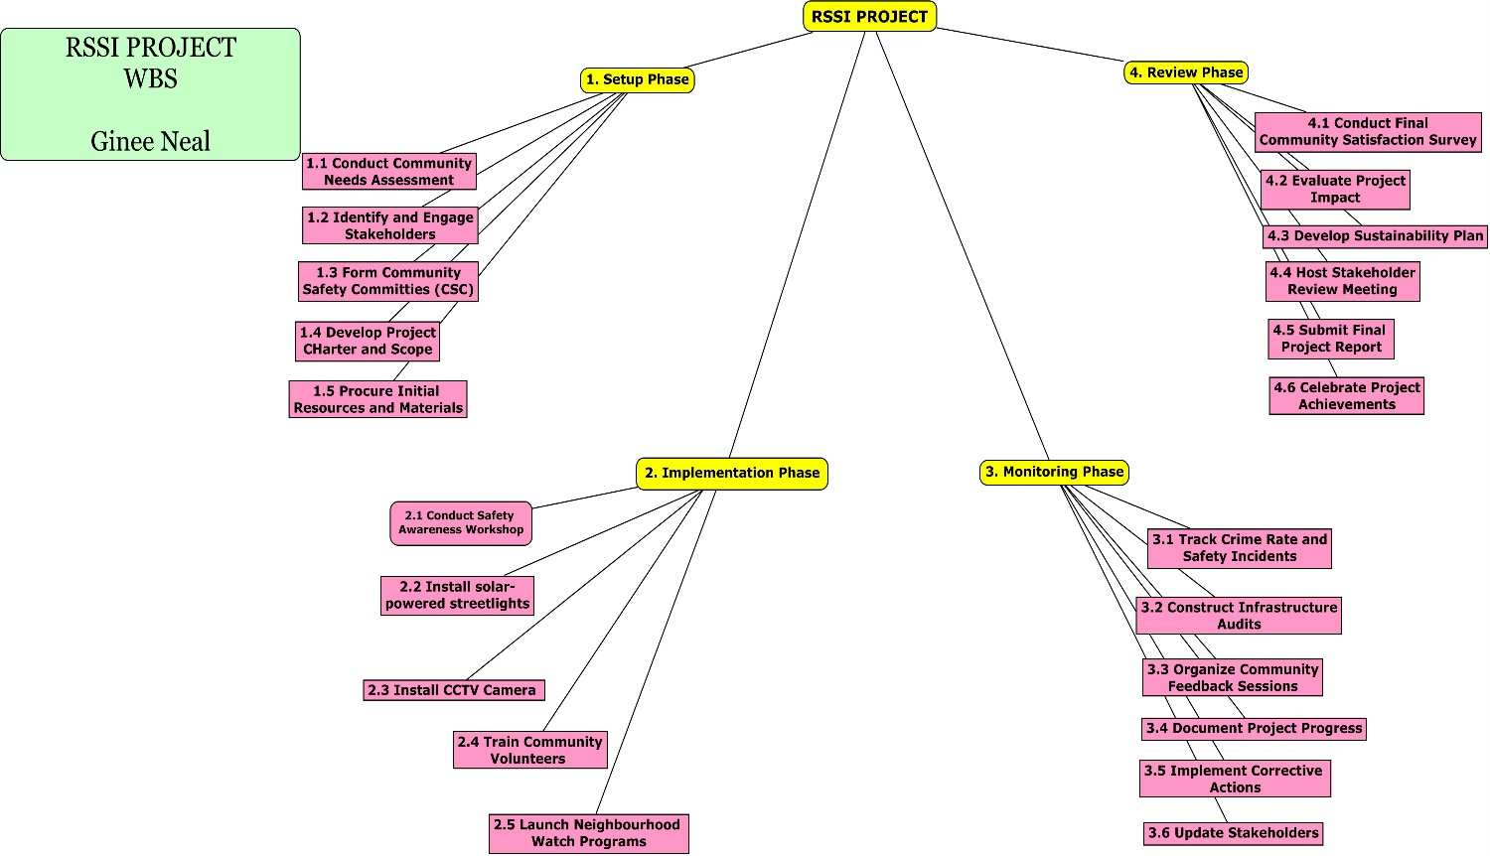
Figure 11 Methodological Framework: Work Breakdown Structure (WBS) for RSSI Project

(Source: The Author)
Note: This Work Breakdown Structure (WBS) represents the methodological framework for implementing the RSSI project. It organizes the project into distinct phases, Setup, Implementation, Monitoring, and Review each with clearly defined tasks. This structured approach ensures systematic planning, execution, and evaluation, aligning with the project’s goals for enhancing rural safety and security.

The WBS outlines the hierarchical decomposition of tasks for the Rural Safety and Security Initiatives (RSSI) project.
Rural Safety and Security Initiatives (RSSI)
1.1 Setup Phase
- 1.1.1 Conduct Community Needs Assessment
  - 1.1.1.1 Design and distribute surveys.
  - 1.1.1.2 Host town hall meetings.
  - 1.1.1.3 Compile and analyze findings.
- 1.1.2 Identify and Engage Stakeholders
  - 1.1.2.1 Create a stakeholder map.
  - 1.1.2.2 Conduct introductory meetings.
  - 1.1.2.3 Define stakeholder roles and responsibilities.
- 1.1.3 Form Community Safety Committees (CSCs)
  - 1.1.3.1 Recruit committee members.
  - 1.1.3.2 Define roles and responsibilities.
  - 1.1.3.3 Conduct orientation sessions.
- 1.1.4 Develop Project Charter and Scope
  - 1.1.4.1 Draft the project charter.
  - 1.1.4.2 Review with stakeholders.
  - 1.1.4.3 Finalize and approve.
- 1.1.5 Procure Initial Resources and Materials
  - 1.1.5.1 Identify and shortlist suppliers.
  - 1.1.5.2 Negotiate contracts.
  - 1.1.5.3 Ensure timely delivery.
2.1 Implementation Phase
- 2.1 Conduct Safety Awareness Workshops
  - 1.2.1.1 Develop training materials.
  - 1.2.1.2 Schedule sessions.
  - 1.2.1.3 Collect participant feedback.

- 1.2.2 Install Solar-Powered Streetlights
  - 1.2.2.1 Conduct site assessments.
  - 1.2.2.2 Procure lighting materials.
  - 1.2.2.3 Install and test functionality.
- 1.2.3 Install CCTV Cameras
  - 1.2.3.1 Survey locations for installation.
  - 1.2.3.2 Procure camera equipment.
  - 1.2.3.3 Install and configure systems.
- 1.2.4 Train Community Volunteers
  - 1.2.4.1 Develop training curriculum.
  - 1.2.4.2 Conduct practical training sessions.
  - 1.2.4.3 Issue completion certificates.
- 1.2.5 Launch Neighborhood Watch Programs
  - 1.2.5.1 Recruit and organize volunteers.
  - 1.2.5.2 Establish patrol schedules.
  - 1.2.5.3 Provide reporting tools.
3.1 Monitoring Phase
- 3.1 Track Crime Rate and Safety Incidents
  - 1.3.1.1 Collaborate with local law enforcement.
  - 1.3.1.2 Analyze monthly crime reports.
  - 1.3.1.3 Identify patterns and trends.

- 1.3.2 Conduct Infrastructure Audits
  - 1.3.2.1 Inspect streetlights and CCTVs.
  - 1.3.2.2 Document findings.
  - 1.3.2.3 Schedule repairs as needed.
- 1.3.3 Organize Community Feedback Sessions
  - 1.3.3.1 Schedule quarterly meetings.
  - 1.3.3.2 Facilitate discussions on project progress.
  - 1.3.3.3 Collect suggestions for improvement.
- 1.3.4 Document Project Progress
  - 1.3.4.1 Maintain weekly logs of activities.
  - 1.3.4.2 Prepare monthly progress reports.
  - 1.3.4.3 Share updates with stakeholders.
- 1.3.5 Implement Corrective Actions
  - 1.3.5.1 Identify issues requiring resolution.
  - 1.3.5.2 Develop action plans.
  - 1.3.5.3 Monitor implementation.
- 1.3.6 Update Stakeholders
  - 1.3.6.1 Distribute monthly updates.
  - 1.3.6.2 Host bi-monthly stakeholder meetings.
  - 1.3.6.3 Provide dashboards summarizing progress.
4.1 Review Phase
- 4.1 Conduct Final Community Satisfaction Survey
  - 1.4.1.1 Design the survey questionnaire.
  - 1.4.1.2 Distribute and collect responses.
  - 1.4.1.3 Analyze and compile findings.
- 1.4.2 Evaluate Project Impact
  - 1.4.2.1 Compare pre- and post-project crime statistics.
  - 1.4.2.2 Assess effectiveness of workshops and programs.
  - 1.4.2.3 Document lessons learned.
- 1.4.3 Develop Sustainability Plan
  - 1.4.3.1 Create maintenance schedules.
  - 1.4.3.2 Transition responsibilities to CSCs/local authorities.
  - 1.4.3.3 Secure funding for long-term activities.
- 1.4.4 Host Stakeholder Review Meeting
  - 1.4.4.1 Present final project results.
  - 1.4.4.2 Discuss recommendations for future projects.
  - 1.4.4.3 Document meeting outcomes.
- 1.4.5 Submit Final Project Report
  - 1.4.5.1 Compile all project data and activities.
  - 1.4.5.2 Highlight successes and challenges.
  - 1.4.5.3 Submit the final report to stakeholders.
- 1.4.6 Celebrate Project Achievements
  - 1.4.6.1 Plan a community celebration event.
  - 1.4.6.2 Recognize contributions with awards or certificates.
  - 1.4.6.3 Document event highlights.
Figure 12 Methodological Gantt Chart for RSSI Project Implementation

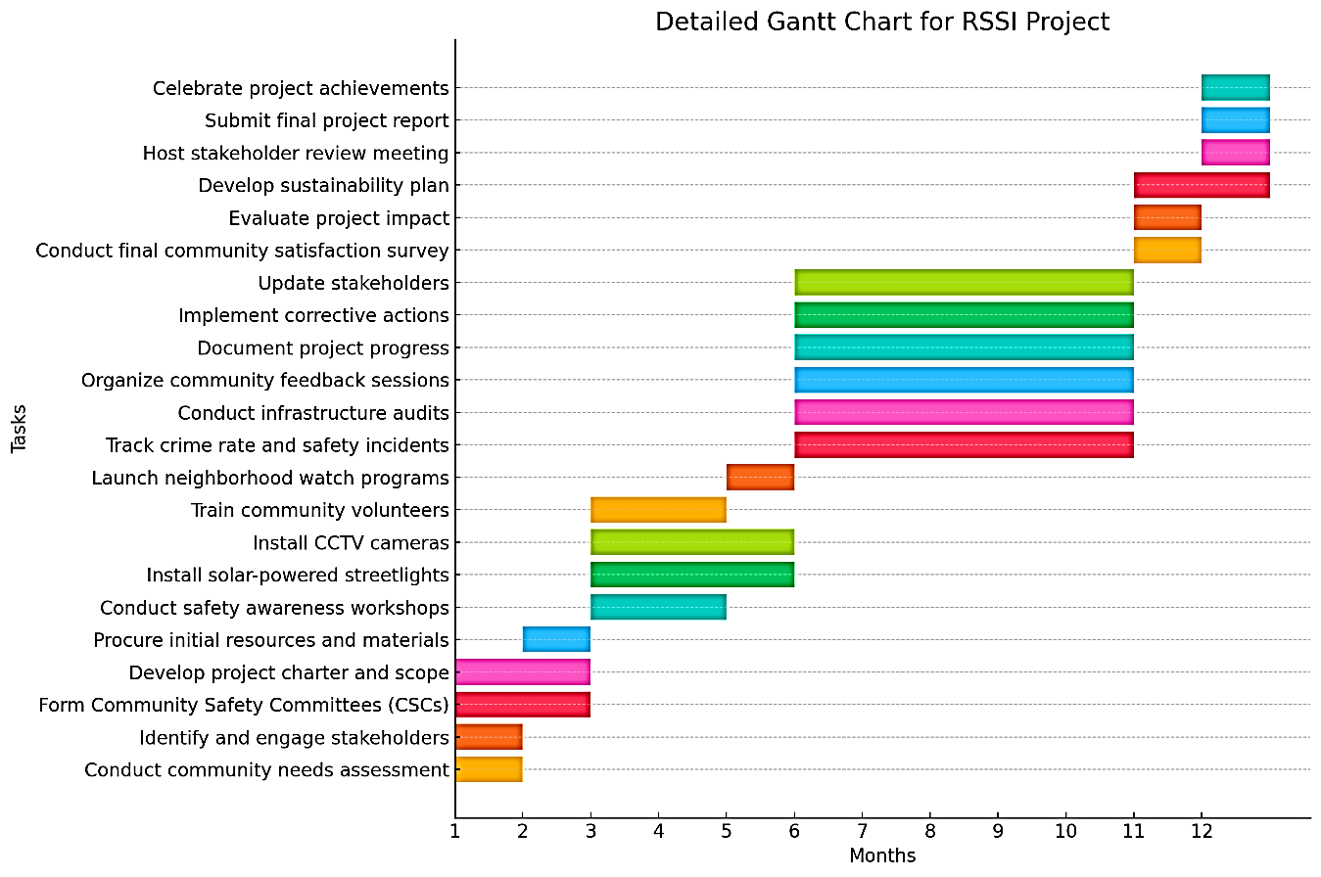
(Source: The Author)
Note: This Gantt chart provides a detailed timeline of the RSSI project's methodological framework, showcasing the sequence and duration of tasks across all phases: Setup, Implementation, Monitoring, and Review. It ensures clarity in task dependencies, efficient resource allocation, and structured project execution to achieve the initiative's safety and security objectives.

Chart 54 Detailed Gantt Chart Data for RSSI Project Implementation

(Source: The Author)
RSSI Gantt Chart Data
Task | Start Month | End Month
Conduct community needs assessment | 1 | 1
Identify and engage stakeholders | 1 | 1
Form Community Safety Committees (CSCs) | 1 | 2
Develop project charter and scope | 1 | 2
Procure initial resources and materials | 2 | 2
Conduct safety awareness workshops | 3 | 4
Install solar-powered streetlights | 3 | 5
Install CCTV cameras | 3 | 5
Train community volunteers | 3 | 4
Launch neighborhood watch programs | 5 | 5
Track crime rate and safety incidents | 6 | 10
Conduct infrastructure audits | 6 | 10
Organize community feedback sessions | 6 | 10
Document project progress | 6 | 10
Implement corrective actions | 6 | 10
Update stakeholders | 6 | 10
Conduct final community satisfaction survey | 11 | 11
Evaluate project impact | 11 | 11
Develop sustainability plan | 11 | 12
Host stakeholder review meeting | 12 | 12
Submit final project report | 12 | 12
Celebrate project achievements | 12 | 12
Note: This table provides the timeline for each task within the RSSI project, specifying start and end months. It offers a structured overview of project activities, from initial planning and resource allocation to implementation, monitoring, and final review. This detailed timeline ensures clarity in task scheduling and supports efficient project management to achieve the initiative’s goals.

Procure Initial Resources and Materials
Actions:
  - Identify suppliers for equipment (solar lights, CCTVs).
  - Negotiate contracts and purchase orders.
  - Ensure timely delivery of materials to project sites.
Responsible: Procurement Team.
Output: Resource Procurement Plan.
Resource Procurement Plan
Project Title: Rural Safety and Security Initiatives (RSSI)
Date: [Insert Date]
Prepared By: [Insert Preparer’s Name/Organization]
Objectives
- Identify all necessary resources (materials, services, equipment) for project implementation.
- Define procurement methods and timelines.
- Ensure compliance with procurement regulations and project budget.
- Establish clear roles and responsibilities for procurement activities.
Procurement Scope
The procurement plan covers the following resources required for the RSSI project:
Chart 55 Resource Allocation Details for RSSI Project

(Source: The Author)
Category | Item | Quantity | Purpose
Infrastructure | Solar-powered streetlights | 20 | Provide adequate lighting in high-crime areas
 | CCTV cameras | 10 | Enable surveillance and monitoring
Equipment | Communication devices (radios) | 10 | Facilitate neighborhood watch programs
 | Maintenance tools | 5 | Ensure upkeep of installed infrastructure
Training Materials | Training manuals | 50 | Educate community volunteers on safety measures
 | First aid kits | 10 | Provide emergency response capability
Services | Installation services (lighting, CCTV) | Contracted | Ensure proper setup of equipment
 | Training facilitators | Contracted | Deliver safety awareness and skill-building workshops
Note: This table outlines the resources required for the RSSI project, categorized into infrastructure, equipment, training materials, and services. It specifies the quantity and purpose of each item, ensuring that resources are effectively utilized to enhance safety, support community engagement, and maintain infrastructure across high-crime rural areas.

Procurement Process
Resource Identification
- Compile a comprehensive list of required materials, equipment, and services based on project needs.
- Validate the list with project stakeholders to ensure completeness.
Supplier Selection
- Identify potential suppliers for each resource category.
- Evaluate suppliers based on quality, cost, reliability, and delivery timelines.
Procurement Methods
Chart 56 Procurement Plan for RSSI Project Resources

(Source: The Author)
Item/Service | Procurement Method | Rationale
Solar-powered streetlights | Competitive bidding | Ensure cost-effectiveness and transparency
CCTV cameras | Direct purchases from verified suppliers | Expedite procurement for critical equipment
Communication devices | Request for Quotations (RFQs) | Gather multiple quotes for comparison
Training facilitators | Contract-based hiring | Leverage expertise for skill-building
Note: This table outlines the procurement methods for essential items and services required for the RSSI project. Each method, such as competitive bidding or RFQs, is chosen to ensure cost-effectiveness, transparency, and timely acquisition.

Timeline
Chart 57 Procurement Timeline for RSSI Project Resources

(Source: The Author)
Procurement Activity | Start Date | End Date | Duration
Resource identification | Month 1, Week 1 | Month 1, Week 2 | 1 week
Supplier selection | Month 1, Week 3 | Month 1, Week 4 | 2 weeks
Contracting and purchasing | Month 2, Week 1 | Month 2, Week 3 | 3 weeks
Resource delivery | Month 2, Week 4 | Month 3, Week 1 | 2 weeks
Note: This table outlines the timeline for key procurement activities in the RSSI project, from resource identification to delivery.

Roles and Responsibilities
Chart 58 Roles and Responsibilities in the RSSI Procurement Process

(Source: The Author)
Role | Responsibility
Project Manager | Oversee procurement activities and ensure alignment with project goals.
Procurement Officer | Manage supplier selection and purchasing processes.
Technical Team | Validate technical specifications of equipment.
Financial Officer | Monitor procurement expenditures to stay within budget.
Note: This table outlines the key roles and their responsibilities in the procurement process for the RSSI project. It ensures a coordinated approach to resource acquisition, with oversight, technical validation, financial monitoring, and alignment with project objectives to facilitate efficient and transparent procurement activities.

Risk Management
Chart 59 Procurement Risks and Mitigation Strategies for RSSI Projects

(Source: The Author)
Risk | Likelihood | Impact | Mitigation Strategy
Delayed resource delivery | Medium | High | Identify backup suppliers; expedite orders
Quality issues in materials | Low | Medium | Pre-qualify suppliers; inspect upon delivery
Cost overruns | Medium | High | Secure multiple quotes; enforce budget controls
Note: This table identifies potential risks in the procurement process for RSSI projects, evaluates their likelihood and impact, and outlines mitigation strategies.

Monitoring and Evaluation
- Maintain a procurement tracker to monitor order status, delivery timelines, and supplier performance.
- Inspect all received resources to ensure compliance with specified standards.
- Conduct post-procurement reviews to evaluate supplier performance and identify improvement opportunities.
Approval
This Resource Procurement Plan has been reviewed and approved by the following:
Chart 60 Procurement Approval Sign-Off Sheet for RSSI Projects

(Source: The Author)
Name | Position | Signature | Date
[Insert Name] | Project Manager
[Insert Name] | Procurement Officer
[Insert Name] | Financial Officer
Note: This sheet records the names, positions, signatures, and dates for key personnel involved in approving procurement activities for the RSSI project.

Implementation Phase (Month 3-5)
Chart 61 Implementation Tasks and Responsibilities for the RSSI Project

(Source: The Author)
Task | Duration | Responsible Entity
Conduct safety awareness workshops | 2 months | Trainers, Community Volunteers
Install solar-powered streetlights | 1.5 months | Technical Team
Install and configure CCTV cameras | 1.5 months | Technical Team
Train community members in safety protocols | 2 months | Trainers
Launch neighbourhood watch programs | 1 month | Community Safety Committees
Conduct conflict resolution training | 2 months | Trainers, External Experts
Note: This table outlines key implementation tasks for the RSSI project, detailing their duration and responsible entities.

Monitoring Phase (Months 6-10)
Chart 62 Monitoring and Reporting Activities for RSSI Projects

(Source: The Author)
Task | Duration | Responsible Entity
Track crime rate and safety incidents | Monthly | Local Law Enforcement
Conduct infrastructure audits | Bi-monthly | Technical Team, CSCs
Organize feedback sessions with the community. | Quarterly | Project Team, Community Leaders
Document project progress | Ongoing | Project Manager
Implement corrective actions for identified issues. | As Needed | Project Team, CSCs
Update stakeholders with progress reports. | Monthly | Project Manager
Note: This table outlines the key monitoring and reporting tasks for the RSSI projects, specifying their frequency and responsible entities.

Review Phase (Month 11-12)
Chart 63 Closure Phase Activities for RSSI Projects

(Source: The Author)
Task | Duration | Responsible Entity
Conduct final community satisfaction survey | 1 month | Project Team
Evaluate project impact (crime rate analysis, feedback) | 1 month | Data Analysts
Develop sustainability plan (handover to CSCs/local government) | 2 months | Project Team, Local Council
Host stakeholder review meeting | 2 weeks | Project Manager
Prepare and submit the final project report | 1 month | Project Manager
Celebrate project achievements with the community event | 1 week | Project Team, Community Leaders
Note This table outlines the key tasks during the closure phase of the RSSI projects, detailing their duration and responsible entities.

Risk Assessment:
  - Develop mitigation plans for identified risks, such as resistance to change or delays in procurement.
Execution Phase
- Community Awareness Campaigns:
  - Organize monthly town hall meetings to educate residents on safety practices.
  - Distribute flyers and radio PSAs tailored to rural contexts.
- Infrastructure Installation:
  - Install 20 solar-powered streetlights in high-crime areas.
  - Set up 5 CCTV cameras at key village entry and exit points.
  - Designate secure storage areas for farming tools and equipment.
- Training Programs:
  - Train 50 community volunteers in neighbourhood watch protocols.
  - Deliver first aid and conflict resolution training for CSC members.
- Implementation Oversight:
  - Assign project officers to supervise installations and coordinate training sessions.
  - Document progress through weekly reports.
Monitoring Phase
Monitoring Strategy:
- Establish baseline crime rates in target areas before project commencement.
- Define KPIs to track project success (e.g., crime rate reductions, community participation levels).
- Data Collection:
  - Monthly crime statistics from local police departments.
  - Feedback forms distributed during community meetings.
- Progress Evaluation:
  - Bi-weekly site visits to verify infrastructure installation and functionality.
  - Monthly CSC meetings to address challenges and gather updates.
- Documentation:
  - Maintain a centralized log of issues and resolutions.
  - Update the monitoring dashboard for real-time project tracking.
- 4. Evaluation Phase
Impact Analysis:
- Conduct a comparative analysis of crime statistics pre- and post-implementation.
- Evaluate the effectiveness of infrastructure improvements and training programs through surveys and interviews.
Sustainability Measures:
- Transition infrastructure maintenance responsibilities to CSCs and local governments.
- Secure additional partnerships to expand successful initiatives to other rural areas.
Key Activities:
- Final Survey:
  - Conduct surveys with 500 residents to assess perceived safety and satisfaction.
  - Measure participation and engagement levels in community programs.
- Stakeholder Reporting:
  - Present findings in a final project workshop with all stakeholders.
  - Publish a detailed project report outlining achievements, challenges, and recommendations.
- Closure and Handover:
  - Formalize handover of project deliverables to CSCs and local government units.
  - Celebrate successes with a community recognition event.
Project Timeline
Chart 64 Phased Timeline and Activities for RSSI Project Lifecycle

(Source: The Author)
Phase | Duration | Key Activities
Planning | Month 1-2 | Engagement, resource planning, timeline setup, risk assessment
Execution | Month 3-9 | Campaigns, installations, training
Monitoring | Month 3-11 | Data collection, progress tracking, issue resolution
Evaluation | Month 12 | Impact analysis, final reporting, closure
Note: This table outlines the four key phases of the RSSI project: Planning, Execution, Monitoring, and Evaluation, along with their durations and core activities.

Performance Metrics
Chart 65 Key Performance Indicators (KPIs) for RSSI Project Success

(Source: The Author)
KPI | Target | Measurement
Reduction in crime rates | 30% reduction in target areas | Police crime statistics
Community engagement | 70% participation in activities | Attendance records, surveys
Infrastructure functionality rate | 95% operational | Infrastructure audits
Community satisfaction | 80% positive feedback | Post-implementation survey results
Note: This table outlines the KPIs used to measure the success of the RSSI project, including targets and methods of measurement.
Risk Monitoring Plan for Rural Safety and Security Initiatives
A Risk Monitoring Plan is a systematic approach to tracking, assessing, and managing risks throughout the lifecycle of a project. For the Rural Safety and Security Initiatives (RSSI), this plan ensures the proactive identification of risks, the implementation of mitigation strategies, and the consistent evaluation of risk effectiveness. The goal is to minimize disruptions, optimize resource use, and ensure project success.
Developing a Project Management Strategic Methodology tailored to the unique challenges of rural safety and security initiatives offers a robust risk monitoring plan. This plan is a critical element of this methodology because it ensures the integration of knowledge areas and processes. Risk management is a core knowledge area in project management. By embedding a monitoring plan, the methodology ensures that risk management processes (identification, analysis, response planning, monitoring) are integrated into the RSSI project’s lifecycle.
Rural safety initiatives often face unpredictable challenges like limited infrastructure, stakeholder variability, and environmental conditions. A tailored risk monitoring plan provides a structured approach to managing these challenges. Therefore, continuous risk monitoring supplies actionable insights for decision-makers, ensuring that strategies remain adaptive and aligned with the dynamic nature of rural projects.
The methodology’s emphasis on risk monitoring creates a resilient project structure capable of mitigating disruptions such as delays in resource delivery, community resistance, or unexpected environmental factors. A documented approach to monitoring and managing risks builds trust among stakeholders, as it demonstrates preparedness and accountability.
Risk Monitoring Plan for Rural Safety and Security Initiatives
Project Title: Rural Safety and Security Initiatives (RSSI)
Date: [Insert Date]
Prepared By: [Your Name/Organization]
Risk Monitoring Approach
Key Activities:
- Establish a Risk Register:
Maintain a centralized log of identified risks, their status, and mitigation actions.
- Periodic Risk Reviews:
Conduct bi-weekly meetings to review risks and track the effectiveness of mitigation strategies.
- Key Performance Indicators (KPIs):
Use specific metrics to monitor risks, such as the frequency of issues or deviations from project timelines.
- Stakeholder Involvement:
Engage stakeholders in risk discussions to gather diverse perspectives and ensure transparency.
Risk Monitoring Framework
Chart 66 Risk Register for RSSI Project Management

(Source: The Author)
Risk  ID | Risk | Category | Owner | Monitoring Frequency | Key Metrics | Review Method
R001 | Lack of community participation | Stakeholder | Community Leaders | Monthly | Attendance at workshops, feedback rates | Surveys, Attendance Logs
R002 | Infrastructure failure | Technical | Technical Team | Monthly | Number of reported malfunctions | Infrastructure Audits
R003 | Funding shortfalls | Financial | Financial Officer | Quarterly | Budget variance, availability of resources | Financial Reports
R004 | Procurement delays | Operational | Procurement Manager | Weekly | Delivery timelines, supplier performance | Procurement Logs
R005 | Resistance to change | Social/Cultural | Engagement Officer | Monthly | Community feedback, participation trends | Focus Groups, community meetings
R006 | Weather disruptions | Environmental | Project Manager | Seasonal | Number of delays, adjustments to schedules | Progress Reports
Note: This table provides a detailed risk register for the RSSI project, including risk IDs, categories, owners, monitoring frequencies, key metrics, and review methods.
Monitoring Processes
Risk Identification and Logging
- Use ongoing activities (e.g., workshops, audits) to identify emerging risks.
- Document new risks in the Risk Register with details on likelihood, impact, and potential mitigation strategies.
Risk Assessment
- Evaluate each risk based on:
  - Likelihood: Probability of the risk occurring (Low, Medium, High).
  - Impact: Degree of disruption caused if the risk materializes (Low, Medium, High).
- Prioritize risks using a Risk Matrix (e.g., high likelihood and high impact risks receive immediate attention).
Risk Escalation
- High-priority risks are escalated to project stakeholders for expedited resolution.
- Assign additional resources or adjust timelines if necessary.
Tools and Templates
Risk Register Template:
Chart 67 Risk Assessment and Mitigation Plan for RSSI Projects

(Source: The Author)
Risk ID | Risk | Category | Likelihood | Impact | Mitigation Plan | Status
R001 | Lack of community participation | Stakeholder | Medium | High | Awareness campaigns | Monitoring
R002 | Infrastructure failure | Technical | Low | High | Regular maintenance | Ongoing
R003 | Funding shortfalls | Financial | Low | Medium | Secure additional funding sources | Resolved
Note: This table outlines identified risks for the RSSI project, categorizing them by likelihood, impact, and associated mitigation plans.
Risk Dashboard:
- Use visual tools (e.g., bar charts, traffic-light indicators) to summarize risk statuses and trends over time.
Issue Log Template:
Chart 68 Issue Log for RSSI Project Management

(Source: The Author)
Issue ID | Description | Category | Raised By | Action Taken | Status
I001 | Low workshop attendance | Stakeholder | Community Leader | Conduct additional outreach | Resolved
I002 | Delay in camera installations | Technical | Technical Team | Adjusted timeline, added resources | Ongoing
Note: This table tracks project-related issues, categorizing them by description and source, along with the actions taken and their current status.
Communication Plan
Stakeholder Updates:
- Share risk updates with stakeholders during monthly progress meetings.
- Provide a summary of high-priority risks, mitigation progress, and emerging concerns.
Reporting Frequency:
- Weekly: Internal team updates focusing on immediate risks.
- Monthly: Stakeholder risk review reports summarizing overall status.
Methods:
- Reports: Share detailed risk summaries using risk dashboards.
- Meetings: Use bi-weekly discussions to focus on critical risks and mitigation progress.
- Alerts: Immediate notification to stakeholders for escalated risks.
Evaluation Metrics
Chart 69 Risk Management Metrics for RSSI Projects

(Source: The Author)
Metric | Target | Frequency
Number of unresolved risks | <5 active risks | Weekly
Time taken to resolve high-priority risks | <2 weeks | Monthly
Percentage of successful mitigations | >90% of risks mitigated | Quarterly
Budget variance caused by risks | <5% of project budget | Quarterly
Note: This table outlines key metrics for evaluating the effectiveness of risk management in the RSSI project.
Continuous Improvement
- Use lessons learned from resolved risks to update mitigation strategies.
- Conduct post-project risk reviews to identify trends and recommend process improvements for future projects.

4.5 To Determine the Necessity and Structure of a Project Management Office (PMO) to Oversee and Support the Execution of Safety and Security Projects, Ensuring Consistency and Quality in Project Management Practices.
To successfully execute safety and security initiatives in rural areas requires a structured and consistent approach to project management. Rural projects, such as those focused on safety and security, often face unique challenges, including limited resources, geographic dispersion, and diverse stakeholder needs. In this context, establishing a Project Management Office is not merely an organizational enhancement but a necessity for ensuring project consistency, quality, and sustainability.
A PMO serves as the centralized entity that provides oversight, support, and guidance to project teams. It standardizes methodologies, optimizes resource utilization, and ensures alignment with strategic goals. For rural safety and security projects, the importance of the PMO lies in its ability to mitigate the risks inherent to these complex undertakings and foster collaboration among diverse stakeholders.
The critical nature of safety and security initiatives, which aim to improve the well-being of vulnerable communities, amplifies the need for the PMO. This project demands meticulous planning, efficient execution, and continuous monitoring to achieve the intended outcomes. Providing a structured framework, a PMO ensures that every aspect of project management, from scope definition to risk management, is addressed systematically.
This section explores the necessity and structure of the PMO tailored to the unique requirements of rural safety and security initiatives. It emphasizes the vital role of a PMO in enhancing consistency, improving project outcomes, and supporting the overarching goals of safety and security in rural contexts. This analysis lays the foundation for integrating the PMO into the strategic methodology that governs these critical projects.
PMO Structure
The Leadership and Governance framework within a Project Management Office is pivotal for maintaining strategic alignment and enabling effective decision-making across projects. This structure ensures that the PMO operates as a cohesive entity, driving consistency and quality in project management practices.
The PMO Director serves as the central leader, overseeing all PMO activities and ensuring that they align with the organization’s overarching goals, particularly regarding safety and security objectives. By managing resources, setting priorities, and monitoring performance, the director ensures that the PMO delivers value, achieves strategic outcomes, and supports organizational success.
This governance model clarifies decision-making, enhances accountability, and fosters collaboration among stakeholders. It ensures that every project under the PMO’s purview contributes meaningfully to the organization’s mission. It establishes a robust foundation for the PMO to address challenges, mitigate risks, and drive impactful results in a structured and efficient manner.
This ensures strategic alignment and decision-making authority within the PMO.
- PMO Director:
  - Oversees the PMO’s operations, ensuring alignment with organizational goals and safety/security objectives.
  - Reports progress and challenges to the Ministry of Home Affairs and New Growth Industries.
- Program Managers:
  - Lead specific program portfolios within the RSSI, such as community safety initiatives, infrastructure deployment (e.g., streetlights and CCTVs), and training programs.
Core Functional Areas
The PMO is divided into specialized units or functional areas, each focusing on critical aspects of project execution. The core functional areas of the PMO work in harmony to ensure effective project management. From detailed planning and proactive risk management to stakeholder collaboration, performance evaluation, and skill development, these units collectively drive project success.
Planning and Scheduling Unit
This unit provides the foundation for project execution by developing detailed project plans, timelines, and work breakdown structures. It manages the master schedule, ensuring that tasks are completed on time and resources are efficiently allocated. This unit coordinates task dependencies, and the unit keeps projects on track and aligned with organizational goals.
Risk and Compliance Unit
Focused on minimizing uncertainties, this unit identifies potential risks during project planning and monitors them throughout execution. It ensures adherence to safety, regulatory, and environmental standards, and oversees the development and implementation of risk mitigation strategies. This proactive approach reduces disruptions and safeguards project outcomes.
Stakeholder Engagement Unit
This unit bridges the gap between project teams and stakeholders, fostering collaboration and alignment. They facilitate town hall meetings, workshops, and feedback sessions, and it ensures open communication and addresses conflicts. This process promotes stakeholder trust, alignment with project goals, and a sense of shared ownership in outcomes.
Monitoring and Evaluation Unit
Dedicated to performance tracking, this unit measures project progress using key metrics such as timelines, budget adherence, and safety outcomes. Regular site visits and audits assess the quality and effectiveness of project activities, while comprehensive reports keep stakeholders informed and engaged.
Knowledge and Training Unit
This unit supports continuous improvement by capturing lessons learned from completed projects and integrating them into future efforts. It develops and distributes training materials, organizes capacity-building programs, and enhances the skills of community members, volunteers, and staff. This focus on knowledge-sharing ensures sustained project success.
Tools and Technology
The Project Management Office utilizes modern tools and technologies to enhance operational efficiency, improve decision-making, and streamline project execution. These tools provide the PMO with the capability to manage tasks, track performance, and facilitate effective communication, ensuring that projects are delivered on time and within scope.
- Project Management Software:
  - Tools like Microsoft Project, Asana, and Trello help organize and monitor tasks, manage timelines, and allocate resources efficiently. They provide a centralized platform for teams to collaborate and stay aligned with project objectives.
- Data Analytics Tools:
  - These tools are instrumental in tracking key performance indicators (KPIs), identifying trends, and analysing project outcomes. They enable the PMO to make data-driven decisions, ensuring transparency and accountability.
- Reporting Dashboards:
  - Dashboards offer real-time visualizations of project performance, including timelines, budgets, and progress metrics. By consolidating data into an easily digestible format, dashboards empower stakeholders with up-to-date insights into project health.
- Communication Platforms:
  - Platforms such as Slack, Microsoft Teams, or traditional email ensure seamless collaboration among internal teams and external stakeholders. These tools support instant messaging, file sharing, and virtual meetings, fostering effective communication across geographically dispersed teams.
Implementation Steps
The implementation of a PMO is structured into four phased steps to ensure scalability, effectiveness, and alignment with project goals. Each phase builds upon the previous one, creating a solid foundation for the PMO to support and enhance the execution of Rural Safety and Security Initiatives (RSSI).
Phase 1: Needs Assessment and Design
The first phase focuses on understanding the unique challenges of the RSSI projects and identifying the specific requirements of the PMO. Key activities include defining the roles, responsibilities, and Standard Operating Procedures (SOPs) that will guide the PMO’s operations. This step ensures that the PMO is tailored to the project's objectives and context.
Phase 2: Staffing and Onboarding
The next phase involves recruiting experienced personnel for key PMO roles. This includes onboarding team members and providing initial training to familiarize them with the project’s goals, methodologies, and tools. This phase ensures that the PMO is equipped with skilled professionals ready to execute its mandate effectively.
Phase 3: Pilot Testing
To validate the PMO’s structure and processes, a pilot phase is conducted on a smaller scale. This phase tests the effectiveness of the PMO framework and identifies any gaps or areas for improvement. The feedback and insights gained during this phase are used to refine processes before full-scale implementation.
Phase 4: Full-Scale Implementation
In the final phase, the PMO is rolled out across all RSSI projects. Continuous monitoring and periodic reviews are conducted to ensure the PMO’s processes remain efficient and aligned with project objectives. This phase marks the full integration of the PMO into the project management ecosystem, enabling consistent and high-quality project execution.
The phased implementation approach ensures that the PMO is established systematically and effectively.
PMO Workflow
The PMO Workflow outlines how the Project Management Office integrates with and supports the RSSI project lifecycle, ensuring structured and efficient project execution. The workflow is divided into five stages, each playing a critical role in managing and delivering project outcomes.
1. Initiation
In this initial stage, the PMO establishes the foundation for the project by defining its scope and objectives. Stakeholder alignment meetings are conducted to ensure that all parties understand and agree on the project goals, fostering collaboration and shared ownership from the outset.
2. Planning
The Planning stage is where the project blueprint is created. The Planning and Risk Units develop detailed schedules and risk registers, identifying and mitigating potential challenges early. Resource allocation is finalized, ensuring that teams have the necessary tools, personnel, and materials to execute the project successfully.
3. Execution
During execution, the PMO actively oversees the implementation of project tasks. The Monitoring and Evaluation Unit tracks progress, ensuring adherence to timelines and deliverables. Simultaneously, the Stakeholder Engagement Unit facilitates ongoing communication and collaboration among all project participants, addressing concerns and maintaining alignment.
4. Monitoring and Controlling
This stage focuses on performance tracking and issue resolution. The PMO uses predefined metrics to measure project progress and identify deviations from the plan. Any issues or risks that arise are escalated to the PMO Director for timely resolution, ensuring that the project remains on track.
5. Closure
The final stage ensures proper project closure and knowledge transfer. Lessons learned are documented by the Knowledge and Training Unit, providing valuable insights for future projects. Final reports summarizing outcomes, challenges, and recommendations are delivered to stakeholders, ensuring transparency and accountability.
Organizational Chart
The PMO is designed with a hierarchical structure emphasizing clear roles, responsibilities, and relationships to support effective project management. This structure is tailored to address the unique needs of rural safety and security initiatives, ensuring that projects are executed with consistency, quality, and alignment to organizational objectives.
The PMO’s tailored structure addresses the specific needs of rural safety initiatives by integrating best practices, fostering adaptability, and promoting knowledge sharing. Serving as a strategic hub for project management, the PMO not only drives operational efficiency but also establishes a foundation for continuous improvement and long-term success.
Determining the necessity and structure of a PMO is a vital step toward achieving excellence in project management practices. Its implementation not only supports the seamless execution of safety and security projects but also positions the organization to respond proactively to future challenges, ensuring a safer and more secure environment for all stakeholders.

4.6 To propose an implementation plan to apply the project management framework and methodology as well as the PMO in the Ministry of Home Affairs and New Growth Industries.
Proposal for Implementing the Project Management Framework and Methodology Alongside a PMO in the Ministry of Home Affairs and New Growth Industries
This proposal outlines a comprehensive plan for implementing a Conceptual Project Management Framework and establishing a Project Management Office (PMO) within the Ministry of Home Affairs and New Growth Industries. This initiative is designed to improve the execution, monitoring, and outcomes of safety and security projects, ensuring alignment with strategic goals and delivering measurable results.
The Ministry of Home Affairs and New Growth Industries has identified the need for a structured approach to managing safety and security initiatives, particularly in addressing the complexities of rural and urban challenges. A Project Management Office will provide the necessary oversight, standardization, and coordination required to ensure the successful delivery of these critical projects. This document presents the objectives, approach, structure, and implementation plan for achieving this transformation.
The primary objective is to establish a robust framework and PMO that:
- Provides a structured methodology for managing safety and security projects.
- Ensures alignment of project goals with organizational objectives.
- Standardizes processes across projects for consistency and quality.
- Enhances resource utilization and stakeholder engagement.
- Delivers projects on time and within budget while achieving intended outcomes.
The implementation will follow a phased approach:
Phase 1: Needs Assessment and Design (Months 1-2) The initial phase will focus on understanding the current project management challenges and defining the specific requirements of the PMO. A detailed needs assessment will identify gaps and opportunities for improvement. Key deliverables will include a draft PMO structure and the development of Standard Operating Procedures (SOPs).
Phase 2: Establishing the PMO (Months 3-4) This phase involves recruiting skilled personnel for key PMO roles, such as the PMO Director and unit leads. Infrastructure, including office space and digital tools, will be set up. Comprehensive training programs will be conducted to equip the team with the knowledge and skills required to execute the framework.
Phase 3: Pilot Testing (Months 5-6) A pilot project will be selected to test the PMO’s processes and methodologies. This allows the Ministry to validate the effectiveness of the framework and make necessary adjustments. The findings will refine the PMO’s operations and ensure readiness for full-scale implementation.
Phase 4: Full-Scale Implementation (Months 7-12) The final phase involves rolling out the PMO and framework across all safety and security projects within the Ministry. Continuous monitoring and evaluation will ensure the effectiveness of the PMO and allow for incremental improvements. Quarterly performance reports will provide transparency and accountability to stakeholders.
The PMO structure will include specialized units:
- Planning and Scheduling Unit:
  - Develops detailed project plans, timelines, and work breakdown structures.
  - Coordinates resource allocation and manages interdependencies between tasks.
- Risk and Compliance Unit:
  - Identifies, monitors, and mitigates risks.
  - Ensures compliance with regulatory and environmental standards.
- Monitoring and Evaluation Unit:
  - Tracks performance metrics such as timelines, budget adherence, and project outcomes.
  - Provides regular progress reports to stakeholders.
- Stakeholder Engagement Unit:
  - Facilitates communication and collaboration with stakeholders, including community leaders and law enforcement agencies.
  - Resolves conflicts and ensures alignment with project goals.
- Knowledge and Training Unit:
  - Captures lessons learned and integrates them into future projects.
  - Organizes capacity-building programs for staff and community members.
To ensure effective implementation, the Ministry will support a change management strategy to address potential resistance, engage stakeholders, and prioritize high-impact areas. Performance metrics such as project completion rates, community resilience, and stakeholder satisfaction will be monitored to measure success.
Implementation Timeline
Chart 70 Phased Implementation Plan for Establishing the PMO in RSSI Projects

(Source: The Author)
Phase | Duration | Key Activities | Deliverables
Needs Assessment and Design | Month 1 - Month 2 | Conduct assessment, define roles, and draft SOPs | Needs assessment report, PMO structure
Establishing the PMO | Month 3 - Month 4 | Recruit staff, set up infrastructure, provide training | Fully staffed and operational PMO
Pilot Testing | Month 5 - Month 6 | Test PMO framework on a pilot project, refine processes | Pilot project report, refined framework
Full-Scale Implementation | Month 7 - Month 12 | Roll out PMO across all projects, monitor and evaluate performance | Operational PMO, quarterly reports
Note: This table outlines the phased approach to establishing the Project Management Office (PMO) for RSSI projects.

The Ministry of Home Affairs and New Growth Industries will ensure the successful establishment of the PMO and the effective application of the Project Management Framework. This initiative represents a strategic step forward in improving project management practices, fostering collaboration, and delivering impactful results for safety and security initiatives.

CONCLUSIONS
The implementation of the methodology and Project Management Framework and PMO directly addresses the general and specific objectives of the project. This has resulted in a comprehensive framework that integrates governance, stakeholder engagement, resource allocation, risk management, and performance measurement. This conclusion provides an overall assessment of the document, ensuring alignment with the specific objectives of the project. By aligning rural safety and security initiatives with structured project management practices, the Ministry of Home Affairs and New Growth Industries ensures that its strategic vision is realized, enhancing community safety and fostering sustainable development.
- A detailed assessment of the rural safety and security landscape in Belize revealed critical challenges, including limited law enforcement coverage, inadequate infrastructure, and lack of structured governance. The diagnostic phase provided essential insights into the specific needs of rural communities, allowing for the development of targeted interventions that align with national security objectives.
These insights informed the development of structured governance models, enhanced stakeholder engagement strategies, and technology-driven solutions to effectively address rural safety concerns.
- project management maturity assessment within the Ministry of Home Affairs and New Growth Industries highlighted inconsistencies in project execution, resource management, and monitoring processes. The findings demonstrated the need for a more structured, standardized approach to project implementation to enhance efficiency and sustainability. The adoption of a tailored project management framework and the establishment of the PMO have strengthened institutional capacity. These tools ensure that projects are executed with precision, fostering efficiency, accountability, and transparency. This advancement provides a robust foundation for managing future safety and security initiatives, addressing both current and emerging challenges.
- This study's conceptual project management framework offers a structured approach to planning, executing, monitoring, and evaluating rural safety projects. The framework integrates best practices in governance, stakeholder engagement, risk management, and resource allocation, ensuring a more systematic approach to improving rural security. The phased approach to implementation sets the stage for scalability and replicability. The success of this framework within the safety and security sector serves as a benchmark, paving the way for similar methodologies to be applied across other ministries and sectors, reinforcing Belize’s commitment to innovation and sustainable growth.
- A project management methodology tailored to rural safety projects was established, incorporating key knowledge areas such as governance, stakeholder engagement, risk management, and performance measurement. The methodology ensures alignment with national policies while addressing the unique challenges of rural environments, such as infrastructure limitations and resource constraints.
- The findings confirmed the necessity of a PMO to provide oversight, structure, and strategic direction for RSSI projects. A dedicated PMO ensures consistency in project execution, enhances accountability, and promotes the institutionalization of best practices. The proposed PMO structure includes defined roles, reporting lines, and decision-making processes to ensure efficiency.
- A phased implementation plan was developed to support the structured adoption of the project management framework and PMO. The plan outlines key steps, including governance establishment, stakeholder training, resource optimization, and continuous evaluation. This structured rollout approach ensures that rural safety initiatives are implemented effectively and sustainably.
- Implementing the Project Management Framework and PMO directly addresses the general and specific objectives of the project. By aligning rural safety and security initiatives with structured project management practices, the Ministry of Home Affairs and New Growth Industries ensures that its strategic vision is realized, enhancing community safety and fostering sustainable development. The PMO is the central authority ensuring that policies, reporting mechanisms, and decision-making structures align with national security goals. Introducing governance policies and escalation procedures ensures that project risks and challenges are addressed efficiently.
- Adopting a tailored project management framework and establishing the PMO has strengthened institutional capacity. These tools ensure that projects are executed with precision, fostering efficiency, accountability, and transparency. This advancement provides a robust foundation for managing future safety and security initiatives, addressing both current and emerging challenges. Active participation from community members, law enforcement agencies, government officials, and NGOs is essential for project success. The stakeholder engagement strategy ensures that communities feel included in safety initiatives and that their concerns are incorporated into project decisions. Regular town hall meetings, feedback loops, and collaboration with local councils help to build trust and long-term sustainability.
- The focus on community engagement, resource optimization, and standardized methodologies ensures long-term impact. The PMO's ability to coordinate stakeholders and integrate feedback mechanisms promotes projects that are not only effective but also resonate with community needs, creating a safer and more cohesive environment. The risk management plan includes a detailed risk register, mitigation strategies, and contingency measures to minimize disruptions. Scenario planning exercises and risk assessment tools ensure that potential challenges are identified early and managed effectively. Adopting Key Performance Indicators (KPIs) allows project managers to track progress, assess the impact of interventions, and adjust strategies as needed.
- This initiative represents a leap forward in project management innovation within the Ministry. The conceptual framework and PMO provide a replicable model for addressing the complexities of rural and urban safety projects, ensuring that the Ministry remains adaptive, proactive, and effective in achieving its goals. The structured project management methodology developed for RSSI incorporates best practices in planning, execution, monitoring, and evaluation. The methodology ensures that each phase contributes to overarching security goals by aligning project activities with defined objectives. The methodology also allows flexibility in adapting to changing rural security needs, ensuring the long-term sustainability of rural safety initiatives.

RECOMMENDATIONS
- The Ministry of Home Affairs and New Growth Industries, Ministry of Rural Transformation and Community Development, Belize Police Department, Project Managers can establish and operationalize a centralized PMO. Prioritize the establishment of a centralized Project Management Office to oversee rural safety and security initiatives. The PMO should focus on standardizing processes, improving governance, and fostering inter-agency collaboration to ensure consistency in project execution and alignment with national safety priorities.
- The Ministry of Home Affairs and New Growth Industries, Project Managers, Community Leaders, Ministry of Rural Transformation, Community Development, and the Belize Police Department can enhance stakeholder collaboration and community engagement by utilizing a robust stakeholder engagement plan that integrates community feedback, fosters trust, and builds partnerships with village leaders, NGOs, and law enforcement. Conduct regular town hall meetings, surveys, and focus groups to ensure the initiatives resonate with community needs and culture. Creating standard operating procedures (SOPs), templates, and workflows for planning, execution, monitoring, and evaluation.
- For Integrating Advanced Risk Management Practices, MHANGI, Project Managers, Belize Police Department, Risk Analysts, can work together to develop a comprehensive risk management framework to identify, monitor, and mitigate risks associated with safety initiatives. Utilize tools such as GIS, risk dashboards, and escalation protocols to address high-priority issues effectively. Conduct post-project reviews to update risk management strategies.
- Implement Technology Driven Solutions: MHANGI, Ministry of E-Governance, Belize Police Department, IT Specialists can leverage modern technologies like GIS for crime mapping, mobile applications for real-time incident reporting, and advanced analytics for monitoring project performance. Develop user-friendly tools for law enforcement and community members to enhance real-time response and data-driven decision-making.
- Develop Capacity-Building Programs Knowledge and Training Unit, MHANGI, Ministry of Public Service, Training Institutions, Belize Police Department can establish ongoing training programs for law enforcement officers, community leaders, and PMO staff. Focus on areas such as community policing, project management best practices, and use of advanced technologies. These programs should be adaptive and updated regularly to reflect emerging trends and tools.
- Strengthen Monitoring and Evaluation Mechanisms, MHANGI, Government Auditors, Project Managers can work together to create a rigorous monitoring and evaluation framework to assess project outcomes against key performance indicators (KPIs) such as crime reduction rates, community satisfaction, and resource utilization. Publish quarterly and annual performance reports to maintain transparency and accountability.
- Adopt Regenerative and Sustainable Development Practices, MHANGI, Ministry of Sustainable Development, Ministry of Energy, Private Sector Investors can align safety and security projects with principles of regenerative and sustainable development. Focus on reducing the environmental footprint of safety measures by utilizing renewable energy for infrastructure and ensuring that initiatives contribute positively to economic and social resilience.
- Expand the Conceptual Framework Across Sectors, Government of Belize, MHANGI, Ministry of Education, Ministry of Health can appeal framework to other critical sectors such as healthcare and education to maximize its impact. This scalability will ensure the framework remains a cornerstone for national development initiatives beyond safety and security.
- Establish a Sustainable Funding Mechanism, Government of Belize, International Development Partners, Private Sector Investors can create a safety and security initiatives by exploring partnerships with international organizations, NGOs, and private sector stakeholders. This approach will ensure long-term financial sustainability.
- Perform Regular Governance Reviews, MHANGI, Project Managers, Government Oversight Agencies can conduct quarterly and annual governance reviews to ensure fine processes, and integrate lessons learned. This will strengthen the alignment between project execution and strategic goals.

VALIDATION OF THE FGP IN THE FIELD OF REGENERATIVE AND SUSTAINABLE DEVELOPMENT
As we grapple with the consequences of environmental degradation in the 21st century, there is an increasing need for innovative approaches that address immediate challenges and promote long-term sustainability. Developing a conceptual framework for Rural Safety and Security Initiatives in Belize embodies this ethos by aiming to enhance community safety while fostering regenerative and sustainable development principles.
Regenerative development focuses on restoring, renewing, and revitalizing sources of energy and materials, going beyond sustainability to create a net positive impact on the environment and society. On the other hand, sustainable development ensures that the needs of the present are met without compromising the ability of future generations to meet their own needs. This project integrates both concepts by emphasizing safety and security as foundational elements for the sustainable growth of rural communities in Belize.
Implementing the RSSI framework is expected to contribute positively to several aspects of sustainable development. By improving the safety and security of rural areas, the framework supports the economic stability of these communities, making them more attractive for investment and development. This aligns with the Sustainable Development Goals (SDGs), particularly SDG 11, which focuses on making cities and human settlements inclusive, safe, resilient, and sustainable. SDG 16 aims to promote peaceful and inclusive societies.
However, like any project, the RSSI framework has potential environmental, social, and economic impacts. To address these, a P5 Impact Analysis has been conducted. This analysis evaluates the project’s effects on product, process, people (social impacts), planet (environmental impacts), and prosperity (economic impacts), providing a comprehensive view of how the project aligns with regenerative and sustainable development principles.
Figure 13 P5 Impact Analysis

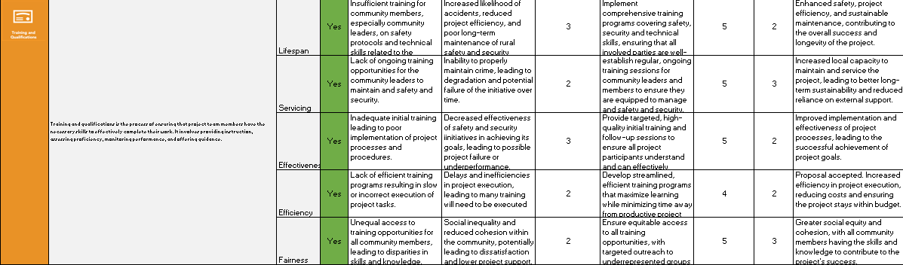
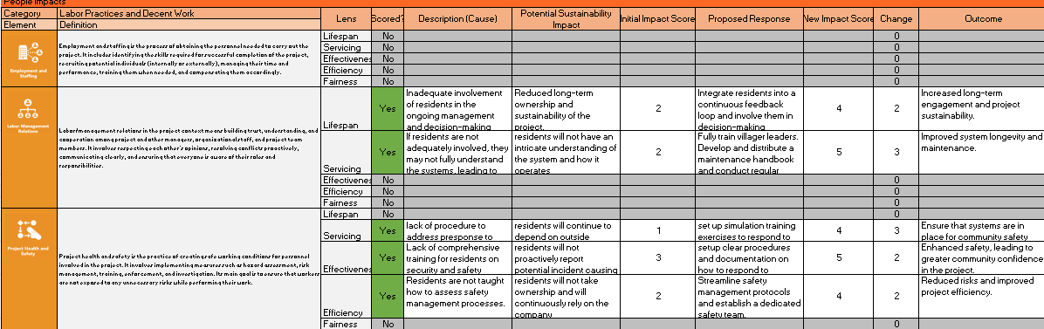
(Source: The Author)

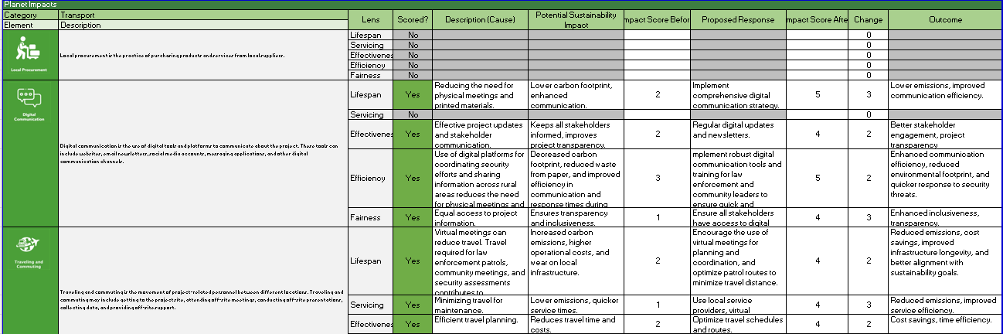
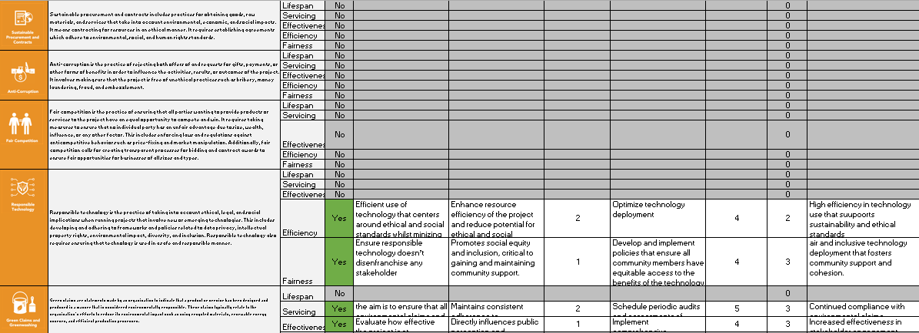
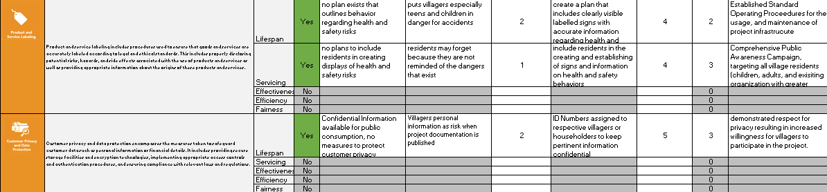
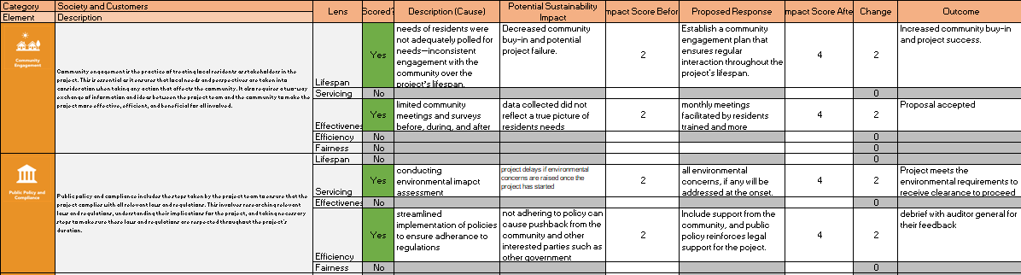
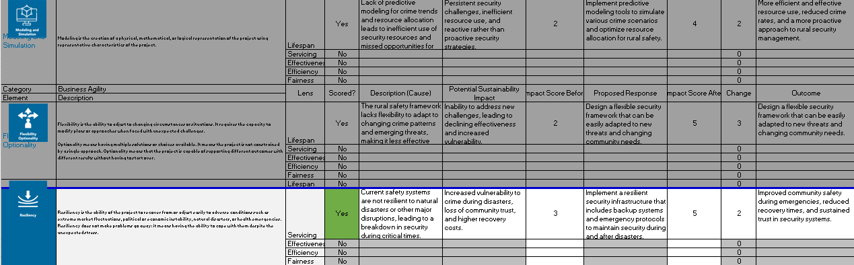
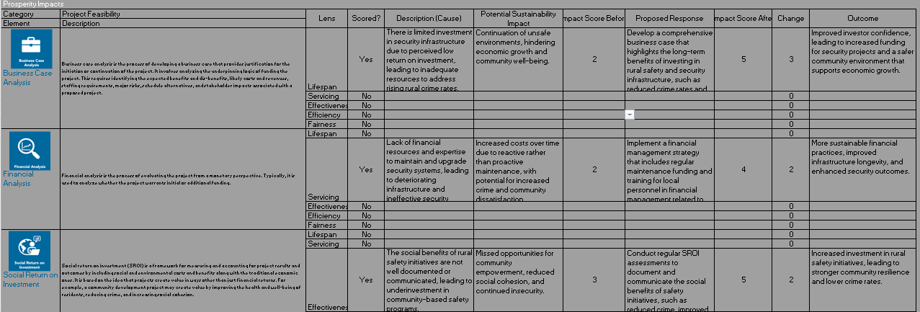
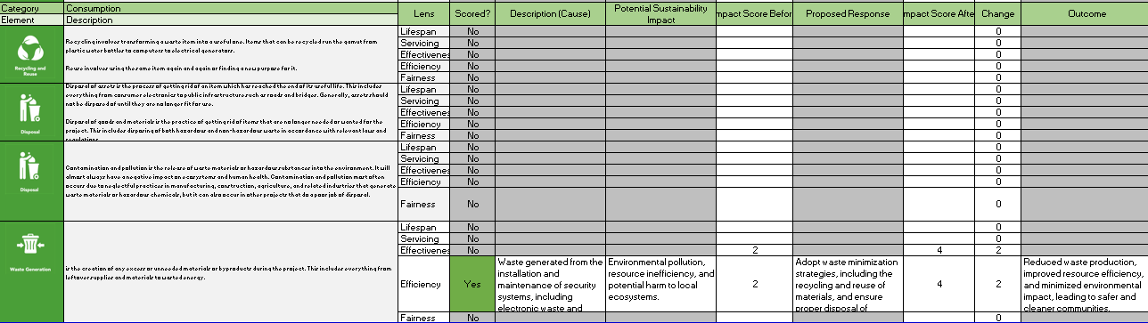
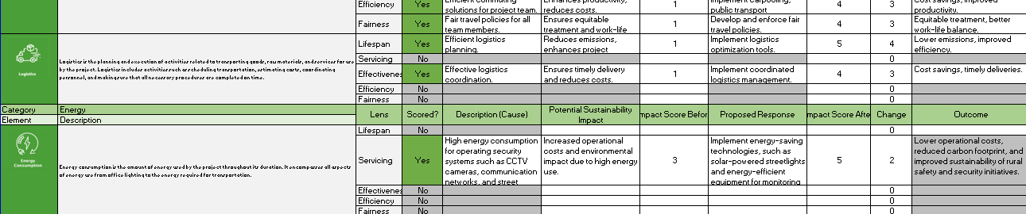
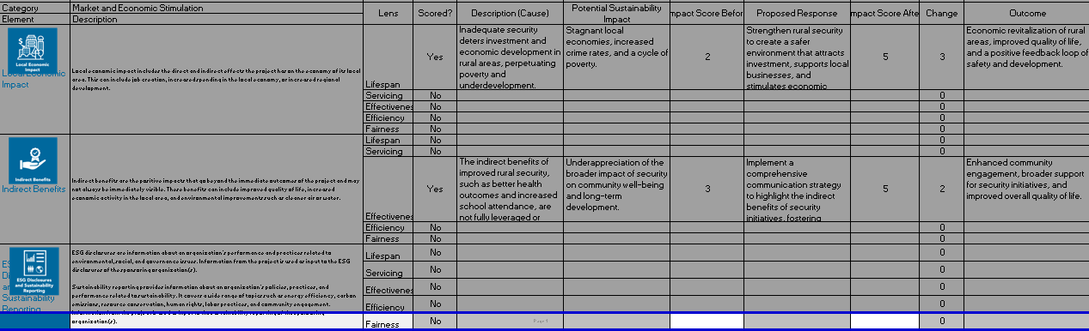
Note: These prosperity impacts are aligned with the goals of developing a sustainable and practical framework for rural safety and security in Belize. They focus on ensuring the initiative addresses immediate security concerns and supports long-term economic and social development.

For the people, the project will positively impact the well-being of rural populations by enhancing safety and security, which are crucial for social stability and quality of life. The framework will incorporate environmental considerations for the planet, ensuring that safety and security measures do not harm the environment. For instance, using technology like GIS can help optimize resource use and reduce environmental degradation. To create a secure environment, the project will indirectly contribute to economic prosperity in rural areas, as businesses and individuals will feel more confident in investing and engaging in economic activities.
The process and project management processes will be designed to align with best sustainability practices, ensuring efficient implementation and minimal waste. The final product, a conceptual framework, and the established PMO will provide lasting value by continuously improving rural safety and security, contributing to the long-term sustainability of rural communities in Belize.
Chart 71 P5 Analysis
(Source: The Author)
Category | Initial Score | New Score | Change
Labor Practices and Decent Work | 1.6 | 3.8 | 2.2
Society and Customers | 1.7 | 3.9 | 2.2
Human Rights | 2.5 | 4.0 | 1.5
Ethical Behavior | 1.5 | 3.5 | 2.0
Overall People Score | 7.3 | 15.2 | 7.9
Transport | 1.5 | 3.8 | 2.3
Energy | 3.0 | 4.5 | 1.5
Land, Air, and Water | 2.5 | 4.3 | 1.8
Consumption | 2.0 | 3.8 | 1.8
Overall Planet Score | 9.0 | 16.4 | 7.4
Project Feasibility | 2.25 | 4.2 | 1.95
Business Agility | 2.5 | 4.4 | 1.9
Local Economic Impact | 2.5 | 4.4 | 1.9
Overall Prosperity Score | 7.25 | 13.0 | 5.75
Lifespan | 1.8 | 3.5 | 1.7
Servicing | 1.9 | 3.7 | 1.8
Effectiveness | 2.0 | 4.0 | 2.0
Efficiency | 2.0 | 3.6 | 1.6
Fairness | 1.4 | 3.2 | 1.8

BIBLIOGRAPHY
Abraham, J., & Ceccato, V. (2022). Crime and safety in rural areas: A systematic review of the English-language literature 1980–2020. Journal of Rural Studies, 94, 250–273. https://doi.org/10.1016/j.jrurstud.2022.05.010
Carboni, J., Duncan, W. R., & Sánchez, J. (2018). P5 standard for sustainability in project management. Green Project Management.
Chen, G., Yang, Q., Chen, X., & Huang, K. (2021). Methodology of Urban Safety and Security Assessment Based on the Overall Risk Management Perspective. Sustainability, 13(12), 6560.
https://doi.org/10.3390/su13126560

Community Safety Framework | Department of Justice. (2020). Justice.
https://www.justice-ni.gov.uk/community-safety-framework

Government of Ireland. (2022). Rural Safety Plan.
https://assets.gov.ie/235118/e99aebbb-cf7d-4509-a177-7c9212eb0bee.pdf

Green Project Management. (2019). The GPM global sustainability report. https://greenprojectmanagement.org
Koeppel, Claire. (2023). Home Security for Rural Areas: Addressing Unique Challenges.
StaySafe.org.
https://staysafe.org/home-safety/home-security-for-rural-areas/

Peake, Tony. (2019). Achieving safety and security in an age of disruption and distrust.(n.d).
https://www.pwc.com/gx/en/government-public-sector-research/pdf/pwc-achieving-safety-security.pdf

Project Management Institute. (2017). A guide to the project management body of knowledge (PMBOK Guide) (6th ed.). Project Management Institute.
Project Management Institute. (2021). The standard for project management (7th ed.). Project Management Institute.
Rural Crime Report 2022. (n.d.). Rural Crime Report 2022 - Download Free Report | NFU
Mutual.
https://www.nfumutual.co.uk/farming/rural-crime/

Sharpe, B. (2022). Rural vs Town & City Security: A Guide. Safe Security Solutions. https://safesecuritysolutions.co.uk/rural-vs-town-city-security-guide/
Team, T. C. (2023). Rural Security: Is your rural property at risk? Clearway.
https://www.clearway.co.uk/news/rural-security-is-your-rural-property-at-risk/

Tenstep. (n.d.). What is green project management? https://www.tenstep.com/green_project_management.html
The National Rural Safety Strategy. (n.d.).
https://www.saps.gov.za/resource_centre/publications/national_rural_safety_strateg y_2019.pdf

APPENDICES

Appendix 1: FGP Charter

CHARTER OF THE PROPOSED
FINAL GRADUATION PROJECT (FGP)

- Student name

Ginee Nicole Neal

- FGP name

Development of a Conceptual Project Management Framework for Enhancing Rural Safety and Security in Belize

- Application Area (Sector or activity)

Safety Interventions / Situational Prevention / Institutional Capacity Building / Community Development / Public Safety / Security Training

- Student signature



- Name of the Graduation Seminar facilitator

Professor Róger Valverde

- Signature of the facilitator



- Date of charter approval

- Project start and finish date

- Research question

How can a structured engagement and action framework effectively enhance safety and security in rural communities of Belize?

- Research hypothesis

Implementing a structured engagement and action framework, based on direct input from rural communities, can significantly improve safety and security in Belize's rural areas by addressing specific local concerns, enhancing situational prevention, and fostering effective community-government collaboration. The hypothesis posits that by engaging rural communities through structured sessions, the initiative will be able to gather nuanced, context-specific information about local safety and security concerns. The hypothesis further suggests that implementing immediate actions based on the feedback from engagement sessions will lead to quick, visible improvements in safety and security. By focusing on situational prevention, the hypothesis acknowledges that modifying the environment and increasing the difficulty of committing crimes can reduce the opportunities for criminal activities.

- General objective
To develop a conceptual framework for enhancing rural safety and security in Belize that addresses specific local concerns improves situational prevention and fosters effective community-government collaboration through structured community engagement and institutional capacity building.

- Specific objectives
- To conduct a comprehensive diagnosis of the current rural safety and security situation in rural Belize to identify key challenges, needs, and opportunities for improvement.
- To diagnose the state of maturity in project management of rural safety and security projects applied to the Ministry of Home Affairs and New Growth Industries, and the Ministry of Rural Transformation and Community Development, in Belize.
- To define a conceptual project management framework for the enhancing of rural safety and security projects applied to the Ministry of Home Affairs and New Growth Industries, and the Ministry of Rural Transformation and Community Development, in Belize.
- To establish a project management strategic methodology that includes essential knowledge areas and processes tailored to the unique challenges of rural safety and security initiatives.
- To determine the necessity and structure of a Project Management Office (PMO) to oversee and support the execution of safety and security projects, ensuring consistency and quality in project management practices.
- To propose an implementation plan to apply the project management framework and methodology as well as the PMO in the Ministry of Home Affairs and New Growth Industries.

- FGP purpose or justification
The Rural Safety and Security Initiative in Belize aims to address the increasing safety and security challenges rural communities face. Recent data shows a 20% increase in reported crimes in these areas over the past five years, highlighting the urgent need for effective interventions. This project is crucial as it seeks to develop a structured and community-driven approach to enhance rural safety and security, ensuring that specific local concerns are addressed and community trust in law enforcement is improved.

Establishing a conceptual project management framework, the initiative aims to standardize the planning, execution, and control of safety and security projects, leading to more effective and efficient interventions. This framework will provide a clear methodology, tailored knowledge areas, and structured processes that can be consistently applied across various projects, ensuring that each initiative is well-defined, executed, and monitored.

The expected benefits of this project include reduced crime rates, improved community engagement, and enhanced institutional capacity in rural Belize. The quantitative impact of the project can be measured by the reduction in crime statistics, improved response times, and increased community satisfaction with safety measures. This project will not only address immediate safety concerns but also contribute to the long-term stability and prosperity of rural communities in Belize.

- Work Breakdown Structure (WBS). In table form, describing the main deliverable as well as secondary, products or services to be created by the FGP.

WBS Level | Deliverable
1 | Final Graduation Project (FGP)
1.1 | FGP Profile
1.1.1 | Introduction
1.1.2 | Theoretical Framework
1.1.3 | Methodological Framework
1.1.4 | Preliminary Bibliographical Research
1.1.5 | Annexes
1.2 | FGP Development
1.2.1 | Diagnosis of Current Situation
1.2.1.1 | Data Collection and Analysis Report
1.2.1.2 | Current Safety Standards Report
1.2.1.3 | Report Writing
1.2.2 | Conceptual Project Management Framework
1.2.2.1 | Project Life Cycle Definition
1.2.2.2 | Project Management Methodology
1.2.2.3 | Knowledge Areas and Processes
1.2.2.4 | Interaction Definitions
1.2.2.5 | PMO Requirement Report
1.2.2.6 | Project Charter Templates
1.2.3 | Immediate Action Plan
1.2.3.1 | Action Plan for Each Region
1.2.3.2 | Implementation Guidelines
1.2.3.3 | Monitoring and Evaluation Plan
1.2.4 | Training and Capacity Building Plan
1.2.4.1 | Training Curriculum
1.2.4.2 | Training Materials and Tools
1.2.4.3 | Training Schedule
1.2.5 | Final Reports
1.2.5.1 | Conclusion
1.2.5.2 | Recommendations
1.2.5.3 | Reference Lists
1.2.5.4 | Annexes
1.2.5.5 | Tutor Approval for Reading
1.3 | Reader’s Review
1.3.1 | Reviewers Assignment Request
1.3.1.1 | Assignment of Two Reviewers
1.3.1.2 | Communication with Reviewers
1.3.1.3 | FGP Submission to Reviewers
1.3.2 | Reviewers Work
1.3.2.1 | Reviewer 1 Reading
1.3.2.2 | Reader 1 Report
1.3.2.3 | Reviewer 2 Reading
1.3.2.4 | Reader 2 Report
1.4 | Adjustments and Modifications
1.4.1 | Report for Reviewers
1.4.2 | FGP Update
1.4.3 | Second Review by Reviewers
1.5 | Defense to Board of Examiners
1.5.1 | Final Review by Board
1.5.2 | FGP Grade Report

- FGP budget
Item Description | Quantity | Unit Cost (USD) | Total Cost (USD)
Software Licenses
Project Management Software (e.g., MS Project) | 1 | 600 | $600.00
Data Analysis Software (e.g., NVivo) | 1 | 1,200 | $1,200.00
Hardware
Laptop | 1 | 1,000 | $1,000.00
External Hard Drive | 1 | 100 | $100.00
Work Tours
Transportation (includes gas/mileage) | 10 trips | 50 | $500.00
Lodging (overnight stays) | 5 nights | 100 | $500.00
Food accommodations | 10 days | 30 | $300.00
Interviews and Data Collection
Focus Group Sessions | 3 | 200 | $600.00
In-Person Interviews in the communities | 10 | 50 | $500.00
Information Processing
Transcription Services | 20 hours | 25 | $500.00
Printing and Binding of Final Document | 5 copies | 50 | $250.00
Miscellaneous
Contingency (10% of Total Budget) |  |  | $605.00
Total Estimated Budget |  |  | USD 6,655.00

- FGP planning and development assumptions
FGP Planning and Development Assumptions
- Availability of Information and Data - Comprehensive and organized data on rural safety and security incidents, village demographics, and existing safety measures will be readily available from local authorities and relevant organizations.
- Support from Stakeholders - Key stakeholders, including community leaders, the Belize Police Department, and local government officials, will actively support and participate in the research and development process.
- Unrestricted Access to Training Resources - Training materials and resources related to rural safety and security, including best practices and case studies, will be accessible without any restrictions for academic and developmental purposes.
- Consistent Researcher Availability and Budget - The student will be able to dedicate a minimum of 15 hours per week to the FGP development process throughout the project timeline as well as prioritize and manage the budget.
- Availability of Necessary Tools and Equipment - The necessary tools and equipment for conducting field research, such as recording devices, transportation, and data analysis software, will be available and functional throughout the project. The FGP will be completed within three months with the availability of all necessary tools and equipment.

- FGP constraints
FGP Constraints for Developing the Conceptual Framework for Rural Safety and Security Initiative are presented below:
- Time Constraint - The maximum time frame to finalize the FGP will be three months. All research, analysis, and documentation must be completed within this period.
- Budget Constraint - The total budget for the FGP is limited to $6,655.00 USD. All activities, including field visits, data collection, and software acquisition, must be managed within this budget.
- Scope Constraint - The scope of the FGP is limited to rural areas in Belize. Urban areas and private security concerns will not be part of the analysis.
- Quality Constraint - All deliverables must meet academic standards and be approved by the Graduation Seminar facilitator, Professor Róger Valverde. This includes adherence to formatting guidelines, thoroughness of research, and accuracy of data.
- Data Availability Constraint - The availability and accessibility of reliable data on rural safety and security issues may be limited. This could impact the depth and breadth of the analysis.
- Stakeholder Engagement Constraint - The level of engagement and cooperation from community leaders and stakeholders in rural areas may vary. This could affect the quality and quantity of data collected during focus groups and interviews.
- Technological Constraint - Dependence on available technology and internet connectivity in rural areas for conducting interviews and collecting data may pose challenges.
- Ethical Constraint - Adherence to ethical guidelines for conducting research, especially when dealing with sensitive information related to safety and security issues, must be strictly followed.

- FGP development risks

FGP Development Risks for Developing the Conceptual Framework for Rural Safety and Security Initiative
- Incomplete Data Collection - Limited availability or accessibility of reliable data on rural safety and security issues. This would be difficult to obtain comprehensive and accurate data from rural areas. This could result in incomplete or biased analysis, affecting the quality and credibility of the final report.
- Limited Stakeholder Engagement - Variability in the level of engagement and cooperation from community leaders and stakeholders. Some community leaders or stakeholders may be unwilling or unable to participate in focus groups and interviews, due to farming etc. This could lead to a lack of critical insights and perspectives, potentially undermining the thoroughness of the framework.
- Technological Challenges - Dependence on available technology and internet connectivity in rural areas. Poor internet connectivity or technological failures during data collection and interviews. This could delay data collection processes and limit the ability to conduct virtual focus groups or interviews effectively.
- Ethical Compliance Issues - Sensitivity of information related to safety and security issues. Potential breaches of ethical guidelines in collecting and handling sensitive information. This could lead to ethical violations, affecting the credibility and integrity of the research and possibly resulting in legal repercussions.
- Project Timeline Delays - Unforeseen obstacles during the research and data collection phases. Delays in data collection, stakeholder interviews, or other critical activities. This could result in the project exceeding the three-month (12-week) completion deadline, impacting the overall project timeline and delivery.
- Health and Safety Concerns - Conducting field visits in areas with potential safety risks. Encountering health or safety issues during field visits could delay fieldwork, affect morale, and increase project costs due to medical expenses or additional safety measures.
- Changes in Government Policies - Potential changes in government policies related to rural safety and security. New regulations or shifts in government priorities that impact the project’s scope or methodology. This could necessitate significant adjustments to the project plan, causing delays and potentially increasing costs.

- FGP main milestones

Milestones are related to deliverables on the second level (deliverables) and third level (control accounts) of the WBS of section 14 of this Charter. At the same time the deliverables are related to the specific objectives (in the case of the FGP please include the times for the tutorship reviews as well as for the readership).

Deliverable | Finish estimated date
- FGP profile
1.1 FGP Charter (Question 1-10) and Bibliography | July 8, 2024
1.2 FGP Charter (Question 11-12) and Work Breakdown Structure | July 15 2024
1.3 FGP Charter (Question 13-19) | July 22, 2024
- Chapter II Theoretical Framework and FGP Charter (Question 20) | July 29, 2024
- Chapter III Methodological Framework and FGP Charter (Question 21) | August 5 2024
- Chapter I Introduction and Chapter 7 Validation in the regenerative and sustainable development field and FGP Charter (Question 22) | August 12, 2024
- FGP Charter Final Corrections and Consolidated Document | August 19, 2024
- Signed FGP | August 26, 2024
- Tutoring Process | September 3, 2024
2.1 Tutor
2.2 Tutor Assignment | September 3,2024
- Adjustment of previous chapters | September 9,2024
  - Chapter IV: Development
- Signed Charter | September 16,2024
- Scope Management Plan | September 23, 2024
- Schedule Management Plan | September 30, 2024
- Cost Management Plan | October 7, 2024
- Quality Management Plan | October 14, 2024
- Resource Management Plan | October 21 2024
- Communications Management Plan | October 28 2024
- Stakeholder Engagement Plan | November 4, 2024
- Procurement Management Plan | November 11, 2024
- Risk Management Plan | November 18, 2024
- Chapter V. Conclusions | November 25, 2024
- Chapter VI. Recommendations | December 2, 2024
- Reading by Reviewers
3.1 Reviewer Assignment request
3.1.1 Assignment of reviewers | December 3, 2024
3.1.2 FGP Submission to reviewers | December 3, 2024
3.2 Reviewer’s Work
3.2.1Reviewer 1
3.2.1.1FGP Reading | December 16,2024
3.2.1.2Reader 1 Report | December 23, 2024
3.2.2 Reviewer 2
3.2.2.1FGP Reading | December 16,2024
3.2.2.2Reader 2 Report | December 23, 2024
- Adjustments and Modification
4.1 Report from reviewer | December 23, 2024
4.2 FGP Update | January 6, 2025
4.3 Second Review by reviewer | January 10, 2025
- Presentation to the Board of Examiners
5.1 Final review by Board | January 17, 2025
5.2 FGP Grade Report | January 17, 2025

- Theoretical framework

  - Estate of the “matter”

Rural areas in Belize face significant safety and security challenges due to their isolation, limited resources, and economic constraints. Historically, these areas have been vulnerable to various forms of crime, including theft, vandalism, and violent offenses. Efforts to address these issues have included community policing, neighborhood watch programs, and collaborations between local authorities and community leaders. Despite these efforts, crime rates in rural areas remain high, highlighting the need for more comprehensive and sustainable solutions.

Various initiatives have been implemented to address these issues. Community policing, neighbourhood watch programs, and collaborations between local authorities and community leaders are some of the common approaches. Despite these efforts, many rural areas continue to experience high levels of crime and insecurity.

The Government of Belize, through the Ministry of Home Affairs and New Growth Industries and other agencies, has undertaken several projects aimed at improving rural safety. These include increasing police presence, community outreach programs, and infrastructure improvements. However, limited funding, logistical challenges, and a lack of coordination often hampered these efforts.

Category | Method/Tool | Data Type | Description | Challenges
Primary Data | Field Interviews | Qualitative | Direct engagement with professionals in clinic construction for in-depth insights | Defining the population and sample size
 | Semi-structured Interviews | Qualitative | Flexible, guided conversations to gather detailed information | Limited time of personnel
Secondary Data | Thesis, Reports | Qualitative & Quantitative | Review of academic and industry literature on clinic construction standards | Few books or comprehensive sources on the subject
 | Bibliographical Files | Qualitative & Quantitative | Compilation of existing research and documentation for reference | Accessing comprehensive and recent data
Survey Tools | Questionnaires (SurveyMonkey, Google Forms) | Qualitative & Quantitative | Structured data collection from a wider audience to validate findings | Designing effective questions and reaching respondents

  - Basic conceptual framework

The basic conceptual framework for the Final Graduation Project (FGP) focuses on developing a conceptual framework for rural safety and security initiatives in Belize. The framework will be built upon foundational concepts drawn from the initial research and understanding of the current challenges and efforts described in sections 2.3.1 and 2.3.2. Here is a list of basic concepts to be included in the framework:

1. Community Policing involves leveraging relationships between law enforcement and community members to address public safety concerns and build trust proactively.
2. Neighbourhood Watch Programs encourage community members to cooperate in monitoring and reporting suspicious activities, fostering a collective sense of security.
3. Interagency Collaboration enhances coordination between government agencies, including local authorities, law enforcement, and community leaders, to streamline efforts and resources.
4. Infrastructure Improvements focus on physical upgrades that enhance security, such as improved lighting, road repairs, and security camera installations.
5. Sustainable Safety Solutions Develop long-term, economically viable, socially acceptable, and environmentally friendly safety strategies.
6. Capacity Building for Strengthening the abilities of local communities and law enforcement to manage safety initiatives effectively, including training and resource provision.
7. Data-Driven Decision Making: Utilizing data from the Belize Crime Observatory and other sources to inform policy and operational decisions.
8. Community Outreach involves regular dialogue with community members to understand their needs and concerns and ensure that safety measures are responsive and inclusive.

- Methodological framework
The Methodological Framework section of the Final Graduation Project (FGP) is designed to outline the specific steps, methods, and tools that will be used to achieve the project's objectives. This section details how each specific objective will be addressed, including the deliverables to be produced, the information sources to be used, the research methods to be applied, the tools required, and any constraints or restrictions that may impact the project's execution.

In the table is a summary of what will be developed in Chapter 3 of the FGP for each of the specific objectives:

Objective | Name of deliverable | Information sources | Research method | Tools | Restrictions
1. Conduct a comprehensive diagnosis of the current rural safety and security situation in Belize | Diagnostic Report on Rural Safety and Security | Primary: Field interviews, surveys, observational data  Secondary: Government reports, journal articles | Analytical method | Surveys and Questionnaires, GIS, Document Analysis | Time constraints, Geographic challenges
2. Diagnose the state of maturity in project management for rural safety and security projects | Project Management Maturity Assessment Report | Primary: Interviews with ministry officials  Secondary: Project management maturity models, case studies | Analytical method | Maturity Models, Benchmarking Tools | Limited availability of key personnel, Budget constraints
3. Define a conceptual project management framework for enhancing rural safety and security projects | Conceptual Project Management Framework Document | Primary: Expert interviews  Secondary: PMBOK Guide, best practices in project management | Inductive method | Workflow Management Software, Collaboration Platforms | Time constraints, Budget limitations
4. Establish a project management strategic methodology for rural safety and security initiatives | Strategic Methodology Plan | Primary: Stakeholder interviews  Secondary: Literature on strategic methodologies | Analytical and Inductive methods | Risk Management Software, Decision Support Systems (DSS) | Geographical challenges, Expert availability
5. Determine the necessity and structure of a Project Management Office (PMO) to oversee safety and security projects | PMO Necessity and Structure Report | Primary: Organizational data, interviews  Secondary: Case studies, PMO literature | Analytical method | Organizational Project Management Software (OPMS) | Budget constraints, Timeframe limitations
6. Propose an implementation plan for the project management framework and PMO | Implementation Plan | Primary: Stakeholder feedback  Secondary: Implementation of case studies, best practices | Inductive method | Project Scheduling Tools, Resource Allocation Tools | Budget limitations, Resource availability

- Validation of the work in the field of regenerative and sustainable development.

The Final Graduation Project (FGP) for the development of a conceptual framework for rural safety and security initiatives in Belize is designed to align with the principles of regenerative and sustainable development. This project aims to address immediate safety and security concerns and contribute positively to the long-term sustainability and resilience of rural communities.

The FGP incorporates sustainable development concepts by ensuring that the strategies and solutions proposed for rural safety and security are environmentally sound, economically viable, and socially equitable. The project emphasizes the use of renewable resources, the preservation of local ecosystems, and the promotion of social cohesion and economic opportunities within rural communities. Focusing on these areas, the project seeks to create a framework that supports these communities' immediate safety needs and long-term well-being, thus contribute ng to their regenerative capacity.

The proposed project adds to regenerative and sustainable development by implementing practices that restore and enhance the natural and social environments. For instance, the project will integrate sustainable land use practices, promote clean energy for safety infrastructure, and encourage community participation in decision-making processes. These actions will help regenerate local ecosystems, empower communities, and create sustainable safety and security solutions that are resilient to future challenges.

To ensure the project’s alignment with regenerative and sustainable development, several indicators will be used to measure progress, which includes

Environmental Impact Indicators - Carbon Footprint Reduction, which will measure the decrease in carbon emissions from using renewable energy sources in security infrastructure.
Biodiversity Conservation: Monitor the project's impact on local biodiversity, including preserving habitats and species.
Economic Impact Indicators - Local Economic Growth, which will track the increase in local employment opportunities and the financial benefits derived from sustainable safety initiatives.
Cost Savings from Sustainable Practices: Calculate the cost reduction associated with implementing energy-efficient technologies and practices.
Social Impact Indicators - Community Engagement will assess the level of community involvement in the planning and implementation phases, ensuring that local voices are heard and considered.
Improvement in Public Safety Perception—Use surveys to measure changes in the community’s perception of safety and security after the project's implementation.
Regenerative Impact Indicators—Restoration of Natural Habitats will monitor the restoration of degraded natural areas, ensuring that the project contributes to the regeneration of local ecosystems.
Long-Term Resilience will evaluate the community's capacity to maintain and adapt safety measures over time, contributing to its resilience against future threats.
These indicators will be tracked using quantitative and qualitative data. By measuring these indicators, the project can demonstrate its contribution to regenerative and sustainable development, ensuring that the benefits extend beyond immediate safety improvements to foster long-term environmental, economic, and social resilience.

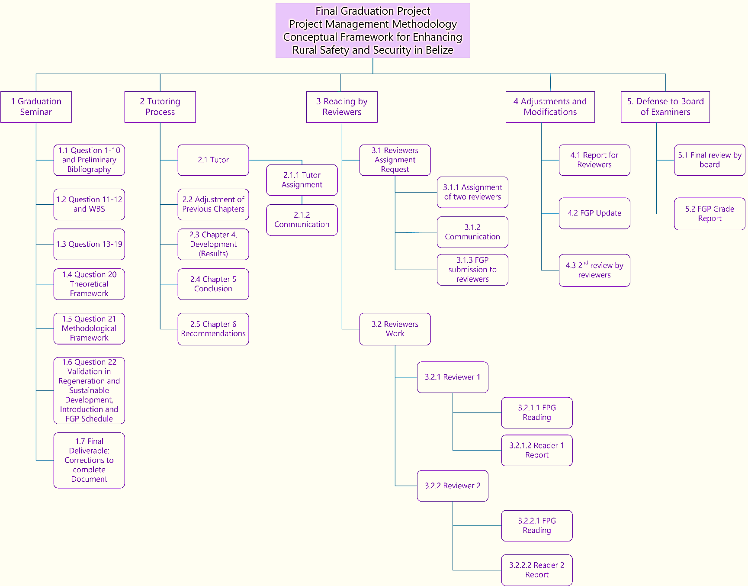
Appendix 2: FGP WBS

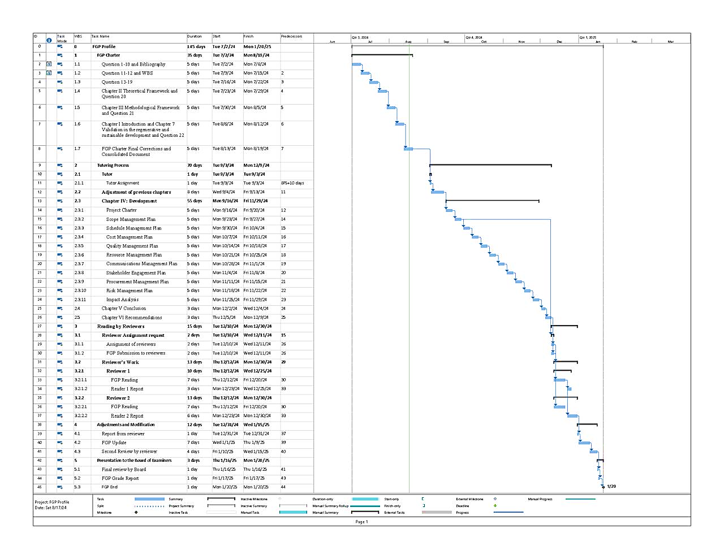
Appendix 3: FGP Schedule

Appendix 4: Preliminary bibliographical research

Koeppel, Claire. (2023). Home Security for Rural Areas: Addressing Unique Challenges.
StaySafe.org.
https://staysafe.org/home-safety/home-security-for-rural-areas/

‌I'm utilizing the above link because the article explicitly addresses security concerns in rural settings, which aligns with rural safety and security. Additionally, the document provides practical advice, such as securing outbuildings, using outdoor lighting, and safeguarding against wildlife threats, which are all relevant information for rural residents.

Sharpe, B. (20220. Rural vs Town & City Security: A Guide. Safe Security Solutions.
https://safess.co.uk/rural-vs-town-and-city-security/

I'm utilizing the above link because the article provides insights into rural and urban security, which can be valuable for your research or writing. Sharpe’s expertise enhances the credibility of the information, and it compares security considerations between rural and urban areas.

Team, T. C. (2023). Rural Security: Is your rural property at risk? Clearway.
https://www.clearway.co.uk/news/rural-security-is-your-rural-property-at-risk/

Utilizing the above link is necessary because the article offers insights into assessing specific risks rural properties face. Identify vulnerabilities related to access points, surveillance, and property layout. This will also contribute to community development and training.

Rural Crime Report 2022. (n.d.). Rural Crime Report 2022 - Download Free Report | NFU
Mutual.
https://www.nfumutual.co.uk/farming/rural-crime/

The above link is useful because the NFU Mutual Rural Crime Report 2023 provides valuable insights into rural crime trends and their impact.

Chen, G., Yang, Q., Chen, X., Huang, K (2021). Methodology of Urban Safety and
Security Assessment Based on the Overall Risk Management
Perspective. Sustainability, 13(12), 6560–6560.
https://doi.org/10.3390/su13126560

The reason for utilizing the above link is that while the Methodology of Urban Safety and Security Assessment primarily focuses on urban areas, I can adapt some of its principles to enhance rural safety and security. Apply the risk assessment framework to identify potential threats specific to rural environments. I am especially considering factors like natural disasters, wildlife interactions, and remote locations. I can also view the vulnerability maps for rural regions, highlighting areas prone to crime or safety risks. Overlay data on infrastructure, population density, and historical incidents. This document also includes how to gain insights into involving local communities in safety planning and incorporating and encouraging neighbourhood watch programs, community policing, and information sharing.

Peake, Tony. (2019). Achieving safety and security in an age of disruption and distrust.
(n.d.).
https://www.pwc.com/gx/en/government-public-sector-research/pdf/pwc-achieving-safety-security.pdf

The above link emphasizes collaboration between the public and private sectors as a prerequisite for a safe, secure, and prosperous society. In this new reality, where trust in institutions is low, holistic approaches are essential.

Government of Ireland. (2022). Rural Safety Plan.
https://assets.gov.ie/235118/e99aebbb-cf7d-4509-a177-7c9212eb0bee.pdf

To apply the insights from the Rural Safety Plan 2022-2024 to my rural safety and security initiative, I have considered evaluating the specific safety challenges in my rural area. Also, identify key risks related to community safety, burglary, theft, roads, animal, and heritage crime. This can be done through community engagement, education training, and collaboration with various stakeholders.

Community Safety Framework | Department of Justice. (2020). Justice.
https://www.justice-ni.gov.uk/community-safety-framework

This citation from the Community Safety Framework speaks to ensuring effective connectivity between responsible agencies, providing an operational roadmap for delivering safer community objectives. I like that it points out key security initiatives that I can utilize for my rural safety and security initiative, such as collaboration and the holistic approach of considering broader issues like antisocial behaviour and underlying vulnerabilities. It also demonstrates the ability to adapt to address emerging issues proactively with the communities.

The National Rural Safety Strategy. (n.d.).
https://www.saps.gov.za/resource_centre/publications/national_rural_safety_strateg y_2019.pdf

This link shows an integrated approach to mobilizing rural communities to create safe and secure environments.

Abraham, J., & Ceccato, V. (2022). Crime and safety in rural areas: A systematic review of the English-language literature 1980–2020. Journal of Rural Studies, 94, 250–273.
https://doi.org/10.1016/j.jrurstud.2022.05.010

The above link is fascinating and will highlight the systematic review by Abraham and Ceccato, which provides valuable insights into crime and safety in rural areas. Touching on the rural-urban continuum, it emphasizes and highlights the importance of safety and understanding safety.

Project Management Institute. (2021). A Guide to the Project Management Body of Knowledge (PMBOK® Guide)–Seventh Edition. Project Management Institute.

Appendix 5: Philological Dictum

AMADO MAURICIO CHAN
Masters of Arts
English
Certified by The Board of Regents of the University System of Georgia
Upon Recommendation of the Faculty of Valdosta State University, 1997

December 17th, 2024

Academic Advisor
Master’s Degree in Project Management (MPM)
Universidad para la Cooperación Internacional (UCI)

Dear Academic Advisor,

Re: Thorough Review and Proofreading of Final Graduation Project submitted by Ginee Nicole Neal in partial fulfilment of the requirements for the Master’s in Project Management (MPM) Degree.

I hereby confirm that Ginee Nicole Neal has made all the corrections to the Final Graduation Project document entitled “Project Management Conceptual Framework for Enhancing Rural Safety and Security Initiative in Belize” as I have advised. In my opinion, the document now meets the literary and linguistic standards expected of a student for a degree at the Master's level.

Amado Mauricio Chan, M.A.
Philologist

