UNIVERSIDAD PARA LA COOPERACION INTERNACIONAL
(UCI)

Development of a Comprehensive Management Plan for the Launch of a Micro Bakery

Alyssa Reyes

FINAL GRADUATION PROJECT SUBMITTED IN PARTIAL FULFILLMENT OF THE REQUIREMENTS FOR THE
MASTER IN PROJECT MANAGEMENT (MPM) DEGREE

Orange Walk Town, Belize

August 2025

UNIVERSIDAD PARA LA COOPERACION INTERNACIONAL
(UCI)

This Final Graduation Project was approved by the University as
partial fulfillment of the requirements to opt for the
Master in Project Management (MPM) Degree

Maria Fernanda Ibarra
__________________________
Full name must be written
TUTOR

Diego Meneses
_________________________
Full name must be written
REVIEWER No.1

Sophia Crawford Mora
__________________________
Full name must be written
REVIEWER No.2

Alyssa Reyes
________________________
Student full name
STUDENT

DEDICATION
This project is dedicated to those individuals whose unwavering support and encouragement made this journey possible.
To my parents, thank you for instilling in me the values of perseverance, hard work, and integrity. Your encouragement to pursue my passions has laid the foundation for this endeavor, and your continued support has guided me throughout.
To my brother, Pocho, your honesty and feedback have helped me grow, not only as a baker but as a person. Your role in this journey has been more significant than you may realize.
To my grandparents, Elisa and Raul Castillo, your kitchen was the beginning of my curiosity and love for baking. Watching Granny and Grampy work together every year for Granny’s Fruitcake sale was always an inspiration. To my grandparents, Felipe and Griselda Reyes, though I never had the pleasure of meeting you, the stories of your bakery and the legacy you left inspires me deeply. I hope to honor your memory through every product I create.
To my aunts and uncles, Tia Magaly, Tio Manuel, Tio Pipo, and Tia Licia, thank you for always believing in me and your constant support. To Tia Mari and Tia Lupe, the role models who’ve made baking an art. Tia Mari, your cheese buns and hojaldras are unforgettable. Tia Lupe, thank you for my first Dutch oven and your endless wisdom in the kitchen. You’ve both inspired and shaped my baking in countless ways.
To my cousins, Bee, Lily, Bree, Gee, and Ito, your enthusiasm, honesty, and unwavering support have been a true source of motivation. Our shared moments in the kitchen remain some of my most cherished memories.
To my partner, Zair Escalante, whose belief in me has never wavered. Your steady
presence, tireless support, and the countless late-night baking sessions we've shared have
been a constant source of strength. This journey wouldn’t have been the same without you
by my side. Your reassurance, unwavering encouragement, and the joy you bring to
every step have made all the difference. Your support has been truly immeasurable, and I’m
endlessly grateful.

ACKNOWLEDGMENTS
I would like to extend my sincere appreciation to those who have supported and guided me throughout the completion of this Final Graduation Project.
To my friends Indira, Alessandra, and Triz, thank you for your continued encouragement and thoughtful words during moments of uncertainty. Your quiet support has been deeply appreciated. To Rosa your guidance and support throughout has been greatly appreciated.
To the friends I made along the way, Jenean, Kimberly, Rico, and Iran, thank you for the camaraderie and shared dedication throughout this academic journey. The insights and encouragement exchanged among us have been both motivating and reassuring.
To my professors, thank you for your commitment to academic excellence and for providing the knowledge and perspective that helped shape this project. I am especially grateful to my tutor, Professor Maria, for your guidance, detailed feedback, and steady support during the development of this work.
Each of you has contributed meaningfully to this process, and for that, I am truly grateful.

ABSTRACT

This Final Graduation Project presents the development of a comprehensive management plan for the successful launch of a micro bakery in Orange Walk Town, Belize. Rooted in principles of sustainability, regenerative development, and strategic project management, the study outlines a phased approach beginning with a home-based operation and expanding to a trailer-based outdoor setup by Year 3. The project was guided by five core objectives: to assess current market demand and customer preferences, analyze competitor offerings, evaluate legal and regulatory frameworks, design operational and financial strategies, and incorporate sustainable and regenerative practices.
A mixed-methods approach was employed, including survey research, interviews, secondary data collection, and financial analysis. The findings informed a tailored business plan that emphasizes lean operations, local sourcing, waste reduction, and community engagement. Project management tools such as the Work Breakdown Structure (WBS), Gantt chart, risk register, and stakeholder matrix were used to support planning and execution phases. Key performance indicators and control mechanisms were established to monitor success and guide continuous improvement.
The results demonstrate the viability of launching a micro bakery that meets both market demand and sustainability standards. By integrating economic, environmental, and social considerations into every aspect of the business model, the project serves as a practical and scalable example of how small enterprises can contribute to local development while remaining operationally efficient. This FGP not only provides a roadmap for business implementation but also validates the importance of aligning entrepreneurship with regenerative and sustainable principles.
Key words: Micro Bakery, Project Management, Sustainability, Regenerative Development, Business Planning

Table of Contents
INDEX OF FIGURES 7
INDEX OF TABLES 8
ABBREVIATIONS AND ACRONYMS 9
EXECUTIVE SUMMARY 10
1 INTRODUCTION 10
1.1. Background 13
1.2. Statement of the problem 14
1.3. Purpose 15
1.4. General objective 17
1.5. Specific objectives 17
2 THEORETICAL FRAMEWORK 19
2.1 Company/Enterprise framework 19
2.2 Project Management concepts 23
2.3 Other applicable theory/concepts related to the project topic and context 30
3 METHODOLOGICAL FRAMEWORK 33
3.1 Information sources 33
3.2 Research methods 34
3.3 Tools 36
3.4 Assumptions and constraints 38
3.5 Deliverables 40
4 RESULTS 42
4.1 Market Study of Bakery Industry 42
4.2 Technical and Legal Study of the Bakery Industry 64
4.3 Financial Feasibility Study 79
4.4 Integrated Management Plan 91
5. CONCLUSIONS 5
6. RECOMMENDATIONS 7
7. VALIDATION OF THE FGP IN THE FIELD OF REGENERATIVE AND SUSTAINABLE DEVELOPMENT 9
5 Bibliography 13
Appendix 1: FGP Charter 15
Appendix 2: FGP WBS 1
Appendix 3: FGP Schedule 1
Appendix 4: Preliminary bibliographical research 2
Appendix 5: Revision Dictum 6

INDEX OF FIGURES
Figure 1 Organizational Structure (Source: Author of Study) 22
Figure 2 Relationship between Project Management Principles and Project Performance Domains (Source: Max Wideman) 25
Figure 3 Project Management Knowledge Areas (Source: Priyanka Sharma) 27
Figure 4 Project Lifecycle (Source: Project Management Institute, 2021) 29
Figure 5 Hybrid Project Lifecycle 30
Figure 6 Business Support Services Outline (Source: BELTRAIDE) 66

INDEX OF TABLES
Table 1 Information sources (Source: Author of Study) 36
Table 2 Research Methods (Source: Author of Study) 37
Table 3 Tools (Source: Author of Study) 39
Table 4 Assumptions and constraints (Source Author of Study) 40
Table 5 Deliverables (Source: Author of Study) 41
Table 6 Scenario Analysis: Estimated Weekly Revenue from Cross-Selling………….…..48
Table 7 Competitor Analysis (Source: Market Research Interviews) 51
Table 8 SWOT Analysis (Source: Market Research Survey) 54
Table 9 Projected 5-year Organizational Structure 73
Table 10 Net Present Value (Source: Author of Study) 89
Table 11 Sample Work Breakdown Structure (WBS) (Source: Author of Study) 91
Table 12 Sample Cost Breakdown 93
Table 13 Sample Quality Checklist 94

ABBREVIATIONS AND ACRONYMS
- SIB – Statistical Institute of Belize
- FGP – Final Graduation Project
- SMEs- Small and Medium-Sized Enterprises
- BCCAR - Belize Companies and Corporate Affairs Registry
- SBDC – Small Business Development Center
- BZD – Belizean Dollars

EXECUTIVE SUMMARY
This Final Graduation Project presents a comprehensive management plan for the strategic launch of a home-based micro bakery in Orange Walk Town, Belize. The research identified a clear market opportunity for high-quality, affordable, and convenient artisanal baked goods, catering to a growing consumer segment. The venture was deemed compelling due to its low overhead, scalability, and commitment to economic, social, and environmental sustainability, leveraging a digitally accessible, locally rooted business model.
The primary objective of the project was to develop a robust management framework for the successful establishment and sustainable operation of the micro bakery. This involved a multi-faceted approach:
- Market Analysis: Conducting a thorough situational analysis of consumer demand and current market conditions.
- Business Model Design: Developing a strategic business model incorporating robust planning and project management methodologies.
- Implementation Strategy: Designing and evaluating a practical implementation roadmap.
- Project Management Plan: Formulating a detailed plan covering scope, cost, schedule, quality, human resources, communication, and risk.
- Financial Validation: Confirming the project's financial viability and long-term sustainability.
The methodology employed a mixed-methods research design, integrating primary data from a consumer survey (72 responses) and interviews with three local bakery owners. This was complemented by secondary data, including Statistical Institute of Belize statistics, competitor pricing, and regional demographics. Project management tools, guided by PMBOK principles (e.g., Project Charter, WBS, Gantt Chart, Risk Register, Financial Forecasts), were instrumental in providing structure, ensuring objective alignment, and enhancing control over all project dimensions.
Key findings validated the project’s strong potential. Consumer interest was found to be high, particularly for signature items like cheese buns and cinnamon rolls, confirming the proposed product strategy. The lean business model, emphasizing weekend operations, pre-orders, and digital platforms, was shown to optimize production and minimize waste. Financial projections were highly favourable: the project demonstrated a Net Present Value (NPV) of BZ$27,441.19 and an Internal Rate of Return (IRR) significantly above the 10% discount rate, confirming strong profitability. These results also supported a planned expansion, including a BZ$30,000 investment in Year 3 for a mobile, outdoor café-style trailer setup. Furthermore, the commitment to sustainability through local sourcing, biodegradable packaging, and minimal physical infrastructure strengthened the overall business case.
Ultimately, the project confirmed that a micro bakery could be successfully launched by taking a phased approach, prioritizing community engagement, and integrating sustainable practices. The comprehensive situational analysis identified a clear market gap, while the rigorous methodology ensured structured and practical planning for successful implementation. The financial outcomes validated both short-term feasibility and long-term sustainability. Key recommendations included an initial home-based launch, maintaining stringent quality control and compliance, leveraging digital marketing, and strategically preparing for the trailer-based expansion. The application of the 7Ps of marketing underscored a well-rounded strategy that aligned both sustainable development goals and evolving customer expectations.

INTRODUCTION
The bakery industry has witnessed a resurgence of interest in recent years, fueled by consumer demand for artisanal, locally sourced products and the growing popularity of micro-entrepreneurial ventures. Micro bakeries, characterized by small-scale production and a focus on quality over quantity, have emerged as a promising business model, particularly in local markets where customers seek personalized service and handcrafted goods (Goncharuk & Aleksandra Figurek, 2023). However, launching and sustaining a micro bakery presents unique challenges, including access to financing, operational efficiency, regulatory compliance, and competition against larger, established brands (Gavilan, 2024).
In Belize, where small and medium-sized enterprises (SMEs) form a significant portion of the economy, micro bakeries hold considerable potential to contribute to local development by promoting sustainable employment, supporting local food systems, and fostering entrepreneurship (Statistical Institute of Belize, 2023). Despite these opportunities, many bakery startups struggle to survive beyond the initial phase due to the absence of structured management plans that integrate project management principles across all stages of business development. Recognizing this gap, the current project was designed to develop a comprehensive management plan tailored specifically to the needs of launching a micro bakery in Belize. This project integrates the best practices in project management, market analysis, financial planning, quality control, and operational strategy to ensure the feasibility, sustainability, and success of the proposed venture.
The following sections present a detailed analysis of the bakery industry landscape, justification for the project’s relevance, the defined general and specific objectives, the methodology employed, and the outcomes and recommendations derived from the project development process.

Background
The micro bakery project was conceived in response to increasing market opportunities identified within Belize’s local food sector. Growing consumer interest in artisanal, locally produced bakery items, combined with the limited presence of structured small bakery operations, indicated a promising niche for development (Gavilan, 2024). The project addresses the need for a management framework that can guide entrepreneurs through the complexities of starting and operating a micro bakery, from initial market research to day-to-day operational execution.
Belize’s economy relies heavily on small businesses, yet many SMEs, particularly in the food sector, face substantial challenges related to financing, supply chain management, and business sustainability. The bakery industry, although vibrant in certain urban centers, remains fragmented and often informal (Gonzalez-Loureiro, 2021). This fragmentation creates a competitive environment where only businesses with strong operational foundations can thrive. Furthermore, the cultural significance of bread and pastry consumption in Belizean households supports the potential for a micro bakery that emphasizes traditional techniques, quality ingredients, and community integration.
The decision to structure the project through formal project management methodologies was informed by the need to minimize risks and enhance strategic planning throughout the startup phase. The Project Management Institute (Project Management Institute, 2021) emphasizes the importance of integrated planning, stakeholder management, and continuous monitoring for project success. Applying these principles to the bakery sector allows for a systematic approach that addresses critical areas such as resource allocation, scheduling, financial management, and risk mitigation.
By developing a management plan that integrates operational, financial, quality, human resource, communication, procurement, and risk management practices, the micro bakery aims to serve as a replicable model for other aspiring entrepreneurs in Belize. Ultimately, this project supports broader national objectives of fostering sustainable entrepreneurship, reducing unemployment, and strengthening local food systems in alignment with sustainable development goals (Goncharuk & Aleksandra Figurek, 2023).

Statement of the problem
Micro bakery startups in Belize face a range of operational and strategic challenges that can hinder their growth and long-term viability. Despite growing consumer interest in locally made and artisanal baked goods, many small bakeries struggle to meet consistent quality standards while maintaining financial sustainability (Gavilan, 2024). These businesses often operate informally, without applying structured project or business management frameworks, which contribute to inefficient workflows, inadequate budgeting, and an inability to adapt to market .
Entrepreneurs entering the bakery sector commonly underestimate the complexities of running a food-based business. Key obstacles include limited access to startup financing, difficulties navigating food safety and regulatory requirements, unstable supply chains, and strong competition from larger-scale commercial bakeries (Statistical Institute of Belize, 2023). Moreover, many small enterprises overlook the importance of formal project planning—such as defining scope, creating a realistic timeline, applying cost controls, identifying risks, and setting measurable quality standards—all of which are essential for sustainable business operations (Project Management Institute, 2021).
In the context of Belize’s competitive and economically vulnerable market, the absence of a formalized management approach increases the likelihood of failure within the first two years of operation. Without an integrated, project-based framework, micro bakeries risk encountering delays, budget overruns, inconsistent quality, and low stakeholder confidence. This Final Graduation Project aims to close this gap by designing a comprehensive management plan tailored specifically to the launch and early operations of a micro bakery in Belize.

Purpose
The purpose of this Final Graduation Project was to develop a comprehensive management plan to facilitate the successful launch of a micro bakery in Belize. The study aimed to address the core operational, financial, and strategic deficiencies typically encountered by micro bakery startups, providing a structured framework grounded in project management principles. By doing so, the project intended to enhance the micro bakery’s chances of achieving sustainable growth, operational efficiency, and market competitiveness.
Specifically, the study investigated key aspects such as market analysis, project scope definition, schedule planning, cost estimation, quality assurance, human resources structuring, risk management, procurement planning, and stakeholder communication. Each element was examined with the objective of integrating best practices into a cohesive management plan that could serve both as an operational guide and a risk mitigation tool during the startup phase.
The project aimed to produce several expected benefits:
- Improve strategic planning and reduce uncertainty during bakery startup operations,
- Provide a clear financial roadmap to support funding acquisition and budget control,
- Define operational processes to maintain product quality and customer satisfaction,
- Develop a proactive approach to risk identification and mitigation, and
- Contribute to the broader development of microenterprises in Belize by providing a replicable model of best practices (United Nations Department of Economic and Social Affairs, 2024; Ellen MacArthur Foundation, 2021).
Ultimately, the project aspired to bridge the gap between entrepreneurial intent and successful business execution within the bakery sector, promoting economic growth and community development in alignment with sustainable development principles.

General objective
The general objective of this project was to develop a comprehensive and integrated management plan for the successful launch of a micro bakery in Belize. The management plan was designed to align the bakery’s operational strategies with project management best practices, ensuring financial feasibility, operational efficiency, quality control, stakeholder engagement, and risk mitigation.
The final deliverable, the management plan, aimed to equip the entrepreneur with the necessary tools, frameworks, and methodologies to effectively navigate the complexities of launching and sustaining a micro bakery. By addressing operational, financial, and strategic factors, the project sought to enhance the bakery’s chances of long-term success while contributing positively to the local economy and food sector development.

Specific objectives
- To conduct a comprehensive market study of the bakery industry in order to define the project context, identify key success factors, and understand stakeholder expectations, including customer preferences, competitor offerings, location dynamics, and demographic trends.
- To perform a technical and legal analysis aimed at identifying the regulatory requirements, investment needs, operational costs, human resource structure, and supply chain considerations necessary for the establishment of a micro bakery.
- To develop a financial feasibility assessment that evaluates the economic viability of the proposed bakery through startup cost analysis, revenue forecasting, and profitability projections.
- To formulate an integrated project management plan that outlines the scope, schedule, cost, quality, risk, stakeholder, and communication strategies required to successfully implement and manage the micro bakery business.

THEORETICAL FRAMEWORK

Company/Enterprise framework
The proposed enterprise is a micro bakery that will operate in Belize, targeting local communities with a variety of handcrafted baked goods. The idea originated from a passion for baking and a desire to contribute to the local food economy through artisanal products. The bakery is designed to function on a small scale, enabling the owner to maintain quality and personal connection with customers while managing operations independently. This framework is essential for guiding its launch and ensuring a professional approach despite limited resources.

Mission and vision statements
The vision of the micro bakery is to become a trusted and beloved neighborhood establishment that reflects the cultural richness and culinary traditions of Belize. It aspires to bring people together through high-quality, locally crafted baked goods while promoting community resilience and seasonal creativity.
The mission of the micro bakery is to create and offer fresh, flavorful, and culturally inspired baked products using quality ingredients and artisanal methods. The bakery is committed to delivering exceptional service, fostering local pride, and supporting sustainable food practices through its day-to-day operations.
This mission and vision serve as the guiding principles for all aspects of the bakery’s development and operations, ensuring that each decision aligns with the core values of quality, authenticity, and community engagement.

Organizational structure
The micro bakery is a startup enterprise in its foundational phase, established as a family-run business with shared ownership among three founding members. The structure is intentionally kept flat to enable flexibility, rapid decision-making, and close oversight of operations. The bakery is owned and operated by the Baker/Owner, supported by a Partner-Investor and an additional silent Investor.
The Baker/Owner serves as the central figure of the business, responsible for all aspects of product development, inventory control, and day-to-day kitchen management. This role includes recipe creation, sourcing ingredients, managing baking schedules, and ensuring consistent product quality in alignment with customer expectations and brand standards.
The Partner-Investor manages the financial and administrative functions of the bakery. This includes maintaining accurate records of income and expenses, overseeing budgeting, preparing reports, managing vendor relationships, and ensuring regulatory compliance. The Partner-Investor also plays a key role in strategic planning alongside the Baker/Owner.
The third co-owner, a silent investor, provides startup capital and remains involved in high-level decision-making when consulted but is not involved in daily operations. This individual supports the growth and sustainability of the business through financial backing and informal advisory input.
As shown in Figure 1, this organizational structure reflects the lean and collaborative nature of a startup enterprise. Although roles are specialized based on skills and responsibilities, the business operates with high levels of communication and joint decision-making. This model supports the startup’s goal of efficient operation, strong quality control, and financial stability during its early stages of development.
Figure 1 Organizational Structure (Source: Author of Study)
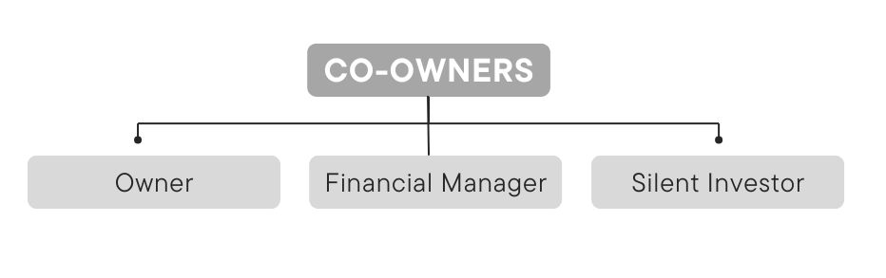
Note: A functional, family-based organizational framework outlining the roles and responsibilities within the micro bakery startup, adapted from “The Power of Org Charts in Your Bakery” by the Retail Bakers of America, which explains how small bakeries can implement simple yet effective organizational structures to support daily operations and future growth.

Products offered
The micro bakery’s product portfolio is designed to balance tradition, innovation, and market responsiveness. At the core of the business are staple bakery items rooted in Belizean culture and everyday consumption habits. These foundational products form the operational base of the business and serve as the starting point for the development of systems around quality control, cost estimation, and scheduling, all of which are central to the Final Graduation Project (FGP).

Core Products
- Breads: A variety of freshly baked loaves suitable for daily household use, serving as a high-demand, high-volume product that anchors the production cycle.
- Cheese Buns: A signature item, these savory pastries are crafted with local cheese and are expected to be among the top-selling goods.
- Plain Buns & Powder Buns: Traditional Belizean sweet buns, offered in both soft and crumbly formats to appeal to different consumer preferences.
- Johnny Cakes: A dense, slightly sweet bread popular for breakfast or sandwiches, positioned as a culturally iconic item with consistent demand.
- Banana Bread: A moist, flavorful loaf designed to minimize waste by using overripe bananas and provide a familiar, comforting option.
These items are central to the bakery’s production flow and form the baseline for procurement planning, pricing strategy, and quality benchmarks addressed in the FGP.

Rotating Seasonal and Feature Products
The bakery will implement a limited-time feature model, offering a new specialty item every one to two weeks. These include:
- Cinnamon Rolls, Brownies, Cookies, Cheesecake, Caprichos, and Hot Cross Buns, with selections based on seasonal relevance, local holidays, and trending preferences.
Each feature product will be available for one week only, creating a sense of urgency and allowing the bakery to test market interest before committing to permanent production. This model supports demand forecasting, minimizes inventory risk, and creates continuous customer engagement. Additionally, it aligns with FGP objectives related to product lifecycle planning, production scheduling, and promotional lead time.
Healthy and Dietary Alternatives

The bakery also intends to introduce low-sugar and health-conscious options as part of its commitment to inclusive product offerings. These will undergo the same trial-feature process to evaluate customer interest and operational feasibility. This effort ties into the FGP’s focus on recipe testing, quality control, and cost analysis.
Production and Sales Strategy

At launch, the bakery will operate with limited daily quantities available for in-store purchase, while also accepting pre-orders for made-to-order items. This dual model supports flexibility in production planning and helps assess consumer buying patterns. As sales stabilize, this structure will provide data for refining inventory management and scaling operations.

Project Management concepts

Project management principles
Project management principles serve as the foundational values and guidelines that influence how projects are executed, managed, and evaluated. These principles include stewardship, stakeholder engagement, team collaboration, value delivery, systems thinking, and adaptability (Project Management Institute, 2021). For microenterprises such as this bakery startup, adherence to these principles ensures alignment between business goals and project outcomes, even within constrained resources. Applying these principles fosters accountability, effective communication, and a commitment to continuous improvement.

Project management domains
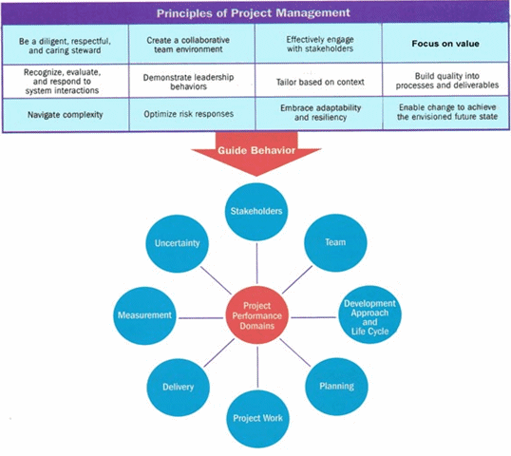
The PMI outlines eight performance domains that represent critical areas of focus during the management of any project. These domains include Stakeholders, Team, Development Approach and Life Cycle, Planning, Project Work, Delivery, Measurement, and Uncertainty (Project Management Institute, 2021). Each domain emphasizes the dynamic and interconnected nature of modern project environments. In the context of the micro bakery, performance domains guide stakeholder coordination, team responsibilities, operational planning, and performance tracking.
Note: Extracted from A Guide to the Project Management Body of Knowledge (The PMBOK® Guide), published by the Project Management Institute, Inc., PA, 2021, Book [B] pB3
Figure 2 Relationship between Project Management Principles and Project Performance Domains (Source: Max Wideman)

Predictive, adaptative and hybrid projects
Project approaches vary depending on the complexity, uncertainty, and context of the project. Predictive (or waterfall) approaches follow a linear, sequential model ideal for well-defined scopes and fixed deliverables. Adaptive (or agile) approaches prioritize flexibility and iterative delivery, commonly used in dynamic environments. Hybrid models blend elements of both, offering structure with the flexibility to adapt as needed (Project Management Institute, 2021; Silva, 2022).
In the case of the micro bakery project, a hybrid approach is most suitable. Predictive methods are applied during the initial planning and resource allocation phases, such as defining scope and estimating costs. However, adaptive methods are used when introducing and testing new product features on a rotating basis. This blended method enables the bakery to maintain structure while allowing space to respond to market feedback and product performance.

Project management
Project management refers to the strategic discipline of applying knowledge, tools, techniques, and skills to fulfill project objectives within scope, time, cost, and quality constraints. It integrates planning, executing, monitoring, and closing activities to deliver value (Project Management Institute, 2021). For startups, project management is particularly valuable, as it introduces structured methodology into environments that might otherwise operate informally. In this project, it provides the framework for launching the bakery efficiently while balancing limited resources, market responsiveness, and long-term vision.

Project management knowledge areas and processes
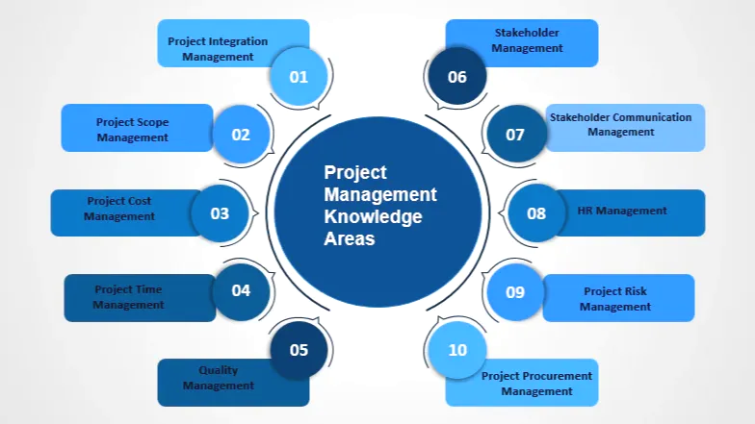
The discipline of project management is organized into ten interrelated knowledge areas that encompass the core competencies required to manage a project effectively. These include integration, scope, schedule, cost, quality, resource, communication, risk, procurement, and stakeholder management (Project Management Institute, 2021). Each area represents a critical dimension of project execution and includes a set of processes and best practices tailored to specific phases of the project life cycle.
Note: Extracted from 10 Project Management Knowledge Areas, as defined by the Project Management Institute (PMI) in the PMBOK® Guide
Figure 3 Project Management Knowledge Areas (Source: Priyanka Sharma)

In the context of the micro bakery project, these knowledge areas provide structured guidance for planning, executing, and monitoring various components of the business setup. For instance, schedule management informs the bakery’s production timeline and launch milestones, while cost management supports the budgeting and pricing of core and seasonal products. Quality management is applied to define and maintain product standards, ensuring consistency across batches. Risk management is used to anticipate and prepare for potential issues such as ingredient shortages or fluctuating seasonal demand. Similarly, stakeholder management facilitates coordination between the bakery’s owners, financial contributors, and customers.

Project life cycle
Managing a project involves guiding it through distinct stages that structure its progression from start to finish. These stages, typically defined as initiation, planning, execution, monitoring, and closure, are designed to keep the project aligned with its purpose and stakeholder needs (Project Management Institute, 2021). Each phase plays a vital role in defining objectives, coordinating activities, and evaluating progress.
In small enterprises, such as a startup bakery, applying a blended or hybrid project model can be particularly effective. This approach draws from both traditional (predictive) and flexible (adaptive) strategies. For example, the early phases of the bakery launch, such as defining schedules, setting budgets, and organizing resources, are best handled with a structured, predictive method. On the other hand, introducing new recipes or seasonal items benefits from adaptive practices that allow for quick changes and customer feedback (Motion, 2024)
This dual approach gives the business both stability and agility. While predictive tools provide clarity and control, adaptive methods help the bakery respond quickly to market shifts and consumer behavior. This is especially useful for startups operating with limited resources and high uncertainty.
Recent findings support the hybrid approach as a valuable tool for smaller businesses. It improves communication, supports faster risk response, and enhances overall project flexibility, key advantages for entrepreneurs navigating competitive environments (Six Sigma, 2024).
Figure 4 Project Lifecycle (Source: Project Management Institute, 2021)
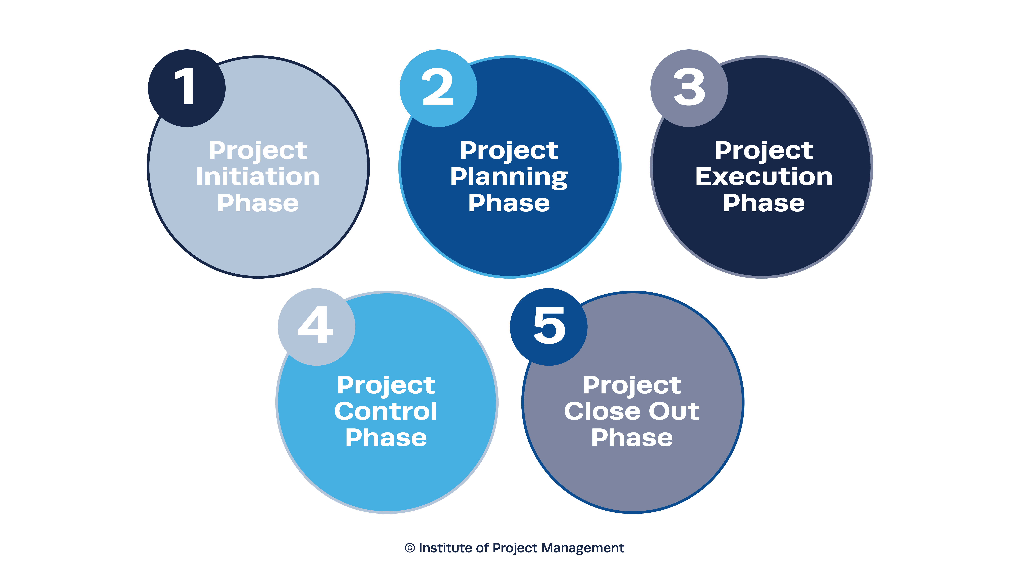
Note: Standard five-phase project life cycle. Adapted from the Institute of Project Management (n.d.), illustrating the structured flow from initiation through to close-out, as applied in traditional and hybrid project management models.

Figure 5 Hybrid Project Lifecycle
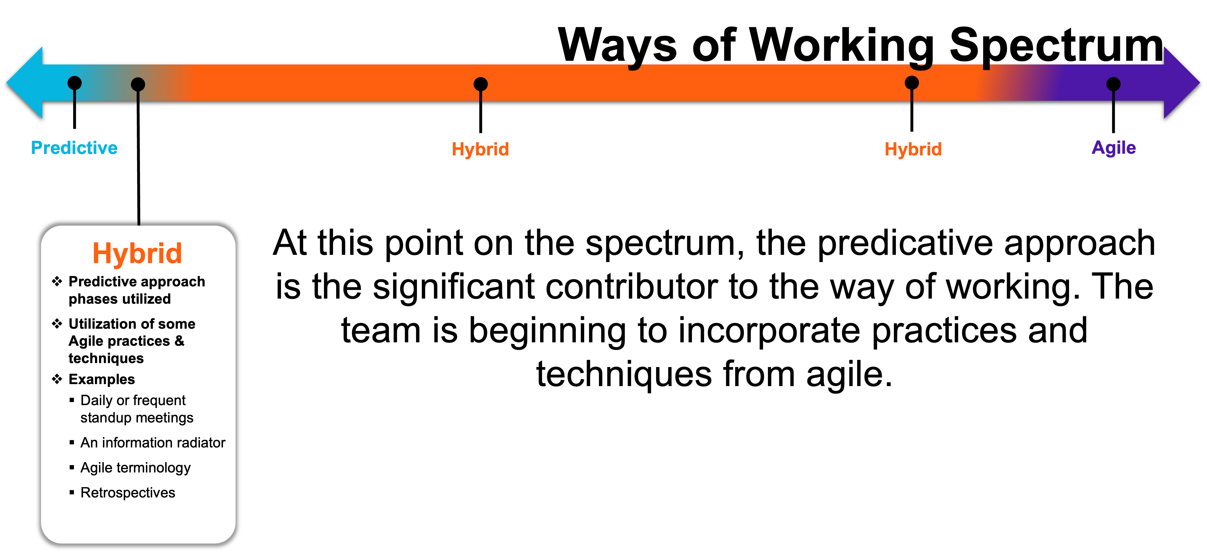
Note: Representation of the hybrid project life cycle. This model integrates structured phases typical of predictive approaches with adaptive practices from Agile methodologies. It demonstrates flexibility to apply iterative feedback and frequent communication practices while retaining elements of linear planning.

Company strategy, portfolios, programs and projects
In project management, strategy reflects the organization’s overarching goals and vision. Portfolios consist of various programs and projects aligned with this strategy. Programs group related projects to achieve combined benefits, while individual projects focus on specific outcomes (Project Management Institute, 2021).
For this micro bakery, the primary project is the development and launch of the business. Although operating as a single-project venture at this stage, the bakery fits within a broader strategic vision of local market growth and product innovation. Over time, this project could evolve into a program that includes product expansion, storefront development, and brand scaling. These potential initiatives would form part of a larger portfolio driven by the founders' long-term entrepreneurial goals.

Other applicable theory/concepts related to the project topic and context

Current situation of the problem or opportunity in study
Micro bakeries are growing in popularity due to increasing consumer demand for artisanal and locally produced food products (Gavilan, 2024). However, their success is often hindered by limited access to formalized management structures and strategic planning tools. Many small food businesses operate informally and lack the frameworks required to ensure sustainability, scalability, and quality control (Knezevic, 2006)
In Belize, while local interest in home-based baked goods is increasing, startup bakeries often face regulatory, operational, and financial constraints that affect their ability to survive beyond the early stages. Challenges such as resource mismanagement, inconsistent product quality, and absence of structured project planning limit growth potential. The gap between consumer expectations and operational capacity underscores the need for an integrated and adaptive project management model tailored to micro-enterprises in the food sector (Statistical Institute of Belize, 2023).

Previous research done for the topic in study
Several studies have examined the role of project management methodologies in the growth and success of small enterprises. Turner, Ledwith, and Kelly (2012) discuss how project management frameworks can improve operational coordination, scheduling, and execution, particularly in settings with constrained resources. These insights are especially relevant for micro and small enterprises that require structured yet adaptable systems.
According to Kumar’s, (Kumar, 2021) hybrid project management approaches in home-based food businesses can enhance customer responsiveness and streamline production cycles. These adaptive methods allow businesses to test and adjust their operations based on real-time feedback, which supports both product development and service delivery.
In addition, (Goncharuk & Aleksandra Figurek, 2023) found that firms employing formal project planning tools—such as Gantt charts, work breakdown structures (WBS), and resource allocation strategies—tend to achieve greater project consistency and stakeholder satisfaction. Their findings highlight the importance of applying structured project tools to improve efficiency and decision-making in microenterprise environments.

Other theory related to the topic in study
The theoretical underpinnings of this project are grounded in several contemporary management frameworks:
- Project Management Theory – This foundational theory informs how projects are structured and executed to meet stakeholder expectations. The Project Management Institute (Project Management Institute, 2021)outlines key knowledge areas and process groups that guide the life cycle of a project, supporting a systematic approach to managing scope, schedule, cost, and quality.
- Contingency Theory – Recent research by (Zhou, 2022) supports the notion that contingency-based decision-making enables startups to adapt their practices according to environmental variables. This theory underscores the importance of customizing project strategies based on resource availability, market conditions, and organizational maturity.
- Resource-Based View (RBV) – According to Gonzalez – Loureiro, (Gonzalez-Loureiro, 2021) small firms that leverage intangible resources, such as employee creativity, social capital, and community goodwill, can outperform competitors even in resource-constrained settings. For micro bakeries, this involves capitalizing on artisanal knowledge, customer loyalty, and product uniqueness.
- Lean Startup Methodology – A report by Stephen Laaper, (Stephen Laaper, 2020) affirms that lean practices are increasingly adopted by micro and small enterprises to validate ideas, reduce waste, and enhance customer alignment. Lean methodology is particularly suitable for bakeries introducing seasonal or experimental products, allowing them to test offerings before full-scale rollout.

METHODOLOGICAL FRAMEWORK

Information sources
Information sources refer to all materials, data, or persons consulted to gather relevant knowledge for the project. These include both primary and secondary sources. According to (Cooper, 2022) information sources are critical for ensuring the validity, accuracy, and reliability of research findings.

Primary sources
Primary sources include first-hand data gathered directly through observation, interviews, focus groups, or surveys. For this project, primary information sources include interviews with local bakery owners, customer surveys, and direct observation of baking operations. These sources offer insight into current market demands, product trends, pricing strategies, and customer preferences relevant to the micro bakery's planning

Secondary sources
Secondary sources refer to data or information collected, analyzed, and published by others. These include books, journal articles, online reports, and government or institutional publications. As noted by (Sekaran & Bougie, 2010) secondary sources help contextualize primary data and support a comprehensive understanding of industry trends and academic findings.
In the context of this FGP, secondary sources include statistical reports from the Statistical Institute of Belize, research articles on project management and food entrepreneurship, PMBOK® guidelines from the Project Management Institute (PMI), and economic outlooks published by the Inter-American Development Bank (IDB).
Table 1 Information sources (Source: Author of Study)
Objectives | Information sources
Objectives | Primary | Secondary
To conduct a comprehensive market study of the bakery industry in order to define the project context, identify key success factors, and understand stakeholder expectations. | - Customer surveys  - Interviews with bakery owners and operators  - Field observations | - SIB statistics  - Market analysis reports  - Academic journal articles on food industry trends
To perform a technical and legal analysis aimed at identifying the regulatory requirements, investment needs, operational costs, human resource structure, and supply chain considerations. | - Consultations with local regulators and business consultants  - Interviews with suppliers and bakery owners | - Government licensing websites  - Business startup cost guides  - SME  - HR manuals
To develop a financial feasibility assessment that evaluates the economic viability of the proposed bakery. | - Quotes from suppliers  - Pricing data from competitors  - Interviews with startup business owners | - Financial modeling templates  - Economic outlook reports  - Startup feasibility studies
To formulate an integrated project management plan that outlines the scope, schedule, cost, quality, risk, stakeholder, and communication strategies. | - Brainstorming sessions  - Planning workshops  - Team input and internal meetings | - PMBOK® GuideProject management textbooks  - Templates from similar case studies

Research methods

Research methods refer to the systematic strategies and techniques employed to gather, analyze, and interpret data. The methodology adopted for this study followed a mixed-methods approach, combining both qualitative and quantitative techniques to ensure a comprehensive and multi-faceted understanding of the bakery market and business viability in Orange Walk Town.
As defined by Saunders, Lewis, and Thornhill (2023), using a combination of several approaches improves the ability of combining data and boosts the reliability of results. Different methods were aligned with each core objective and included the following:
- Surveys: Distributed digitally to gather structured, quantifiable insights into customer preferences, purchasing behaviors, and interest in artisanal baked goods. A total of 73 responses were obtained.
- Interviews: Conducted with three local bakery owners to gain qualitative insights into operational challenges, pricing strategies, and regulatory experiences.
- Observational Analysis: Used to study product placement, customer footfall, and layout in local bakery environments.
- Secondary Data Review: Included national demographic data (Statistical Institute of Belize), startup feasibility guides, economic outlook reports, and competitor pricing analyses.
These research methods supported each of the four primary project objectives. Table 2 below summarizes the alignment between objectives and applied research methods.
Table 2 Research Methods (Source: Author of Study)
Objectives | Research Method 1 | Research Method 2
1. To conduct a comprehensive market study of the bakery industry in order to define the project context, identify key success factors, and understand stakeholder expectations. | - Field Surveys with potential customers and local residents  - Interviews with bakery owners and retail managers | - Competitor benchmarking analysis  - Demographic analysis using national statistics
2. To perform a technical and legal analysis aimed at identifying the regulatory requirements, investment needs, operational costs, human resource structure, and supply chain considerations. | - Legal and regulatory document review  - Expert consultations with local authorities and business owners | - Supplier interviews for costing and equipment needs  - HR role mapping sessions
3. To develop a financial feasibility assessment that evaluates the economic viability of the proposed bakery. | - Budget simulations using vendor quotations  - Cost estimation using financial forecasting tools | - Revenue forecast for market trends  - Break-even and profitability modeling
4. To formulate an integrated project management plan that outlines scope, schedule, cost, quality, risk, stakeholder, and communication strategies. | - Brainstorming sessions with project team  - Application of PMBOK-based templates | - Work Breakdown Structure workshops  - Surveys on risk perception and stakeholder engagement

Tools
Tools in project management refer to concrete instruments or aids—such as templates, software applications, visual diagrams, or structured frameworks—that help carry out tasks effectively and generate specific results (Project Management Institute, 2021). These instruments are essential in organizing project data, guiding planning efforts, monitoring progress, and supporting informed decision-making throughout each phase of a project.
In the context of this micro bakery initiative, tools have been carefully selected for their practicality in small business settings and their capacity to enhance planning, implementation, and evaluation processes. The selection draws upon standards from the PMBOK® Guide and is customized to align with the operational needs of a bakery startup. These included:
- Consumer Survey Tools: Google Forms was used for data collection, enabling real-time response tracking and automatic aggregation.
- SWOT Analysis: Used to evaluate internal strengths and weaknesses versus external opportunities and threats.
- Work Breakdown Structure (WBS): Structured the project into manageable tasks across four phases.
- Gantt Chart: Helped visualize the project timeline, dependencies, and scheduling from setup to launch.
- Financial Modeling Tools: Included a startup budget planner, cost estimation templates, and break-even analysis spreadsheets developed using Microsoft Excel.
- Legal Compliance Checklist: Ensured that all required licenses and food safety regulations were considered in the operational plan.
- Risk Register & Stakeholder Register: Aligned with PMBOK® guidelines, used to identify and assess potential risks and stakeholder engagement plans.
These tools allowed for a methodical approach to both planning and implementation while supporting continuous monitoring and evaluation. Their selection also reflects best practices as advised by the PMBOK® Guide (PMI, 2021).

Table 3 Tools (Source: Author of Study)
Objectives | Tools
1. To conduct a comprehensive market study of the bakery industry in order to define the project context, identify key success factors, and understand stakeholder expectations. | SWOT Analysis, Market Research Templates, Consumer Survey Tools, Competitor Benchmarking Reports, Demographic Analysis Dashboards
2. To perform a technical and legal analysis aimed at identifying the regulatory requirements, investment needs, operational costs, human resource structure, and supply chain considerations. | Legal Compliance Checklist, Equipment Costing Sheets, Organizational Structure Templates, HR Salary Scales, Supplier Cost Matrix
3. To develop a financial feasibility assessment that evaluates the economic viability of the proposed bakery. | Cost Estimation Templates, Startup Budget Planner, Financial Forecasting Spreadsheet, Break-Even Analysis Tool
4. To formulate an integrated project management plan that outlines the scope, schedule, cost, quality, risk, stakeholder, and communication strategies. | Project Charter Template, Work Breakdown Structure (WBS), Gantt Chart, Risk Register, Quality Checklist, RACI Matrix, Communication Plan Template, PMBOK®-aligned Planning Tools

Assumptions and constraints
Assumptions and constraints help define the conditions and boundaries under which a project is planned and executed.
Assumptions are statements accepted as true without definitive proof, based on experience or expectations, which influence project planning. These assumptions provide a baseline for decision-making and resource planning (Project Management Institute, 2021).
Constraints, on the other hand, are limiting factors that can restrict project execution. These typically include scope, time, cost, quality, or resource limitations that must be managed to ensure the project’s success.
Table 4 Assumptions and constraints (Source Author of Study)

Objectives | Assumptions | Constraints
1. To conduct a comprehensive market study of the bakery industry in order to define the project context, identify key success factors, and understand stakeholder expectations. | Reliable and recent market data will be available from customers, competitors, and industry reports. | Limited access to localized or up-to-date Belizean market data may reduce depth of analysis.
2. To perform a technical and legal analysis aimed at identifying the regulatory requirements, investment needs, operational costs, human resource structure, and supply chain considerations. | Legal and regulatory guidelines will remain consistent during the planning period. Vendors and suppliers will provide accurate quotes. | Delays in obtaining legal approvals, fluctuating supplier pricing, and difficulty sourcing qualified staff may impact timelines and costs.
3. To develop a financial feasibility assessment that evaluates the economic viability of the proposed bakery. | Forecasts for sales, costs, and profit margins are based on realistic market behavior and consumer demand. | Economic instability or inflation may affect pricing assumptions and profit margins.
4. To formulate an integrated project management plan that outlines the scope, schedule, cost, quality, risk, stakeholder, and communication strategies. | Project planning tools and stakeholder collaboration will be consistent throughout the project. | Limited technical knowledge or planning experience may delay execution or reduce accuracy of the project plan.

Deliverables
According to the Project Management Institute, a deliverable is defined as “any unique and verifiable product, result, or capability to perform a service that is required to be produced to complete a process, phase, or project” (PMI, 2021, p. 704). Deliverables serve as tangible outcomes that represent the successful completion of planned activities throughout the project life cycle. Each deliverable is designed to meet the objectives of the Final Graduation Project (FGP) and supports the structured implementation of the micro bakery.
These deliverables were developed based on the knowledge areas identified in the PMBOK® Guide, aligning each one with a corresponding specific objective. They consist of planning documents, analysis reports, frameworks, and strategies that will guide the bakery from startup through initial operations. The deliverables will also function as references for future decision-making, enabling the bakery to manage quality, scope, time, cost, resources, and risk in a consistent and controlled manner.

Table 5 Deliverables (Source: Author of Study)
Objectives | Deliverables
1. To conduct a comprehensive market study of the bakery industry in order to define the project context, identify success factors, and understand stakeholder expectations. | Market Research Report, Customer Survey Analysis (with graphs), Competitor Benchmarking Summary, Location Analysis Summary, Demographic and Consumer Preference Report
2. To perform a technical and legal analysis aimed at identifying the regulatory requirements, investment needs, operational costs, human resource structure, and supply chain considerations. | Legal Requirements Checklist, Equipment & Setup Cost Table, Organizational Structure Diagram with Roles & Salaries, Supplier and Cost Matrix
3. To develop a financial feasibility assessment that evaluates the economic viability of the proposed bakery through startup cost analysis, revenue forecasting, and profitability projections. | Financial Feasibility Report, Startup Budget Forecast, Revenue Projections, Break-even Analysis Sheet
4. To formulate an integrated project management plan that outlines the scope, schedule, cost, quality, risk, stakeholder, and communication strategies required to successfully implement and manage the micro bakery business. | Integrated Project Management Plan, Project Charter, Work Breakdown Structure (WBS), Gantt Chart, Cost Management Plan, Quality Plan, Risk Register, Stakeholder Register, Communication Plan

RESULTS

Market Study of Bakery Industry
Understanding the preferences, behaviors, and expectations of potential consumers is a critical first step in the successful planning and launch of a micro bakery. This section aims to provide a comprehensive overview of the customer segment within the Orange Walk Town area by analyzing survey data that reflects real-time insights into purchasing habits, desired products, price sensitivity, and preferred services. These insights will inform strategic decisions related to product development, pricing models, service offerings, and marketing positioning.
To collect relevant data, a structured survey was designed and disseminated digitally via social media platforms and direct messaging apps to reach a diverse and representative sample of potential consumers. The goal of this data collection effort was to capture a broad range of demographic characteristics and consumer behaviors, especially within the bakery sector. The survey was kept concise to encourage completion while ensuring that essential questions were covered to guide business planning.
The questionnaire consisted of 22 structured questions grouped into three categories: demographic information, purchasing habits, and service preferences. It included age brackets, employment sector, and community of residence, followed by questions about the types and frequency of baked goods purchased, pricing comfort levels, and interest in seasonal items. Respondents also indicated preferred bakery locations, purchase timing, beverage pairings, and breakfast preferences, including whether they favor full plates or grab-and-go options. Additional questions assessed their choice between pickup or delivery, payment method preferences, and suggestions for product or service improvements in local bakeries.
A total of 73 complete responses were collected, providing a substantial sample for preliminary market analysis. The data generated offers valuable insights into consumer demand trends, preferred price points, and service expectations that are directly relevant to the operational planning of a small-scale, home-based bakery. By interpreting this data, the project can effectively align its offerings with stakeholder needs and ensure that the bakery launches with a well-informed, demand-driven strategy.

Customer Insights
Understanding the preferences, behaviors, and expectations of consumers is vital to developing a successful business model for the proposed micro bakery. This section depicts insights gained from primary research, including a structured survey and interviews with bakery owners. The objective is to identify key customer patterns such as product preferences, pricing sensitivity, and service expectations, as well as to understand how these align with stakeholder needs and operational feasibility.
The survey gathered 73 complete responses, providing a robust sample size for preliminary market analysis. Respondents were selected from various communities across Orange Walk Town, the intended location of the bakery. The questionnaire focused on demographic characteristics, purchase behavior, product interest, service preferences, and pricing comfort zones. Additional insights were gathered through interviews with local bakery owners to compare consumer perspectives with existing business operations and identify potential gaps in the market.

Demographic Profile of Respondents
To understand the target audience for the proposed micro bakery in Orange Walk Town, a demographic breakdown of survey respondents was conducted. The survey collected 73 responses from a diverse group of individuals residing primarily in Orange Walk Town and its surrounding areas. The demographic analysis aims to establish a foundational understanding of the typical customer base, including their age, employment sector, and geographic location, critical factors for product targeting and service customization.
The age distribution of respondents highlights that the majority fall within the 25–34 age group, followed by a smaller representation from 18–24 and 35–44. This suggests a customer base primarily composed of young working adults who may value both convenience and quality in baked goods. The presence of consumers in the 45–54 and 55+ brackets indicates a secondary market segment that could be tapped through traditional favorites or nostalgic offerings.
Figure 4 Age Distribution of Respondents (Source: Market Research Survey)
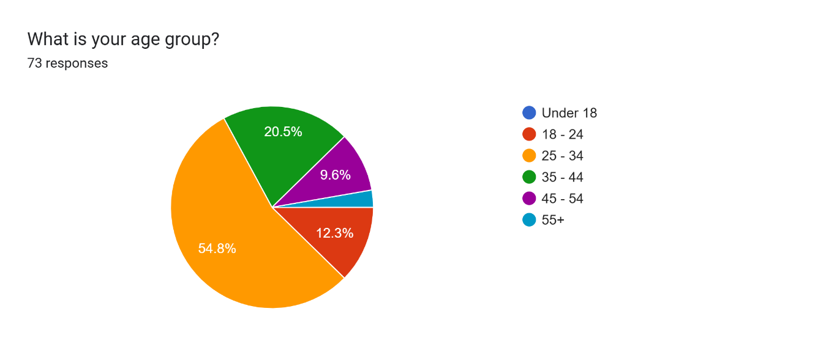
Note: This graph illustrates the age breakdown of the 73 survey respondents. The dominant group falls within the 25–34 age range, suggesting a primary target market of young adults with active purchasing behaviors. This demographic insight supports the development of convenience-based products such as grab-and-go breakfast items and modern packaging.

Respondents came from a variety of occupational sectors, indicating broad market reach. These sectors include education, retail, tourism/hospitality, healthcare, banking, IT, logistics/distribution, and self-employment, among others. This variety suggests opportunities to tailor offerings (such as grab-and-go breakfast items for busy professionals) and marketing strategies (such as workplace deliveries or loyalty programs).
Geographically, most respondents indicated residency within Orange Walk Town, particularly areas close to central business zones or residential communities like those near 123 Supermarket. This aligns favorably with the bakery’s proposed home-based location on Bliss Drive, which is accessible and in proximity to schools, shops, and transit points, providing a strategic advantage for foot traffic and local brand recognition.

Purchase Behavior
The data indicates that most customers purchase baked goods 1–2 times weekly, with a sizable number also purchasing 3–4 times. This frequency suggests strong recurring demand. Peak buying times range from early morning through lunchtime, underscoring the opportunity to align product availability with daily routines. This timing insight suggests the need for early preparation and scheduling to meet customer expectations, particularly for items consumed such as breakfast or midday snacks.

Figure 5 Purchase Frequency (Source: Market Research Survey)

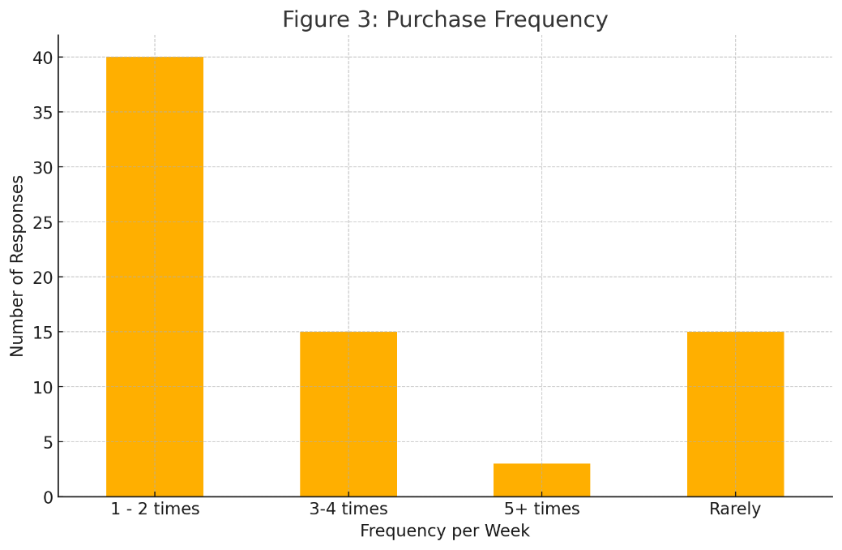
Note: This graph displays how often respondents purchase baked goods. The majority report buying 1–2 times per week, confirming consistent demand for fresh products. This frequency highlights the importance of establishing routine purchasing habits and maintaining regular product availability.

Product Preferences
Customer preferences lean heavily toward traditional Belizean baked goods. Cheese buns, Johnny cakes, and banana bread are among the most favored, while sweet options like cupcakes, cookies, and cinnamon rolls also perform well. Notably, there is growing interest in health-conscious products such as gluten-free, low-sugar, and high-fiber options, reflecting an evolving consumer mindset toward wellness. Furthermore, the survey highlighted enthusiasm for seasonal or limited-time offerings, with many respondents expressing interest in rotating menus, which is an opportunity to introduce creative and themed products that drive anticipation and loyalty.
Figure 6 Product Preferences (Source: Market Research Survey)
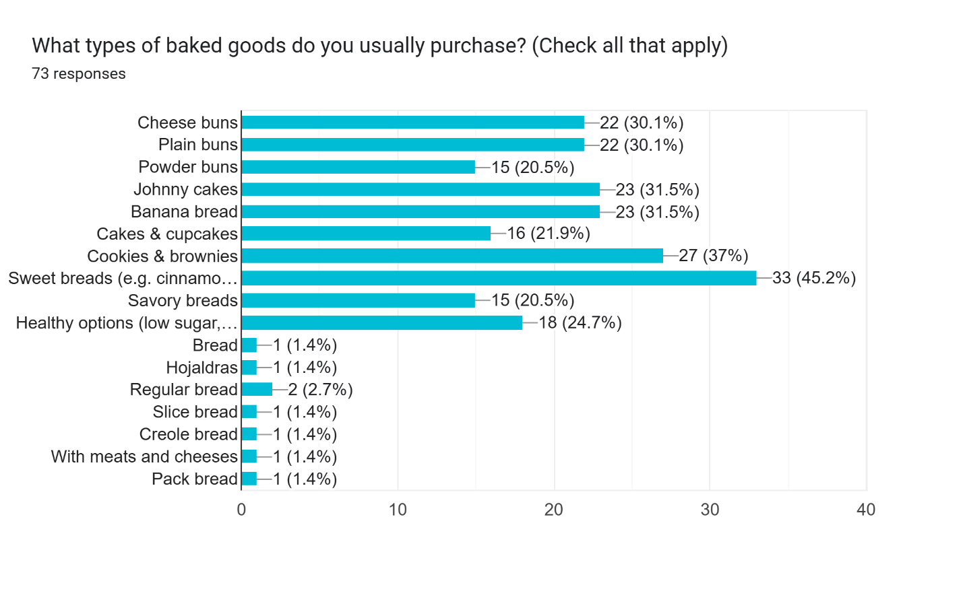
Note: This chart identifies the most frequently preferred bakery items among respondents, with Johnny cakes, cheese buns, and banana bread ranking highest. This insight directly informs product development, indicating which core items to prioritize in the launch phase.

Breakfast items emerged as a highly attractive category, with many customers indicating they would be interested in placing breakfast orders. Preferences are split between full breakfast dishes and on-the-go options like Johnny cake sandwiches, offering dual product lines that can cater to both leisurely and time-conscious consumers.
Beverage Preferences

Customers overwhelmingly pair baked goods with beverages, with coffee and juice ranking highest. This presents a clear cross-selling opportunity: bundling coffee or juice with baked goods could increase the average transaction value and enhance the customer experience. Tea and flavored water also hold appeal, especially among health-conscious segments.
Cross-Selling Strategy and Financial Projections
To enhance average transaction value and improve revenue efficiency without significantly increasing operational complexity, a cross-selling strategy will be implemented. This approach involves pairing high-demand baked goods with complementary beverages such as coffee, iced tea, or flavored water. These product combinations aim to increase impulse purchases and improve customer satisfaction by offering convenient bundle options.
Table 6 Scenario Analysis: Estimated Weekly Revenue from Cross-Selling (Source: Author of Study)
Bundle | Average Customers per Week | Estimated Add-On Rate (30%) | Price per Beverage | Additional Weekly Revenue (BZD$)
Cinnamon Rolls + Coffee | 150 | 45 | BZD $3.00 | BZD $135.00
Cheese Buns + Iced Tea | 120 | 36 | BZD $3.50 | BZD $126.00
Banana Bread + Flavored Water | 90 | 27 | BZD $3.00 | BZD $81.00
Total Weekly Revenue | — | — | — | BZD $342.00
Monthly and Annual Projections
- Monthly (4 weeks):
BZ$342.00 × 4 = BZ$1,368.00
- Annual (48 operational weeks):
BZ$342.00 × 48 = BZ$16,416.00
These projections demonstrate the potential for significant revenue generation through strategic cross-selling. Even with conservative assumptions (30% add-on purchase rate), an additional BZ$1,300–BZ$1,400 per month could be earned. This additional revenue stream can support reinvestment into packaging, equipment maintenance, or marketing.

Price Sensitivity
A majority of respondents are comfortable paying between $2–$4 BZD per item, with a smaller group willing to spend up to $7 BZD. This price sensitivity suggests a need to position offerings as affordable indulgences. While maintaining artisanal quality, a careful pricing strategy is essential to stay competitive while also ensuring healthy profit margins. These insights support a product mix strategy that includes core staples at entry-level prices and premium or seasonal offerings that command slightly higher pricing.
Figure 6 Price Preferences (Source: Market Research Survey)

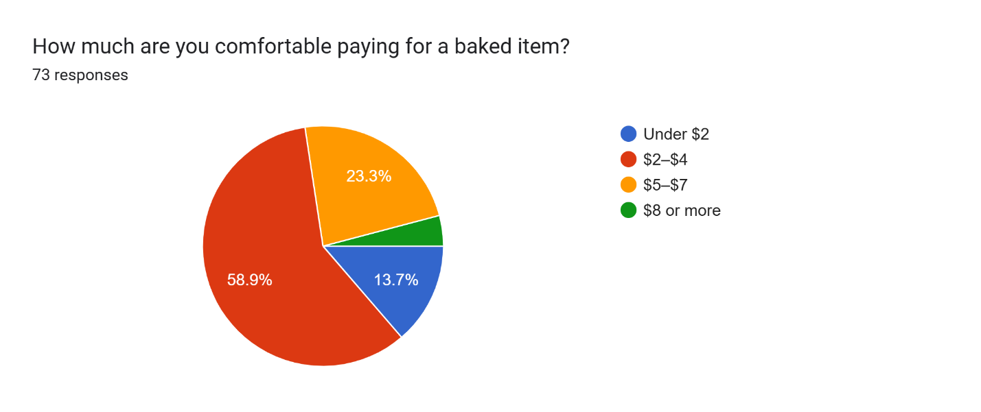
Note: This graph reflects price sensitivity among consumers, with most respondents indicating comfort in the BZ$2–BZ$4 range. This validates the need for a value-driven pricing model that balances affordability with quality to appeal to the broader market.

Service Expectations
In terms of service preferences, customers show a balanced demand for both pickup and delivery options. However, many still prefer the traditional pickup model, likely due to the familiarity and cost-effectiveness. Payment readiness leans toward cash and mobile payments, reflecting the growing local use of digital wallets and banking apps. Preferred purchasing times, as revealed earlier, reinforce the need for flexible service hours, particularly in the early morning and at lunchtime windows.

Summary of Key Findings
The market study demonstrates that consumers in Orange Walk Town are driven by tradition, convenience, and evolving dietary awareness. They crave familiar tastes but are open to exploring seasonal specials and healthier alternatives. Their price expectations are clear, and their service preferences allow for a hybrid model of pickup and future delivery expansion.
These insights are not only informative but, they are also transformative. They offer a roadmap for launching a bakery that feels tailored, relevant, and responsive to the community’s needs. By centering customer expectations in the planning process, the micro bakery can distinguish itself from mass-produced competitors and build a loyal, engaged customer base from the very beginning.

Competitor and Product Analysis
Understanding the competitive landscape is essential for positioning a micro bakery effectively within the local market. This section provides a structured analysis of existing bakeries operating in Orange Walk Town and Belize City, focusing on their product offerings, pricing strategies, service models, and market positioning. This evaluation is based on primary interviews with local bakery owners, as well as secondary research gathered from bakery menus, social media platforms, and customer feedback.
Overview of Local Bakery Competitors

Three notable bakeries were reviewed: Bakery A, Bakery B, and Bakery C. These establishments were selected based on their proximity to the target location, customer visibility, and variety of offerings.
Table 7 Competitor Analysis (Source: Market Research Interviews)
 | Bakery A | Bakery B | Bakery C
Top-Selling Baked Goods | Cinnamon Rolls, Sticky Buns, Assorted Cheesecake Flavors | Cakes (Slice cakes & regular size cakes) & Sweet Bread | Banana Bread, Brownies, Powder Buns
Customer Pricing Preferences | $7.50 to $10 per item | $4 - $7 cake slices $0.50 - $1.25 sweet bread | $3 - $6
Operational Challenges | Short-staffed | Shelf-life management and freshness, daily production planning | Suppliers frequently run out of raw materials
Product Development & Selection | Based on customer demand/wants | Tracking customer wants and repeat purchases | Management team
Marketing & Promotional Strategies | Social Media (Facebook & Instagram) | Social Media | Donation route (preferred over TV or Radio ads)
Peak Sales Periods | 2 PM - 5 PM | 10 AM – 12 PM & 5 PM - 7 PM | 7 AM - 9 AM
Note: This comparative table outlines the operational dynamics of three prominent bakeries in Orange Walk Town. It highlights product focus, pricing tiers, customer engagement strategies, and operational constraints. This comparison informs strategic positioning by identifying areas of overlap and differentiation potential for the proposed bakery, particularly in product innovation, marketing approach, and service delivery. All prices are in Belizean Dollars.
These bakeries serve different market segments, from budget-conscious customers to those seeking premium or artisanal options. However, each leaves strategic space for differentiation, particularly in product innovation and consumer engagement.

Product Benchmarking
Based on interviews and menu reviews, the most common products offered across bakeries include buns, cakes, johnny cakes, and sweet breads. Despite their popularity, there is limited incorporation of health-conscious items (e.g., gluten-free, high-fiber) and modern packaging.
The product benchmarking exercise identified gaps in seasonal product planning, breakfast-on-the-go solutions, and innovative pairings with beverages such as flavored coffee or teas. These gaps represent key opportunities for a new bakery to differentiate itself.

Pricing Positioning
The collected price lists showed that most bakeries operate within a $1.00–$6.00 range for standard items. Premium items such as seasonal pies or specialty cakes may reach up to $10.00. This insight aligns with consumer survey findings indicating that most customers are comfortable spending $2–$4 per baked item, with some openness toward higher pricing for artisanal or limited-time goods.

Service and Customer Engagement
All three competitors primarily rely on in-store pickup with limited or no delivery services. Their customer interaction occurs largely through walk-ins or social media responses. Loyalty programs, pre-order systems, or direct community involvement are notably absent.
This presents a valuable opportunity for a new bakery to engage differently through WhatsApp order systems, scheduled pickups, subscription offerings, and community collaborations (e.g., school tie-ins or morning delivery services).

Notable Gaps and Strategic Opportunities
From the competitive analysis, the following gaps were identified:
- Lack of health-conscious or specialty products.
- Minimal investment in aesthetic presentation and packaging.
- Limited use of digital platforms for order placement or loyalty tracking.
- Underserved segments such as schoolchildren, office workers, and commuters seeking grab-and-go options.
A micro bakery positioned as an artisan, customer-focused operation offering convenience, innovation, and personalization can successfully capitalize on these gaps. These findings will directly inform branding, menu development, and operations strategy in later stages of the business planning process.
Table 8 SWOT Analysis (Source: Market Research Survey)
Strengths | Weaknesses
• Clear product demand patterns identified (e.g., cheese buns, banana bread, Johnny cakes) | • Limited current product differentiation among competitors makes customer expectations harder to exceed without added value
• Existing consumer interest in health-conscious and breakfast items presents innovative potential | • Lack of visibility from competitors may reduce benchmark quality for innovation
• Opportunities to leverage modern marketing tools (e.g., social media, digital ordering) | • Inexperience in bakery operations could pose a challenge for operational efficiency and pricing accuracy
• Established access to equipment and location minimizes startup costs | • Initial home-based setup may limit product range and volume compared to competitors
Opportunities | Threats
• Untapped market segments: seasonal products, grab-and-go breakfast, and healthy options | • Established bakeries with loyal customer bases could respond quickly to new competition
• Customers are actively looking for new bakery experiences and variety | • Price-sensitive market may resist premium pricing for artisanal or specialized items
• Strong desire for delivery and modern convenience services (as revealed in survey) | • Rising ingredient costs and supply chain volatility may affect pricing and availability
• Potential to develop a niche through rotating menus and digital engagement | • Regulatory or food safety requirements may create barriers during expansion

Note: This SWOT matrix synthesizes internal and external factors impacting the proposed micro bakery’s viability. It draws on insights from customer surveys, competitor benchmarking, and operational planning. This tool is instrumental in guiding strategic decision-leveraging strengths such as low startup costs and identifying market opportunities like health-conscious products and digital services, while acknowledging existing threats such as price sensitivity and regulatory requirements.

Location Analysis and Cost Integration
A bakery's accessibility, clientele, and operational sustainability are all significantly influenced by its location. Location affects foot traffic, logistical efficiency, and the viability of initial operations financially, especially for microbusinesses. The strategic and financial ramifications of opening the proposed micro bakery at 88 Bliss Drive in Orange Walk Town are examined in this section. This research attempts to determine whether the chosen location is suitable for supporting the bakery's initial launch as well as future growth by evaluating the physical environment, competitive dynamics, and cost-related aspects.
Orange Walk Town serves as a hub for residential and commercial activity in northern Belize, offering a unique mix of customer demographics, transport connectivity, and business potential. The site under consideration lies within a densely populated zone with a high volume of daily movement due to its proximity to schools, supermarkets, and other businesses. It provides inherent logistical and marketing advantages due to its visibility and ease of access from the main highway.
Furthermore, the use of a home-based structure reduces startup overhead by eliminating rental costs and leveraging existing assets, such as an industrial oven and baking equipment. This model not only aligns with lean business practices but also creates flexibility, in adapting to market demand. However, as with any location strategy, trade-offs exist especially in the form of regulatory limitations, operating hour constraints, and competitive saturation in the broader Orange Walk area.
This subsection will therefore present a detailed overview of the site characteristics, assess strategic strengths and weaknesses, analyze current and future cost implications, and determine how the location supports the business’s short- and long-term goals.
Location Overview

A well-selected location can significantly influence the success of a micro bakery, especially in a town like Orange Walk, where local foot traffic, proximity to key institutions, and ease of access play important roles in consumer decision-making. This section provides an in-depth analysis of the chosen location, highlighting its strategic positioning, inherent advantages, and operational considerations.
The proposed micro bakery will begin as a home-based business located at 88 Bliss Drive in Orange Walk Town, an address strategically positioned with easy access from the main highway. The area benefits from a mixed-use zoning pattern, combining residential housing with nearby commercial businesses. Key nearby landmarks include 123 Supermarket, The Healthy Butcher across the Street, Agricentro Fruit & Vegetables shop a 5-minute walk away, a school within walking distance, an ATM, a local restaurant, a dialysis center, and a nail salon. This commercial-residential blend ensures a steady flow of potential customers from various demographics. The location is five minutes away from the town center by vehicle and boasts strong visibility due to its proximity to the highway. Accessibility and foot traffic potential are enhanced by the presence of multiple high-use destinations nearby.
Strategic Advantages
One of the standout advantages of the proposed bakery location is the elimination of rental expenses during the initial phase, as the business will operate from the owner’s home. This significantly reduces startup and operational costs. Additionally, the household already has commercial grade baking equipment, including an industrial oven and mixers, previously used for seasonal baking. The central location enhances delivery feasibility and makes it easy for customers to access pickup services. The property includes parking space, enabling drive-up and potential dine-in developments. Its visibility from the highway allows for strong brand exposure to passersby, supporting future growth plans without relocation.
Limitations & Operational Constraints
Despite its advantages, the home-based model presents certain operational limitations. Initially, the bakery will operate only on weekends due to the owner's full-time employment. This restricts production capacity and customer reach to specific days. The home setup may also pose challenges for creating a walk-in or dine-in atmosphere, limiting spontaneous sales and reducing the depth of customer experience. Furthermore, Orange Walk already hosts multiple small bakeries, presenting significant competition. Long-term expansion could also raise zoning and licensing concerns as the business grows.
Cost Implications
The home-based nature of the business model offers a lean startup advantage. Initial capital expenditures are minimized due to the absence of rent and the use of pre-existing equipment. Operating costs will primarily include utilities (water, electricity), raw materials (flour, eggs, sugar, etc.), labor if needed, and packaging.
Future plans include renting a commercial space on the same compound. Rent prices for a business in this area range from BZ$1,000 to BZ$1,800, based on interviews conducted with the compound's landlord, who currently rents to a pawn shop, a dialysis center, an electricity collection agency, and hosts an ATM.
For expansion, the business now envisions operating from a custom-fitted cargo trailer bakery stationed on the same lot. Based on current marketplace pricing, a fully outfitted trailer suitable for bakery operations is projected to cost between BZ$15,000–BZ$25,000. To complement the trailer, an outdoor garden-style dining space will be created. This space will include:
- Four patio table sets (each with four chairs) priced at BZ$800 per set, providing a comfortable open-air seating area for guests.
- Blanket rentals at BZ$5 each to encourage picnic-style dining on the lawn, enhancing the overall experience and providing low-cost dine-in flexibility.
- Separate bathroom area will be constructed to support dine-in operations without being integrated into the trailer itself.
Other Cost Considerations:
- Branding and Marketing: Initial promotional setup (logos, signage, menu design, and digital media content) is budgeted at BZ$1,500.
- Licensing & Permits: Estimated at BZ$300–BZ$500 annually, subject to business scale.
- Utilities & Supplies: Monthly operating expenses will vary by production volume but are expected to remain manageable due to the staged nature of expansion.
Compliance & Permitting Considerations:
To legally operate a micro bakery in Belize, whether from a home-based kitchen or a cargo trailer, certain permits and licenses are required. These typically include a Trade License from the local Town Council (estimated BZ$200–BZ$500 annually based on business size and location), a Food Handler’s Certificate for all food prep staff, and clearance from the Public Health Department, particularly if a food trailer or outdoor dining is involved. For the planned expansion, zoning and structural approvals may be needed for the cargo trailer installation and the construction of a dedicated bathroom facility. These requirements align with the guidelines outlined in (BELTRAIDE, 2022), which emphasizes proactive compliance as a foundation for sustainable growth.
Expansion Potential
The property has ample space for gradual expansion. Plans include launching the cargo trailer bakery model with adjacent garden-style seating to foster a warm, community-oriented atmosphere. This layout allows for both traditional seating and informal picnic-style options, broadening the appeal to various customer types. A mobile van remains a future consideration to extend reach to schools and workplaces. The strategic positioning of the lot along a high-traffic corridor supports sustainable scale-up without the need for costly relocation.
Summary & Strategic Fit
The proposed location presents a strategic fit for launching a cost-effective and accessible micro bakery. With zero rental obligations in the initial phase, access to equipment, and high visibility, it aligns closely with customer preferences for pickup and convenience. The home-based setup provides a low-risk foundation for experimentation, allowing the business to test products, build a loyal customer base, and prepare for scalable growth. With nearby businesses and institutions feeding foot traffic, the site represents a strategic strength that supports a lean, phased business model grounded in realistic, localized operations.

Demographic and Community Profile
Understanding the demographic composition and community characteristics of Orange Walk Town is essential for aligning the micro bakery’s business strategy with the preferences and expectations of its target audience. This section provides a profile of the town’s residents, highlighting population structure, employment patterns, household dynamics, and cultural preferences. These insights will guide decisions on product offerings, pricing, and service delivery models to ensure market fit and customer satisfaction.
Population Overview

Orange Walk Town is a bustling hub in northern Belize with a diverse and growing population. While exact figures fluctuate, the town is known for its tightly knit communities and economic activities centered around trade, education, and small-scale enterprise. The typical household size ranges from four to six individuals, and many families operate or support small businesses. This community dynamic is conducive to supporting localized ventures such as micro bakeries, which benefit from community loyalty and word-of-mouth promotion.

Age Distribution
The majority of survey respondents fall within the 18–44 age range, a demographic associated with both earning power and active consumer behavior. This aligns with broader district-level data, suggesting a youthful and economically active population. These age groups tend to value convenience, variety, and quality—factors that directly influence their food purchasing decisions. By targeting these segments, the bakery can focus on product innovation, seasonal offerings, and branding strategies that resonate with a vibrant and trend-aware audience.
Income and Employment Profile

Survey data indicates a diverse employment landscape, with notable representation from the education, healthcare, tourism, and retail sectors. Self-employment is also significant, reflecting a strong entrepreneurial spirit in the community. While income levels vary, the preferred pricing range for baked goods is between BZ$2 and BZ$4 which suggests sensitivity to affordability. This highlights the need for value-driven offerings that combine quality with competitive pricing, making the bakery accessible to a wide cross-section of the population.
Community Infrastructure and Economic Activity
The bakery’s location is surrounded by active commercial and service-based establishments, including schools, a supermarket, a restaurant, and a medical center. This provides not only a ready market but also frequent foot traffic and visibility. The mixed zoning environment supports small business growth and makes it easier to introduce complementary services like pre-order pickups and event catering.
Cultural and Social Preferences
Cultural preferences in Orange Walk lean toward traditional baked goods with a nostalgic or homemade appeal. However, there is a growing openness to health-conscious alternatives and seasonal specialties. Socially, there is a strong culture of morning bakery runs and purchasing in bulk for family needs. The community also places value on locally made products and personal connections with vendors, which presents an opportunity for the bakery to build strong customer relationships.
Implications for Bakery Operations
The demographic and community insights strongly support the feasibility and relevance of a micro bakery in Orange Walk Town. The youthful, working-class population is likely to appreciate accessible, flavorful, and high-quality baked goods that fit into their routines and budgets. The location’s proximity to essential services and institutions further enhances its viability. Tailoring offerings reflect community tastes while incorporating trends such as healthy options and seasonal items that can position the bakery as both dependable and innovative. This alignment between community profile and business model strengthens the foundation for sustainable success.
Orange Walk Town Demographic & Socioeconomic Data
To enhance the primary research findings with national-level statistics, this subsection provides official demographic and socioeconomic data for Orange Walk Town, sourced from the 2022 Population and Housing Census conducted by the Statistical Institute of Belize (Statistical Institute of Belize, 2023).
According to the Census, the total population of Orange Walk Town is 13,624 individuals, comprising 6,626 males and 6,998 females, indicating a slightly higher female population (SIB, 2023, p. 17). The town is the most populated urban center in the Orange Walk District, accounting for over 40% of the district's total population.
The median age in Orange Walk Town is 27 years, highlighting a youthful demographic that aligns with the age profile observed in the survey, where the majority of respondents were between 25–34 years old. This reinforces the finding that the primary target market consists of economically active young adults likely to engage in regular bakery purchases.
The average household size in Orange Walk Town is 4.1 persons per household, and over 65% of households report having children under the age of 15 (SIB, 2023, p. 29). This family-oriented structure suggests high demand for baked goods catering to both adults and children, such as cheese buns, cupcakes, and sandwich options.
In terms of education and employment, 54% of Orange Walk Town residents over the age of 15 have completed secondary education or higher, and the employment rate is estimated at 58% (SIB, 2023, pp. 34–36). Common employment sectors include retail, education, healthcare, and public administration, aligning with findings from the project’s primary survey and supporting the feasibility of weekday and early morning bakery operations targeted at working professionals.
Socioeconomic data from the 2021 Labour Force Survey suggests that the average monthly income in the Orange Walk District is approximately BZ$1,000–BZ$1,200, depending on sector and experience level (Statistical Institute of Belize, 2023). This supports the project's pricing model, where 80% of survey respondents indicated comfort with bakery items priced between BZ$2–BZ$4, further affirming product-market alignment.
Overall, this supplementary data reinforces the demand potential for a community-anchored micro bakery in Orange Walk Town, with a customer base that is young, employed, and family-centered, and whose income levels support frequent purchases of affordable, high-quality baked goods.

Technical and Legal Study of the Bakery Industry
Launching a micro bakery demands a comprehensive understanding of the technical and legal requirements that govern food businesses in Belize. This section presents a technical and legal study designed to guide the structured launch and sustainable growth of the proposed micro bakery in Orange Walk Town. The objective is to identify all mandatory legal, operational, and investment prerequisites, helping to mitigate compliance risks and improve financial planning accuracy.
Small enterprises in Belize often face significant barriers due to inconsistent knowledge of registration protocols, licensing conditions, or infrastructure needs (BELTRAIDE, 2022). As such, this analysis addresses critical areas including business licensing, public health certifications, and space compliance, which are essential to legally operate a food-related venture. In addition, it outlines the financial commitments required to prepare a functional baking space, whether from home or a modified cargo trailer, including equipment procurement, utility infrastructure, and food safety modifications.
This section also examines workforce needs and salary benchmarks to define an initial organizational structure tailored to the scale and scope of the operation. Supplier sourcing, ingredient pricing, and utility costs are evaluated to establish realistic monthly operating budgets. Together, these elements will form the operational foundation for a lean yet legally compliant bakery that aligns with local market conditions.

Legal Requirements to Operate
Business Name Registration

The formalization process begins with the registration of the business name through the Belize Companies and Corporate Affairs Registry (BCCAR). This procedure applies to sole proprietorships and partnerships and requires a name availability search, followed by submission of a completed Business Name Registration Form. The processing timeline typically ranges from two to five working days. Associated fees vary from BZ$25 to BZ$50, depending on the business structure and type of registration (BELTRAIDE, 2022)
Trade License

All businesses operating within a municipality must obtain a Trade License from the respective Town Council. For a home-based or mobile micro bakery situated in Orange Walk Town, the license fee is calculated based on either the rental value of the premises or the estimated turnover of the business. The standard licensing cost for small businesses ranges from BZ$200 to BZ$500 annually. Prior to issuance, a site inspection by the Trade Licensing Board may be required to assess suitability (BELTRAIDE, 2022)
Food Handler’s Certificate

Personnel engaged in food preparation or handling are mandated to obtain a Food Handler’s Certificate from the Ministry of Health and Wellness. This certification process includes attendance at a food safety training session and successful completion of a written assessment. The certificate remains valid for one year and must be prominently displayed within the food establishment. All individuals involved in production or packaging of baked goods, including the business owner, are required to be certified (SBDCBelize, n.d.-b).
Public Health Approval

Given that the business will involve the preparation and sale of food to the public, inspection and approval from the Public Health Department is compulsory. For home-based bakeries, compliance is contingent upon meeting minimum sanitary standards, including hygiene, pest control, and access to handwashing stations. In the case of a mobile bakery operating from a cargo trailer, the inspection must confirm appropriate waste management, water access, and compliance with mobile unit structural guidelines (BELTRAIDE, 2022).
Tax Registration

Registration with the Belize Tax Service Department (BTSD) is required for the issuance of a Tax Identification Number (TIN). In cases where projected annual revenues exceed BZ$75,000, the business must also register for General Sales Tax (GST). GST-registered businesses are obligated to charge 12.5% tax on applicable goods and services and to remit this amount monthly. Noncompliance may result in penalties and legal action (BELTRAIDE, 2022).
Social Security Registration
In instances where employees are hired, the business must be registered with the Social Security Board (SSB). Both employer and employee are required to contribute to the national scheme, with the employer responsible for timely submission of contributions by the 14th of each month. Accurate payroll records must be maintained to demonstrate compliance with national labor regulations (BELTRAIDE, 2022).

Optional: Business Support Services

Although not mandatory, small business operators are encouraged to engage with institutions such as BELTRAIDE and SBDC Belize. These entities provide valuable support services including business plan development, entrepreneurship training, market research assistance, and access to funding opportunities such as micro-loans and startup grants (SBDCBelize, n.d.-b).
Figure 6 Business Support Services Outline (Source: BELTRAIDE)
Legal Requirement | Responsible Agency/Entity | Estimated Cost (BZ$) | Frequency
Business Name Registration | BCCAR | 25 – 50 | One-time
Trade License | Orange Walk Town Council | 200 – 500 | Annual
Food Handler’s Certificate | Ministry of Health & Wellness | ~30 | Annual
Public Health Clearance | Public Health Department | Varies (no fixed cost) | Annual/reinspection
Tax Identification Number | Belize Tax Service Department | Free | One-time
GST Registration (if applicable) | Belize Tax Service Department | Free | Monthly filings
Social Security Registration | Social Security Board | Based on payroll | Monthly

Equipment and Space Preparation Costs

Establishing a functional and compliant space for bakery operations requires careful planning of equipment procurement, space setup, and health and safety upgrades. This section outlines the projected costs and logistical requirements for outfitting the micro bakery across different operational phases beginning with a home-based setup and evolving into a cargo trailer bakery with a dedicated outdoor dining space.
Equipment Inventory

Launching even a small-scale bakery requires specialized commercial and domestic-grade baking equipment. The inventory below outlines essential tools and appliances, along with estimated cost ranges based on research from local Belizean suppliers and regional online platforms (e.g., Brodies, Benny’s, and regional suppliers via Facebook Marketplace):

Equipment | Quantity | Estimated Cost (BZ$)
Industrial Oven (existing) | 1 | Already available
Commercial Mixer (existing) | 1 | Already available
Additional Stand Mixer (4.5–6 qt) | 1 | 450 – 600
Cooling Racks | 2–4 | 75 – 150 each
Worktables and prep surfaces | 2 | 200 – 300 each
Storage Shelves (for dry goods) | 2–3 | 150 – 250 each
Food-grade Containers | 10+ | 10 – 25 each
Measuring Equipment | Set | 75 – 100
Scales (Digital) | 2 | 60 – 90 each
Packaging Supplies (starter stock) | - | 300 – 500
Display Shelf (for trailer setup) | 1–2 | 250 – 400
Blender or food processor (optional) | 1 | 200 – 300
Note: Where items are marked as “existing,” no upfront cost is expected during the startup phase. These assets reduce initial capital expenditure considerably.

Space Setup Scenarios

To accommodate the bakery’s evolving operational model, three primary space configurations are considered:
A. Home-Based Kitchen Setup
The initial phase will utilize the existing residential kitchen setup, which includes access to an industrial oven and mixer. Minor upgrades such as a designated baking zone, organized storage, and handwashing station may be required to meet Public Health standards.
- Cost Estimate: BZ$300 – BZ$500 (storage bins, shelving, labeling, sanitization station)
- Limitations: Restricted hours of operation, space constraints, and zoning limitations for customer access
B. Cargo Trailer Setup
In the expansion phase, a customized cargo trailer will be converted into a mobile bakery. The trailer must be fitted with counters, lighting, power outlets, plumbing for water access, and food-safe surfaces. Basic equipment and display space will also be installed.
- Trailer Base Price: BZ$15,000 – BZ$25,000 (based on Facebook Marketplace listings and regional trailer suppliers)
- Fit-Out and Fixtures: BZ$5,000 – BZ$8,000 (electrical, stainless-steel counters, shelving, water system)
- Additional Utilities: Generator or hookup to compound power grid (BZ$800 – BZ$1,200 depending on scale)
C. Outdoor Garden Dining Space
A picnic-style outdoor dining area will be developed next to the trailer on the family property to enhance customer experience.
- Patio Sets: 4 sets at BZ$800 each = BZ$3,200
- Blankets for Lawn Dining: BZ$35 each (5-10 units)
- Signage, Lighting & Decor: BZ$1,000 – BZ$1,500 (solar lights, menu board, branded signs)
- Fencing & Shade Canopy (if needed): BZ$1,500 – BZ$2,500
This setup allows for both traditional and casual dining options, encouraging customer engagement and increasing dwell time.

Permits and Safety Upgrades

Compliance with health and safety requirements involves targeted investments in sanitation, infrastructure, and utilities:
- Handwashing Station Installation: BZ$150 – BZ$300 (sink, water source, dispenser)
- Plumbing & Water Tanks: BZ$500 – BZ$1,000 (for cargo trailer setup)
- Ventilation Fan or Airflow System: BZ$300 – BZ$600
- Fire Extinguisher & First Aid Kit: BZ$100 – BZ$250 (required for certification)
- Pest Control Measures: BZ$100 – BZ$200 (screened vents, rodent-proof storage)
These upgrades are critical for receiving approval from the Public Health Department and maintaining ongoing sanitary conditions, particularly in compact food service environments like trailers.

Organizational Structure
A clearly defined organizational structure is critical for the sustainable operation and gradual scaling of the micro bakery. This section outlines the initial staffing strategy, wage projections, labor compliance requirements, and a projected five-year staffing model to support business growth and customer demand.
Human Resources Plan
In the startup phase, the micro bakery will operate with a lean team designed to optimize labor costs while maintaining efficient production and service quality. The following roles are essential:
- Owner/Head Baker: Responsible for product development, baking, quality control, purchasing supplies, and managing operations.
- Part-Time Bakery Assistant: Supports the Head Baker with dough preparation, baking assistance, cleaning, and packaging.
- Weekend Cashier/Delivery Assistant (Optional): Assists with customer pickups, basic cashier duties, and local deliveries when applicable.

Role | Responsibilities
Owner/Head Baker | Recipe development, baking, inventory control, purchasing, and administration.
Bakery Assistant | Prep support, baking assistance, cleaning, packaging.
Cashier/Delivery Support | Customer service, order pickup facilitation, mobile delivery support.

Staff during the startup phase will align with weekend-only operations and will gradually increase as the bakery transitions into expanded hours.
Salary Estimates and Labor Cost Planning

Wage benchmarks are informed by Belize’s labor standards and typical compensation for bakery staff in small food businesses. The following are projected salary estimates:
- Bakery Assistant (Part-Time/Weekend): BZ$3.75–BZ$5.00 per hour (National minimum wage as of January 2023 is BZ$5.00/hr for all categories).
- Cashier/Delivery Assistant: BZ$3.75–BZ$5.00 per hour (may vary based on delivery responsibilities).

Social Security contributions are mandatory for all employed persons in Belize. The employer must contribute 8.0% of an employee’s insurable earnings, while the employee contributes 3.5%, for a combined total of 11.5% (Social Security Board, 2024). Payroll records must be maintained, and contributions must be submitted monthly to ensure compliance with labor laws.

Staffing considerations:

- Initially, the bakery will operate primarily under the owner with occasional help on weekends.
- As sales grow, increased demand will justify additional hours for part-time roles and potentially hiring for new positions.
Future Hiring Plans

By year five, the micro bakery is projected to operate multiple days per week with expanded customer service, marketing, and delivery functions. The organizational chart will be updated to reflect this expansion:

Table 9 Projected 5-year Organizational Structure
Position | Key Responsibilities
Owner/Head Baker | Business strategy, recipe innovation, production oversight, supply chain management.
Assistant Baker | Day-to-day baking operations, dough prep, product consistency, sanitation.
Cashier/Cleaner | POS management, customer interactions, packaging, cleaning, and closing duties.
Delivery Driver | Managing local deliveries, tracking orders, assisting with logistics and outreach.

This expanded team will support full weekday and weekend operations, delivery services, and limited catering. Staffing decisions will be based on customer volume, seasonal peaks, and business profitability.

Suppliers and Operational Inputs

A successful bakery relies heavily on the consistent availability of high-quality ingredients, packaging materials, and supporting utilities. This section outlines the critical inputs required for day-to-day operations, evaluates sourcing options, and provides baseline cost projections. These insights are intended to guide procurement planning, supplier selection, and cost management strategies, both at launch and throughout the bakery’s growth trajectory.
Ingredient Sourcing

The core ingredients required for the micro bakery include flour, eggs, sugar, butter or margarine, milk, yeast, salt, baking powder, flavorings (e.g., vanilla, cinnamon, nutmeg), and additives such as chocolate chips, raisins, and nuts. Additionally, non-edible materials such as parchment paper, baking pans, gloves, food-safe containers, and cleaning agents are essential for daily operations.
Sourcing strategies for these ingredients involve a comparison between local retail outlets and bulk/wholesale suppliers. Local retail purchases offer convenience and immediate access, especially for smaller batch productions during the initial phase. However, this approach often comes with higher per-unit costs. Bulk purchasing through wholesalers or distributors, such as local food service providers or cooperatives, presents significant cost savings, particularly when demand scales up. For example, while a 5-pound bag of all-purpose flour may cost BZ$5.00 at retail, a 100-pound sack from a bulk distributor may yield a lower per-pound rate. This cost efficiency becomes especially important for high-consumption inputs such as flour and sugar.
Perishability is a key factor influencing sourcing decisions. Eggs, milk, and butter have shorter shelf lives, generally requiring weekly or biweekly replenishment to maintain freshness and food safety standards. On the other hand, dry goods like flour, sugar, salt, and flavorings can be stored for several weeks or months under proper conditions, making them suitable for bulk storage. An inventory rotation system using the “first in, first out” (FIFO) method is recommended to reduce waste and ensure ingredient quality.
Initial sourcing will combine retail and bulk options, with a gradual transition toward wholesale procurement as production volume increases. This hybrid approach provides operational flexibility during the launch phase and positions the bakery for cost-effective scaling.
Supplier Evaluation

Evaluating and selecting reliable suppliers is critical to maintaining production consistency, cost control, and product quality. Key evaluation criteria include supplier reliability, pricing transparency, availability of credit or flexible payment terms, delivery reliability, and product quality.
In Orange Walk Town and surrounding areas, local wholesale distributors such as Quality Poultry Products, L&R Distributors, and 123 Supermarket are common choices for foodservice-oriented businesses. Interviews with existing bakery operators indicate that while prices are competitive, supply inconsistencies, especially for items like eggs, butter, or packaging, can occur during peak periods or in adverse weather conditions.
To mitigate these risks, the business will establish relationships with at least two backup suppliers for each critical input, particularly perishable goods and packaging. Backup vendors help ensure supply chain resilience and provide leverage for price negotiations. Formalizing these relationships through written agreements or recurring order commitments is advisable for managing expectations and delivery timelines.
Additionally, supplier responsiveness to small business needs such as minimum order quantities, delivery schedules, and customer service will influence vendor selection. Establishing strong supplier relationships will also open opportunities for promotional pricing and priority restocking.
Monthly Supply Cost Estimates

Accurate monthly budgeting for supplies is fundamental to financial forecasting and cash flow management. Based on projected weekly production of approximately 100–120 items (buns, sweetbreads, breakfast sandwiches, etc.), the estimated monthly ingredient cost ranges from BZ$800 to BZ$1,000. This estimate assumes mid-range ingredient prices and includes perishables like eggs and dairy products.
Packaging is another recurring cost category. The bakery will use eco-friendly cardboard boxes, labels, plastic wrappers, and cups for bundled beverage offerings. Monthly packaging costs are expected to range between BZ$200 and BZ$300, depending on product line variety and order volume. Custom labeling and branding may introduce additional one-time design or printing costs in the range of BZ$150–BZ$250, which can be amortized over multiple months.
It is advisable to regularly review ingredient costs against market fluctuations and adjust pricing or sourcing strategies accordingly. Inflation, fuel prices, and changes in supplier policies may all impact monthly input costs.
Utility and Service Providers

Utility access and associated costs vary depending on the operational model—home-based kitchen versus cargo trailer. For the home-based phase, the primary utilities include electricity and water. Based on data from residential utility bills in Orange Walk, monthly expenses are expected to average BZ$120 for electricity and BZ$40 for water, considering the power usage of commercial baking equipment and cleaning requirements.
In the trailer model, additional infrastructure such as mobile water tanks, solar panels, or electrical hookups may be needed depending on location and connection points. Monthly utility costs in this model are projected to be slightly higher—approximately BZ$150–BZ$200—due to the use of additional lighting, refrigeration, and ventilation systems.
Internet and mobile payment solutions (e.g., E-kyash or bank card terminals) are vital for operations and customer convenience. The cost of a basic mobile internet package is estimated at BZ$40–BZ$60 monthly. Mobile payment services often come with transaction fees ranging from 1.5% to 3% per sale, which should be accounted for in pricing and cost tracking systems.
Together, utilities and service costs are expected to range from BZ$200 to BZ$300 monthly in the early stages of operation, depending on the model and production scale. These costs will scale with expansion and should be monitored closely through a monthly expense tracking system.

Summary of Findings
The technical and legal study of the proposed micro bakery has revealed the comprehensive set of requirements necessary to launch and sustain the business in compliance with national regulations. These include formal business registration, licensing, health and safety approvals, tax registration, and adherence to labor and social security laws. Operational requirements such as space configuration, procurement of equipment, and selection of suppliers were also addressed to ensure readiness for both initial and scaled production.
A detailed review of potential operational models, home-based kitchen, and cargo trailer bakery, highlighted the varying levels of investment and infrastructure needs. The home-based model offers a lean startup option with minimal rent and shared utility expenses, while the cargo trailer model supports strategic expansion with improved customer experience and brand visibility. The projected investment ranges for equipment, space preparation, and utilities provide a grounded basis for budget development and future financial planning.
From a human resources standpoint, the business can initially function with a lean team, expanding gradually as demand grows. Strategic role allocation and adherence to labor regulations ensure not only operational efficiency but also organizational sustainability. Supplier selection and operational input planning reflect a pragmatic approach, balancing affordability with reliability to maintain product consistency and reduce disruptions.
Collectively, the legal and technical framework aligns with the expectations expressed by potential customers in the market study. Customers prioritized product quality, accessibility, and service reliability factors directly supported by the proposed infrastructure and staffing strategy. By grounding the business model in both compliance and practical efficiency, the project is well-positioned to achieve long-term sustainability and carve a competitive edge in Orange Walk’s bakery market.

Financial Feasibility Study
A financial feasibility study assesses whether a proposed business can achieve profitability within a defined operational structure and market context. For this micro bakery project, the financial feasibility analysis evaluates start-up and ongoing costs, revenue projections, and potential return on investment. This section provides a comprehensive overview of the financial model underpinning the business plan, integrating cost estimates, pricing strategies, and sales forecasts to determine sustainability and scalability.
Startup Capital Requirements
Launching the micro bakery requires a lean yet effective allocation of capital. Initial costs include equipment, branding, packaging, licenses, and minor renovations to prepare the home-based kitchen. The projected costs are based on a phased development approach:
- Equipment & Appliances: BZ$8,000–BZ$12,000 (industrial oven, mixers, cooling racks, food prep tools)
- Cargo Trailer (Phase 2): BZ$15,000–BZ$25,000 for a fully outfitted trailer
- Outdoor Dining Setup: BZ$3,200 for four patio sets + BZ$5 each for picnic blankets
- Branding & Signage: BZ$1,500
- Licensing and Permits: BZ$500 (Trade License, Public Health approval, Food Handler’s Certificates)
- Initial Inventory & Supplies: BZ$1,200
Total estimated startup investment ranges between BZ$29,400–BZ$43,400, depending on the scope of Phase 1 versus Phase 2 implementation.
Revenue Forecasting

Revenue projections for the micro bakery are grounded in primary survey data collected from 72 respondents, the majority of whom reported purchasing baked goods 1–4 times per week. Pricing strategies were tailored to consumer feedback, which indicated an average willingness to pay between BZ$2 and BZ$4 per item, with openness to higher pricing for premium or bundled offerings.
Weekend Operating Revenue (Phase 1 – Home-Based Only)
During the initial startup phase, the bakery will operate exclusively on weekends (Saturday and Sunday). Based on estimated demand and promotional efforts, the business is projected to achieve an average of 100 individual transactions per weekend at an average price of BZ$3.50 per item:
- Gross weekly revenue: 100 × BZ$3.50 = BZ$350
- Monthly revenue (4 weekends): 4 × BZ$350 = BZ$1,400
This establishes a baseline for monthly income in the early stage.

Revenue Enhancement through Bundle Box Strategy
To increase average order value and streamline production, a “Weekend Treat Box” strategy will be implemented. These curated dessert boxes will contain 3–4 signature baked goods and will retail at BZ$12 to BZ$20, depending on the menu.
- Estimated sales: 25 boxes/week at an average price of BZ$15
- Weekly bundle box revenue: 25 × BZ$15 = BZ$375
- Monthly bundle box revenue: 4 × BZ$375 = BZ$1,500
This approach not only boosts total revenue but also allows for efficient batch production, which reduces ingredient waste and improves labor output.
C. Upselling and Product Mix Optimization
To further maximize profitability, strategic upselling tactics will be applied:
- Beverage pairings (cold brew, hibiscus tea, fresh juice):
Assuming 30% of customers add a drink,
Estimated: 30 drinks/week × BZ$4 = BZ$120/week or BZ$480/month
- On-site add-ons and impulse items:
Items like mini cakes, cinnamon roll upgrades, and pastries
Estimated: BZ$100–BZ$150 per week or BZ$400–BZ$600/month
These contribute directly to higher per-customer spending and provide additional value without significantly increasing overhead.
Total Monthly Revenue Forecast (Phase 1)
Revenue Stream | Monthly Estimate
Standard baked goods | BZ$1,400
Bundle boxes | BZ$1,500
Upsells & beverages | BZ$500 (average)
Total Projected Revenue | BZ$3,400
This demonstrates the potential to more than double the original BZ$1,400 monthly revenue by employing bundling, upselling, and targeted marketing—all within the same limited weekend operating hours.
Future Revenue Growth Potential
Once weekday operations begin, through pre-orders, breakfast pick-ups, and expanded dine-in or delivery services, revenue could increase significantly. Conservative projections estimate weekly income between BZ$500–BZ$700, or BZ$2,000–BZ$2,800 monthly, even before incorporating large-scale catering or mobile sales.
Other long-term revenue drivers include:
- Dine-in experiences (higher spend per customer)
- Mobile van deliveries to schools and offices
- Seasonal menus and holiday specials
Strategic Implications

The combination of these revenue streams highlights a clear strategy for maximizing earnings during Phase 1. By increasing order value, offering pre-order convenience, and appealing to weekend demand patterns, the bakery can generate sustainable income to reinvest in its Phase 2 infrastructure, such as trailer outfitting and garden dining spaces without extending operating hours. This financial momentum supports scalability, brand growth, and a smooth transition to weekday sales.

Break-Even Analysis
Break-even analysis helps identify the minimum sales volume required to cover monthly expenses.
Assuming:
- Average item price: BZ$3.50
- Monthly expenses: BZ$1,300
Break-even point = 1,300 / 3.50 = 371 units/month or approximately 93 units per week.
Given current consumer interest and Orange Walk Town’s foot traffic, this target is realistic within the weekend operating model, with further profitability expected upon expansion.
Financial Sustainability and Scalability

The lean startup model, combined with phased infrastructure investment, provides financial flexibility. Operating from a home base in the early stages enables efficient cost control and testing of product-market fit. As brand equity grows, the shift to the cargo trailer and outdoor dining model enables increased revenue without a dramatic spike in overhead.
With careful budgeting and incremental reinvestment, the micro bakery is projected to become profitable within the first 6–9 months. Strategic marketing and community engagement will support customer retention and revenue growth. The feasibility study confirms that the bakery is financially viable, scalable, and aligned with the preferences and purchasing power of its target market.
Revenue Optimization Strategies During Initial Phase
To maximize profitability while operating only on weekends during the initial home-based phase, the following strategies will be implemented:
Pre-Order System (Midweek Lead-Up)
- Launch a digital pre-order form (via WhatsApp or Google Forms) every Wednesday.
- Encourage early reservations with limited weekend availability (e.g., “Only 30 boxes available this weekend!”).
Curated Dessert Boxes
- Offer a “Weekend Treat Box” with a mix of 3–4 baked items priced between BZ$12–BZ$20.
- Improves average transaction value and production efficiency.
Breakfast & Brunch Focus
- Feature weekend-only grab-and-go breakfast combos (cheese buns, filled johnny cakes, cinnamon rolls).
- Target morning foot traffic and churchgoer
Loyalty Incentives
- Introduce a punch card system (buy 5, get 1 free).
- Designed to build consistent weekly customers.
Social Media Campaigns
- Hype products every Thursday–Saturday with behind-the-scenes reels and product showcases.
- Use urgency messaging to drive traffic ("Limited boxes available this weekend!").
Upsell Beverages
- Include cold brew coffee, hibiscus tea, or fresh juice for BZ$3–BZ$5.
- Increases the average ticket value per customer.
Pickup Experience
- Enhance the pickup zone with signage, a chalkboard menu, and limited patio seating.
- Offer on-site extras for impulse sales.
These combined efforts aim to increase monthly earnings from BZ$1,400 to as high as BZ$2,500 during the weekend-only phase, allowing reinvestment and early-stage growth. By maximizing per-customer value, building a loyal base, and improving operational efficiency, the bakery can generate sustainable revenue even with limited operating hours. This early financial momentum is critical for funding the second-phase expansion into a cargo trailer model and outdoor dining experience, laying the groundwork for broader weekday operations and long-term profitability.
Classification of Costs: Fixed vs. Variable
A critical component of cost management is distinguishing between fixed costs and variable costs, as this distinction supports more accurate financial forecasting, break-even analysis, and long-term budget planning. This section provides a structured classification of both types of costs for the micro bakery and outlines how they will be monitored and adjusted in alignment with operational growth.
Fixed Costs
Fixed costs are recurring expenses that remain stable regardless of production volume or sales output. These costs are essential to maintaining business operations and do not fluctuate with the number of products sold. For the micro bakery, identified fixed costs include:
- Licensing and Permits: Trade license, food handler’s certificates, and public health approvals, typically paid annually (approx. BZ$500/year).
- Branding and Marketing Tools: Digital tools and platforms such as Canva Pro or social media ad spend, budgeted at BZ$100/month.
- Utilities (Base Usage): Electricity, water, and internet access for equipment, cleaning, and communication. Estimated between BZ$150–BZ$250/month, relatively stable regardless of production.
- Salaries (Once Staff Hired):
  - Assistant Baker: BZ$200–BZ$300/month (weekend-based initially)
  - Cashier/Cleaner: BZ$150–BZ$250/month
  - Delivery Driver (future phase): BZ$250–BZ$350/month
- Maintenance and Service Fees: Minor repair costs, garden cleaning, trailer servicing, estimated at BZ$50–BZ$100/month.
- Social Security Contributions: Required once staff is hired, calculated as a percentage of salaries, averaging BZ$75–BZ$100/month depending on staff levels.
These costs create a baseline of operational expenditure that must be covered regardless of sales volume. Managing them efficiently is critical during the early weekend-only phase.
Variable Costs
Variable costs fluctuate depending on the volume of goods produced and sold. These include ingredients, packaging, and related consumables. They are directly tied to sales activity and production output. Key variable costs for the bakery include:
- Ingredients: Flour, sugar, eggs, butter, milk, flavorings, chocolate, nuts, and other baking ingredients. Estimated at BZ$0.70–BZ$1.50 per unit depending on recipe complexity.
- Packaging: Boxes, cups, labels, wrappers, bags, typically BZ$0.25–BZ$0.50 per item.
- Utilities (Usage-Based Increase): Oven and mixer usage, water for washing, and refrigeration for ingredients increase with production volume.
- Beverage Ingredients (For Upsells): Coffee, hibiscus tea, juices—BZ$0.80–BZ$1.25 per serving, variable depending on product mix.
- Blanket Rentals for Outdoor Dining: BZ$5/blanket (optional add-on, depends on customer uptake).
As demand increases, particularly with the shift to weekday sales and dine-in service, these variable costs will scale proportionally. Monitoring them closely supports accurate cash flow projections and pricing decisions.
Cost Forecasting Based on Demand
While monthly supply costs (BZ$600–BZ$800) have been estimated based on current sales expectations, these projections are tied to anticipated demand trends identified in Objective 1:
- Survey data suggests 100–150 weekend transactions per month at an average spend of BZ$3.50.
- As the business scales to weekday sales, monthly transactions could increase to 400–600.
- Accordingly, supply and packaging costs will rise and should be budgeted as a percentage of forecasted revenue (35–45%).
Application in Financial Planning
Incorporating these classifications into the budget model will:
- Improve break-even analysis by clarifying how many units must be sold to cover fixed costs.
- Support pricing strategy by identifying per-unit contribution margins.
- Guide cash flow modeling in Objective 3, helping determine if monthly revenues can sustain both cost categories.
Fixed and variable cost data will be reviewed quarterly and adjusted based on actual sales trends and operational changes, ensuring the financial health and scalability of the micro bakery.
Financial Evaluation Tools: Cash Flow, NPV, and IRR

A comprehensive financial evaluation has been conducted to assess the viability and sustainability of the micro bakery business. This includes a 5-Year Cash Flow Projection, followed by the calculation of the Net Present Value (NPV) and Internal Rate of Return (IRR). These tools offer crucial insight into whether the business is expected to generate sufficient returns to justify the initial and ongoing investments.
Cash Flow Projection

The table below outlines projected cash inflows and outflows from Year 0 (pre-launch investments) through Year 5, considering your phased growth approach from home-based weekend operations to full mobile service via a trailer setup by Year 3.
Year | Description | Net Cash Flow (BZ$)
0 | Small Equipment Purchase (Home Setup) | -4,500
1 | Weekend-Only Home-Based Sales | +5,700
2 | Expanded Production on Weekdays | +10,800
3 | Trailer Investment (Outdoor Setup) | -30,000
4 | Mobile Sales + Garden Seating | +18,000
5 | Business Maturity and Optimization | +22,000

Years 1 and 2 prioritize profitability with low overhead while operating from home. In Year 3, the BZ$30,000 investment enables mobile expansion via trailer and garden-style pickup, which is expected to boost earnings in Years 4 and 5. The dip in Year 3 is strategic and aligns with long-term growth.
Net Present Value (NPV)

Net Present Value (NPV) is a critical tool used to determine the value of future earnings in today’s currency. It adjusts cash flows using a discount rate—in this case, 10%, reflecting the time value of money and opportunity cost.
Table 10 Net Present Value (Source: Author of Study)
Year | Net Cash Flow (BZ$) | Discount Factor (10%) | Present Value (BZ$)
0 | -4,500 | 1.0000 | -4,500.00
1 | +5,700 | 0.9091 | +5,181.82
2 | +10,800 | 0.8264 | +8,926.91
3 | -30,000 | 0.7513 | -22,539.00
4 | +18,000 | 0.6830 | +12,294.00
5 | +22,000 | 0.6209 | +13,659.80
Total NPV: BZ$13,023.53

The positive NPV of BZ$13,023.53 indicates that the project is expected to generate a return exceeding the cost of capital. Despite the significant outflow in Year 3, the returns in subsequent years outweigh the investment, reinforcing the project’s financial feasibility.
Internal Rate of Return (IRR)

The Internal Rate of Return (IRR) was calculated to assess the financial viability of the proposed micro bakery project across the five-year projection period. The IRR represents the discount rate that sets the net present value (NPV) of all projected cash inflows and outflows to zero, effectively measuring the rate of return the project is expected to generate based on the anticipated cash flow schedule.
For this analysis, the IRR calculation was applied to the annual net cash flows outlined in the table Cash Flow Table#. The result is an IRR of approximately 73.8%, indicating strong potential for profitability relative to typical small business benchmarks. This elevated rate reflects the impact of phased investments, particularly the trailer setup in Year 3, and the anticipated increase in operating cash flows in Years 4 and 5. Overall, the IRR suggests that the planned growth strategy is financially robust, provided projected cash flows are realized as planned.

Integrated Management Plan

Scope Management Plan
The project scope was defined to include all essential activities required for a successful launch and future expansion of the micro bakery. Major deliverables range from establishing the home bakery kitchen and developing a product line to branding, digital sales infrastructure, and the introduction of a mobile trailer in year three. Progress is tracked using a Work Breakdown Structure (WBS) that segments project activities into manageable components and assigns clear responsibility for each. This method supports ongoing scope verification and helps manage any changes or additions to the project as new opportunities arise.
Table 11 Sample Work Breakdown Structure (WBS) (Source: Author of Study)
WBS Code | Task | Subtasks
1.0 | Project Planning | Market research, Feasibility analysis, Registration
2.0 | Home Bakery Setup | Kitchen renovation, Equipment purchase
3.0 | Product Development | Recipe testing, Menu finalization
4.0 | Branding & Marketing | Logo design, Social media setup
5.0 | Digital Infrastructure | Landing page, Order/payment integration
6.0 | Operations Launch | Weekend sales, Customer feedback
7.0 | Expansion Preparation | Weekday ops, Hiring, Equipment scaling
8.0 | Trailer Launch | Trailer purchase, Licensing, Mobile launch prep
To support alignment and reduce ambiguity, a concise Project Charter is also maintained, summarizing key objectives, roles, constraints, and success criteria.
Sample: Project Charter Excerpt
Component | Description
Project Title | Home-Based Artisan Micro Bakery Launch
Project Manager | Alyssa Reyes
Purpose | To establish a scalable micro bakery serving niche products
Key Objectives | Launch home ops (Yr 1), expand to weekdays (Yr 2), trailer launch (Yr 3)
Assumptions | Access to oven, start-up funding, local demand
Constraints | Part-time ops initially, staffing, trailer budget cap
Success Criteria | Positive cash flow Year 1.5, ≥85% customer satisfaction

Schedule Management Plan
A phased project schedule with clear milestones helps keep the micro bakery’s development organized and on track. Each stage, from initial setup through full expansion, is mapped out so the team can anticipate what needs to happen next and allocate resources efficiently. By breaking down project activities into defined phases, the bakery can focus on key priorities at each step, adapt quickly to new developments, and ensure nothing falls through the cracks.
To make scheduling and task coordination easier, visual tools like Gantt charts or project timelines are used to lay out all major activities and deadlines in one place. Weekly calendars and digital scheduling platforms help everyone stay aligned on daily operations, marketing, and production, making it easy to track responsibilities, avoid overlaps, and keep the momentum going as the business grows.
Table: Project Schedule Milestones
This table breaks down each phase of the bakery’s growth, showing when key activities take place and what the main priorities are for each period.
Phase | Timeline | Key Activities
Setup | Year 0 | Equipment purchase, recipe development, branding
Home Launch | Year 1 | Start weekend sales, monitor customer feedback
Transition | Year 2 | Expand to weekdays, prep for mobile setup
Expansion | Year 3 | Trailer launch, garden seating, marketing push

Figure 7 Gantt Chart (Source: Author of Study)

This Gantt chart outlines the phased implementation of a sustainability initiative from January 2025 to December 2027. It tracks ten strategic tasks, each with designated durations, start and finish dates, responsible parties, and project dependencies.

Project Structure & Components
- Task Scope: Includes policy development, training, waste audits, infrastructure upgrades, customer engagement, and community programs.
- Assigned Resources: Tasks are distributed among internal roles (Owner, Manager, Staff) and external contributors (Contractors).
- Dependencies: Key tasks build on each other, ensuring structured progression and resource alignment.

Key Milestones
- Q1 2025: Launch of supplier selection policy
- Q2–Q3 2025: Waste reduction initiatives, staff training, and initial audits
- 2026–2027: Infrastructure transitions (e.g. trailer setup), solar energy study, water conservation upgrades
- Late 2027: Expanded community engagement and enhanced composting/recycling program

Sample: Weekly Operations Calendar
This weekly operations calendar keeps the team organized and ensures that nothing important is missing. Each person knows their role and what needs attention on any given day, helping the bakery run smoothly from ingredient prep to weekend sales.
Day | Activity | Responsible | Notes
Monday | Ingredient Ordering | Manager | Confirm stock levels
Wednesday | Marketing Post Scheduling | Marketing Lead | Set up weekend promos
Friday | Dough Prep | Baker | Ready for Saturday sales
Saturday | Sales & Customer Pickup | Team | Upsell at checkout

Cost Management Plan
Effective cost management is maintained through quarterly reviews, ongoing forecasting, and strict expense tracking. Both startup and expansion costs are planned for, ensuring resources are available as the business grows.
Sample Cost Breakdown
Table 12 Sample Cost Breakdown
Expense Category | Year 0 (BZ$) | Year 3 (BZ$)
Kitchen Setup | 2,500 | —
Branding/Packaging | 1,000 | —
Initial Inventory | 1,000 | —
Trailer & Equipment | — | 25,000
Regular financial forecasts are used to estimate monthly revenues, net margins, and to adjust operational plans as needed.
Sample: Revenue and Profit Projections
Year | Projected Revenue (BZ$) | Net Profit Margin
1 | 18,600 | 30%
2 | 24,000 | 35%
3 | 36,000 | 40%

Quality Management Plan
Product and service quality are maintained through documented processes and routine monitoring. Recipe standardization, cleanliness, and customer experience are prioritized. Checklists are used to ensure daily and weekly tasks are completed as required.
Table 13 Sample Quality Checklist
Task | Frequency | Responsible | Status
Clean & sanitize kitchen | Daily | Baker | ✔
Ingredient freshness check | Daily | Kitchen Asst. | ✔
Batch sample testing | Each Batch | Quality Lead | ✔
Customer feedback review | Weekly | Manager | ✔
A compliance guidelines table is used to monitor regulatory requirements and ensure timely renewals.
Table Compliance Monitoring Sample
Area | Requirement | Authority | Status | Notes
Registration | Sole proprietor registration | Companies Registry | ✔ | Jan 2025 complete
Health Card | Food handler license | Local Health Dept. | ✔ | Renew every 2 years
Food Safety | Kitchen inspection | Public Health Office | ⬜ | Scheduled Aug 2025
Labeling | Allergen disclosure | Bureau of Standards | ⬜ | In progress

Risk Management Plan
Risk management uses a structured register to track key risks, their probability and impact, and the assigned mitigation strategies. This ensures proactive handling of supply, operational, or compliance risks.
Table Risk Register (Sample)
Risk ID | Description | Likelihood (1–5) | Impact (1–5) | Score | Mitigation Strategy
R1 | Equipment delivery delay | 3 | 4 | 12 | Order early, confirm supplier timelines
R2 | Ingredient shortage | 4 | 5 | 20 | Build multiple supplier relationships
R3 | Health inspection fail | 2 | 5 | 10 | Pre-inspection, sanitation checklists
R4 | Low customer turnout | 3 | 4 | 12 | Pre-launch marketing, community sampling
Roles and responsibilities for risk response are clarified with a RACI matrix.
Table Sample RACI Matrix
Task | Responsible | Accountable | Consulted | Informed
Kitchen Setup | Operations Lead | Project Mgr. | Suppliers | Team
Menu Dev. | Head Baker | Project Mgr. | Bakers | Team
Marketing | Marketing Lead | Project Mgr. | Design Team | Team
Licensing | Operations Lead | Project Mgr. | Health Inspector | Team

Stakeholder Management Plan
Stakeholder analysis identifies all key groups, assesses their interests and influence, and defines targeted engagement strategies. This structured approach supports buy-in and ongoing collaboration.
Table Stakeholder Analysis Grid
Stakeholder | Role | Influence | Interest | Engagement Approach
Owner | Decision Maker | High | High | Weekly meetings, updates
Customers | End Users | High | High | Feedback, product testing
Suppliers | Resource Provider | Medium | Medium | Regular orders, reviews
Authorities | Regulator | High | Low | Compliance reports, check-ins
Community | Brand Advocate | Medium | Medium | Social events, promotions

Communication Management Plan
Communication is managed with clear protocols for all audiences, both internal and external, using structured templates and set frequencies to ensure alignment and timely information flow.
Table Communication Matrix
Communication Type | Frequency | Audience | Method/Tool | Purpose
Ops Updates | Weekly | Owner/Team | WhatsApp, Email | Track progress
Sales Reports | Monthly | Owner | Google Sheets | Monitor performance
Customer Engagement | Weekly | Customers/Public | Instagram, Facebook | Boost loyalty, promote
Compliance | Quarterly | Authorities | Email, Reports | Ensure legal alignment
Feedback Collection | Monthly | Customers | Surveys, Social | Service improvement

CONCLUSIONS

- This project set out to design a comprehensive and actionable management plan for launching and scaling a micro bakery. The work demonstrates that a well-structured, phased approach grounded in project management principles is not only practical but also highly effective for guiding a small business from concept to sustainable operation in the local context.
- The initial situational analysis laid a strong foundation by identifying genuine market opportunities and clarifying the operational realities of a home-based bakery. This careful assessment helped ensure that all strategic decisions were rooted in actual market demand and realistic resource planning, making the path forward both clear and achievable.
- Organizing the project into distinct phases, with clear milestones and resource plans, allowed for steady progress while keeping the overall vision in focus. Strategic use of tools such as the work breakdown structure, project schedule, and risk register provided the clarity and discipline needed to manage both day-to-day tasks and long-term investments. This structure made it possible to adapt to changing circumstances without losing momentum.
- The consistent application of project management methodologies had a meaningful impact on quality and performance. Well-documented processes, regular quality checks, and proactive risk management created a strong operational backbone. Transparent communication and ongoing stakeholder engagement contributed to a positive project culture and supported effective decision-making.

- Routine monitoring, feedback loops, and a commitment to continuous improvement ensured that the project remained aligned with its goals. By integrating regular reviews and stakeholder input, the bakery was able to respond effectively to both customer needs and regulatory requirements, reinforcing its reputation for quality and reliability.
- The financial analysis, particularly the IRR and NPV calculations, demonstrated that the micro bakery model is not only viable but also holds strong potential for profitability. These results validate the project’s strategic choices and highlight the value of integrating sound financial planning with project management best practices.

RECOMMENDATIONS
- Future entrepreneurs seeking to launch a micro bakery or similar small business should begin with a thorough situational analysis. Investing time in understanding the local market, regulatory environment, and operational challenges helps ensure that initial decisions are grounded in reality rather than assumptions. This early assessment provides a roadmap for setting achievable goals and making informed choices throughout the business lifecycle.
- Adopting a phased approach to growth is highly recommended. By breaking the project into manageable stages and establishing clear milestones, business owners can build confidence, better allocate resources, and reduce the risk of overextension. Regularly updating project schedules and financial forecasts enables more agile responses to new opportunities and unforeseen challenges.
- Project management methodologies, including the use of structured tools such as work breakdown structures, risk registers, and stakeholder engagement plans, should be integrated into the business from the outset. These practices foster discipline, improve accountability, and support transparent communication across all levels of the organization. For small businesses with limited resources, this structured approach provides much-needed clarity and control.
- Continuous quality assurance and proactive risk management are essential for long-term success. Entrepreneurs should establish standardized procedures for product quality, customer service, and compliance with health and safety regulations. Regularly collecting and acting on feedback from customers, staff, and other stakeholders ensures that the business remains responsive, relevant, and resilient in a changing environment.
- Financial planning should remain at the center of all strategic decisions. It is important to conduct regular financial analyses, including IRR and NPV calculations, to assess the ongoing viability and profitability of the business. Transparent tracking of costs, revenues, and investments enables better decision-making and strengthens the case for future expansion or reinvestment.
- Finally, small business owners are encouraged to cultivate a learning mindset and remain open to adaptation. The ability to reflect on progress, embrace feedback, and make data-driven adjustments will not only strengthen day-to-day operations but also position the business for sustainable growth in the long term.

VALIDATION OF THE FGP IN THE FIELD OF REGENERATIVE AND SUSTAINABLE DEVELOPMENT

The micro bakery project moves beyond traditional sustainability by intentionally applying regenerative development principles and aligning its management approach with the GPM Global P5 Standard for Sustainability (People, Planet, Prosperity, Process, Product). The aim is not just to reduce negative impacts, but to restore and enhance the local environment, economy, and social well-being through everyday business operations and strategic decisions.
GPM Tools and Policies for Sustainable Administration
To ensure sustainable administration, the following key processes and policies are embedded into the business plan:
Supplier Selection Policy:
A formal supplier evaluation process is implemented, using a checklist based on the P5 Standard. Preference is given to suppliers who:
- Practice regenerative agriculture or sustainable sourcing (e.g., crop rotation, reduced pesticide use, fair labor)
- Are located within Belize to minimize transportation emissions
- Provide products in minimal or recyclable packaging
This process is reviewed annually to encourage continuous improvement among suppliers.
Energy and Resource Management:
The bakery commits to energy efficiency by using ENERGY STAR-rated kitchen appliances, installing LED lighting, and optimizing batch baking schedules to minimize oven and equipment run times. The expansion to a trailer café includes a feasibility study on integrating solar panels, aiming to meet at least 30% of energy needs from renewable sources within three years. Water conservation is addressed by fitting low-flow fixtures and training staff in efficient cleaning methods.
Waste Reduction and Circularity:
A written waste management policy governs the separation of organic waste (for composting or donation) and recyclables (cardboard, glass, and select plastics). Monthly waste audits are conducted to track progress and identify new reduction opportunities. Inventory management is digitalized to minimize ingredient spoilage and over-ordering, further reducing food waste.
Sustainable Financial Administration:
Financial forecasting tools and dashboards are used not only for profitability but also to monitor spending on regenerative initiatives (e.g., local supplier premium, composting program costs). Cost controls are set to maintain affordable pricing without compromising fair wages or sustainability investments.
Community and Employee Engagement:
The bakery holds quarterly staff workshops on sustainability and regenerative practices—covering topics like eco-friendly baking, resource management, and local sourcing. Staff are encouraged to suggest process improvements, and contributions are recognized through an internal “Green Ideas” incentive. At least one annual community event or workshop on sustainable food or composting is organized, reinforcing the bakery’s community leadership.
Sustainability Monitoring and Continuous Improvement:
KPIs are established, such as the percentage of ingredients sourced from regenerative suppliers, percentage of renewable energy use, and volume of waste diverted from landfill. Progress is reviewed bi-annually, and results are published in a brief “Sustainability Snapshot” on social media and the bakery’s notice board, encouraging transparency and community feedback.
Integration with the 7Ps of Marketing:
The 7Ps framework is leveraged to embed regeneration into every aspect of the marketing mix:
- Product: Baked goods are designed for nutrition and minimal environmental impact, using seasonal and local ingredients.
- Price: Fair pricing strategies cover both living wages and the added cost of eco-friendly packaging.
- Place: Initial home-based operations and modular trailer expansion reduce land and resource use.
- Promotion: Educational content and community stories on social media raise awareness about sustainability.
- People: Local hiring, fair labor, and sustainability training create shared value.
- Process: Lean production, supplier screening, and waste policies ensure continuous improvement.
- Physical Evidence: Biodegradable packaging, branded containers, and in-store displays visibly reflect the bakery’s commitment to sustainability.
By applying GPM tools and clear regenerative policies, the micro bakery builds sustainability and regeneration into its daily administration. This approach creates a resilient business model that restores natural and social systems, supports local prosperity, and delivers measurable benefits for people, planet, and community.

Bibliography
- American University. (2023). Qualitative Methods in Monitoring and Evaluation: Thoughts Considering the Project Cycle. Retrieved from programs.online.american.edu: https://programs.online.american.edu/msme/masters-in-measurement-and-evaluation/resources/qualitative-methods-project-cycle
- BELTRAIDE. (2022). Establishing a Business in Belize. . Retrieved from Beltraide.bz: https://www.beltraide.bz/establishing-a-business.html
- Cooper, D. R. (2022). Business Research Methods. New York: McGraw-Hill Education.
- Euna Solutions. (2023, March 03). Why Methodology Matters – And How to Include it in Your Grant Proposal. Retrieved from eunasolutions.com: https://eunasolutions.com/resources/project-methodology-a-grant-proposals-plan-of-attack/
- Gavilan, G. T. (2024). HOME BAKING INDUSTRY: BASIS FOR MICRO-ENTREPRENEURIAL STUDY. Malaysian e Commerce Journal, 88-94.
- Goncharuk, A., & Aleksandra Figurek, M. M. (2023). Forming the Efficient Business Model for Bakery. Baking Business Sustainability Through Life Cycle Management, 187-202.
- Gonzalez-Loureiro, M. &.-C. (2021). Micro firms’ competitive advantage: Leveraging intangible resources. European Journal of Management and Business Economics, 30(2), 160–177.
- Kerzner, H. (2022). Project management: A systems approach to planning, scheduling, and controlling. New Jersey: John Wiley & Sons Inc.
- Knezevic, D. I. (2006). Small Scale food Processing in Canada. Alberta, Canada.
- Kumar, R. &. (2021). Project planning frameworks and success factors for startups. . Journal of Entrepreneurship and Innovation in Emerging Economies, 7(1), 24–41.
- Motion. (2024, March 27). Hybrid Project Management: The Best of Two Worlds. Retrieved from Use Motion: ://www.usemotion.com/blog/hybrid-project-management
- Project Management Institute. (2019). Practice Standard for Scheduling - Third Edition. Newtown Square: Project Management Institute.
- Project Management Institute. (2021). A Guide to the Project Management Body of Knowledge (PMBOK® Guide) - Seventh Edition. Newton Square: Project Management Institute.
- Ross, S. A. (2022). Corporate Finance . New York: McGraw-Hill Education.
- Sekaran, U., & Bougie, R. (2010). , A Skill Building Approach. In Research Methods for Business (pp. 180-219). John Wiley & Sons Limited.
- Silva, P. L. (2022). Hybrid project management approaches in small firms: A systematic review. International Journal of Project Management Studies, , 11(4), 45–60.
- Six Sigma. (2024, November 27). Hybrid Project Management: The Ultimate Guide to Blending Agile and Waterfall Methodologies. Retrieved from Six signma: https://www.6sigma.us/project-management/hybrid-project-management/
- Statistical Institute of Belize. (2023). Population and Housing Census 2022 Summary Findings Report. Retrieved from Statistical Institute of Belize: https://sib.org.bz/wp-content/uploads/2022-Census-Summary-Findings.pdf
- Stephen Laaper, B. K. (2020, August 21). Digital Lean Manufacturing. United States.
- Villegas Aguilar, P. (2018). Sustainability Challenges in Belize. Belize City: The Belize Times.
- Zhou, L. &. (2022). Contingency theory and startup adaptability: A conceptual analysis. . Journal of Small Business Strategy, 32(1), 15–29.

Appendix 1: FGP Charter

CHARTER OF THE PROPOSED
FINAL GRADUATION PROJECT (FGP)

- Student name

Alyssa Reyes

- FGP name

Development of a Comprehensive Management Plan for the Launch of a Micro Bakery

- Application Area (Sector or activity)

Entrepreneurship/ Small Business Development

- Student signature

- Name of the Graduation Seminar facilitator

- Signature of the facilitator

- Date of charter approval

- Project start and finish date
April 22, 2025 | August 25, 2025

- Research question

What elements must a comprehensive management plan include to effectively support the successful launch and operation of a micro bakery?

- Research hypothesis

Is it possible to develop a comprehensive management plan that enables the structured and efficient launch of a micro bakery while addressing key project management knowledge areas?

- General objective
To develop a comprehensive management plan for the launch of a micro bakery that aligns with the ten project management knowledge areas, in order to ensure an organized, efficient, and sustainable business start-up.

- Specific objectives
1. To conduct a comprehensive market study of the bakery industry in order to define the project context, identify key success factors, and understand stakeholder expectations, including customer preferences, competitor offerings, location dynamics, and demographic trends.
2. To perform a technical and legal analysis aimed at identifying the regulatory requirements, investment needs, operational costs, human resource structure, and supply chain considerations necessary for the establishment of a micro bakery.
3. To develop a financial feasibility assessment that evaluates the economic viability of the proposed bakery through startup cost analysis, revenue forecasting, and profitability projections.
4. To formulate an integrated project management plan that outlines the scope, schedule, cost, quality, risk, stakeholder, and communication strategies required to successfully implement and manage the micro bakery business.

FGP purpose or justification
a. There is limited localized project management support tailored to food-based microenterprises in Belize. Many small businesses launch informally, without structured plans that align with recognized frameworks like PMBOK. This project seeks to address that gap by developing a tailored management plan for micro bakeries, supporting first-time entrepreneurs in building sustainable operations.
b. According to the Statistical Institute of Belize (SIB), micro, small, and medium-sized enterprises (MSMEs) account for over 70% of employment in Belize, with a substantial portion operating within the food and hospitality sector. Despite their economic importance, many MSMEs lack formalized project structures and strategic planning (SIB, 2023).
c. The Belize Chamber of Commerce and Industry (BCCI) has emphasized that one of the key reasons small businesses fail is poor planning and weak management systems, particularly in early-stage startups. A structured project management plan grounded in the PMBOK Guide could provide better outcomes by improving efficiency, accountability, and operational control (BCCI, 2022).

- Work Breakdown Structure (WBS). In table form, describing the main deliverable as well as secondary, products or services to be created by the FGP.

WBS Code | Deliverable/Task Description
1 | Graduation Seminar
1.1 | FGP Deliverables
1.1.1 | Charter
1.1.2 | WBS
1.1.3 | Chapter 1 – Introduction
1.1.4 | Chapter 2 – Theoretical Framework
1.1.5 | Chapter 3 – Methodological Framework
1.1.6 | Annexes
1.1.6.1 | Schedule
1.1.6.2 | Bibliography
1.2 | Graduation Seminar Approval
2 | Tutoring Process
2.1 | Tutor
2.1.1 | Tutor Assignment
2.2 | Adjustments to Previous Chapters (if needed)
2.3 | Chapter 4 Results
2.3.1 | Situational Analysis of the Micro Bakery Industry
2.3.1.1 | Conduct market research (target audience, demand, trends)
2.3.1.2 | Perform SWOT analysis (internal strengths/weaknesses + external opportunities/threats)
2.3.1.3 | Analyze competitors and industry benchmarks
2.3.1.4 | Identify regulatory or startup requirements in the food industry
2.3.1.5 | Deliverable: Situational Analysis Report
2.3.2 | Defining Project Scope and Key Deliverables
2.3.2.1 | Define project objectives and boundaries
2.3.2.2 | Outline assumptions and constraints
2.3.2.3 | Develop the Scope Statement
2.3.2.4 | Create a Deliverables List and Exclusions
2.3.2.5 | Create the Scope Management Plan
2.3.2.6 | Deliverable: Project Scope Statement & Scope Management Plan
2.3.3 | Development of the Project Schedule
2.3.3.1 | Create the Work Breakdown Structure (WBS)
2.3.3.2 | Identify tasks and dependencies
2.3.3.3 | Build a Gantt Chart with timeline and milestones
2.3.3.4 | Allocate time for each work package
2.3.3.5 | Deliverable: Project Schedule & WBS Diagram

2.3.4 | Cost Estimation and Budget Planning
2.3.4.1 | Identify all startup costs
2.3.4.2 | Estimate operational costs
2.3.4.3 | Use estimation techniques
2.3.4.4 | Create the Cost Management Plan
2.3.4.5 | Deliverable: Startup Budget and Cost Plan
2.3.5 | Establishing Quality Standards for Product and Service Delivery
2.3.5.1 | Define quality expectations
2.3.5.2 | Create quality control and assurance procedures
2.3.5.3 | Develop performance indicators
2.3.5.4 | Create the Quality Management Plan
2.3.5.5 | Deliverable: Quality Control Checklist and Quality Plan
2.3.6 | Resource and Role Planning
2.3.6.1 | Identify human resources needed
2.3.6.2 | Assign responsibilities and roles
2.3.6.3 | Estimate workload and hours
2.3.6.4 | Create the Resource Management Plan
2.3.6.5 | Deliverable: Roles & Responsibilities Matrix and Resource Plan
2.3.7 | Communication Planning for Internal and External Coordination
2.3.7.1 | Identify stakeholders and communication needs
2.3.7.2 | Set up communication channels and frequency
2.3.7.3 | Develop communication matrix or plan
2.3.7.4 | Include reporting formats
2.3.7.5 | Deliverable: Stakeholder Communication Plan
2.3.8 | Risk Identification and Mitigation Strategies
2.3.8.1 | Identify internal and external risks
2.3.8.2 | Conduct qualitative risk assessment
2.3.8.3 | Develop response strategies
2.3.8.4 | Create the Risk Management Plan
2.3.8.5 | Deliverable: Risk Register and Mitigation Plan
2.3.9 | Procurement Planning for Supplies and Equipment
2.3.9.1 | List equipment, ingredients, and services
2.3.9.2 | Define criteria for selecting suppliers
2.3.9.3 | Plan procurement schedule and methods
2.3.9.4 | Create the Procurement Management Plan
2.3.9.5 | Deliverable: Vendor List and Procurement Plan
2.3.10 | Integration of Project Components into a Comprehensive Management Plan
2.3.10.1 | Compile all project components
2.3.10.2 | Ensure consistency across sections
2.3.10.3 | Validate alignment with PMBOK knowledge areas
2.3.10.4 | Incorporate tutor feedback
2.3.10.5 | Deliverable: Integrated Bakery Launch Management Plan
2.4 | Chapter 5 – Conclusions
2.5 | Chapter 6 – Recommendations
3 | Reading by Reviewers
3.1 | Reviewers
3.1.1 | Assignment of Two Reviewers
3.1.2 | Communication
3.1.3 | FGP Submission to Reviewers
3.2 | Reviewers' Work
3.2.1 | Reviewer 1
3.2.1.1 | FGP Reading
3.2.1.2 | Reader 1 Report
3.2.2 | Reviewer 2
3.2.2.1 | FGP Reading
3.2.2.2 | Reader 2 Report
4 | Adjustments
4.1 | Report for Reviewers
4.2 | FGP Update
4.3 | Second Review by Reviewers
5 | Presentation to Board Examiners
5.1 | Final Review by Board
5.2 | FGP Grade Report

- FGP budget
Item | Estimated Cost (USD) | Description
Software Licenses | $150 | Project management and document editing tools (e.g., MS Project, Word)
Printing and Binding | $75 | Final document printing and binding
Reference Materials | $200 | Books, journals, and research articles on bakery startups and management
Expert Consultation | $300 | Sessions with bakery owners, financial advisors, or consultants
Stationery and Office Supplies | $50 | Notebooks, pens, paper, printing supplies
Miscellaneous | $100 | Transportation, coffee meetings, other unplanned research-related costs
Total Estimated Budget | $875

- FGP planning and development assumptions
- Access to information on small business regulations and bakery startups in Belize will be organized and readily available through government or business development portals.
- Stakeholders such as bakery owners and startup consultants will be available for interviews or surveys as part of data collection.
- The researcher will dedicate a minimum of 15 hours per week to work on the FGP throughout the development period.
- The project management methodologies (PMBOK) used are applicable and adaptable to small business startup environments like micro bakeries.

- FGP constraints
- The FGP must be completed within the designated academic window.
- Budget limitations will restrict the number of expert consultations and materials that can be purchased.
- Only data from Belizean sources will be considered to maintain local relevance and scope.
- Access to small business owners for interviews may be limited by availability or scheduling conflicts.

- FGP development risks

- Delayed responses from stakeholders or bakery consultants might result in setbacks during the data collection phase, which could impact the timely completion of the situational analysis and stakeholder analysis deliverables.
- Technology issues such as software crashes or lost files could lead to delays in producing key project documents like the WBS, budget, and integrated plan, especially if backups are not consistently maintained.
- Supply chain disruptions or ingredient shortages in the local bakery market might affect the procurement planning section, making it difficult to outline a realistic sourcing strategy.
- Unexpected changes in national regulations or food safety laws could impact assumptions made in the operational and compliance sections of the management plan, requiring rework or revalidation of deliverables.

- FGP main milestones

Milestones are related to deliverables on the second level (deliverables) and third level (control accounts) of the WBS of section 14 of this Charter. At the same time the deliverables are related to the specific objectives (in the case of the FGP please include the times for the tutorship reviews as well as for the readership).

Deliverable | Finish Estimated Date
1.1 FGP Profile
1.1.1 Introduction | April 29, 2025
1.1.2 Literature Review | May 6, 2025
1.1.3 Methodology | May 13, 2025
1.1.4 Theoretical Framework | May 20, 2025
1.1.5 Preliminary Findings | May 27, 2025
1.2 FGP Development
1.2.1 Data Collection | June 3, 2025
1.2.2 Data Analysis | June 10, 2025
1.2.3 Draft Report Submission | June 17, 2025
1.2.4 Tutorship Review 1 | June 24, 2025
1.2.5 Tutorship Review 2 | July 1, 2025
1.2.6 Revised Draft Submission (with Philologist Review) | July 15, 2025
1.3 Readers Review
1.3.1 Reader's Feedback Collection | August 5, 2025
1.3.2 Implementation of Feedback | August 15, 2025
1.4 Board of Examiners Evaluation
1.4.1 Final Draft Submission | August 18, 2025
1.4.2 Presentation Preparation | August 20, 2025
1.4.3 Defense | August 25, 2025

- Theoretical framework

  - Estate of the “matter”

The micro and artisan bakery industry has seen significant growth worldwide, driven by consumer demand for locally sourced, high-quality, and artisanal products (Gaux, 2024). In Belize and similar small markets, micro bakeries are increasingly viewed as viable business opportunities that promote entrepreneurship, local food culture, and community development (Inter-American Development Bank, 2024).
Currently, the primary challenges facing micro bakeries include limited operational planning, lack of structured management processes, inconsistent production scaling, and difficulties in maintaining quality while expanding (Bell, 2022). Although some businesses successfully transition from home-based bakeries to commercial operations, many fail due to the absence of comprehensive business and operational frameworks (SustainWeb, n.d.).
Previous research on small business management and bakery startups emphasizes the importance of project planning, market analysis, resource allocation, and operational efficiency for sustainable success (TouchBistro, 2022; Upmetrics, 2025). Several studies have proposed solutions such as the adoption of lean management principles, the use of standardized operating procedures (SOPs), and the integration of digital marketing and e-commerce platforms to enhance business viability (Virtuzone, 2023; PastryClass, 2023).
Notably, the implementation of structured management plans has shown positive results in helping micro bakeries improve production consistency, optimize costs, and strengthen customer loyalty (Open University, 2022). Studies in regions like Latin America and the Caribbean highlight the role of culturally adapted business models that respect local tastes and traditions while applying modern operational practices (6Wresearch, 2025).
To date, however, research specifically targeting the development of a comprehensive management plan tailored for launching a micro bakery—especially in smaller economies like Belize—is limited. Most available studies focus either broadly on small businesses or on operational practices in larger bakery enterprises. This gap highlights the need for focused frameworks that guide aspiring entrepreneurs through the unique challenges of establishing and scaling a micro bakery business.
To complete this section, several research activities were conducted, including the review of scholarly articles, business reports, case studies of successful micro bakeries, interviews with local business experts, and analysis of existing frameworks for small food production businesses.

  - Basic conceptual framework

The following basic concepts will be used as foundational elements throughout the development of the project:
- Micro Bakery Business Model
Understanding the structure, operational needs, and key success factors of small-scale bakery enterprises.
- Project Management Principles
Application of planning, execution, monitoring, and closure phases to ensure an organized and efficient bakery launch.
- Market Analysis
Research methods for identifying target customers, competition, and market demand for bakery products.
- Operational Efficiency
Strategies to optimize production, supply chain, inventory management, and staffing within small bakery operations.
- Financial Planning and Budgeting
Preparation of startup budgets, cost management strategies, pricing models, and cash flow projections.
- Risk Management
Identification, assessment, and mitigation of potential risks related to food production, operations, and small business sustainability.
- Quality Control and Food Safety
Implementation of hygiene standards, food handling regulations, and quality assurance practices specific to bakery products.
- Customer Relationship Management (CRM)
Approaches for building and maintaining a loyal customer base through service excellence and engagement.
- Marketing and Branding
Fundamentals of promoting bakery products, developing a strong brand identity, and leveraging digital marketing channels.
- Sustainability Practices
Incorporating environmentally responsible practices in sourcing, production, and packaging.

- Methodological framework

Objective | Name of deliverable | Information sources | Research method | Tools | Restrictions

1. To conduct a comprehensive market study of the bakery industry in order to define the project context, identify key success factors, and understand stakeholder expectations, including customer preferences, competitor offerings, location dynamics, and demographic trends. | Market Research Report, SWOT Analysis, Competitor Analysis Summary | Secondary: Industry reports, statistical bulletins, academic research. Primary: Surveys with potential customers, interviews with bakery owners. | Qualitative and descriptive analysis, survey data interpretation | Google Forms (surveys), SWOT matrix, Interview guides | Limited access to Belize-specific data; low response rate to surveys; logistical delays in interviews
2. To perform a technical and legal analysis aimed at identifying the regulatory requirements, investment needs, operational costs, human resource structure, and supply chain considerations necessary for the establishment of a micro bakery. | Legal Requirements Checklist, Operations Setup Plan, HR Framework, Supplier & Equipment List | Secondary: Belize legal codes, industry setup guides, food safety regulations.Primary: Consultations with government offices, quotations from suppliers, HR role interviews | Document review, expert consultation, benchmarking | Compliance checklists, Equipment costing spreadsheets, Staffing templates | Possible changes in regulations; availability of reliable local supplier quotes
3. To develop a financial feasibility assessment that evaluates the economic viability of the proposed bakery through startup cost analysis, revenue forecasting, and profitability projections. | Financial Feasibility Report, Projected Cash Flow Statement, Break-even Analysis | Secondary: Market pricing data, cost modeling resourcesPrimary: Vendor quotations, projected customer demand survey | Financial modeling, cost-benefit analysis | Excel templates for budgeting and forecasting, financial dashboards | Inaccurate vendor quotes or unpredictable cost fluctuation; estimating demand may be subjective
4. To formulate an integrated project management plan that outlines the scope, schedule, cost, quality, risk, stakeholder, and communication strategies required to successfully implement and manage the micro bakery business. | Comprehensive Project Management Plan (including WBS, Gantt Chart, Risk Matrix, Quality Plan) | Secondary: PMBOK® Guide, project management literaturePrimary: Interviews with experienced small business owners | Analytical method, project plan design | WBS templates, Risk Register, RAM chart, Communication Matrix | Some components may be theoretical and require validation; limited small business comparables

- Validation of the work in the field of the regenerative and sustainable development.

The proposed Final Graduation Project (FGP), “Development of a Comprehensive Management Plan for the Launch of a Micro Bakery,” aligns with the principles of regenerative and sustainable development by promoting local food production, minimizing environmental impact, and supporting community-based entrepreneurship (Food and Agriculture Organization, 2022; Ellen MacArthur Foundation, 2021).
How the FGP Complies with Sustainable and Regenerative Development:
- Local Sourcing of Ingredients: The project encourages sourcing ingredients from local farmers and suppliers, reducing carbon emissions associated with transportation and supporting the local economy (Food and Agriculture Organization, 2022).
- Waste Reduction Strategies: The operational plan will include waste minimization practices, such as composting organic waste, recycling packaging materials, and using biodegradable alternatives where possible (U.S. Environmental Protection Agency, 2023).
- Energy Efficiency: The bakery’s design and operations will emphasize energy-efficient equipment and sustainable production methods to reduce environmental impact.
- Community Empowerment: The project aims to create job opportunities, promote skill development, and support economic resilience at a local level (International Labour Organization, 2024).
- Sustainable Business Practices: A strong focus will be placed on financial sustainability, ensuring the bakery can operate independently over the long term without overexploitation of natural or human resources (Ellen MacArthur Foundation, 2021).
Contribution of the Project to Sustainable Development:
By fostering a business model that prioritizes local integration, resource efficiency, and community development, the micro bakery will actively contribute to the Sustainable Development Goals (SDGs) outlined in the most recent Sustainable Development Goals Report 2024 (United Nations Department of Economic and Social Affairs, 2024), including:
- SDG 8: Decent Work and Economic Growth (United Nations Department of Economic and Social Affairs, 2024)
- SDG 12: Responsible Consumption and Production (United Nations Department of Economic and Social Affairs, 2024)
- SDG 11: Sustainable Cities and Communities (United Nations Department of Economic and Social Affairs, 2024)
This alignment reflects a commitment not only to economic viability but also to positive social and environmental impact, contributing to broader global efforts to accelerate sustainable development.
Moreover, regenerative principles will be incorporated by promoting biodiversity-friendly sourcing practices and continuously seeking improvements in environmental and social impact through business operations (Ellen MacArthur Foundation, 2021).

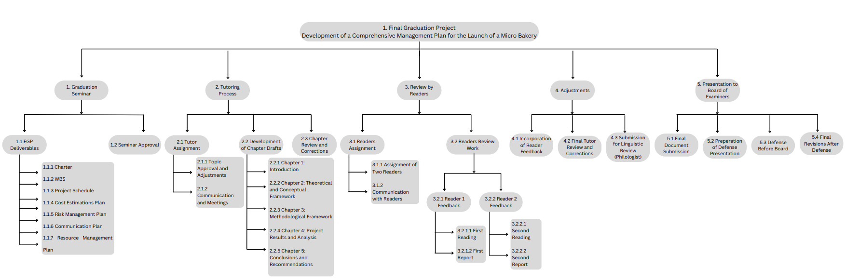
Appendix 2: FGP WBS

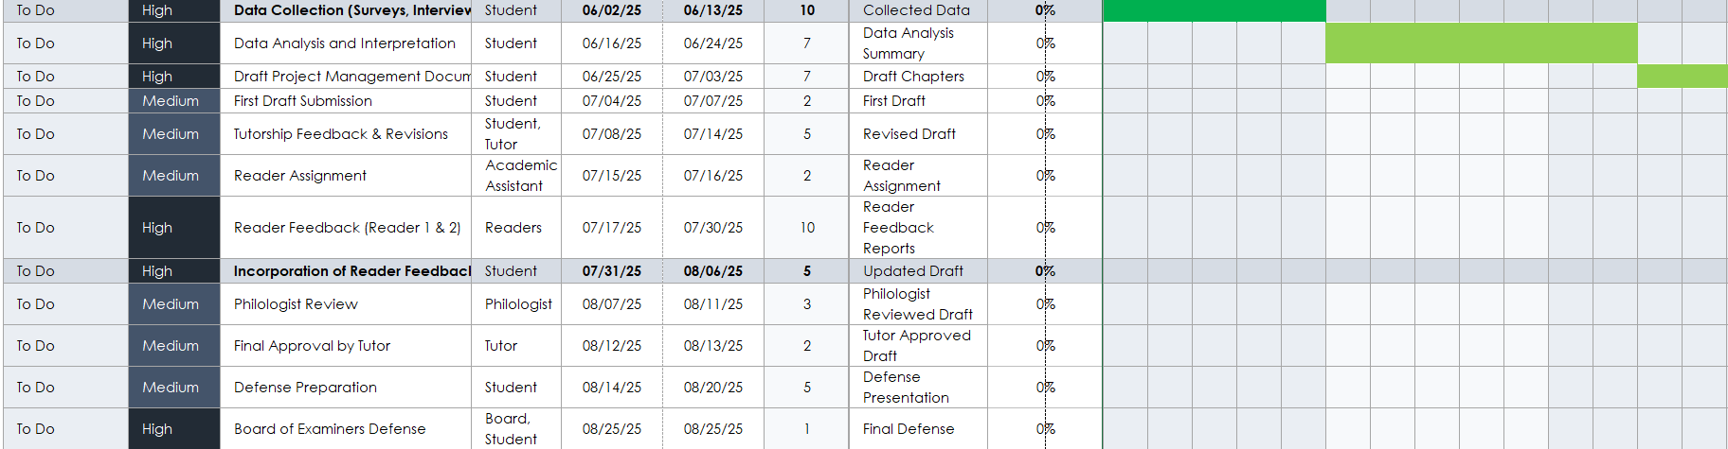
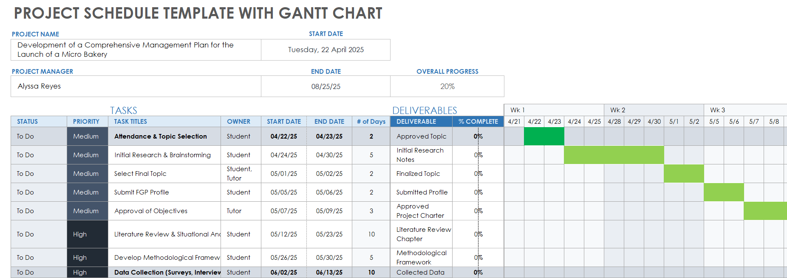
Appendix 3: FGP Schedule

Appendix 4: Preliminary bibliographical research

This guide outlines how to write a business plan for startups, offering essential templates and examples.
Write Your Business Plan. (n.d.). U.S. Small Business Administration.
A practical step-by-step guide for starting a small business, including registration, licensing, and operational planning.
10 Steps to Start Your Business. (n.d.). U.S. Small Business Administration.
This report examines challenges and opportunities for MSMEs in Belize, focusing on access to finance.
Access to Finance for MSMEs in Belize: Challenges and Opportunities. (2024). Inter-American Development Bank.
This business case study demonstrates operational best practices in managing bakery projects, offering practical insights for managing bakery startup phases effectively.
Bake a Cake – Operations Management Case Study. (n.d.). IBS Center for Management Research.
This comprehensive report offers detailed insights into global bakery industry trends, market dynamics, and growth opportunities, providing a valuable foundation for analyzing the external factors affecting the launch of a micro bakery.
Bakery Products Market Report – Industry Trends, Size & Growth. (2023). Mordor Intelligence.
This planning guide provides a structured approach to crafting a business plan tailored to a bakery startup, outlining key components such as marketing, operational, and financial strategies.
Bakery Business Plan Template [Updated 2025]. (2025). Upmetrics.
This article outlines essential structural and revenue considerations within the bakery industry, helping define critical success factors for startup bakeries.
Bakery Industry Analysis - Small Business. (n.d.). Chron.com.
An analysis of the challenges and future risks facing small bakery businesses.
Sustaining Small Bakery Businesses: Looking to the Future in Challenging Times. (2022). Bell, E.
This forecast report analyzes trends, challenges, and growth opportunities in the Belize bakery products market.
Belize Bakery Products Market (2025–2031): Forecast & Outlook. (2025). 6Wresearch.
This detailed report on the benefits and policies supporting local food systems.
Local Food Systems: Practices, Benefits, and Policies. (2022). Food and Agriculture Organization of the United Nations.
This study explores the growing home baking industry and its potential as a foundation for micro-entrepreneurial ventures.
Home Baking Industry: Basis for Micro-Entrepreneurial Study. (2024). Gaux, L.
This academic report examines the application of project management principles within a bakery environment, supporting the development of the micro bakery’s project management framework.
Project Management of a Bakery. (2023). IvyPanda.
This case study explores the open hiring practices of Greyston Bakery, providing inspiration for integrating social responsibility into the bakery’s strategic plan.
Greyston Bakery's Open Hiring Model. (2023). MEF Associates.
An initiative promoting the growth of microbakeries and artisan bread production.
Microbakery | Real Bread Campaign. (n.d.). SustainWeb.
Study highlighting the challenges and resilience strategies of small bakeries in modern economies.
OU Study Shows Challenges Facing Small Bakeries. (2022). Open University.
A professional guide offering templates and instructions for writing bakery business plans.
Free Bakery Business Plan Template & Writing Guide [2025]. (2022). TouchBistro.
An in-depth guide with a free bakery business plan template tailored for new bakery startups.
Free Bakery Business Plan Template: An In-Depth Guide. (2023). Virtuzone.
This technology implementation case study illustrates the digitization of bakery sales processes, presenting modern strategies for operational efficiency.
Schneider’s Bakery Digitizes Sales - Case Study. (n.d.). SiteKiosk.
This report analyzes the development and support environment for SMEs in Belize.
SME Business Development Report. (2022). Belize Chamber of Commerce and Industry (BCCI).
A comprehensive beginner's guide to starting a small business, including business structure, planning, and financing options.
Starting a Small Business. (n.d.). Investopedia.
Guidelines on promoting decent work as part of sustainable development strategies.
Promoting Decent Work for Sustainable Development. (2024). International Labour Organization.
Outlines the U.S. Environmental Protection Agency's hierarchy for sustainable materials management.
Sustainable Materials Management: Non-Hazardous Materials and Waste Management Hierarchy. (2023). U.S. Environmental Protection Agency.
A global update on progress towards achieving the Sustainable Development Goals, useful for aligning bakery sustainability initiatives.
The Sustainable Development Goals Report 2024. (2024). United Nations Department of Economic and Social Affairs.
An exploration of regenerative economy principles, applicable for building sustainable business practices.
The Concept of Regenerative Economy. (2021). Ellen MacArthur Foundation.
A sample bakery business plan designed to inspire entrepreneurs starting bakery businesses.
Unlocking Success: A Sample Bakery Business Plan for Your Inspiration. (2023). PastryClass.
An official labor market report providing key employment and economic data for Belize.
Labour Force Survey Report. (2023). Statistical Institute of Belize (SIB).
This government sector report presents an in-depth analysis of the bakery market within the United States, offering concrete data on consumption patterns, product categories, and marketing strategies, useful for situational analysis.
Sector Trend Analysis – Bakery Products in the United States. (2023). Agriculture and Agri-Food Canada.
This detailed guide offers a step-by-step method to create a home bakery business plan, emphasizing scalability and local market penetration, highly relevant for a micro bakery concept.
How to Create a Home Bakery Business Plan (Template Included!). (n.d.). Philosophy of Yum.

Appendix 5: Revision Dictum
